HEURISTIC SEARCH: A* AND UNIFORM-COST SEARCH
Route calculation, heuristic comparison and failure analysis
Name: Muhammad Abdullah
Roll: 066

Problem setup
This exercise models a route from campus building S to building G. The directed links and costs are S→A (1), S→B (4), A→C (2), C→G (3), and B→G (5). The heuristic estimates are h(S)=5, h(A)=4, h(B)=4, h(C)=2 and h(G)=0.
A* ranks each option using f(n)=g(n)+h(n). The g value is the cost already travelled from S, while h estimates the cost still needed to reach G.
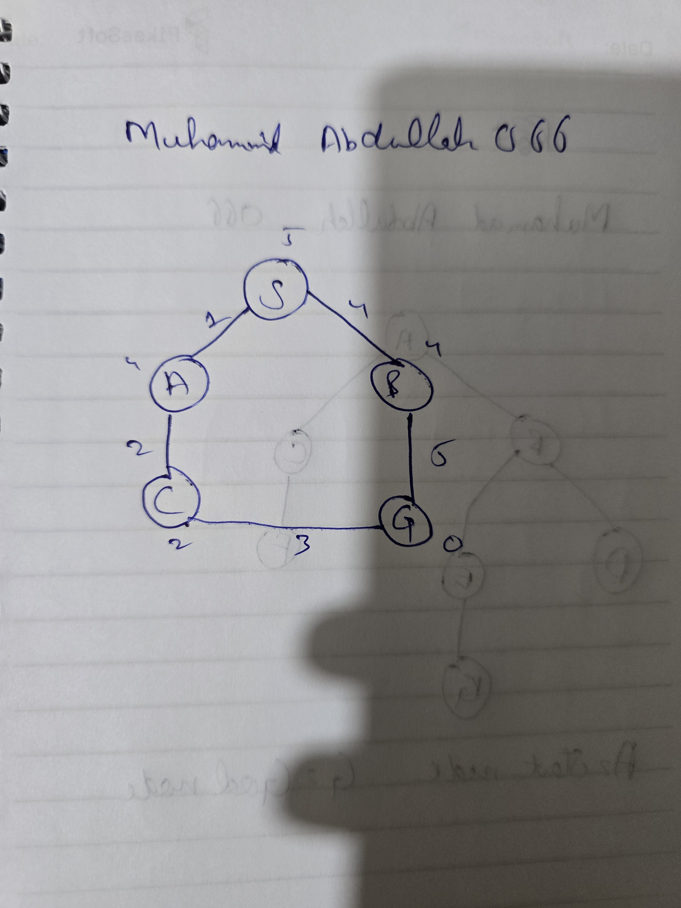

Task 1 — Manual A* trace
Expansion | Current node values | Frontier after expansion | Next choice
1 — S | g=0, h=5, f=5 | A: g=1, h=4, f=5; B: g=4, h=4, f=8 | A is chosen because its f-value is smaller.
2 — A | g=1, h=4, f=5 | C: g=3, h=2, f=5; B: f=8 | C becomes the best available option.
3 — C | g=3, h=2, f=5 | G: g=6, h=0, f=6; B: f=8 | G is selected before B.
The route returned by A* is S → A → C → G. Adding the edge costs gives 1 + 2 + 3 = 6.

Task 2 — A* compared with UCS
Uniform-Cost Search is equivalent to using A* with h(n)=0 for every node. UCS therefore considers only the cost already accumulated, while A* can use a heuristic estimate to guide the order of exploration.
Point of comparison | A* | UCS
Priority rule | g(n) + h(n) | g(n) only
Nodes expanded in this example | 3 | 4
What guides the search? | Cost so far plus estimated remaining cost. | Cost accumulated from the start.
For this graph, A* expands three nodes and UCS expands four. The goal is recorded when removed from the queue but is not counted as expanded because its outgoing edges are not examined. This is an observation about the supplied example, not a universal rule that A* always expands fewer nodes.

Task 3 — Testing an overestimated heuristic
Only h(C) is changed: its value rises from 2 to 10. The true remaining cost from C to G is 3, so the new estimate is too high and is not admissible.
Candidate | g(n) | h(n) | f(n)
C after A is expanded | 3 | 10 | 13
B from S | 4 | 4 | 8
G reached through B | 9 | 0 | 9
B is selected before C because its f-value is 8 rather than 13. The search reaches G by way of B, producing S → B → G with a cost of 9. The cheaper path through A and C is delayed, so the returned answer is no longer optimal.

Failure analysis and suggested safeguards
The inflated estimate makes the route through C look less attractive than it really is. Once the heuristic overestimates the remaining cost, A* loses its usual optimality guarantee. Heuristic values should use the same units as the edge costs and should be checked for admissibility and consistency against known examples.
The search implementation should also keep the best known g-value for each node and ignore stale priority-queue entries. That prevents an outdated, more expensive route from being processed after a cheaper one has already been discovered.

Reflection and limitations
- I learned how the g, h and f values affect the order in which A* examines possible routes.
- The same approach can be used in maps, campus navigation and other pathfinding tasks.
- The surprising result was that changing one estimate changed the route cost from 6 to 9.
- In another experiment, I would test more graphs and verify the heuristic before comparing performance.
The edge weights in this task are illustrative units, not actual measurements of campus travel. The conclusions apply to this small graph and its stated assumptions. The code and outputs should be kept for reproducibility, and external material should be acknowledged.

