Name: Muhammad Abdullah
Roll: su-92-bsaim-f25-066
Section: BSAI 3B

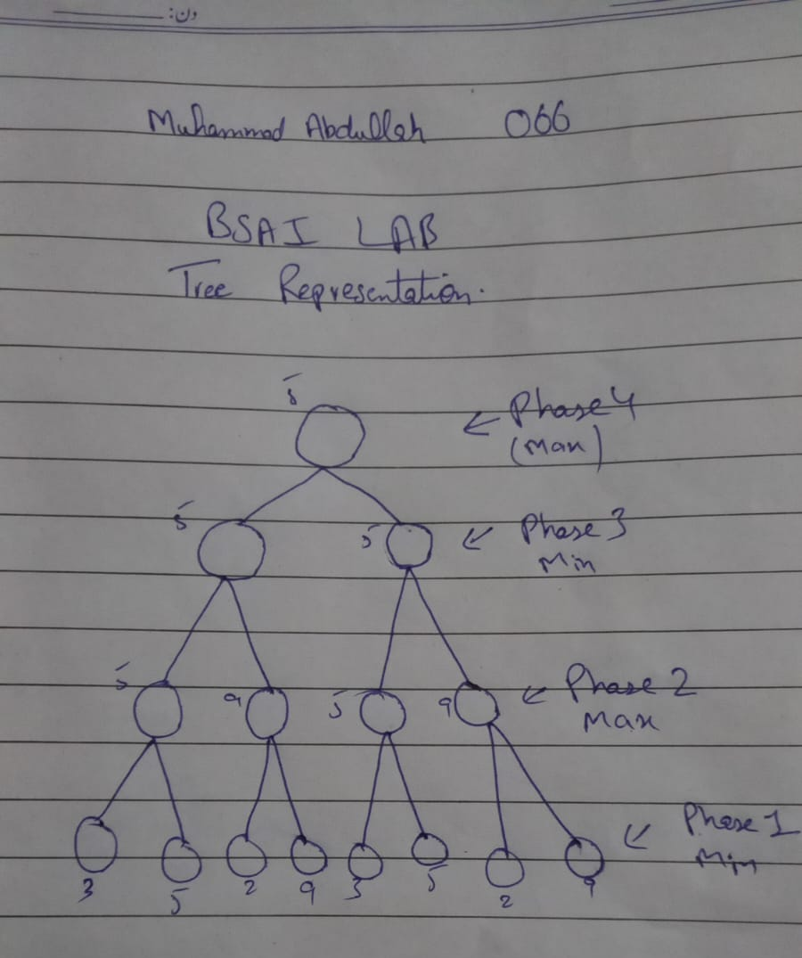
Task 01: Tree By Hand Using Minimax

Task 02:
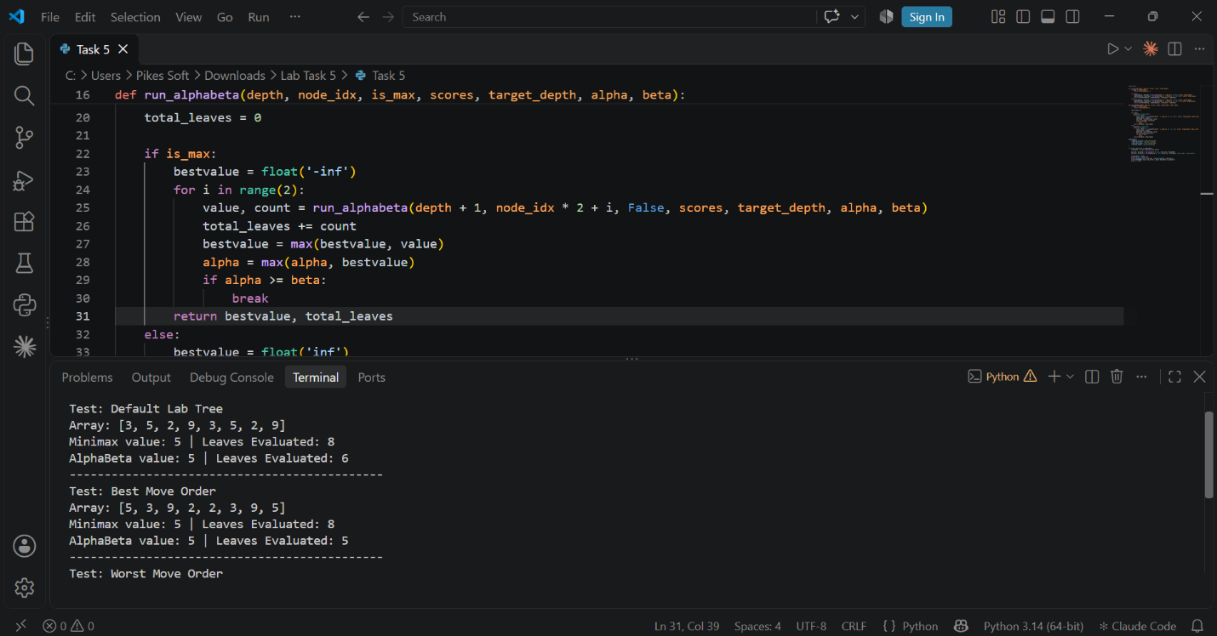

Reflectoin:
1. What did you learn today?
I learn that minimax selects the best moves by assuming both players make optimal decisions.
2. What surprised you?
The thing that surprised me is how significantly branch ordering affects search efficiency.
3. What would you do differently next time?
I will try to apply dynamic move ordering or evaluation functions before searching.
4. How will you apply this in real AI system?
In real AI system I will use Alpha Beta pruning along with strong move to minimize search depth and save execution.

