Hands-on Exercise No. 1
DigiSkills 3.0 Batch-04 | Full Stack Development with MERN

Name: Abdul Rehman

Question 1: Personal Profile Web Page

Part 1: HTML Only (Marks 3)

HTML code (index.html in VS Code)
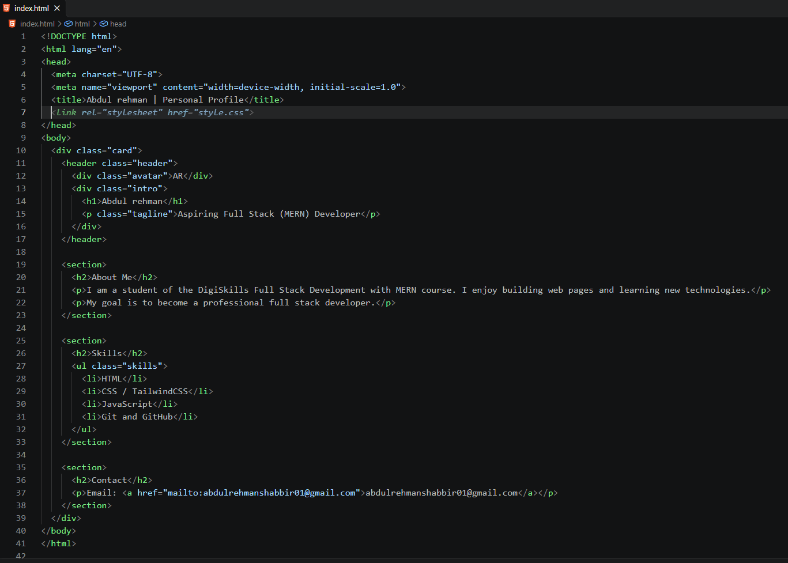

Browser output (unstyled page)
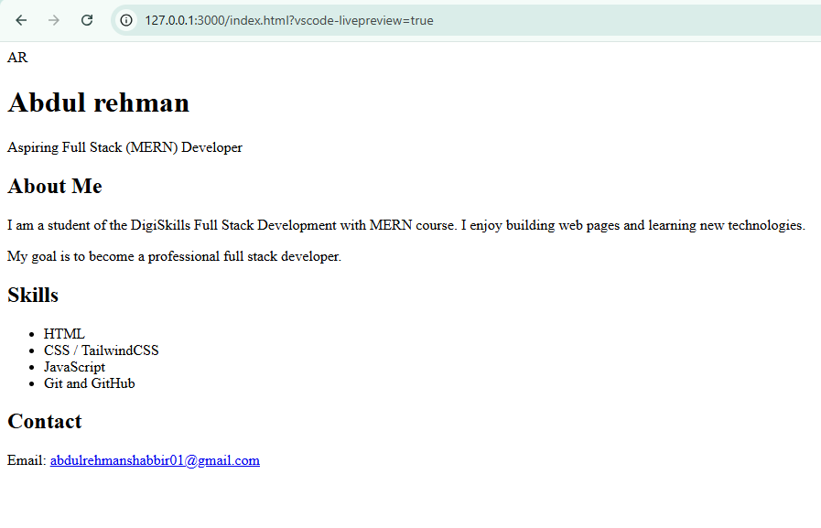

Part 2: CSS Styling (Marks 2)

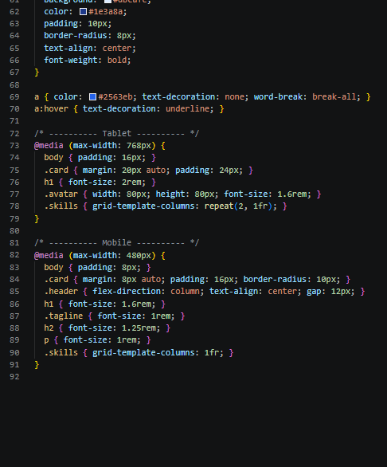
CSS code (style.css in VS Code)
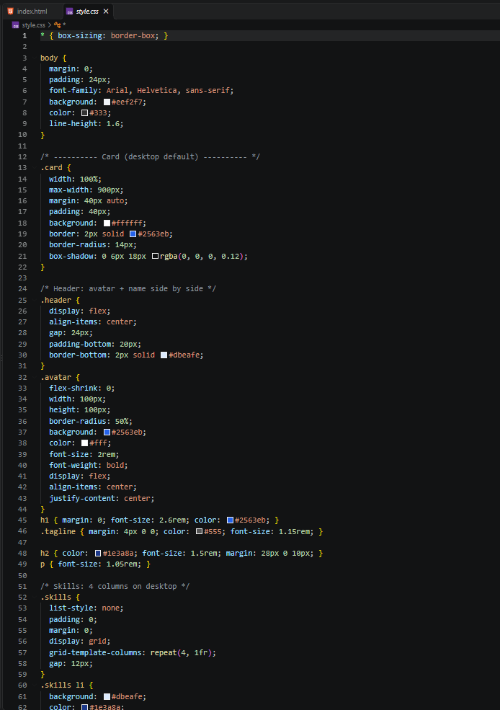

Final styled browser output
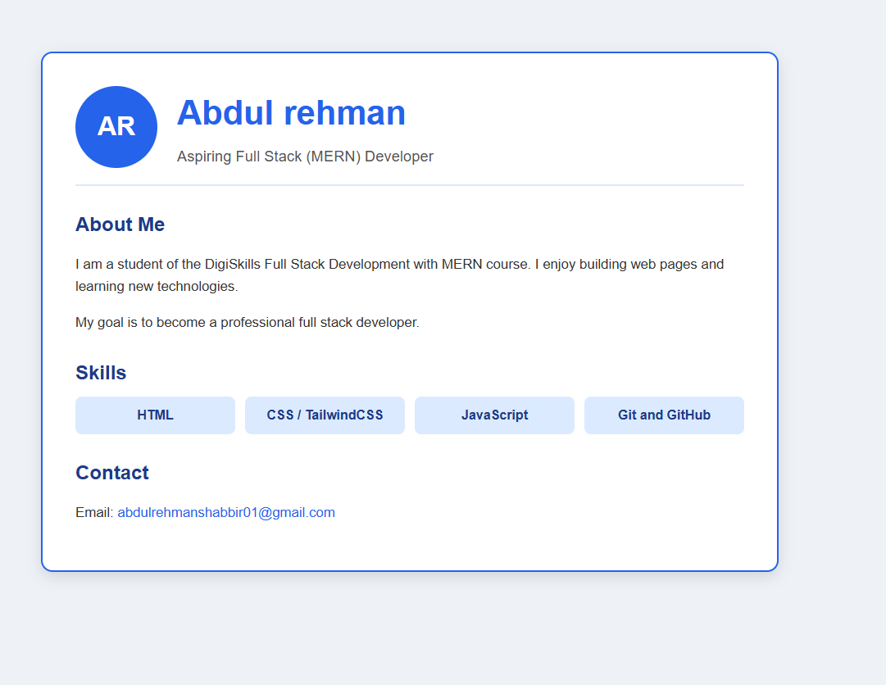

Responsive view (narrow window / mobile mode)
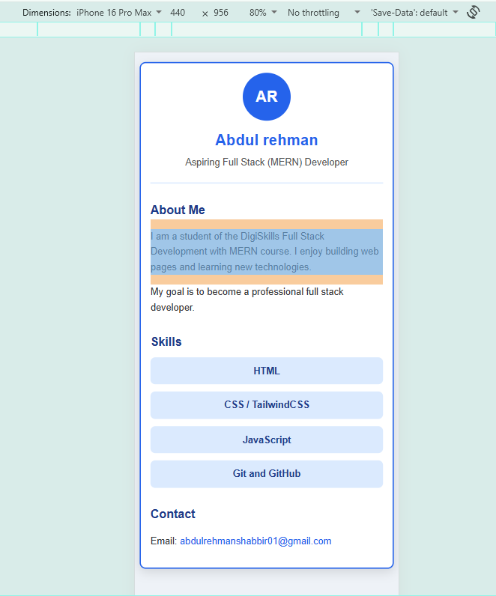

Question 2: Git Repository and Upload

Part 1: Initialize Git Repository (Marks 2)

Project folder
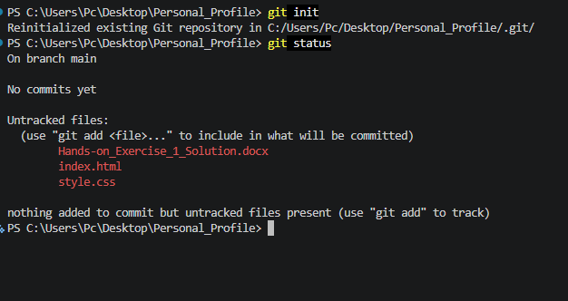

Part 2: Upload to GitHub (Marks 3)

Terminal: git add . and git commit
[ Paste screenshot: Terminal: git add . and git commit ]

Terminal: git remote add origin and git push
[ Paste screenshot: Terminal: git remote add origin and git push ]

GitHub repository showing uploaded files
[ Paste screenshot: GitHub repository showing uploaded files ]

