Quantum Relief
Risk-diversified pre-positioning of flood relief stock with constraint-preserving QAOA
Qiskit optimisation hackathon · Domain: Disaster Response · Brief report

1. Problem statement
Context. Floods such as those of 2022 cut off whole districts, and restocking after the water rises is slow and sometimes impossible. Relief agencies therefore pre-position stock (food, tents, medicine) in warehouses before the monsoon. The budget covers only K of N candidate sites.
The difficulty. The sites that reach the most people tend to share river basins, and a severe flood cuts off every site in a basin together. Picking sites one by one on expected reach concentrates stock where it is most likely to be lost at the same time.
Users. Provincial and national disaster-management planners deciding where to stock before the season.
Objective. Maximise the expected number of people reached minus a caution weight times the variance of people reached, while stocking exactly K sites. Expected reach and risk are competing objectives.

2. Formulation
Element | Definition
Decision variables | x_i = 1 if site i is stocked, else 0 (i = 1..N)
Input data | 2,000 simulated flood seasons give mu_i (mean people reached by site i) and Sigma_ij (covariance between sites)
Objective | minimise C(x) = -sum_i mu_i x_i + lambda * sum_ij x_i Sigma_ij x_j
Constraint | sum_i x_i = K
Test instance | N = 10 sites in 4 river basins, K = 4, 210 valid plans, lambda = 0.005
Scenario model. In each season every basin floods severely with a fixed probability (25% to 35%). A site in a flooded basin is cut off with probability 0.25 to 0.85 depending on the site; otherwise with probability 0.03. A cut-off site reaches nobody. Site names are real places; capacities and probabilities are synthetic.
Quantum representation. Substituting x_i = (1 - Z_i)/2 turns the cost into an Ising Hamiltonian with one Z term per site and one ZZ term per pair of sites, on N qubits with no ancilla or slack qubits. Coefficients are divided by the largest QUBO entry so they are of order 1. A unit test confirms that the Hamiltonian reproduces the classical cost on all 1,024 bitstrings.

3. Algorithm and justification
QAOA is used because the cost is natively quadratic in binary variables, which is exactly what a QAOA cost layer implements: one RZZ gate per pair and one RZ gate per site. The budget constraint is built into the circuit instead of being added as a penalty:
- Initial state: a Dicke state, the equal superposition of all plans with exactly K sites, prepared with the deterministic Bartschi-Eidenbenz construction written gate by gate.
- Mixer: a ring of XX+YY rotations. Each one partially swaps a chosen and an unchosen site, so the number of chosen sites never changes.
- Training objective: CVaR at alpha = 0.10, the mean cost of the best 10% of outcomes, which rewards concentrating probability on the best plans.
- Optimiser: COBYLA. Depth 1 starts from a coarse grid; each deeper circuit starts from the interpolated optimum of the previous depth.
- Read-out: 2,048 shots. The five most-measured plans form a shortlist that is scored exactly, and the best is returned.
A standard QAOA with an X mixer and a penalty term is implemented as the quantum reference.
Assumptions. Ideal gates for the main results, all-to-all qubit connectivity, and statevector simulation during training.

4. Architecture
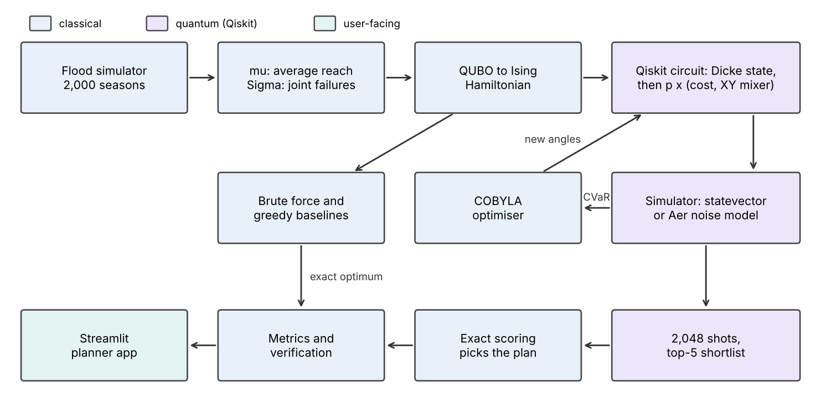
Figure 1. Hybrid classical-quantum pipeline.

5. Results and classical comparison
Every quantum result is compared with brute force over all 210 valid plans (the exact optimum) and with a greedy plan that stocks the four sites with the highest expected reach.

5.1 Circuit variants
Variant | Layers p | Valid shots | Approx. ratio | P(optimum) | vs random
Standard QAOA (penalty) | 1 | 50% | 0.62 | 0.2% | 0.5x
Standard QAOA (penalty) | 2 | 65% | 0.62 | 0.3% | 0.7x
Standard QAOA (penalty) | 3 | 88% | 0.63 | 0.4% | 0.9x
Dicke + XY mixer | 1 | 100% | 0.74 | 2.6% | 5.4x
Dicke + XY mixer | 2 | 100% | 0.79 | 4.7% | 9.9x
Dicke + XY mixer | 3 | 100% | 0.83 | 4.9% | 10.4x
Dicke + XY mixer + CVaR | 1 | 100% | 0.74 | 3.1% | 6.6x
Dicke + XY mixer + CVaR | 2 | 100% | 0.80 | 6.1% | 12.9x
Dicke + XY mixer + CVaR | 3 | 100% | 0.80 | 10.0% | 21.1x
Approximation ratio = (worst - mean) / (worst - best) over valid plans. A random valid plan is optimal with probability 0.48%.
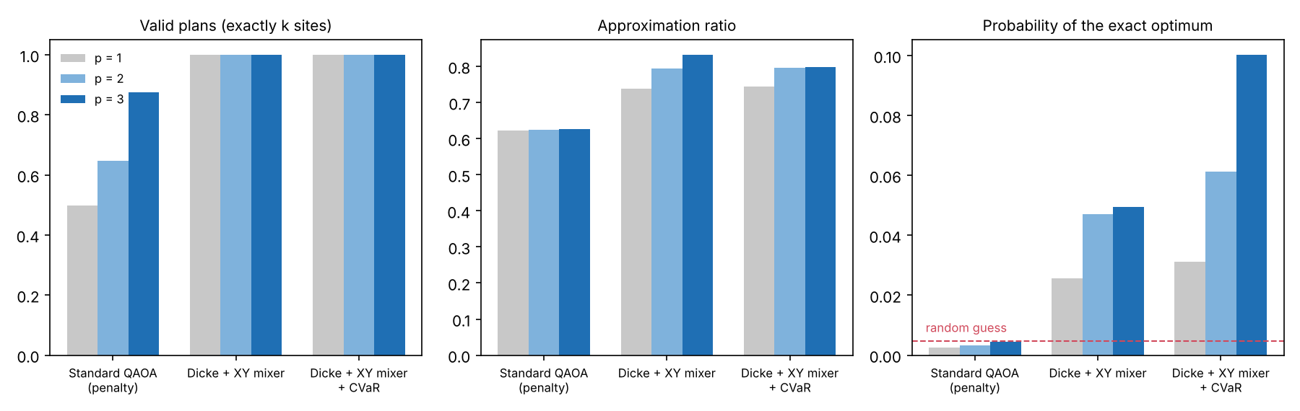
Figure 2. Penalty QAOA against the constraint-preserving variants.

5.2 Decision quality across caution levels
People in thousands; Mean is the expected number reached. Bad-year reach is the 5th-percentile season over 20,000 fresh simulated seasons that the optimiser never saw. Rank is the position of the quantum pick among all 210 plans; the quantum pick equals the exact optimum at all six caution levels.
Plan | lambda | Sites | Mean | Std. dev. | Bad year | Rank
Greedy top-4 | - | Nowshera, Charsadda, Sukkur, Larkana | 274.7k | 108.6k | 90.0k | -
Quantum pick | 0 | Nowshera, Charsadda, Sukkur, Larkana | 274.7k | 108.6k | 90.0k | #1
Quantum pick | 0.002 | Nowshera, Charsadda, Sukkur, D.G. Khan | 269.0k | 93.2k | 76.0k | #1
Quantum pick | 0.005 | Nowshera, Sukkur, D.G. Khan, Multan | 255.5k | 72.3k | 136.0k | #1
Quantum pick | 0.01 | Nowshera, Sukkur, D.G. Khan, Multan | 255.5k | 72.3k | 136.0k | #1
Quantum pick | 0.02 | Charsadda, D.G. Khan, Jhang, Multan | 234.1k | 61.7k | 126.0k | #1
Quantum pick | 0.05 | Charsadda, D.G. Khan, Jhang, Multan | 234.1k | 61.7k | 126.0k | #1
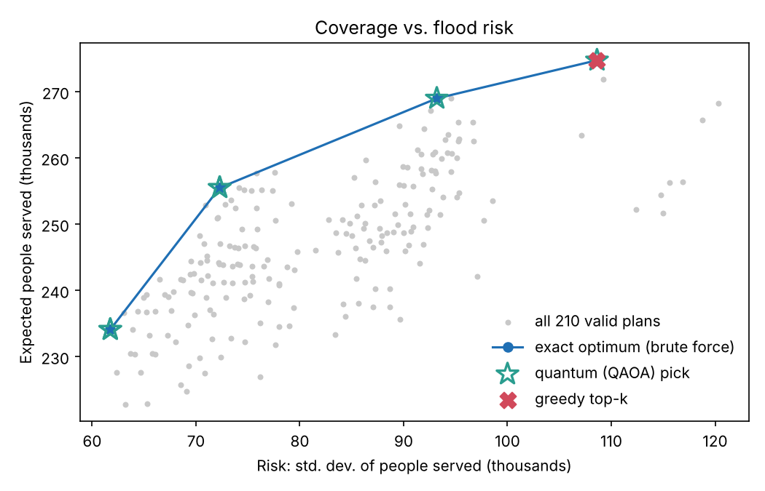
Figure 3. Coverage against risk: exact frontier and quantum picks.

5.3 Hardware noise
The 3-layer circuit compiles to 574 CX gates. Under depolarising noise the budget guarantee no longer holds and invalid shots are discarded.
CX error rate | Valid shots | P(optimum) | Rank of pick
0 (ideal) | 100% | 9.5% | #1
0.1% | 70% | 6.5% | #1
0.3% | 40% | 2.5% | #1
1.0% | 25% | 0.4% | #1

6. Limitations and what did not work
- No quantum speed-up. With 10 sites brute force takes milliseconds. This is a correct small formulation, not evidence of advantage.
- Not hardware-ready. At a 1% two-qubit error only about a quarter of shots remain valid and the optimum is measured no more often than by chance.
- The penalty method did not improve with depth. It gained valid shots (50% to 88%) but its approximation ratio stayed near 0.62 and it found the optimum no better than a random guess.
- CVaR is a trade-off. At 3 layers it doubled the probability of the optimum (4.9% to 10.0%) but lowered the average approximation ratio (0.83 to 0.80).
- Variance is not tail risk. At lambda = 0.002 the optimal plan has lower variance than greedy but a worse bad year (76k against 90k), and lambda = 0.02 is worse in a bad year than lambda = 0.005. A downside-only risk measure would be more suitable.
- Small search space. With 210 valid plans, sampling alone would eventually find the optimum, so the report gives the probability of the optimum and not only the final pick.
- Synthetic data. Capacities and flood probabilities are invented to be plausible. The model selects which sites to stock, not how much to place at each, and it does not forecast weather.

7. Next steps
Replace variance with a downside risk measure; weight sites by expected need in the affected areas; use historical flood records; test a shallower Dicke preparation with symmetry-based error mitigation on real hardware.

References
- Farhi, Goldstone, Gutmann. A Quantum Approximate Optimization Algorithm. 2014.
- Hadfield et al. From the Quantum Approximate Optimization Algorithm to a Quantum Alternating Operator Ansatz. 2019.
- Bartschi, Eidenbenz. Deterministic Preparation of Dicke States. 2019.
- Barkoutsos et al. Improving Variational Quantum Optimization using CVaR. 2020.
- Zhou et al. Quantum Approximate Optimization Algorithm: Performance, Mechanism, and Implementation on Near-Term Devices. 2020.
- Nagurney, Nagurney. A Mean-Variance Disaster Relief Supply Chain Network Model for Risk Reduction. 2016.

