|  |  |
| --- | --- |
| download | COMSATS University Islamabad, Vehari Campus Department of Computer Science |

**Name: Abdul Rehman**

**Class: BCS-SP22-4A Submission Deadline: 10 Sep 2023**

**Subject: Data Structures and Algorithms-Lab Instructor: Yasmeen Jana Max Marks: 10 Reg. No: SP22-BCS-003(A)**

**Email: [yasmeenjana@cuivehari.edu.pk](mailto:yasmeenjana@cuivehari.edu.pk)**

**You can ask queries related to Lab Activities on the above email.**

**Activity 1:**

Create a GitHub Account. Make a repository with the name “**DSA_Lab”. Mention the link here after the account creation.**

**Solution:**

**Activity 2:**

Write any 15 programs that will explain the concepts of pointers.

In this file, you should place the code and its output screenshot.

After completing the activities, Upload the final pdf and code to the “**DSA_Lab”** repository.

**Name: Abdul Rehman**

**Roll no: SP22-BCS-003(A)**

**Assignment: 01**

**Subject: Data Structures**

**Teacher: Mam Yasmeen**

**CUI Vehari**

(1)

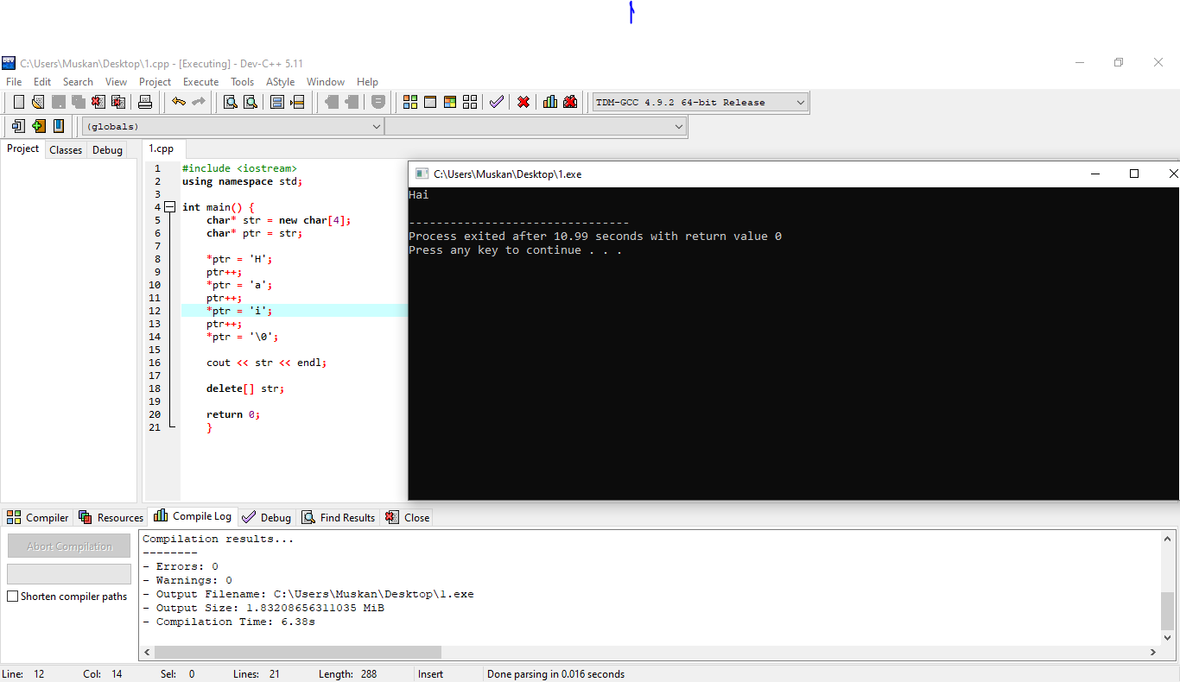

(2)

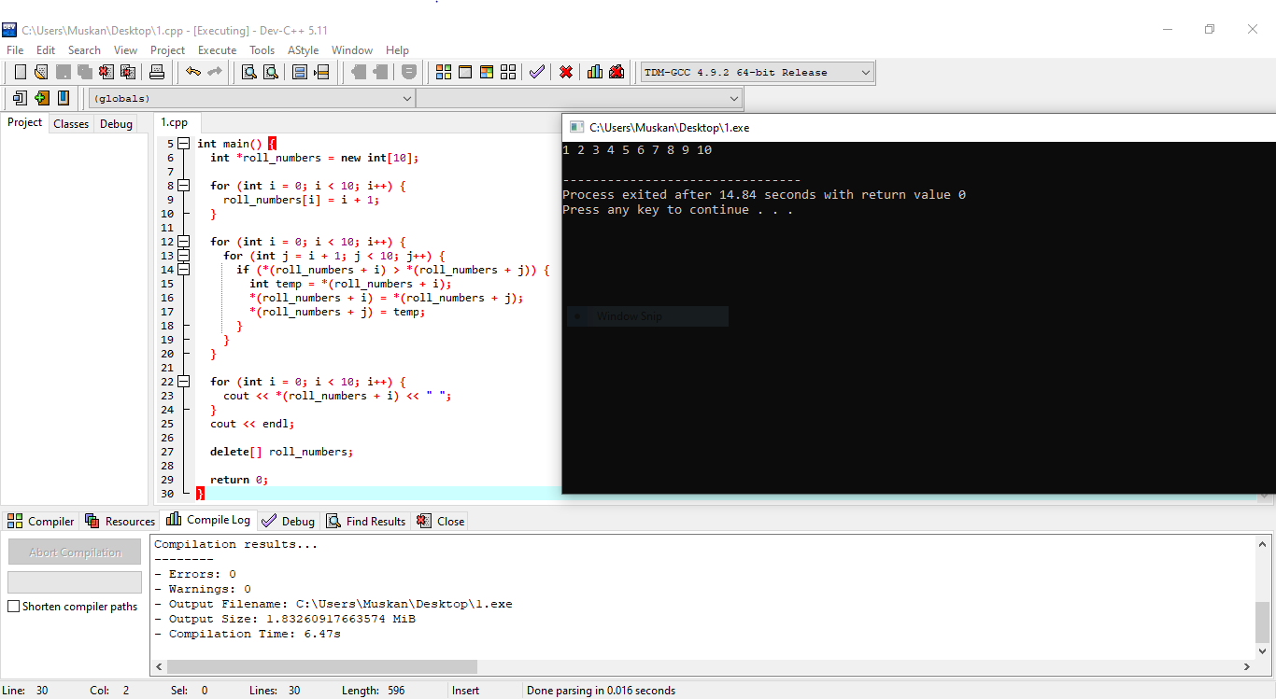

(3)

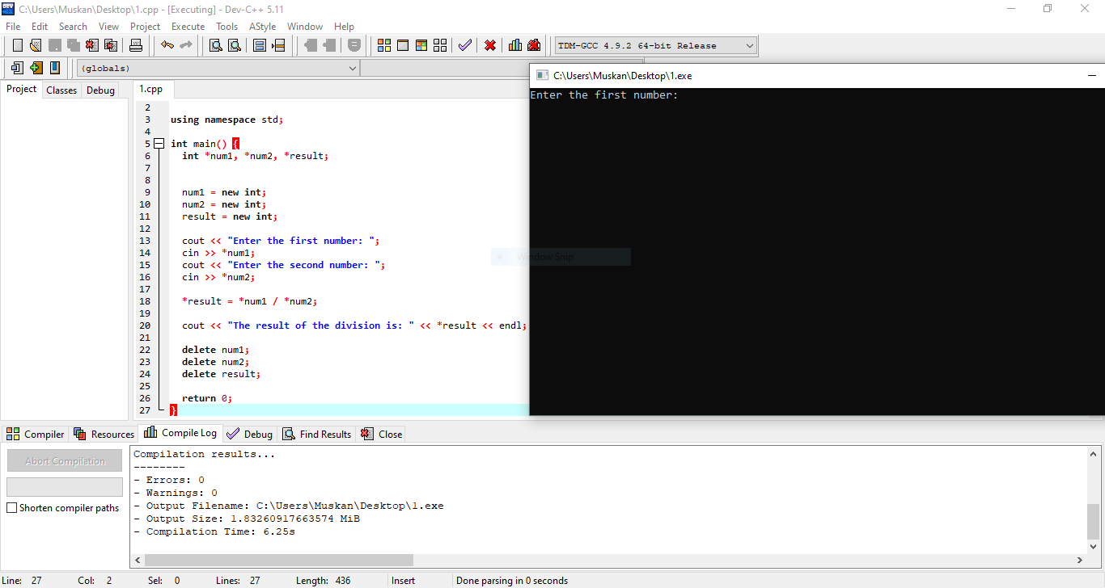

(4)

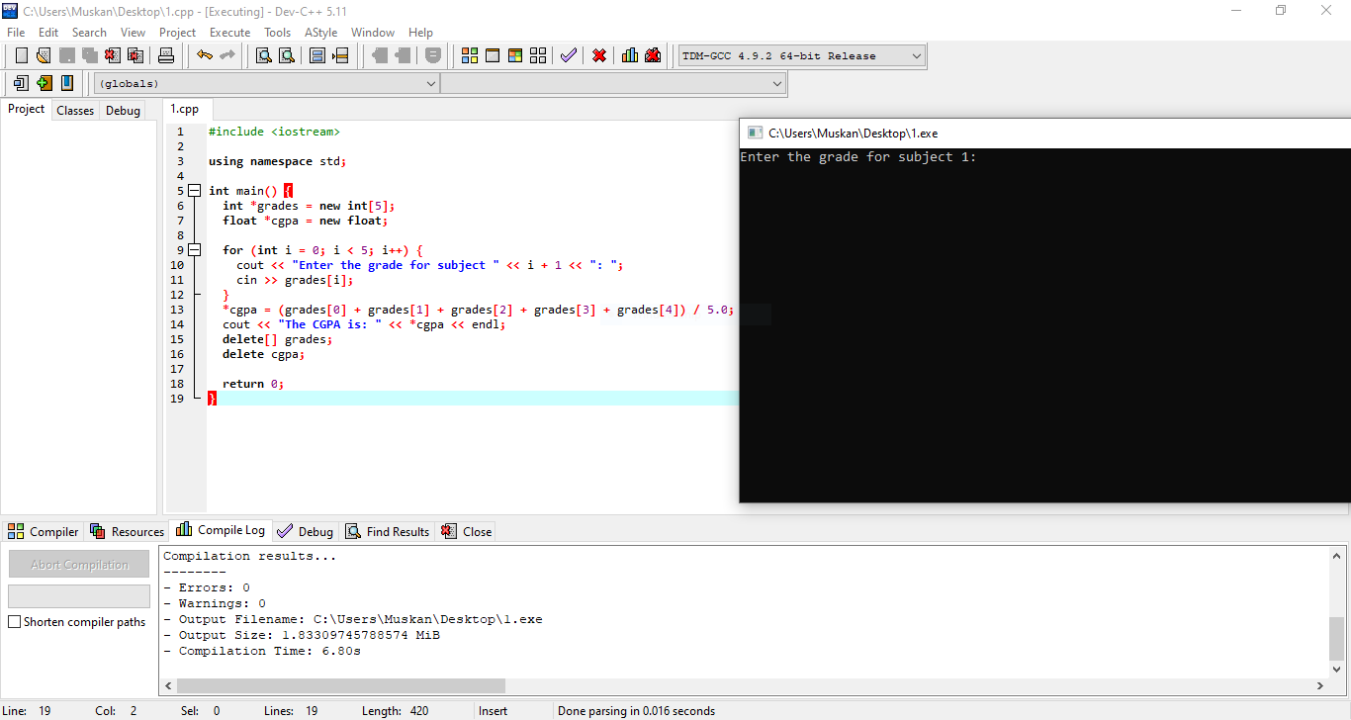

(5)

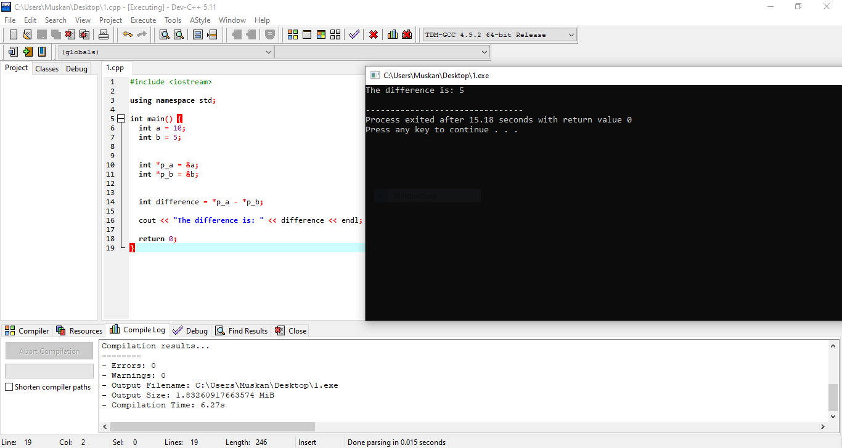

(6)

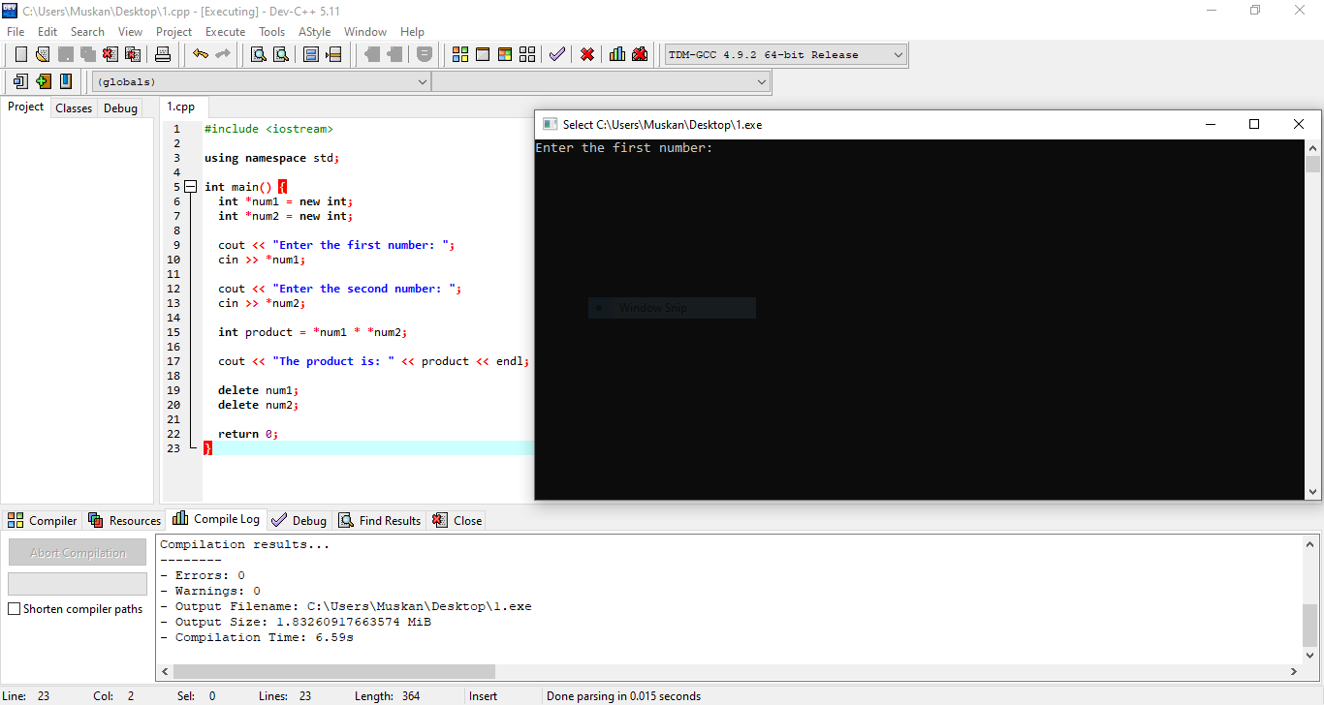

(7)

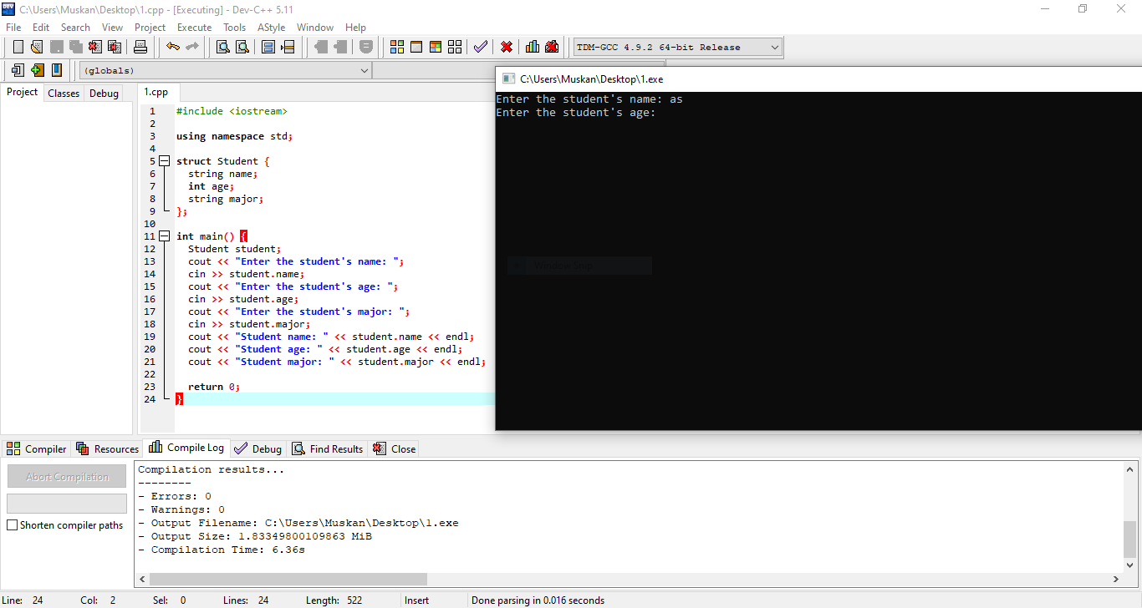

(7)

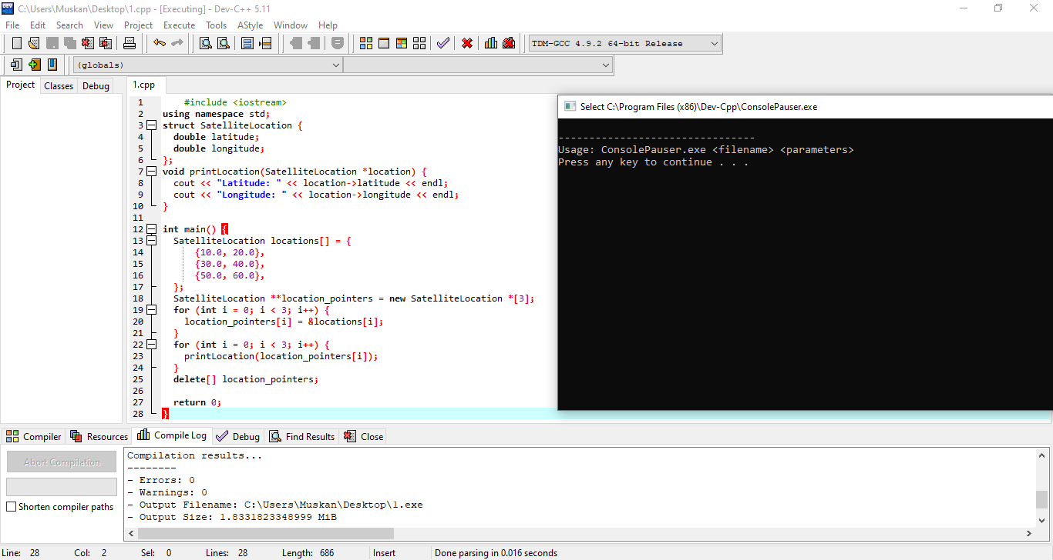

(8)

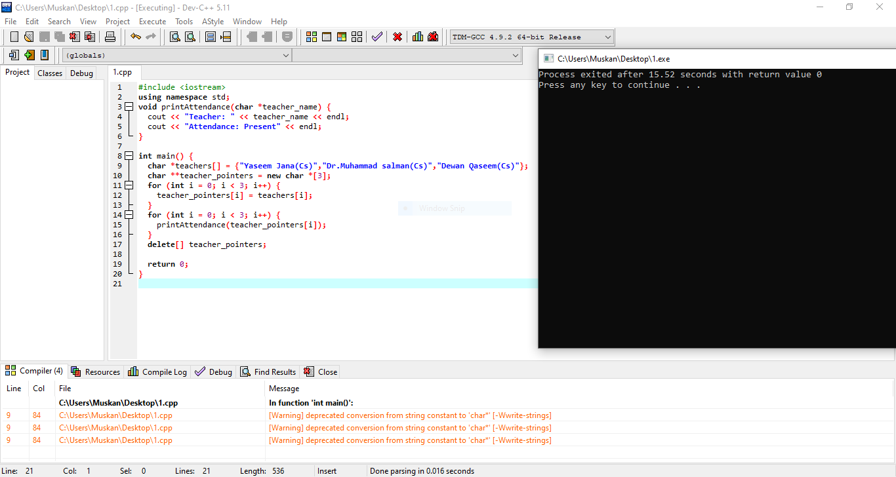

(9)

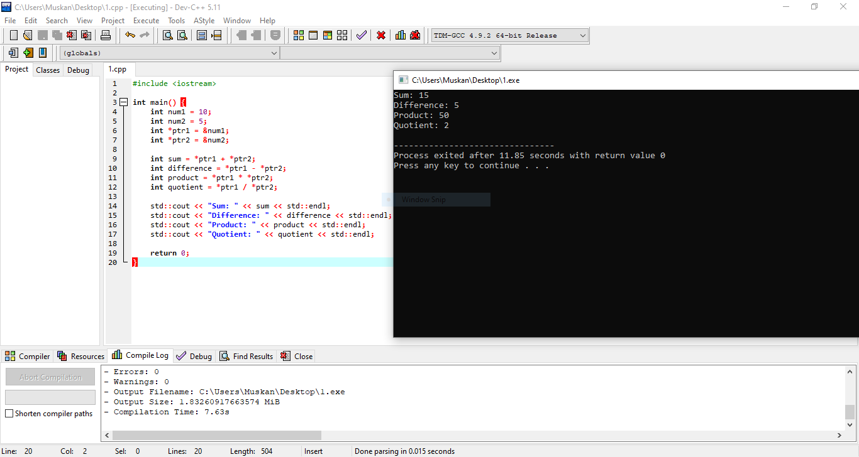

(10)

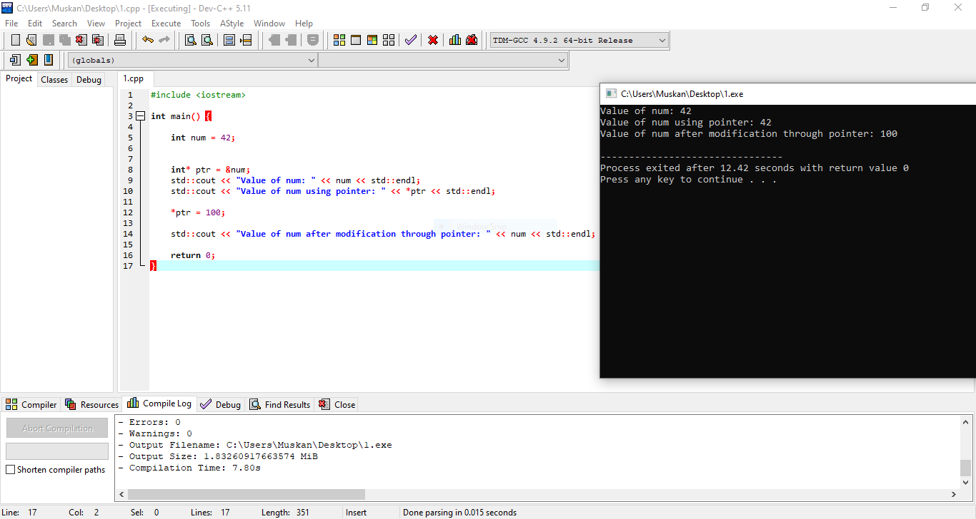

(11)



(12)

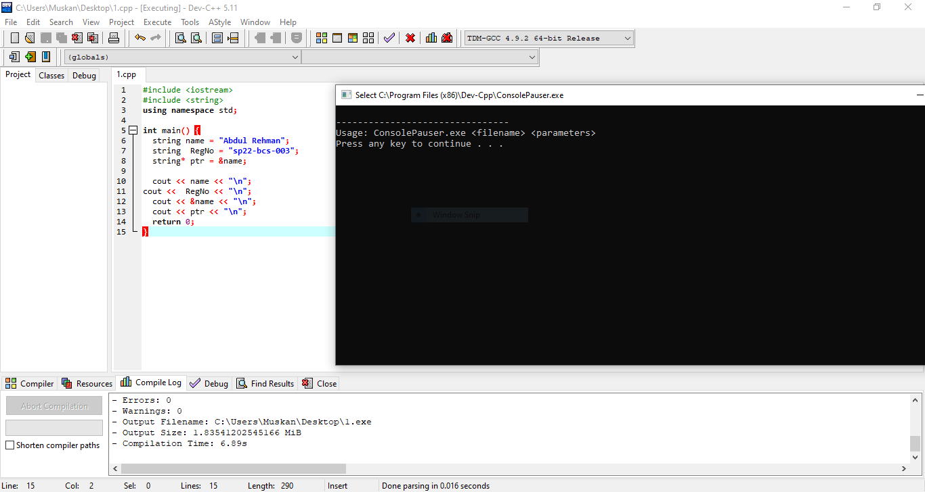

(13)

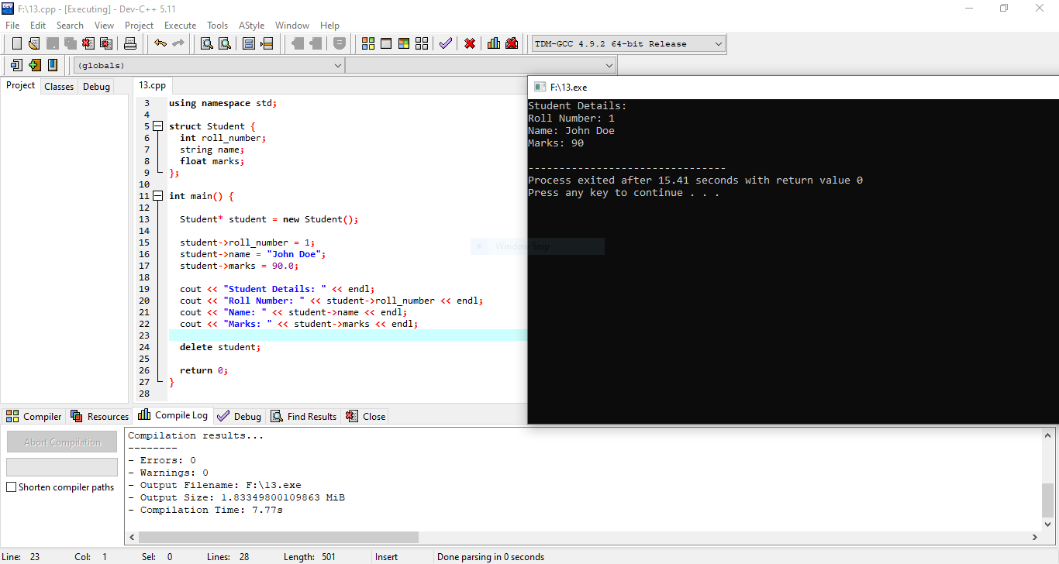

(14)

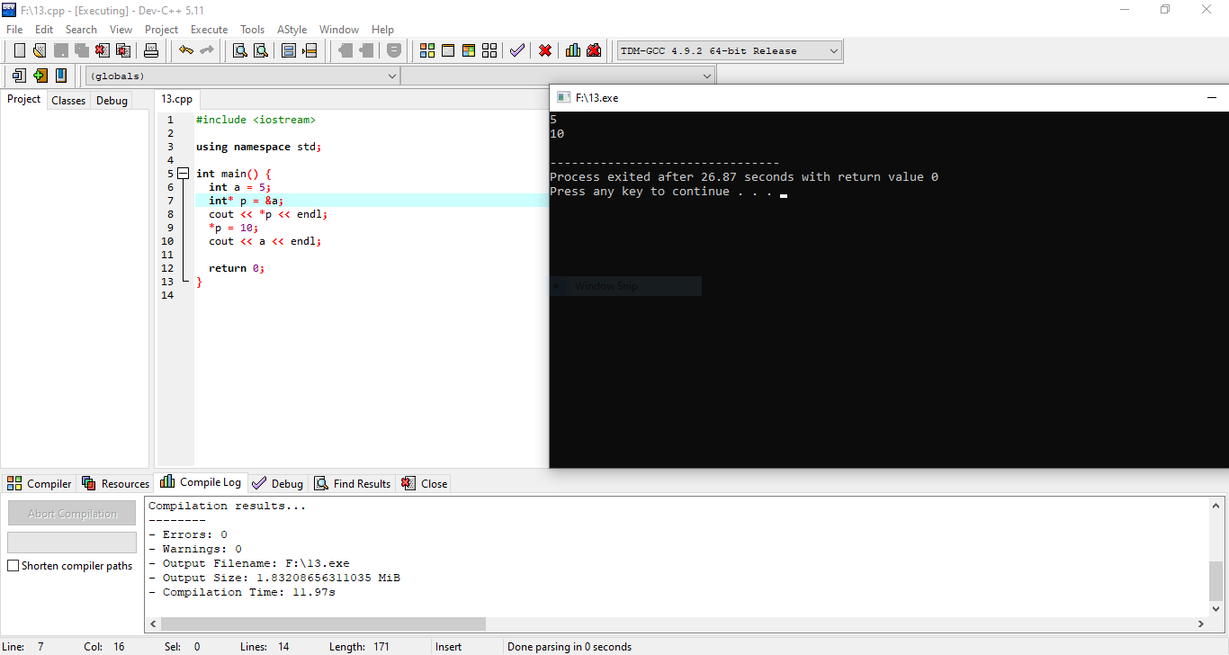

(15)

