Bloodlytics


By:

Muhammad Fahad
10301
Muhammad Shahzaib
10994
Amir Sohail
9463

Supervised by:
Mr. Zohaib Shahid

Riphah College of Computing
Riphah International University, Faisalabad Campus
Fall 2021
A Project Documentation Submitted to

Riphah College of Computing
Riphah International University, Faisalabad Campus
As a Partial Fulfillment of the Requirement for the Award of the Degree of
Bachelors of Science in Computer Science

Riphah College of Computing
Riphah International University, Faisalabad Campus
Final Approval

This is to certify that we have read the report submitted by Muhammad Fahad (10301), Muhammad Shahzaib (10994), Amir Sohail (9463) for the partial fulfillment of the requirements for the degree of the Bachelors of Science in Software Engineering (BSSE)/ BSCS. It is our judgment that this report is of sufficient standard to warrant its acceptance by Riphah International University, Faisalabad Campus for the degree of Bachelors of Science in Software Engineering (BSSE)/ BSCS.

Committee:

1 | Mr. Zohaib Shahid  (Supervisor)
2 | Name of Co Supervisor (if any)
3 | Principal  Riphah College of Computing

Declaration

We hereby declare that this document “Bloodlytics” neither as a whole nor as a part has been copied out from any source. It is further declared that we have done this project with the accompanied report entirely on the basis of our personal efforts, under the proficient guidance of our teachers especially our supervisor Mr. Zohaib Shahid. If any part of the system is proved to be copied out from any source or found to be reproduction of any project from anywhere else, we shall stand by the consequences.

___________________________
Muhammad Fahad
10301

___________________________
Muhammad Shahzaib
10994

___________________________
Amir Sohail
9463
Dedication
I am tremendously appreciation to Allah Almighty the most Gracious and the most Merciful that he is the one who help us and he gives us the strength through we can do everything. After Allah Almighty, I dedicate this work to my parents, who have always loved, supported and been my primary mentors in not just education, but in every step of my life.
Acknowledgement

First of all, we are obliged to Allah Almighty the Merciful, the Beneficent and the source of all Knowledge, for granting us the courage and knowledge to complete this Project.
This project consumed a huge amount of work, time and dedication. The contributions of many people in their different ways have made it possible. In this project, we had to take the help and guideline of some respected persons, who deserve our greatest gratitude. The completion of this project gives us much pleasure. We would like to show our gratitude to our supervisor, Mr. Zohaib Shahid (Lecturer Computing), for giving us great guidelines for project throughout numerous consultations. I express my warm thanks to them for his effort in proofreading the drafts and his collaborative help in developing this project.
Many people, especially our project panel members have made valuable suggestions on this project which gave us an inspiration to improve our work.
We express gratitude to all the Department faculty members for their help and support because of that we are at this stage and able to make our project. Their experience has been an interesting and rewarding one.
Finally, we would like to thank our parents for their unceasing encouragement, unconditional support both financially and emotionally throughout our degree.
___________________________
Muhammad Fahad
10301

___________________________
Muhammad Shahzaib
10994

___________________________
Amir Sohail
9463

Abstract

With the advancement of technology, healthcare is becoming very modernized. Still, in this era, many hospitals and NGOs, in Pakistan, work hard to maintain smooth blood donation systems but it still remains a challenge due to the large population. The Bloodlytics app will help people in receiving blood from the donors according to their requirements. They will also be able to donate blood via this app. It has been inspired by the model of Careem and Uber. It is a hybrid mobile application, inspired by Careem and Uber, and has been built using Web application technology. The user’s location and blood group will be used. According to that, the required donors will be shown on the map, within an area of a radius of 2 km, around the user. The user can, then, reach out to the donor of their choice. Along with this feature, stats like male to female ratio of donors in the area, smoker to non-smoker ratio etc. will be shown too. Overall, this project will help in the automation of the system of blood donation. As a result, a better healthcare system will come into being.

Table of Contents

Chapter 1 12
1.1 Introduction 12
1.2 Background 12
1.3 Motivations and Challenges 12
1.4 Goals and Objectives 13
1.5 Solution Overview 14
1.6 Report Outline 14
Chapter 2 16
2.1 Introduction 16
2.2 Literature Review/Technologies Overview 16
2.2.1 Websites 17
2.2.2 Mobile Apps 17
2.3 Summary 23
Chapter 3 25
3.1 Introduction 25
3.2 Problem Scenarios 25
3.3 Functional Requirements 25
3.3.1 Admin 26
3.3.2 Sign In 26
3.3.3 Sign Up 26
3.3.4 Home Screen 26
3.3.5 History 26
3.3.6 Report 26
3.3.7 Search a donor 26
3.3.8 Map 27
3.4 Non-Functional Requirements 27
3.4.1 Usability 27
3.4.2 Accessibility 27
3.4.3 Performance Requirement 27
3.4.4 Operational and Environmental Requirement 27
3.4.5 Reliability 28
3.4.6 Maintainability 28
Chapter 4 30
4.1 Introduction 30
4.2 Architectural Design 30
4.3 Data Flow Diagrams 31
4.4 Use Cases Diagram 33
4.5 Activity Diagram 34
4.6 State Diagram 35
4.7 Swim Lane Diagram 37
4.8 Sequence Diagram 37
4.9 Class Diagram 39
4.10 ER Diagram 40
References and Bibliography 41

List of Figures

Figure 1 Total Male and Female Numbers [5] 20
Figure 2 Architecture of mHealth 21
Figure 3 System architecture of Blood Donation and Life Saver App 22
Figure 4 Work Flow Diagram of B Door App 23
Figure 5 Data Flow Diagram Level 0 32
Figure 6 Data Flow Diagram level 1 33
Figure 7 Data Flow Diagram level 2 34
Figure 8 Use Case Diagram 35
Figure 9 Activity Diagram 36
Figure 10 State Diagram 37
Figure 11 Swimlane Diagram 38
Figure 12 Sequence Diagram 39
Figure 13 Class Diagram 40
Figure 14 ER Diagram 41

Chapter 1:
Introduction

Introduction

Bloodlytics is a Hybrid mobile application where the user can donate or receive blood according to their requirements. This app has been inspired by the model of Careem and Uber. The user can pick and contact the blood donor of their choice. Real time data analytics of the donor will be done and displayed like their health data, ETA etc. The exact location of the blood donor will be tracked by using Google Maps. In the same way, the donor can also interact with the patient for seamless blood arrangement. Overall, this app will reduce the human effort of arranging blood in emergency situations. The person who goes online with this application will see live donors in his or her area on the map and contact them immediately.

Background

Concerning the department of health, blood donation and its systems have always played a crucial part. On a daily basis, a large number of patients require blood donation and many blood donors have to be managed. It is estimated that 0.7095 million liters (l) of blood are donated each year in Pakistan[1]. As of 2018, there are 150 public blood banks and 450 private blood banks in Pakistan [2]. Many hospitals and NGOs work hard to maintain smooth blood donation systems but it still remains a challenge due to the large population.

Motivations and Challenges
In Pakistan, the healthcare system is in a dire need of improvement. Blood donation is a very important part of any healthcare system. The present systems, in place, are not very efficient. This leads to a loss of many innocent lives which could have been saved. Many existing websites and application work to help people but there is a problem that donor data is not up to date. Real time data analytics has not been incorporated which can give the user a better experience. Mostly, the user cannot communicate with the donors properly and their availability cannot be confirmed. Therefore, a system is required which can facilitate smooth blood donation and seamless contact between the user and the donor. The main challenge may be that due to loss of internet connectivity, the real time data analytics will be affected. There might be a lag in their generation. Having updated health data will be a challenge along with data security.

Goals and Objectives
Bloodlytics app, will facilitate users who require blood and the donors as well. The patient or their attendant can search donors, based on the location of the user (in a radius of 5 km), blood group and other requirements like smoker/non-smoker and health conditions etc. The donors, which will show up, will be live and in this way, the donor can also know that a legitimate person requires the donation. Once, the donor receives a notification of the user, he or she can respond to it and be on his or her way. The data of the donors will be kept updated. Considering the donors, when they sign up on the app, their fresh blood report (1 week old by a selected lab) will be uploaded as well along with other health stats like age, HIV status, smoker/non-smoker etc.

Real time data analytics will play a part here. The user will be able to see the ETA and other health stats of the blood donor. Data Visualization will play a role here as the user will be able to compare the stats like smoker/non-smoker, blood report, past record, gender etc. and pick the donor of their choice. Some metrics, which will be shown to the user, are
- No. of times a donor donated blood in the last year/month
- Comparison of Smoker/Non-smoker in the patient's area (Bar Graph/Pie Chart)
- Comparison of Ages of the Donors in the patient's area (Bar Graph/Pie Chart)
- Comparison of Gender of the Donors in the patient's area (Bar Graph/Pie Chart)
- Comparison of period since last donation was done by the donor.

Solution Overview
Technology may be a valuable instrument for people to superior connected with the community and day by day social media have made our lives easier. In our project, People will interacts with each other easy and donate or receive blood as their requirement. Our outcome is to developed hybrid mobile application for the purpose of facilitating blood donation which will save dear lives. Our project covers blood donors and the patients who require blood. The real time data analytics will improve the experience of the users and the donors. More accountability on the part of the donors will be observed. The user and the donor get a choice of getting and giving blood. This app is related to healthcare. Overall, this app will help a third world country like Pakistan to manage blood donation in an already crumbling healthcare system in a somewhat proper manner.

Report Outline
This project report provides a detailed overview of the hybrid mobile application, its challenges and goals. This document describes the project’s target audience and problem solution for audience. In the first chapter, we are describing the overview, background, goal and challenges of mobile application. Then in second chapter there are different researches related to our project and existing systems. There we are showing the review of the recent technologies and the results . Then in the third chapter, we are showing the actual need of this application in society after that we describe the requirement analysis, functioning, non-functioning requirement and details of previous system problem. Then in fourth chapter, we show our implementation of app and design. After that we represent the working diagrams, architecture and the procedure of our app.

Chapter 2: Literature/
Market Survey

Introduction
Before starting to develop an app it is important to understand and study the existing system or description of the current situation in mobile applications for donation blood. We are doing literature & market survey because we want to know that what previous applications and websites management system are developed. What are the modules they are working on and what are the gaps we are going to fulfil in the development.
In recent years, many applications and websites are work for donating blood these websites and app build for just giving the information to the user like providing data of donor which are not up to date the proper contact is also not available so the receiver can’t communicate with the donor these existing system are not helping the people because donor are not active properly. This literature shows the need to collecting enough blood from the donor and provide to the receiver for saving their life. Also this literature show how much needs of blood in Pakistan and rate of people how are not getting blood and ratio of death in Pakistan. The lack of blood donation and storing blood in rural areas of Pakistan people are die because of lack of blood in these area also get infected because of unsafe blood .Throughout the efficient study of existing system this paper gathering articles and researches which are discuss or analyze from the perspective of blood donation.

Literature Review/Technologies Overview
Technology is best when it brings people together. It is observed that technology is consumed a lot of our time today. According to figures from the Pakistan Telecommunication Authority (PTA), there were 152 million cell phones in Pakistan in March 2019. In 2020, 40.59M Pakistani people are using smart phone as we see due to increase in technology change how much people are using mobile phones. Mobile phone ownership between urban and rural areas is not significant (94.7% compared to 83% respectively) [1]. In recent year the trend of using different app in mobile phone are increasing day by day people prefer using app at home instead of going out of house for doing something like in Pakistan people are using pick and drop service by using uber and cream. Uber has 500M+ download in play store also cream has 10M+ download on play store.
In recent years, many existing system provide the services of blood donation and receiving. The main issue with these apps and websites is that the data is mostly not up to date. The donors are not active mostly. Proper contact with the donors is not established some times. Also, the health stats of the donors are never available. The following app and websites are given blow:

Websites
- hayat.pk
- shaukatkhanum.org.pk
- www.bdsp.org.pk
- http://www.blood.pk/
- Facebook Blood Donation Group

Mobile Apps
- Blood Donor App
- Frinds2Support.org
- Bloodkad
- Bloods Friends
In Pakistan, the unavailability of blood has leads to a number of deaths and many patients suffer from ill-health. The exchange of blood helps save millions of lives every year. It can help improve life anticipation and the quality of lives of patients suffering from life threatening conditions and diseases, like thalassemia, haemophilia, anaemia, cancer, kidney failure, dialysis, bleeding after child birth, cardiac bypass surgery and supports complex medical and surgical procedures. According to one estimate, 75 % of clinics in Pakistan don't have transfusion committees, due to which rate of pointless and unscreened blood transfusion is very tall within the country. Pakistan has a high load of thalassemia patients according to estimates, 5000 children are born with thalassemia each year and 70,000 patients are enlisted with the illness. Every two to five weeks thalassemia patients need blood, to maintain the pretransfusion hemoglobin level above 9–10.5 g/dl.
On a daily basis, a large number of patients require blood donation and many blood donors have to be managed. It is estimated that 0.7095 million liters (l) of blood are donated each year in Pakistan [2]. As of 2018, there are 150 public blood banks and 450 private blood banks in Pakistan [3]. Pakistan’s annual blood exchange requirement is approximately 1.5 million bags 90 % of total blood exchange in Pakistan is donated by the friends and relatives of patients. Around 10-20 % of blood supply is still donated by professional donors. Any person between the age of 17 and 65 years and weighing 50kg or more can donate blood at least three times a year.
In Pakistan, the equipment is required for screening of safe donor’s blood have to be imported. Free blood services in the country say it is proving difficult to continue their charity endeavour. Most blood banks in Pakistan offer services free of cost, with expenses borne by donations from private citizens and philanthropists, reports the international media. According to the National Institute of Child Health (NICH) since last year, the price of [a full] blood bag has increased from Rs1,800 to Rs2,200, which includes the cost of blood screening [4].
A web based blood donation system was being tested by Blood Donation Society, Gomal University, Dera Ismail Khan, Pakistan [5]. In this system user get the information of donor of the same blood group that is present in the record. This system can connect receiver and donor, Receiver request the donor for blood donation. This system were generated donor report provided information like donor Name, Father-Name, Profession, Bloodgroup, Gender, Phone-No, Donation-date. This report were generated both in tabular as well as in graphical form [5]. User can compare different donor health.it also show total number of donors registered in table, user also get analysis, Gender-wise, Professional-wise, City-wise. In this system the tools/Technology are use ASP, XML, Java and SQL SERVER.
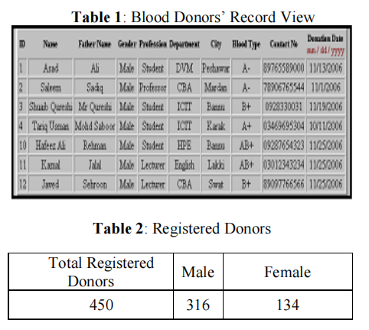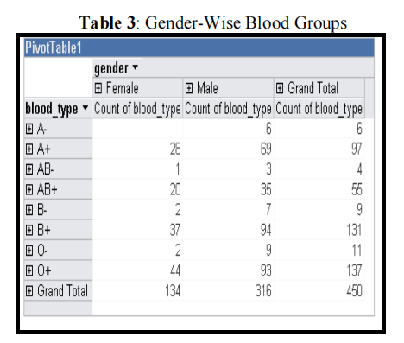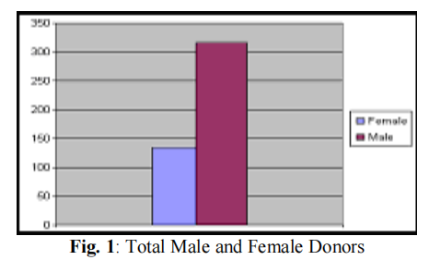
Figure 1 Total Male and Female Numbers [5]

mHealth is a new wellness horizon that provides healthcare facilities through mobile devices and networking technology [6]. Android based blood donation application is an M-Health solution to connect the requester and donor at any time and from any place. This application is use the networking technology of cloud computing for keeping the application data available anywhere and anytime. This application is to use it as a volunteer blood donor as well requester. Requester can broadcast the message along urgency sign of required blood to the registered users and notification message will send to all the volunteer blood donors.
When a blood donor will confirm the blood donation then it will be marked as donor found in the receipt list. Web services are used as communication bridges between the donor and receiver via cloud server. This services contains data of donor like register user, authenticate user, broadcast alert messages, and update response functions.
The propose architecture of blood donation application [6] as shown in Figure 2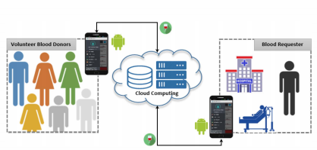
Figure 2 Architecture of mHealth

In this application, it has two modes (donor and requester) to interact with the proposed m-Health application. In voluntary donor mode, system will ask necessary information about the name, surname, user name, password, city, age and blood group or in case of requester mode, application ask patient name, age, blood type, urgency of blood, hospital name, and contact information.
User can login the system by entering name and password. In case of new user, User can sign in by providing the information about the name, surname, user name, password, city, age and blood group. Once user will register to blood donation application he/she can see the panel then user can ask for blood donation by filling the application. Once user will request for the blood an alert message will be deliver to all the register volunteer donors when the request accepted the data of donor will appear in list.
Blood Donation and Life Saver-Blood Donation App is an application that can search donor near your area using GPS in the range of 10 km [7]. Those users who register in this application their data with the blood group detail will be display using GPS. In this application user can enter details like name, phone number, age, weight, date of birth, blood group, address. The person who is login with the data provided during registration will see donor list around him. User can select the person of the same blood group then a notification is send to the donor when a donor accepts the notification an OTP code is send to the user for confirmation then they contact each other. The technologies use in this app are PHP, MY SQL, Android. This blood donation application contain admin, donor, patient, database and application. The system architecture shows in Figure 3 [7].

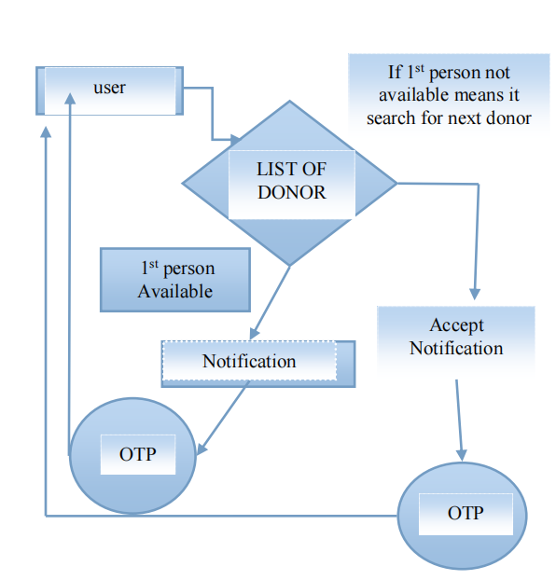
Figure 3 System architecture of Blood Donation and Life Saver App

B Door App-Blood Donation application is using the technology of google by using flutter and android studio in they attach backend of firebase [8]. This application is design for making user data confidential. For this purpose, they create their own institute which is connected with different hospital and NGO’S. In this application a person become donor if it can donate blood at least one time he/she can get a certificate and get a user id from hospital or NGO’S.
Through this certificate user will become a donor. Hospital and NGO get authentication and get approval from the institute. Hospital and NGO can see all list of donor with this application. The user registration module is used to collect users (above 18 years of age) personal details like name, Blood type, Mobile Number, User Location, User government ID proof, User Image Upload, Address, Gender, and Date of birth. This system guarantees the user protection and the donor's privacy using J48 decision tree algorithm. The user who login with this application will see the list of donor in the area of 50Km. User can send a message or call the donor via the app during an emergency. Eligible donor will also receive special alert messages or call from any hospital or blood bank during emergency. This app will also show static location of donor in map. Delete existing donor can be done by Hospitals or Blood Banks of the existing customer’s details. Edit customer plan details can be done by Hospitals or Blood Banks as the Donor wish.
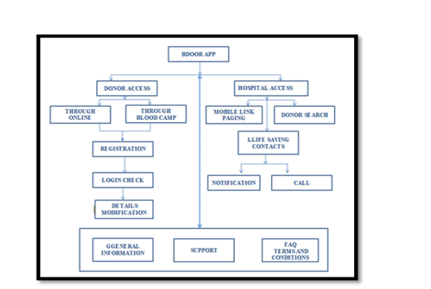
Figure 4 Work Flow Diagram of B Door App

Summary

This literature review has identified or show the detail overview of the relevant publications to the topic proposed. The knowledge provided by them made us possible to understand more about the user requirements which is necessary to create and develop better experience for the users. This literature identifies the problems in previous existing system in the market. As well as, the issues related to application and website which are developed in recent years. This literature also discuss the technologies use in different applications and website. The mobile technologies using now a day in all world and usage of mobile application in the world. Many systems are discussed in above literature

A Web base information system for blood donation, M-Health Blood Donation Application, B Door App-Blood Donation and Life Saver-Blood Donation App their architecture and working are discuss in detail. The different web and app technologies are use in it, some app are using network technology like cloud computer for the purpose of storing and retrieval of data some app use machine learning for securing the data of receiver and donor by using algorithm of J48 their location can be track by GPS so when the donor is available for blood donation will show in the data list. Different web and application provide different solution to reduce the issue facing by the society. Many existing systems are not update the user data they are just providing the information which are not up to date which will create a chance of death of patient because the unavailability of blood.

Chapter 3:
Requirements Analysis

Introduction
The main purpose of this document is to give detailed description about different requirements of our project. Secondary purpose is to define all the possible functions of our project. Detailed description about the features, interfaces and requirements is given in this document. So as already many applications are present on internet. There are number of blood donation applications are present on internet with different unique features and also made of different programming languages. As there are many applications present with unique features but the basic features remain same like login ,signup, become a donor etc. So we are also keen to develop a Hybrid mobile application with unique and new features. Like This app has been inspired by the model of Careem and Uber. The user can pick and contact the blood donor of their choice. Real time data analytics of the donor will be done and displayed like their health data, ETA etc.

Problem Scenarios
The main issue with these apps and websites is that the data is mostly not up to date.
The donors are not active mostly. Proper contact with the donors is not established some times. Also, the health statics of the donors are never available. Real time data analytics is missing and such a feature can add a lot of value to such healthcare systems. The problems to be addressed for the development of an application through which the user can perform the basic operations such as Easily contact with donor, Real-time data visualization etc.

Functional Requirements
The functional requirements that should be fulfilled by the application.

Admin
Admin handle both frontend and backend of the app. Its include almost everything like Database, Data visualization, Health Report of the donor etc.

Sign In
An interface where users can login in to the app and access to all the features of the app like Search a donor, become a donor etc.

Sign Up
In Sign up page user can fill all the require field Like Name, Email, Password, Location, Smoker, Non-Smoker, Blood group and Gender etc.

Home Screen
User have its own dashboard where user can check his/her profile.
Have multiple options in the Home screen like Profile, Search a donor, History, Report etc.

History
In History option user can check the pervious history of the donor, Who donate blood.

Report
In Report option user can check the pervious report of the donor, Who donate blood.

Search a donor
In app there is a search bar where user can search a donor nearby his/her town or location. So user can easily pick a donor according to his/her requirements.

Map
In Map user can see available donors in his/her area and contact with them through their Phone numbers.

Non-Functional Requirements
These are the requirements that ensure efficient working of the system and effect the technical requirements. The non-functional requirements that should be fulfilled by the application are mentioned below.

Usability
These are the features that enhance the quality of user’s experience. The application should be user friendly and easy to use by all types of user.

Accessibility
The user should be provided with a guide to make him understand how to use the application and it’s features.

Performance Requirement
The user interface should be designed keeping in view that the application would be used by technical and non-technical people. The UI should be descriptive and should give a clear understanding of the functionalities provided by the application.

Operational and Environmental Requirement
The application should be able to respond to requests quickly without large delays. Ensuring latency can ensure that the application is working efficiently Without any performance lags.

Reliability
The application should not crash, process incorrect inputs or corrupt user data. In case of any error the user should be notified about the error along any corrective action that could be taken to correct it.

Maintainability
In case of an error the system should be able to restore itself from the error state and rerun the process after identifying the cause of the error and correcting it or resolve it.

Chapter 4:
System Design

Introduction
Design is the first step in the development of a product or a software. Once the requirements of a software are clear and agreed upon then the design phase of the system starts. Design explains how different components of the system will interact with themselves and also with the user. It also explains that what functionalities would be accessible to the user and the degree of coupling among the components of the system. Design documents explain the flow of control, component dependence, functionalities of a system and the activities carried out to perform those functionalities. These design documents help the developers to program the application according to the user requirements. The basic design documents include use case diagrams, activity diagrams and sequence diagram.

Architectural Design
The Architectural design is a discipline that focuses on covering and meeting the needs and demands, to create living spaces, using certain tools and especially, creativity. Therefore, the aim is to combine the technological and the aesthetic, despite the general belief that architecture is only a technological task.
In the same way, it mixes design, understood as the creative process, and architecture, which is based on the creation and presentation of solutions at a technical level. By mixing both disciplines, architectural design seeks the values and formal qualities of the works, through spatial experiences. In general, we associate it with drawings, sketches or outlines of a project, and it is one of its fundamental basis. In this aspect of architectural design, there are also other factors involved, that are related to geometry, space or aesthetics, among others. After all, architecture, and therefore architectural design, is made up of many elements and processes or phases.

Data Flow Diagrams
A data flow diagram shows the way information flows through a process or system. It includes data inputs and outputs, data stores, and the various sub processes the data moves through. DFDs are built using standardized symbols and notation to describe various entities and their relationships.
Data flow diagrams are also categorized by level. Starting with the most basic, level 0 and then level 1, 2.

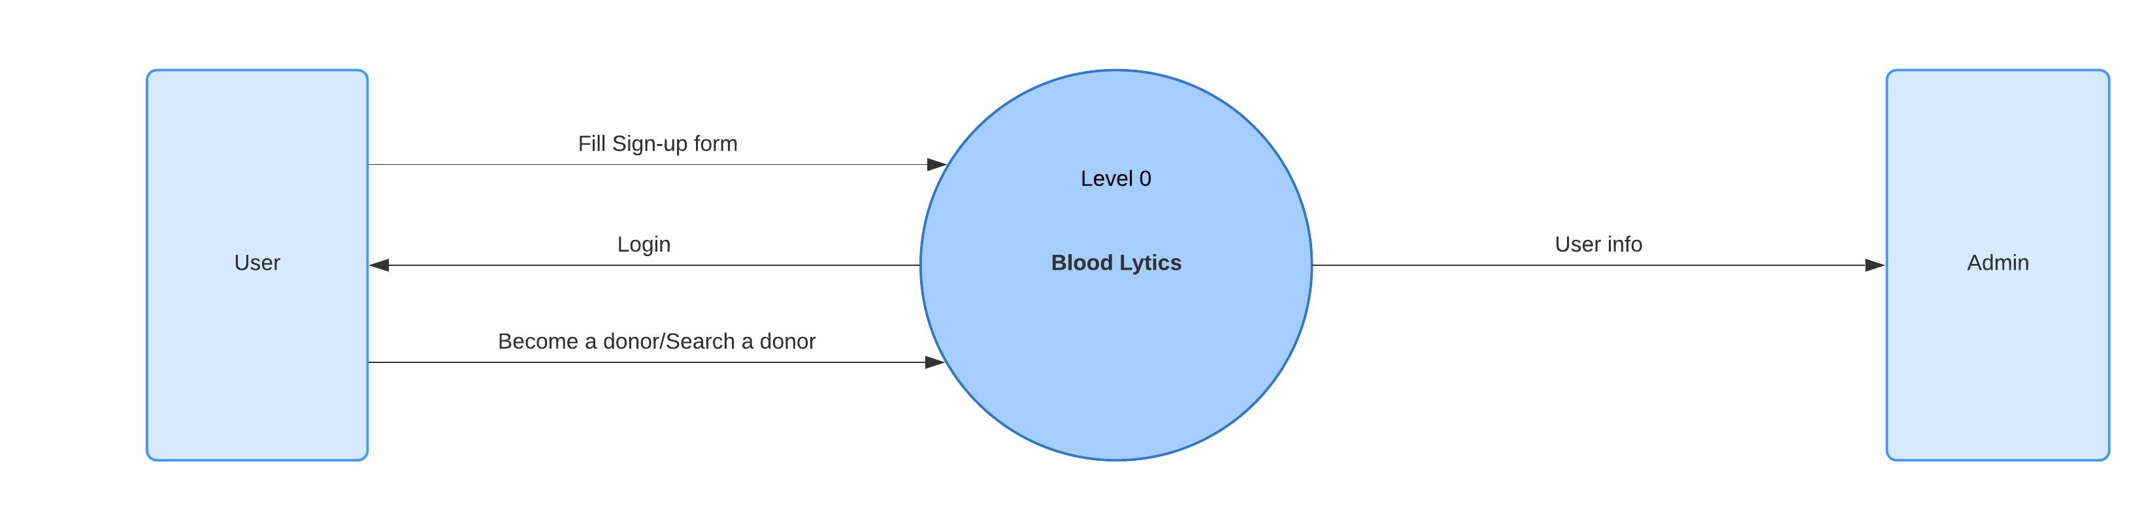
Figure 5 Data Flow Diagram Level 0
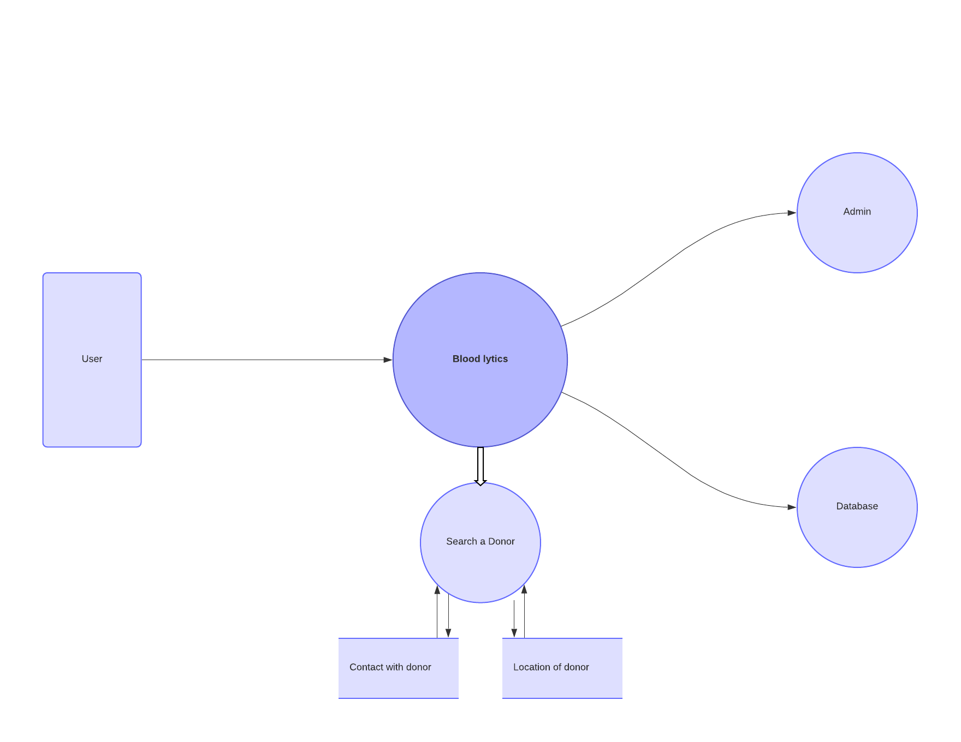
Figure 6 Data Flow Diagram level 1
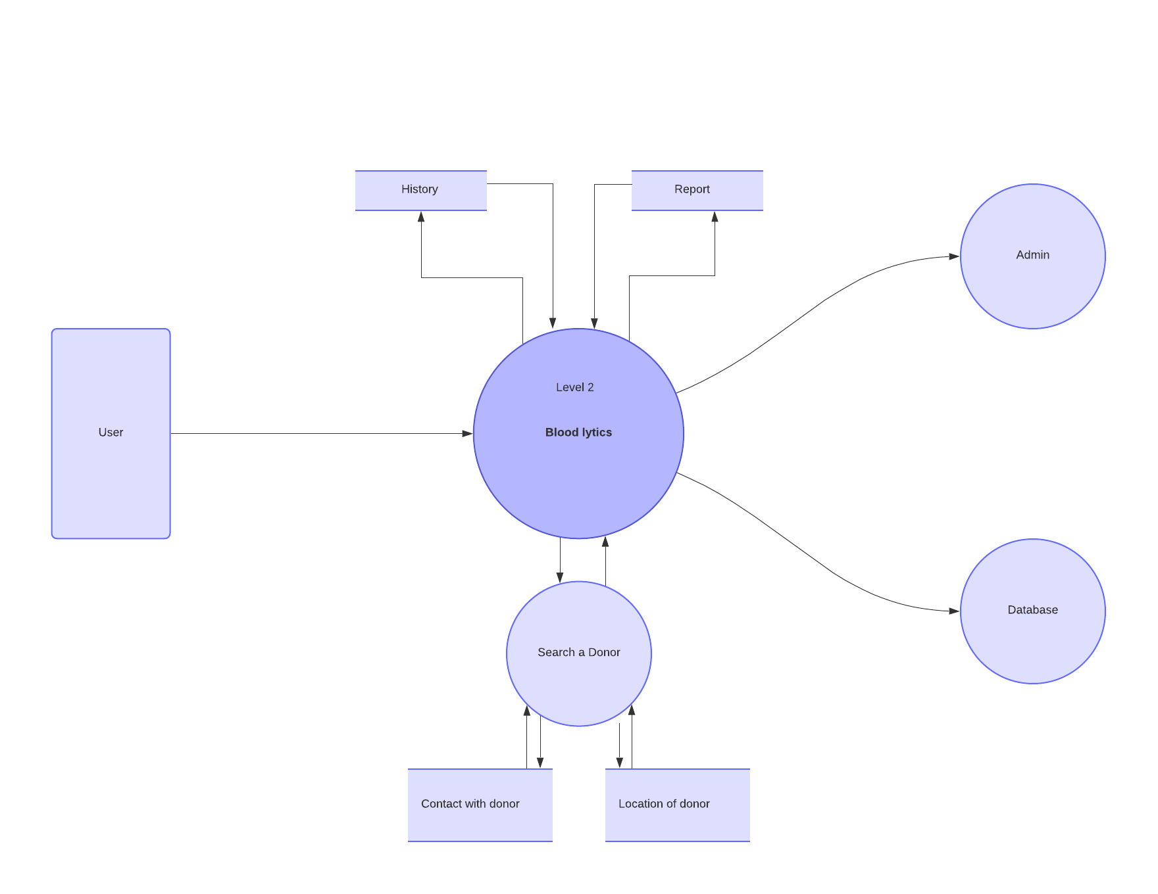
Figure 7 Data Flow Diagram level 2

Use Cases Diagram
Use case diagram can summarize the details of system's users (also known as actors) and their interactions with the system.
In our Use Case Diagram we show the actual working of both admin and user (as actors). Admin can handle front and backend work like manage full app, database, data visualization and all the user of the application.
Figure 8 Use Case Diagram

Activity Diagram
In Activity diagrams we considered the behavior of front end of our application because this diagram describes what must happen in the system being modeled.
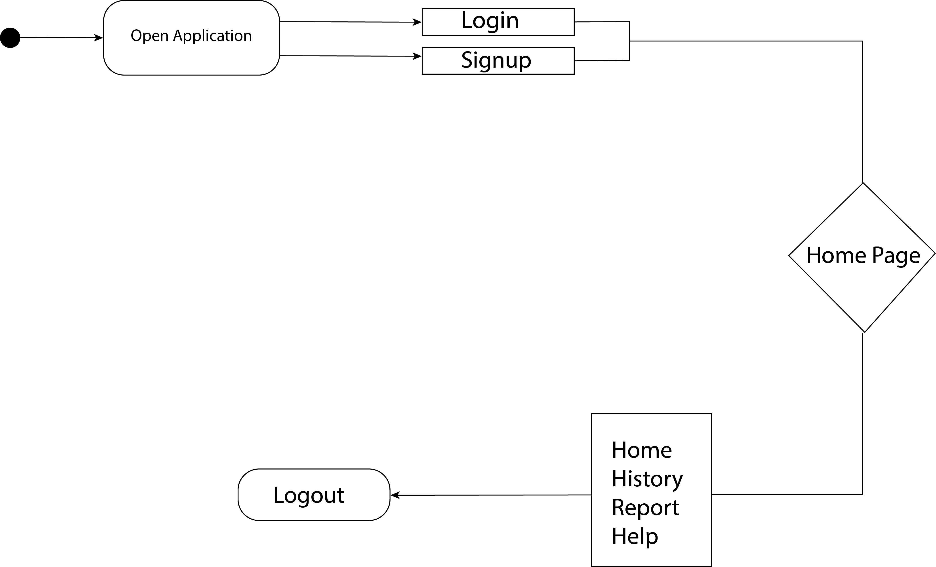
Figure 9 Activity Diagram

State Diagram
A state diagram consists of states, transitions, and activities. We use state diagrams to illustrate the dynamic view of our application. Especially important in modeling the behavior of our app interface.
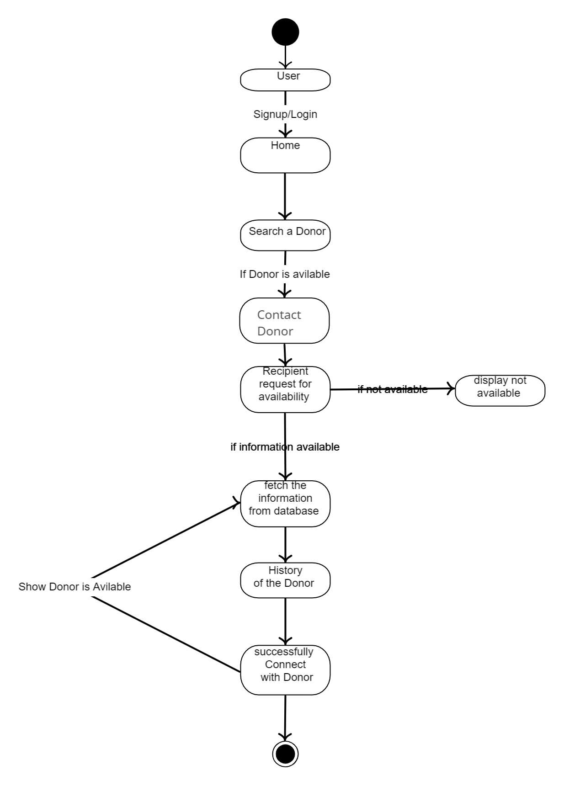
Figure 10 State Diagram

Swim Lane Diagram
A Swim Lane diagram is a type of flowchart that delineates who does what in a process. A Swim Lane diagram provides clarity and accountability by placing process steps within the horizontal or vertical “swimlanes”. In this diagram we shows User, Donor interaction between these lanes.
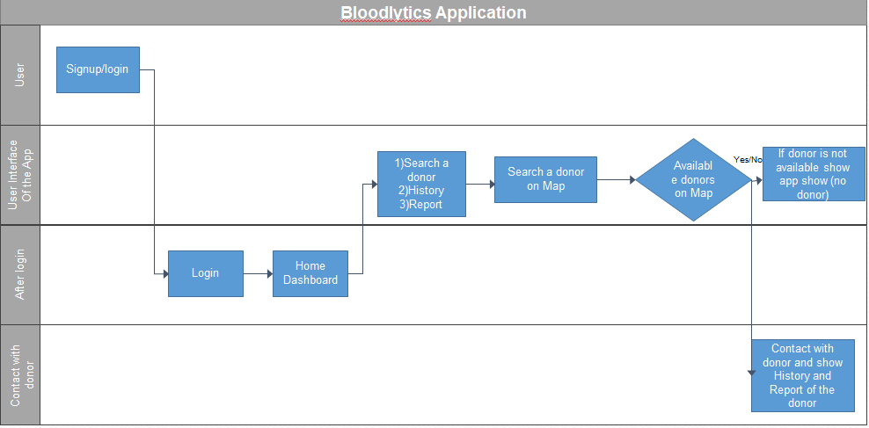
Figure 11 Swimlane Diagram

Sequence Diagram
A sequence diagram is a type of interaction diagram because it describes how and in what order of objects works together. In this diagram we describe whole phenomenon of the app how it works and how data comes from database and also show the front end working of our App.
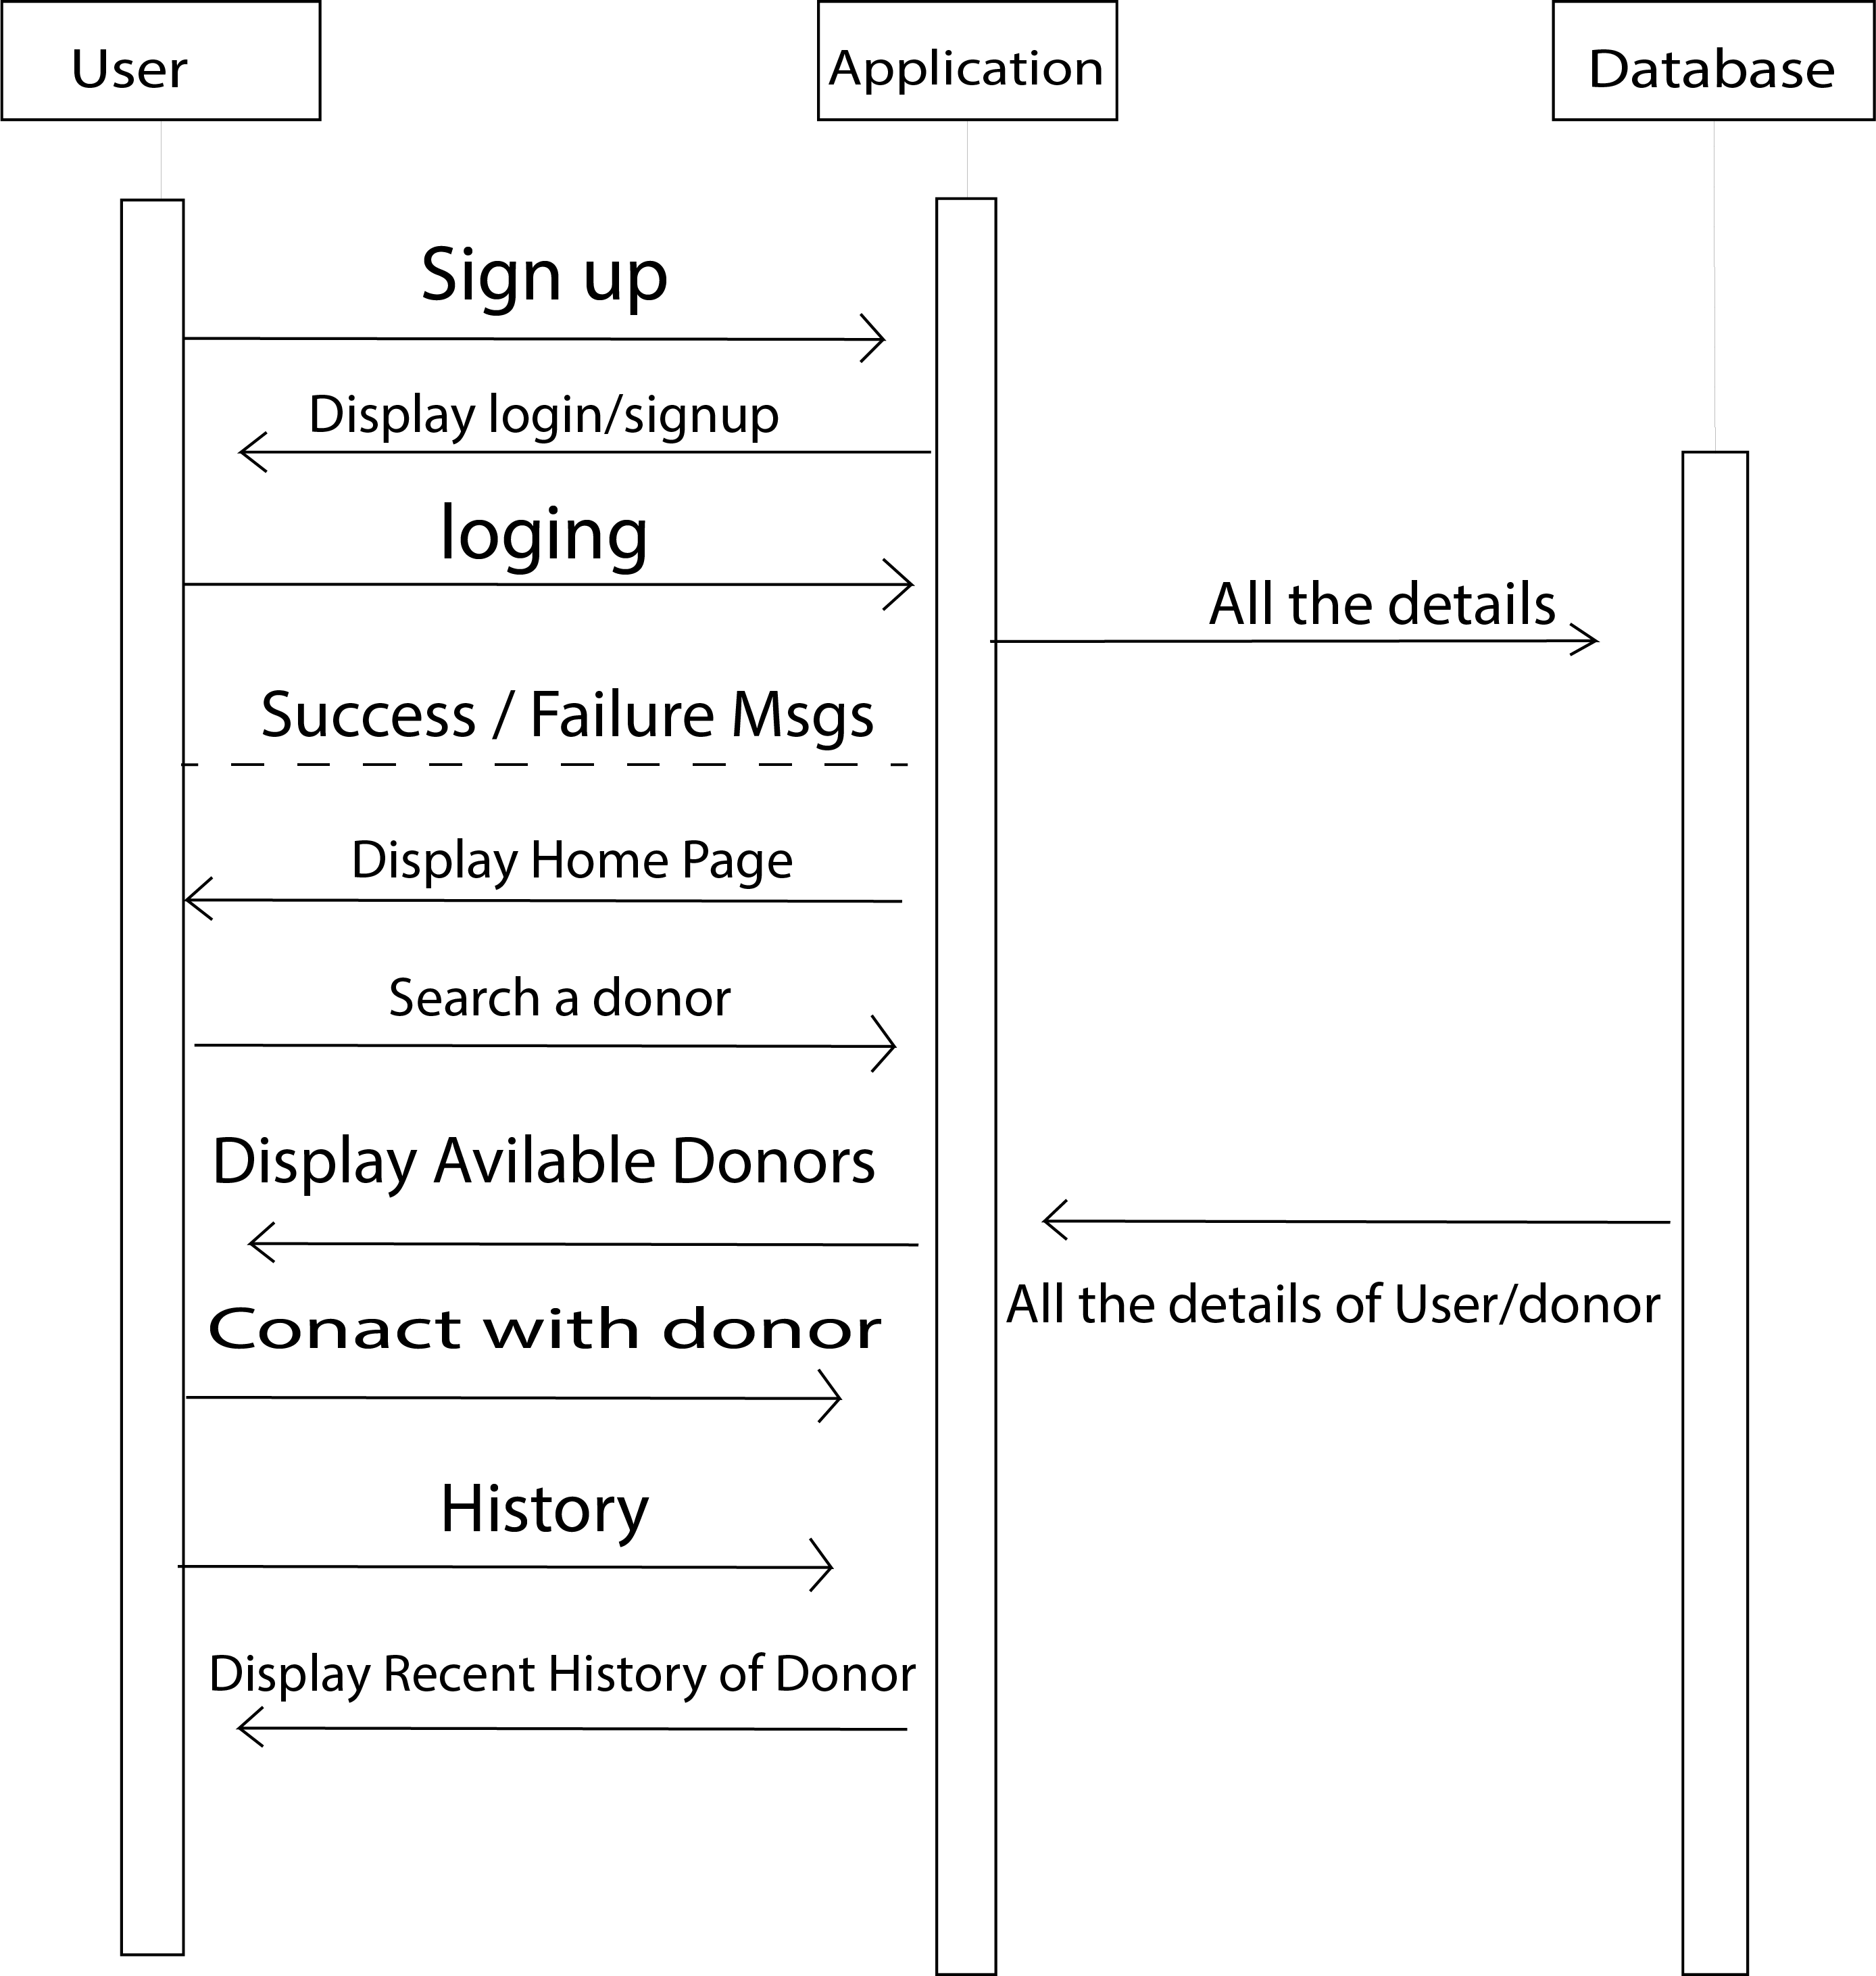
Figure 12 Sequence Diagram

Class Diagram
Class diagrams are a type of structure diagram because they describe what must be present in the system being modeled. In this diagram we show the donor and user relationship and their meta data, which is stored in database.
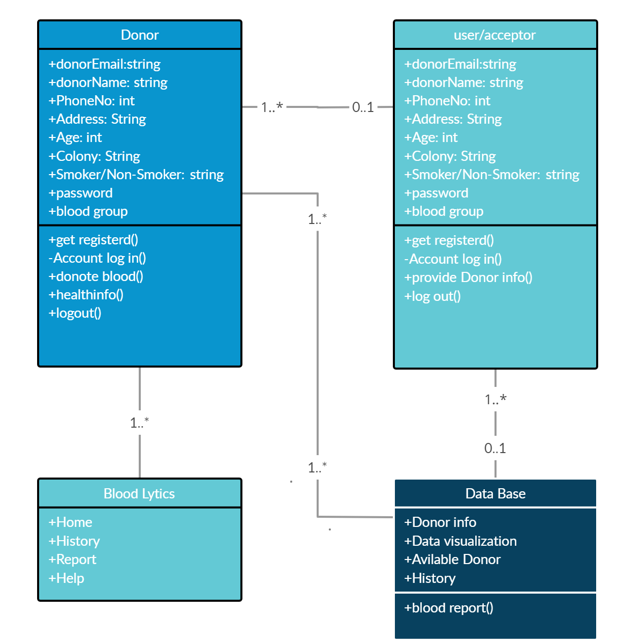
Figure 13 Class Diagram

ER Diagram
An Entity Relationship (ER) Diagram is a type of flowchart that illustrates how “entities” such as people, objects or concepts relate to each other within a system. ER Diagrams are most often used to design or debug relational databases.

Figure 14 ER Diagram

References and Bibliography

