|  |
| --- |
| **Date of Birth** |
| 27/9/2001 |
|  |
| **Telephone** |
| +923054456433 |
|  |
| **Email** |
| 192345@lhr.nu.edu.pk |
| mehrabalishah52@gmail.com |
|  |
|  |
|  |
|  |
|  |
|  |
|  |

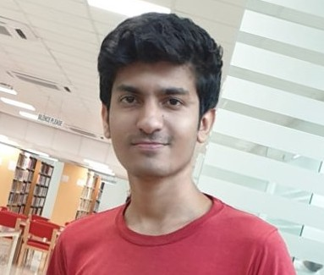

|  |
| --- |
|  |
| **Faizan Bayounus** |
| BS (Computer Science) |
| **Education** |
| **National University of Computer and Emerging Sciences, Karachi Campus** |
| BS (Computer Science) – 2023 |
| **Cordoba School, Karachi** |
| A levels – 2019  **Kingsley American School, Karachi**  O levels – 2017   |  | | --- | | **Experience****Triangle Global Services Jan, 20211 - Present** HR Coordinator | |
| **Projects/Portfolio** |
| **Flight Management System** |
| MERN based Application in which Students can Apply in all the universities by filling only one form. As this project I was done in group. I was working only on front-end of the project but I have basic Knowledge of Node and MongoDB as well. |
| **Movie Ticketing System** |
| Developed this website using with HTML CSS and JavaScript Bootstrap.  **Tic-Tac-Toe Game**  made this web-based application using ASP.NET framework, C#, SQL server, HTML and CSS. |
| **Skill share Clone** |
| Developed an Skill share clone using React. |
| **FYP** |
| Idher fyp ki description likhde |
| **Activities, Honors & Awards** |
| **Runner up, Programming Competition, Coders cup 2019** |
| **Skills & Tools** |
| Object Oriented Programming, Database Systems, Software Design and Analysis, Data Structures, Design and Analysis of Algorithms, Artificial Intelligence, Web Programming |
| **Interests & Hobbies** |
| Cricket, Video games, movies, TV shows, Technology, Web development,Books |