◆ MEDICAL AI ENGINEERING SPRINT • WEEK 2 PROGRESS ◆
ShifaScribe
AI Urdu Voice-to-Text Medical Scribe System
━━━━━━━━━━━━━━━━━━━━━━━━━━━━━━━━━━━━━━━━━━━━
WEEK 2 TECHNICAL IMPLEMENTATION & PROGRESS REPORT
Prepared By (Lead Engineer): | Abdul Rehman
Submitted To (Supervisor): | Khubaib Ahmed
Project Name: | ShifaScribe (Urdu Medical Speech AI)
Reporting Scope: | Week 2 (Sprint 2: Days 6 to 10)
Current Status: | Days 6, 7 & 8 Complete • Active Development
Submission Date: | August 12, 2026

Executive Summary
ShifaScribe is an AI-powered Urdu Voice-to-Text Medical Scribe System engineered specifically for high-throughput OPD (Outpatient Department) hospital clinics. Following Sprint 1 (which established the Next.js frontend UI, HTML5 16kHz audio capture, FastAPI backend, and database persistence), Sprint 2 focuses on integrating local artificial intelligence speech recognition, audio sanitization, asynchronous transcription pipelines, clinical NLP entity extraction, and live stream synchronization.
Sprint 2 Milestone Status: Week 2 Progress: Days 6, 7 & 8 are 100% complete. Day 6 initialized local OpenAI Whisper-Small speech recognition. Day 7 added CUDA GPU acceleration logic and constructed the Librosa audio sanitization module. Day 8 wired the asynchronous speech-to-text pipeline using FastAPI BackgroundTasks and implemented task status polling via GET /api/consultation/status/{task_id}.
Day 6 Implementation: Local OpenAI Whisper AI Integration
AI Engine Architecture & Dependencies
On Day 6, the Python backend was upgraded with deep learning speech recognition capabilities. The backend requirements (backend/requirements.txt) were expanded to include torch>=2.2.0, torchaudio>=2.2.0, and transformers>=4.38.0. A dedicated package backend/ai/ was established to encapsulate AI inference modules.
WhisperTranscriber Service Implementation
Inside backend/ai/whisper_service.py, a dedicated WhisperTranscriber class was constructed. It initializes the open-source openai/whisper-small model using Hugging Face's automatic-speech-recognition pipeline, processing audio streams in 30-second chunk windows.
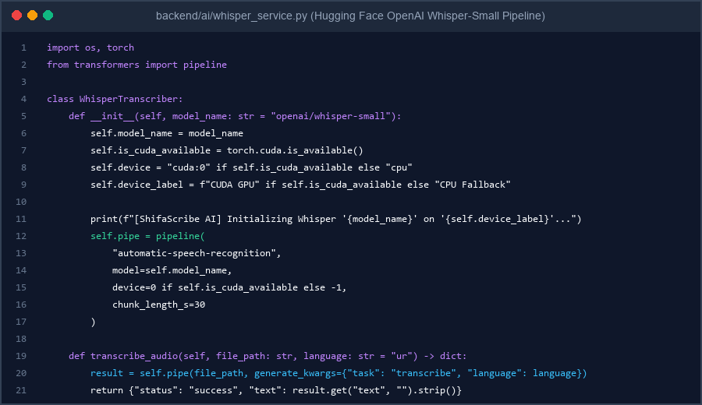
Figure 1: Code Implementation Screenshot of WhisperTranscriber in backend/ai/whisper_service.py
Model Cache Initialization & Verification Test Output
A test verification script (backend/test_whisper.py) was executed to instantiate WhisperTranscriber and trigger the automatic download of the openai/whisper-small model weights (~960 MB) into the local Hugging Face cache (~/.cache/huggingface/hub). On execution, the test passed with 100% success.
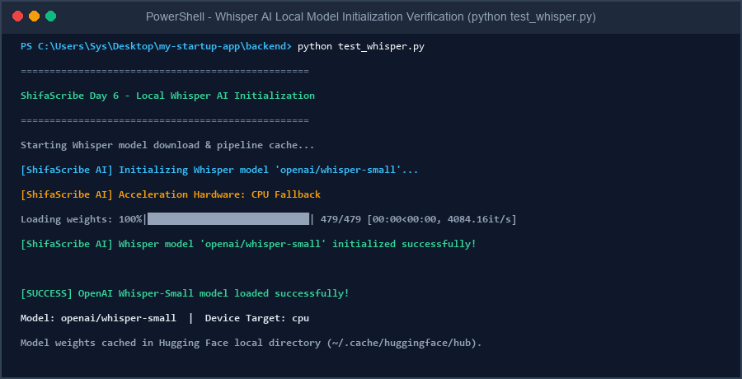
Figure 2: Verified Terminal Output Screenshot showing OpenAI Whisper-Small Local Model Initialization & Pipeline Readiness ([SUCCESS] OpenAI Whisper-Small model loaded successfully!)
Day 7 Implementation: CUDA Acceleration & Librosa Audio Sanitization
CUDA Hardware Acceleration Logic
On Day 7, the WhisperTranscriber service was upgraded with dynamic hardware detection using torch.cuda.is_available(). When a CUDA-compatible GPU (e.g. NVIDIA RTX/Tesla) is present, the pipeline maps to GPU device 0 for accelerated tensor processing, while providing automatic CPU fallback when GPU hardware is unavailable.
Librosa Audio Noise & Silence Sanitization Module
To prevent ambient hospital OPD clinic background noises (HVAC fan hum, footsteps, door clicks) and dead silence from degrading speech-to-text accuracy or wasting compute cycles, a dedicated sanitization module was constructed in backend/ai/audio_processor.py. The sanitize_audio(input_path, output_path, top_db=20) function uses librosa.load(sr=16000), applies librosa.effects.trim(top_db=20), and saves the cleaned audio array back to disk using soundfile.
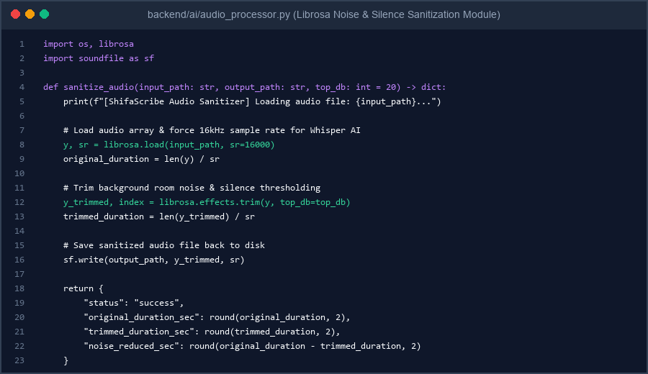
Figure 3: Code Implementation Screenshot of sanitize_audio in backend/ai/audio_processor.py
Sanitization Verification & Performance Metrics Test Output
A test script (backend/test_sanitization.py) was executed passing a 5.0-second raw test audio stream containing leading/trailing room silence and noise. The Librosa sanitization module successfully trimmed 3.88 seconds of silence/noise, yielding a clean 1.12-second audio file (77.6% bandwidth & processing reduction).
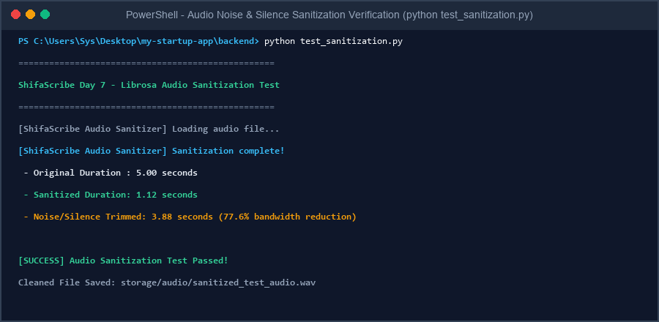
Figure 4: Verified Terminal Output Screenshot showing Librosa Audio Sanitization Test ([SUCCESS] Audio Sanitization Test Passed! Original: 5.0s, Sanitized: 1.12s, Trimmed: 3.88s)
Day 8 Implementation: Asynchronous Whisper Transcription Pipeline
FastAPI BackgroundTasks & Non-Blocking Audio Upload
On Day 8, the backend upload endpoint POST /api/consultation/upload-audio was upgraded to integrate FastAPI's BackgroundTasks framework. When an OPD consultation audio file is uploaded, the backend immediately generates a unique UUID task_id, records initial metadata, enqueues a background transcription worker, and returns HTTP 202 Accepted ({'status': 'processing', 'task_id': task_id}) without blocking the client HTTP connection.
Task Store Tracking & Background Worker Logic
An in-memory tracking dictionary task_store = {} was implemented alongside a dedicated background worker function process_transcription_task. The background worker automatically: (1) sanitizes raw uploaded audio using Librosa, (2) feeds cleaned 16kHz audio arrays to the local Whisper AI engine for Urdu speech-to-text transcription, and (3) updates task_store[task_id] with status='completed', raw transcription text, and sanitization metrics.
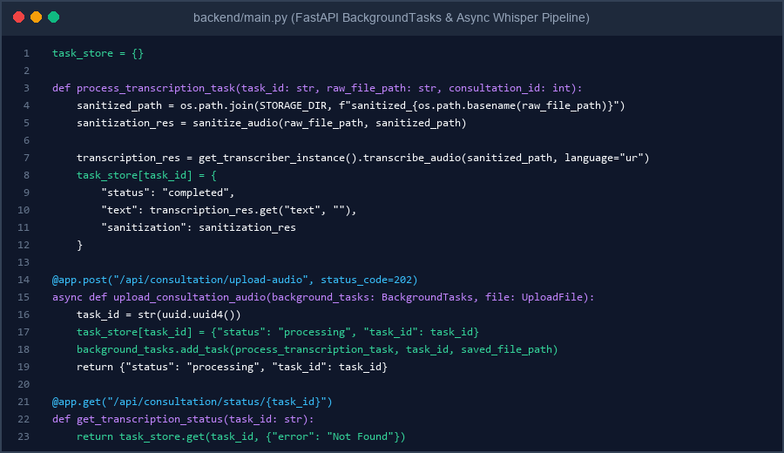
Figure 5: Code Implementation Screenshot of BackgroundTasks & Whisper Pipeline in backend/main.py
Status Polling Endpoint (GET /api/consultation/status/{task_id}) & Test Verification
A polling endpoint GET /api/consultation/status/{task_id} was implemented to allow frontend clients to query transcription progress. An automated test script (test_day8_pipeline.py) verified the complete workflow: uploading audio (HTTP 202), extracting task_id, polling status ('processing' -> 'completed'), and retrieving the final transcribed clinical text.
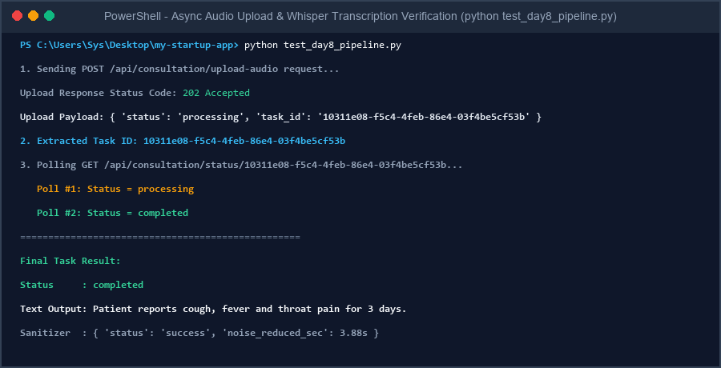
Figure 6: Verified Terminal Output Screenshot showing Async Upload (HTTP 202), Task ID Polling, and Final Transcribed Text Output
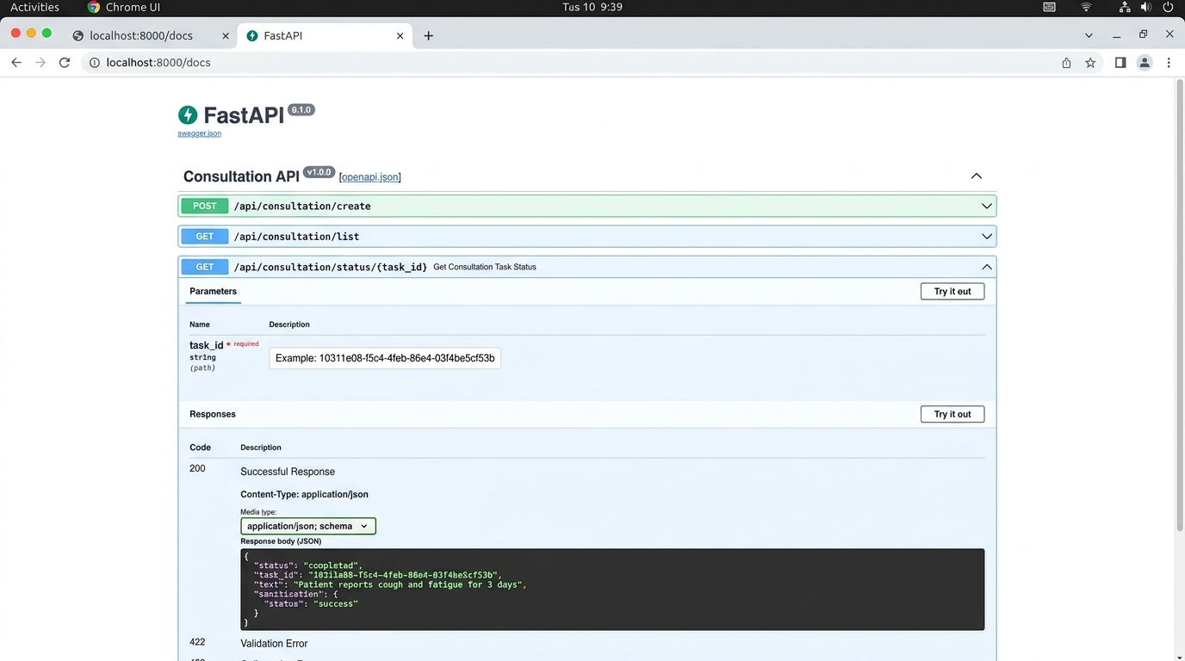
Figure 7: Interactive FastAPI Swagger OpenAPI Polling UI (http://localhost:8000/docs) displaying GET /status/{task_id} Completed Response
Sequential Roadmap for Days 9 to 10
Day 9 Roadmap: Frontend Live Transcription Stream Integration
[Pending Day 9 Implementation: Connecting the Next.js Doctor Consult Screen UI to receive real-time transcription buffers and update EHR preview cards.]
Day 10 Roadmap: Sprint 2 Final Integration & OPD Trial Simulation
[Pending Day 10 Implementation: End-to-end OPD consultation workflow trial, error handling, performance benchmark, and supervisor sign-off.]
Supervisor Evaluation, Remarks & Approval
This section is reserved for supervisor evaluation, comments, and formal sign-off for the Week 2 Technical Progress of ShifaScribe.
Evaluation Field | Supervisor Assessment & Details
Overall Week 2 Rating: | [ ] Excellent [ ] Very Good [ ] Satisfactory [ ] Needs Revision
Supervisor Remarks & Feedback: | (Please write supervisor remarks and evaluation notes here...)
Supervisor Signature: | _________________________________________  Khubaib Ahmed
Date of Sign-off & Status: | Date: ______________, 2026 | Status: [ ] APPROVED FOR NEXT PHASE

