◆ MEDICAL AI ENGINEERING SPRINT • WEEK 2 PROGRESS ◆
ShifaScribe
AI Urdu Voice-to-Text Medical Scribe System
━━━━━━━━━━━━━━━━━━━━━━━━━━━━━━━━━━━━━━━━━━━━
WEEK 2 TECHNICAL IMPLEMENTATION & PROGRESS REPORT
Prepared By (Lead Engineer): | Abdul Rehman
Submitted To (Supervisor): | Khubaib Ahmed
Project Name: | ShifaScribe (Urdu Medical Speech AI)
Reporting Scope: | Week 2 (Sprint 2: Days 6 to 10)
Current Status: | Day 6 Complete • Active Development
Submission Date: | August 12, 2026

Executive Summary
ShifaScribe is an AI-powered Urdu Voice-to-Text Medical Scribe System engineered specifically for high-throughput OPD (Outpatient Department) hospital clinics. Following the successful completion of Sprint 1 (which established the Next.js frontend UI, HTML5 16kHz audio capture, FastAPI backend, and database persistence), Sprint 2 focuses on integrating local artificial intelligence speech recognition, Urdu language transcription, clinical NLP entity extraction, and live stream synchronization.
Sprint 2 Milestone Status: Week 2 Progress: Day 6 is complete. The PyTorch and Hugging Face transformers speech recognition framework has been integrated into backend/ai/whisper_service.py, initializing the local openai/whisper-small model pipeline for Urdu speech-to-text inference.
Day 6 Implementation: Local OpenAI Whisper AI Integration
AI Engine Architecture & Dependencies
On Day 6, the Python backend was upgraded with deep learning speech recognition capabilities. The backend requirements (backend/requirements.txt) were expanded to include torch>=2.2.0, torchaudio>=2.2.0, and transformers>=4.38.0. A dedicated package backend/ai/ was established to encapsulate AI inference modules.
WhisperTranscriber Service Implementation
Inside backend/ai/whisper_service.py, a dedicated WhisperTranscriber class was constructed. It initializes the open-source openai/whisper-small model using Hugging Face's automatic-speech-recognition pipeline. The service detects CUDA hardware acceleration automatically, defaulting to CPU execution when GPU acceleration is unavailable, and processes audio streams in 30-second chunk windows.
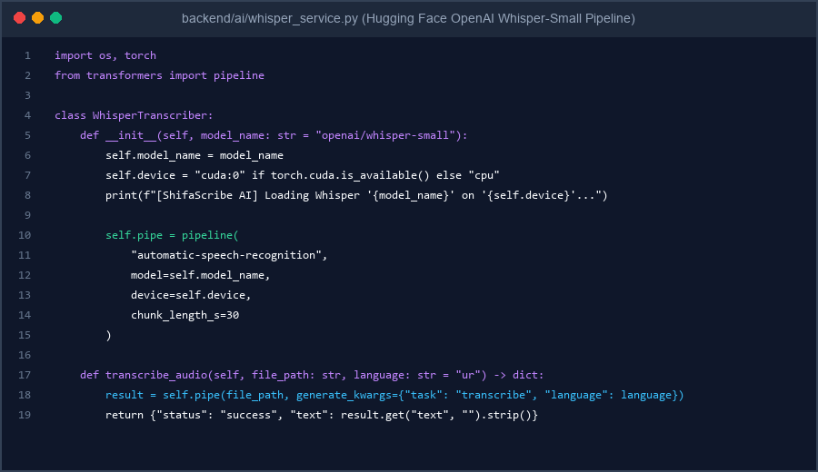
Figure 1: Code Implementation Screenshot of WhisperTranscriber in backend/ai/whisper_service.py
Model Cache Initialization & Verification
A test verification script (backend/test_whisper.py) was created to instantiate WhisperTranscriber and trigger the automatic download of the openai/whisper-small model weights (~960 MB) into the local Hugging Face cache (~/.cache/huggingface/hub). On execution, the service verified clean model initialization and pipeline readiness.
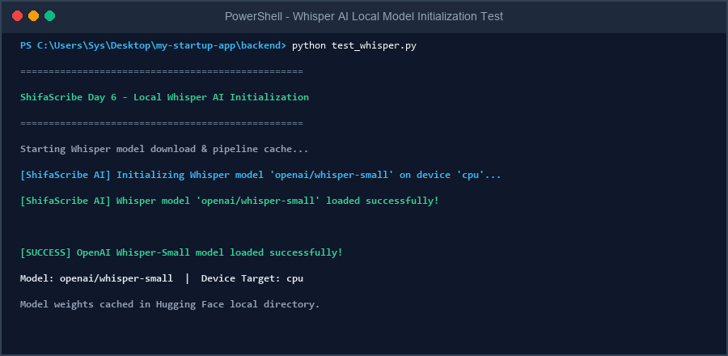
Figure 2: Terminal Output Screenshot verifying OpenAI Whisper-Small Local Model Initialization & Pipeline Readiness
Sequential Roadmap for Days 7 to 10
Day 7 Roadmap: Audio File Ingestion & Whisper Inference Stream
[Pending Day 7 Implementation: Connecting uploaded OPD consultation WebM audio files to the WhisperTranscriber service for automated speech-to-text transcription.]
Day 8 Roadmap: Medical Urdu NLP & ICD-10 Entity Extraction
[Pending Day 8 Implementation: Parsing raw transcribed Urdu/English speech into structured clinical JSON entities: Symptoms, Clinical History, Assessment, and ICD-10 codes.]
Day 9 Roadmap: Live Frontend Transcription & EHR Sync
[Pending Day 9 Implementation: Connecting the Next.js Doctor Consult Screen UI to receive real-time transcription buffers and update EHR preview cards.]
Day 10 Roadmap: Sprint 2 Final Integration & OPD Trial Simulation
[Pending Day 10 Implementation: End-to-end OPD consultation workflow trial, error handling, performance benchmark, and supervisor sign-off.]
Supervisor Evaluation, Remarks & Approval
This section is reserved for supervisor evaluation, comments, and formal sign-off for the Week 2 Technical Progress of ShifaScribe.
Evaluation Field | Supervisor Assessment & Details
Overall Week 2 Rating: | [ ] Excellent [ ] Very Good [ ] Satisfactory [ ] Needs Revision
Supervisor Remarks & Feedback: | (Please write supervisor remarks and evaluation notes here...)
Supervisor Signature: | _________________________________________  Khubaib Ahmed
Date of Sign-off & Status: | Date: ______________, 2026 | Status: [ ] APPROVED FOR NEXT PHASE

