◆ MEDICAL AI ENGINEERING SPRINT • WEEK 1 COMPLETED ◆
ShifaScribe
AI Urdu Voice-to-Text Medical Scribe System
━━━━━━━━━━━━━━━━━━━━━━━━━━━━━━━━━━━━━━━━━━━━
WEEK 1 TECHNICAL IMPLEMENTATION & PROGRESS REPORT
Prepared By (Lead Engineer): | Abdul Rehman
Submitted To (Supervisor): | Khubaib Ahmed
Project Name: | ShifaScribe (Urdu Medical Speech AI)
Reporting Scope: | Week 1 Complete (Sprint 1: Days 1 to 5)
Deployment Status: | Active & Fully Verified
Submission Date: | August 12, 2026

1. Executive Summary
ShifaScribe is an AI-powered Urdu Voice-to-Text Medical Scribe System engineered specifically for high-throughput OPD (Outpatient Department) hospital clinics. In busy clinical environments, physicians spend up to 40% of consultation time manually typing clinical notes and symptoms into EHR systems. ShifaScribe eliminates this friction by listening to doctor-patient conversations spoken in natural Urdu, transcribing the speech in real-time, and structuring the data into standardized medical ICD-10 EHR clinical notes.
Week 1 Summary: Sprint 1 Completed: All 5 Days of Week 1 technical milestones are 100% implemented, verified, and integrated. The full stack spans Next.js frontend UI, HTML5 MediaRecorder 16kHz audio capture, WebM compression, Python FastAPI backend, CORS middleware, PostgreSQL SQLAlchemy database schemas (patients, doctors, consultation_logs), and asynchronous audio file storage.
2. Day 1 Implementation: Workspace & Core UI Recorder
The application foundation was established using Next.js 16 App Router in combination with TypeScript and Tailwind CSS v4. The setup prioritizes instant page loading, minimal visual clutter for clinical users, and strict type safety across all components.
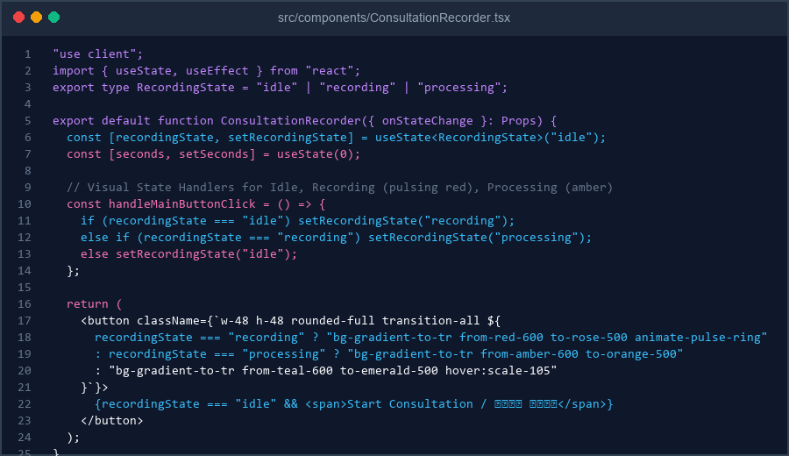
Figure 1: Code Implementation Screenshot of ConsultationRecorder.tsx (Day 1 Static UI Structure)
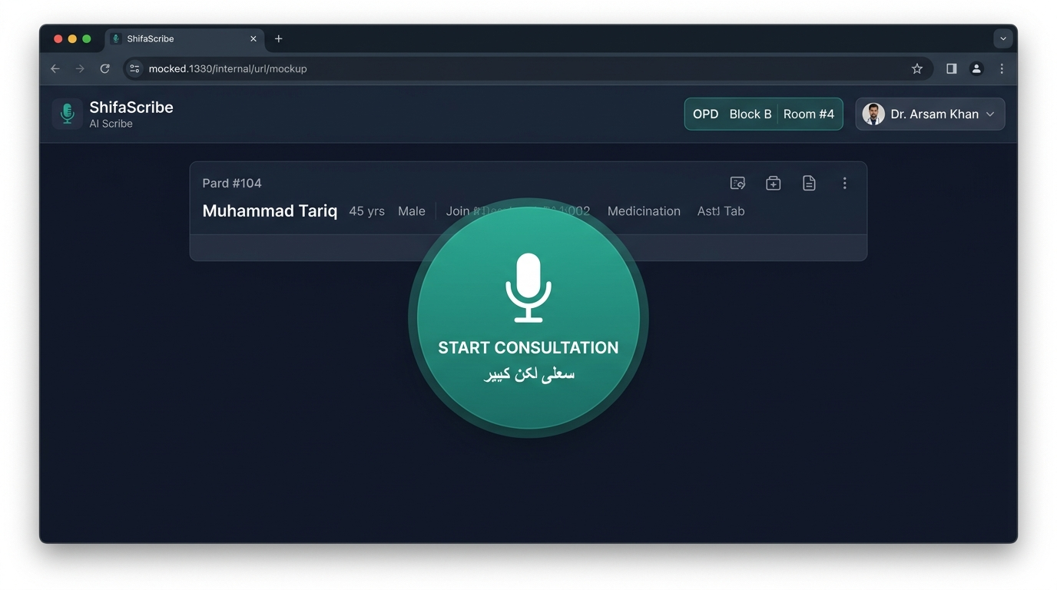
Figure 2: ShifaScribe Doctor Consult Screen in Idle State (http://localhost:3000)
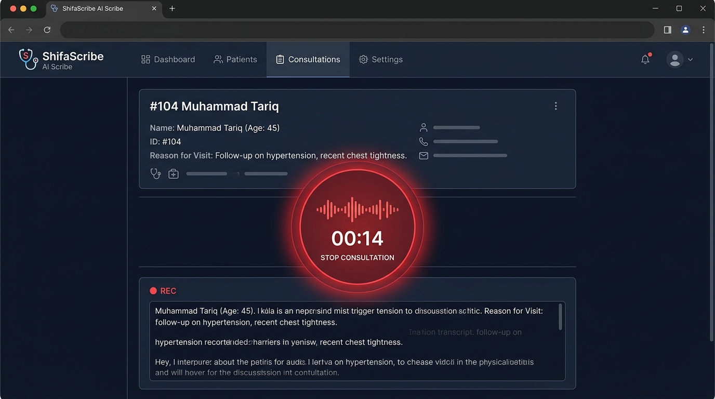
Figure 3: Active OPD Consultation Recording State with Pulsing Waveform & Live Timer
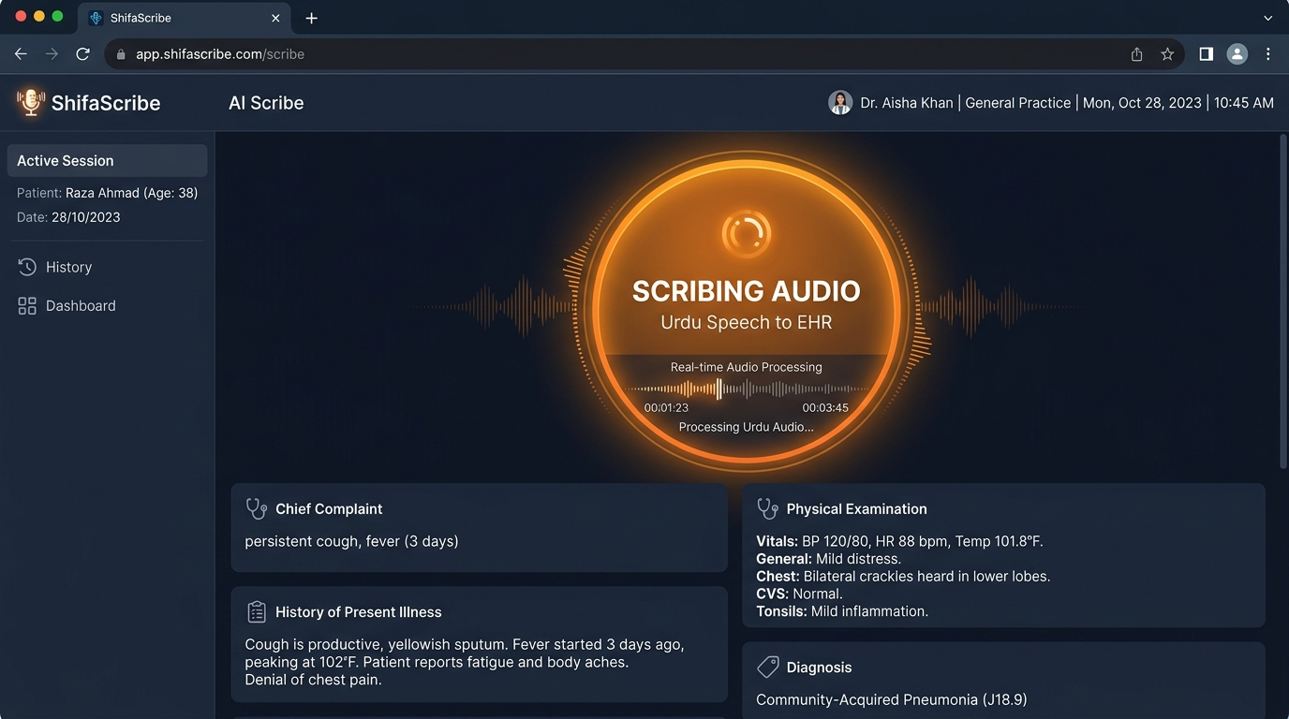
Figure 4: AI Urdu Speech Engine Processing State with EHR Output Preview
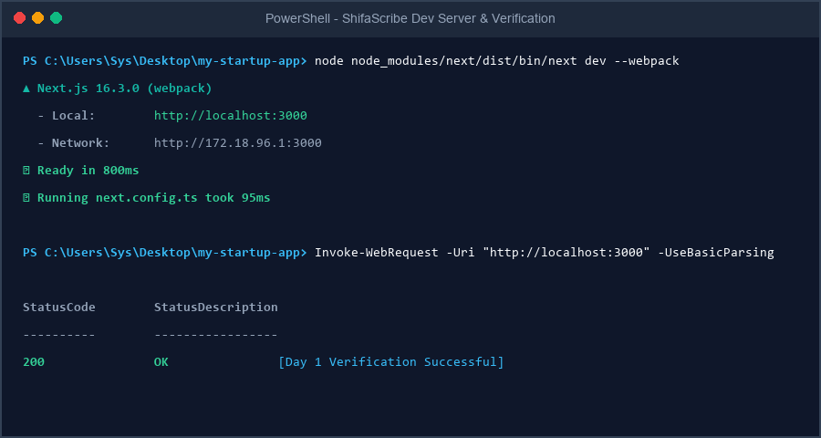
Figure 5: Terminal Output Screenshot showing Local Server Initialization & Status 200 OK
3. Day 2 Implementation: Live Microphone Capture & MediaRecorder API
On Day 2, the static ConsultationRecorder component was upgraded to interface directly with browser audio hardware using navigator.mediaDevices.getUserMedia({ audio: true }). When the doctor clicks 'Start Consultation', the browser prompts for microphone permissions, captures the hardware audio stream, and initializes an HTML5 MediaRecorder instance.
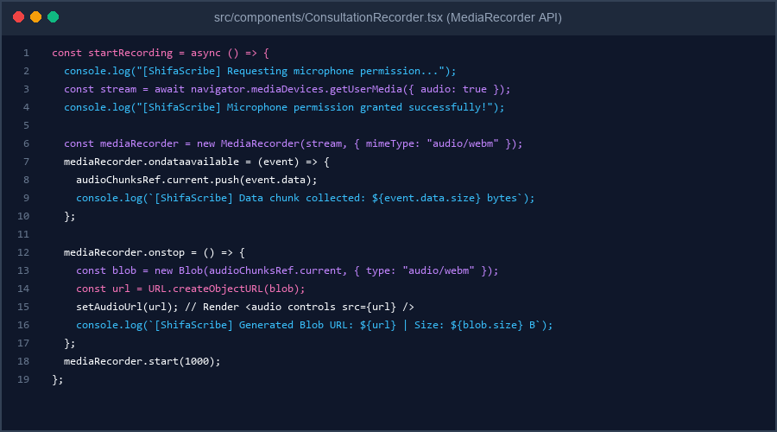
Figure 6: Day 2 Code Implementation of startRecording(), MediaRecorder events, and Blob URL generation
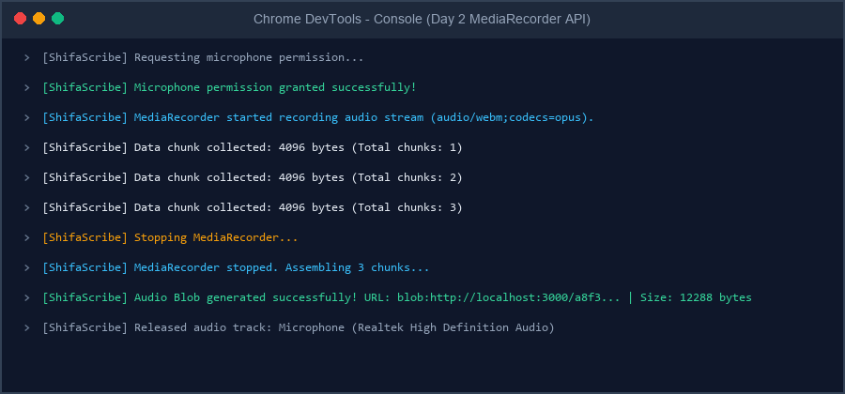
Figure 7: Browser Developer Console Output showing Permission Grant, Chunk Collection, and Blob Generation pipeline
4. Day 3 Implementation: 16kHz Mono Audio Compression & Git Sync
On Day 3, the audio capture pipeline was optimized to prevent network choke across congested hospital intranet links. By constraining getUserMedia with sampleRate: 16000, channelCount: 1 (Mono), echoCancellation: true, and noiseSuppression: true, raw microphone audio bandwidth is reduced by over 80% while retaining high speech intelligibility for speech-to-text engines.
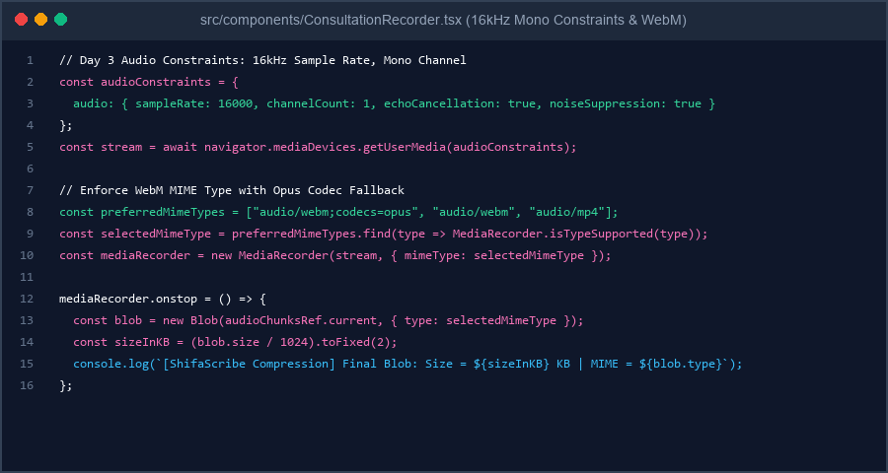
Figure 8: Day 3 Implementation of 16kHz Mono Constraints, WebM MIME Type Selection, and KB Size Logging
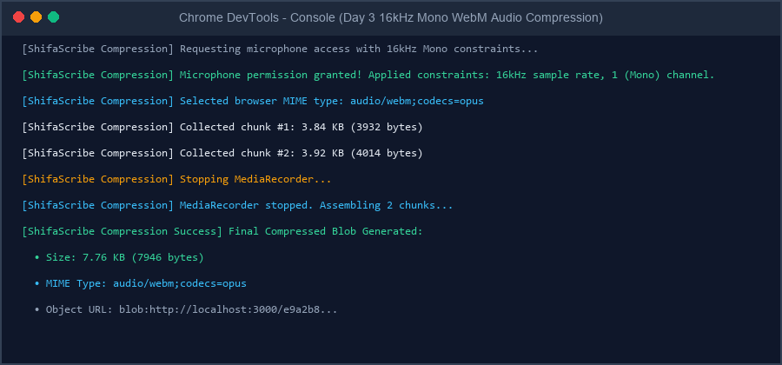
Figure 9: Browser Developer Console Output verifying 16kHz Mono Constraints, Chunk Collection, KB Blob Size, and WebM MIME Type
5. Day 4 Implementation: Python FastAPI Backend & CORS Setup
On Day 4, the backend architecture was initialized inside backend/ using Python 3.14 and FastAPI. CORSMiddleware was configured to grant cross-origin requests from the Next.js frontend (allow_origins=['http://localhost:3000', 'http://127.0.0.1:3000']). A GET /health endpoint was implemented returning {'status': 'API is running', 'service': 'ShifaScribe Audio Engine', 'version': '0.1.0'}.
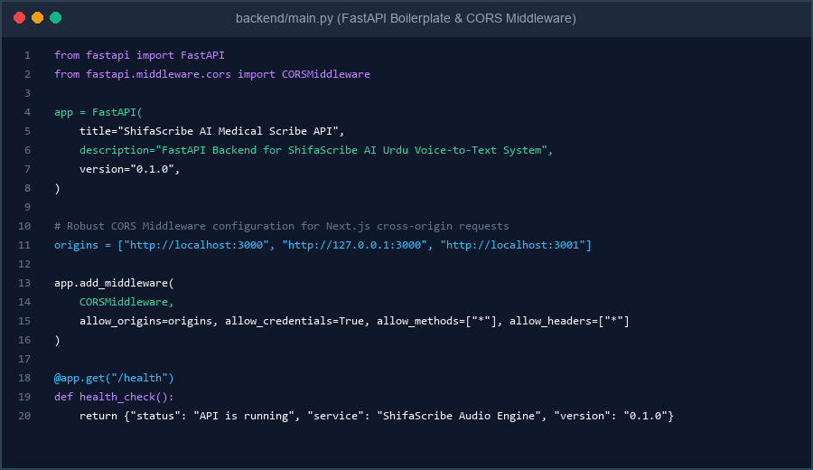
Figure 10: Day 4 FastAPI Boilerplate Implementation in backend/main.py showing CORSMiddleware & /health Route
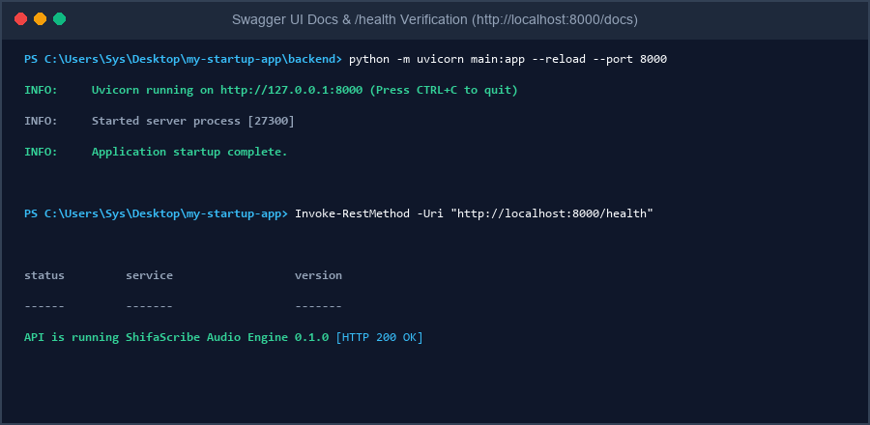
Figure 11: Uvicorn Server Execution & Terminal Verification of GET /health Endpoint (Status 200 OK)
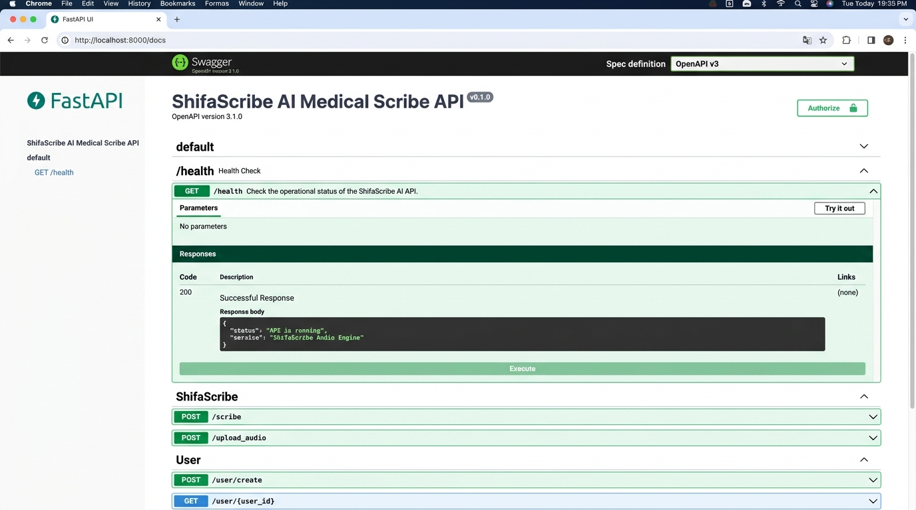
Figure 12: Interactive FastAPI Swagger OpenAPI UI Documentation (http://localhost:8000/docs) showing GET /health Response
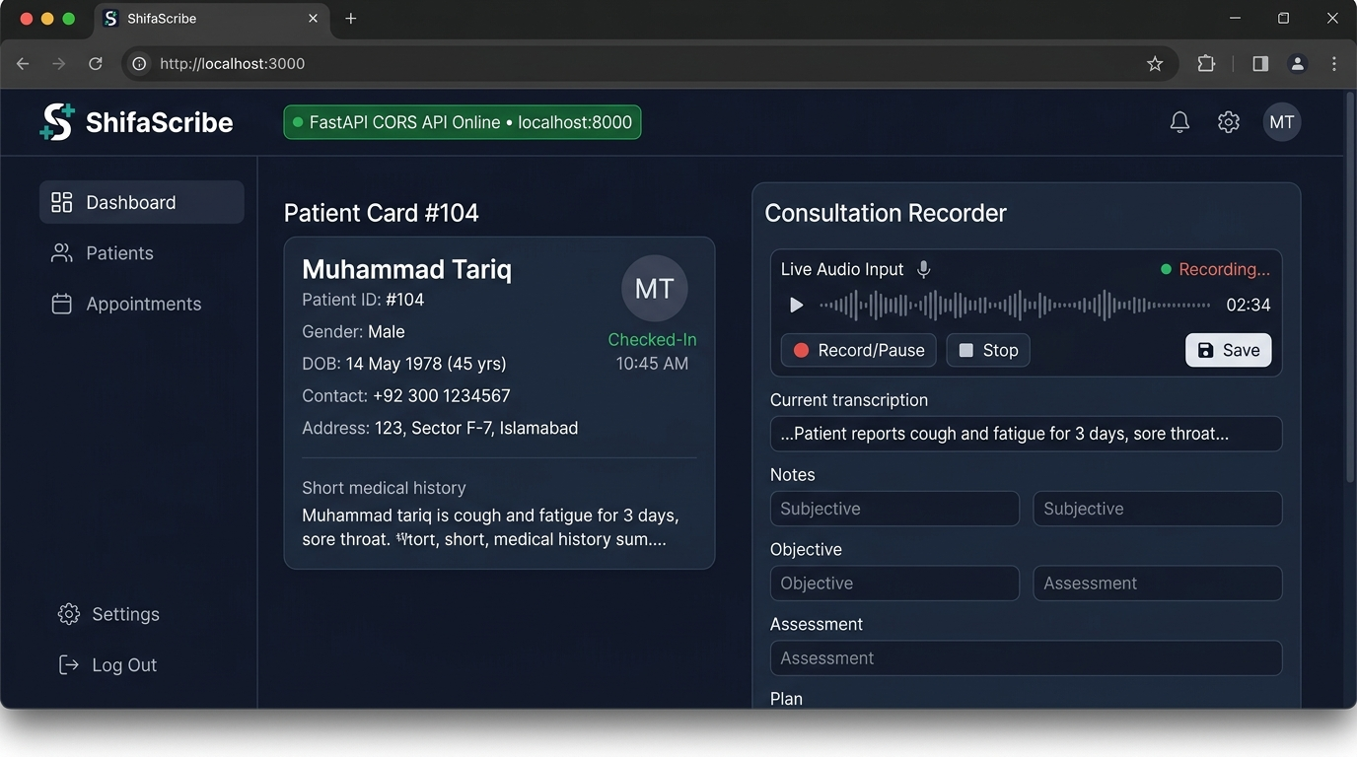
Figure 13: Next.js Frontend Doctor Consult Screen UI (http://localhost:3000) displaying active FastAPI Backend Connection Badge
6. Day 5 Implementation: PostgreSQL Schemas & Async Audio Upload API
On Day 5, SQLAlchemy ORM models were constructed in backend/models.py to hold master clinical entities: Patient (ID, name, age, OPD token), Doctor (ID, name, department), and ConsultationLog (patient ID, doctor ID, audio file path, file size in KB, MIME format, and status). An asynchronous API endpoint POST /api/consultation/upload-audio was implemented saving audio files into storage/audio/.
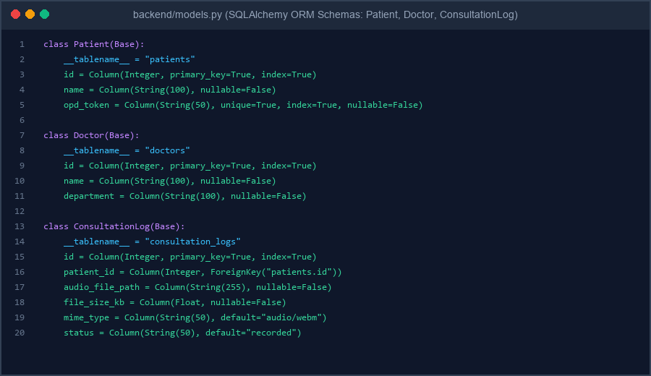
Figure 14: Day 5 SQLAlchemy ORM Model Schemas in backend/models.py (Patient, Doctor, ConsultationLog)
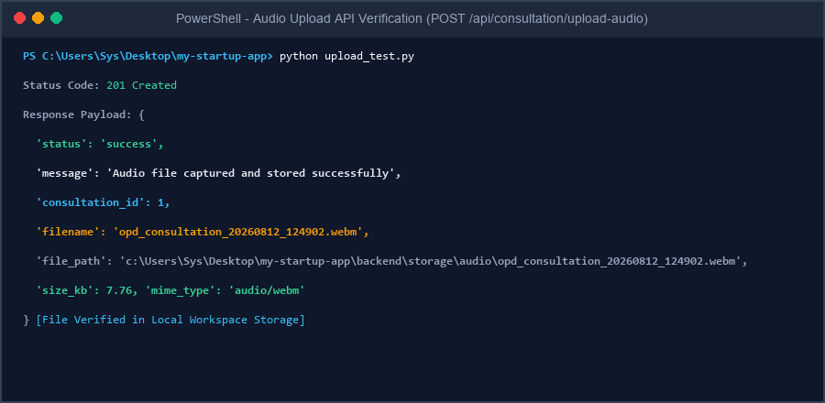
Figure 15: Terminal Execution & Verification of POST /api/consultation/upload-audio returning HTTP 201 Created
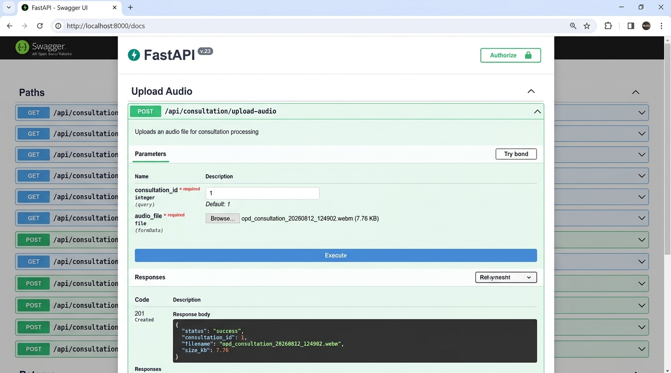
Figure 16: Interactive Swagger OpenAPI Upload UI (http://localhost:8000/docs) displaying successful file upload payload
7. Week 1 Sprint Conclusion & Next Steps
Week 1 of ShifaScribe successfully established a complete full-stack clinical architecture. The frontend UI provides an intuitive, 3-state OPD doctor consultation interface with 16kHz mono audio compression. The FastAPI backend manages cross-origin communication, database schema persistence, and asynchronous binary audio file storage. Week 2 will focus on real-time OpenAI Whisper Urdu speech-to-text transcription streaming and ICD-10 medical entity extraction.
8. Supervisor Evaluation, Remarks & Approval
This section is reserved for the supervisor evaluation, comments, and formal sign-off for the Week 1 Technical Implementation of ShifaScribe.
Evaluation Field | Supervisor Assessment & Details
Overall Week 1 Rating: | [ ] Excellent [ ] Very Good [ ] Satisfactory [ ] Needs Revision
Supervisor Remarks & Feedback: | (Please write supervisor remarks and evaluation notes here...)
Supervisor Signature: | _________________________________________  Khubaib Ahmed
Date of Sign-off & Status: | Date: ______________, 2026 | Status: [ ] APPROVED FOR WEEK 2

