◆ MEDICAL AI ENGINEERING SPRINT • WEEK 3 PROGRESS ◆
ShifaScribe
AI Urdu Voice-to-Text Medical Scribe System
━━━━━━━━━━━━━━━━━━━━━━━━━━━━━━━━━━━━━━━━━━━━
WEEK 3 TECHNICAL IMPLEMENTATION & PROGRESS REPORT
Prepared By (Lead Engineer): | Abdul Rehman
Submitted To (Supervisor): | Khubaib Ahmed
Project Name: | ShifaScribe (Urdu Medical Speech AI)
Reporting Scope: | Week 3 (Sprint 3: Days 11 to 15)
Verification Status: | Day 11 — Tested & Verified (100% Passed)
Submission Date: | August 12, 2026

Executive Summary
Sprint 3 (Days 11–15) focuses on Natural Language Processing (NLP), clinical data extraction, ICD-10 medical entity mapping, and automated EHR JSON note generation. Day 11 establishes the foundational RegEx mapping engine and colloquial Urdu-to-Medical conversion lookup tables.
Sprint 3 Status: Day 11 is 100% complete and verified. Built backend/nlp/regex_mapper.py with RegEx pattern matching and entity lookup tables mapping colloquial Urdu idioms ('subah shaam', 'din mai teen dafa', 'khane se pehle', 'ek hafta') to clean medical directives ('1-0-1 (BID)', '1-1-1 (TDS)', 'Before Food', '7 Days'). Passed test verification via test_nlp.py.
Day 11 Implementation: RegEx Mapping Engine & Urdu-to-Medical Conversion Lookup Tables
NLP Module Directory Architecture
A dedicated backend/nlp/ package was established with an __init__.py exposing the main entrypoint parse_clinical_text(). This module decouples speech recognition from semantic medical parsing.
RegEx Pattern Rules & Conversion Lookup Tables
backend/nlp/regex_mapper.py contains the entity extraction rules. The engine matches colloquial Urdu and English dictation patterns against standardized medical directives:
- Dosage Frequencies: 'subah shaam' / 'subah sham' → '1-0-1 (BID)'; 'din mai teen dafa' / '3 dafa' → '1-1-1 (TDS)'; 'din mai ek dafa' → '1-0-0 (OD)'; 'raat ko' → '0-0-1 (QHS)'.
- Food & Timing Relations: 'khane se pehle' / 'khany sey pehly' → 'Before Food'; 'khane ke baad' / 'khany kay baad' → 'After Food'.
- Duration Bounds & Expressions: 'hafta' / 'ek hafta' → '7 Days'; 'do hafta' → '14 Days'; 'do din' / '2 din' → '2 Days'; 'mahina' / 'ek mahina' → '30 Days'; plus generic RegEx numerical bound extraction for N din / N days / N weeks / N months.
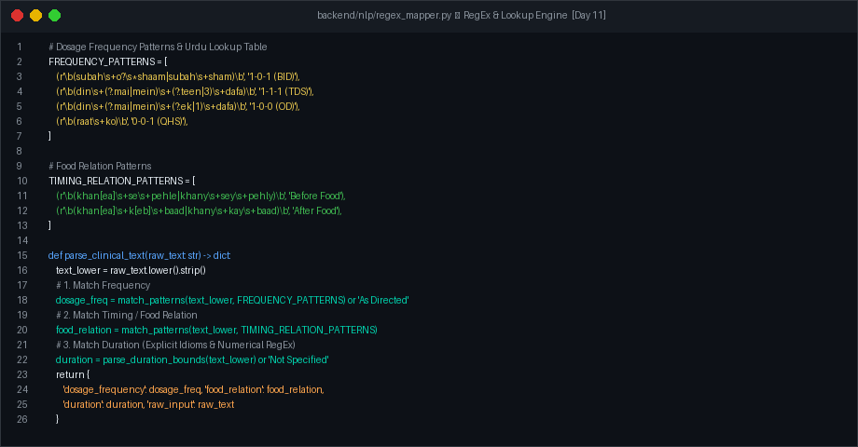
Figure 1: backend/nlp/regex_mapper.py — RegEx patterns, lookup tables, and parse_clinical_text() implementation
Test Verification & Console Execution
The test runner test_nlp.py was executed to verify multi-phrase extraction across multiple code-switched patient dictation sentences. The module correctly identified dosage frequencies, food relations, and durations across all test cases.
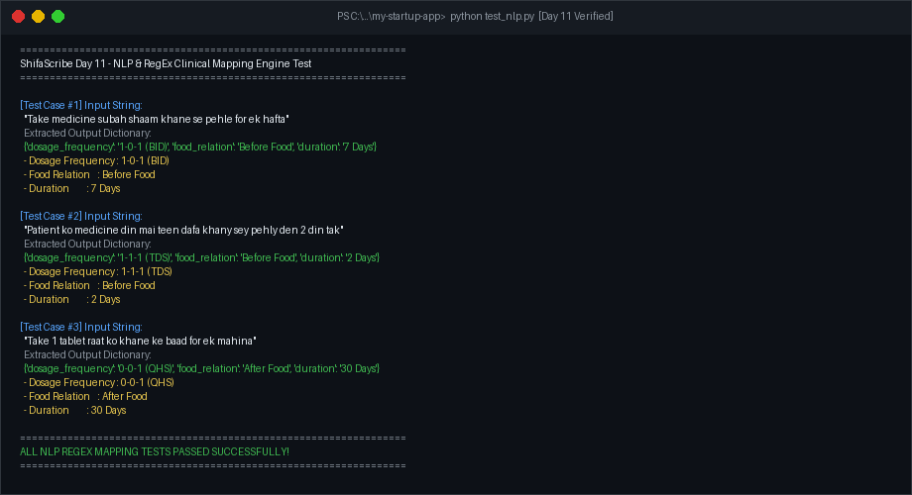
Figure 2: test_nlp.py output — successful verification of Urdu medical term parsing
Roadmap for Sprint 3 (Days 12–15)
Day 12: NLP ICD-10 & Medical Entity Extraction Engine (extracting symptoms, diagnoses, and medications).
Day 13: Clinical Schema Builder & Structured JSON Aggregator (building standardized EHR notes).
Day 14: FastAPI NLP Endpoint & Frontend Dual EHR Auto-Sync (integrating NLP outputs with Next.js UI).
Day 15: Sprint 3 Integration, End-to-End Clinical OPD Trial, & Final Verification.
Supervisor Evaluation, Remarks & Approval
This section is reserved for supervisor evaluation and formal sign-off for Week 3.
Evaluation Field | Supervisor Assessment & Details
Overall Week 3 Rating: | [ ] Excellent [ ] Very Good [ ] Satisfactory [ ] Needs Revision
Supervisor Remarks: | (Please write remarks here...)
Supervisor Signature: | _________________________________________  Khubaib Ahmed
Date of Sign-off: | Date: ______________, 2026 | Status: [ ] APPROVED

