Tenancy options in EC2:
1) Shared (Default): You share the hardware with other users
2) Dedicated: You run a dedicated instance. Your instance run on a single hardware but can be shared by other instances of your account. This way you can ensure that your instance stays on the same hardware but you can’t customize the underlying hardware.
3) Dedicated Hosts: You run a dedicated server. This gives you visibility of cores, ports and sockets of the server and allows you to precisely manage your instances on it. It helps you to have your own licensing software for the server.

AWS is Cloud Service Provider which means it has services that can manage your application. However, platforms which provide few or less services and primarily focuses on lending compute power are called Cloud Platforms

AWS services can be chained together, can be accessed over a single API, uses metered billing, IaaS offering, IaC automation and rich monitoring built in.

CloudTrail is used to track user activities on your AWS account, the logs are by default sent to S3 bucket. You can integrate it with CloudWatch Logs.

4 core services:
1) Compute 2) Networking 3) Storage 4) Databases

Administrator User has access to all the services and resources
Power user also has access to all services and resources but it is not allowed to manage user and groups.

Account alias is an alternative to account id, this eases the login procedure in console.
Default AWS region is set by the account’s region setting.
AWS budgets can be used to set a budget threshold for your account. In addition to budget monitoring, you can add alerts and actions to your budget to control IAM and service control policy permissions as well as AWS resources when thresholds are exceeded or you are approaching the threshold. Threshold can be monetary or even hours allocated to an instance
Only first two budgets are free, after these two budgets, the third budget will incur $0.02 daily cost.
Different types of budgets: 1) Cost 2) Usage 3) Saving Plan Utilization(How much is covered by saving plan) 4) Reservation Utilization (how much is covered by reservation)
An IAM role will be needed by AWS budget to execute actions.
Budget reports can be created too
SNS can send you notifications on your email.
CloudWatch is a collection of services 1) CloudWatch alarms 2) CloudWatch Logs 3) Cloud Watch Metrics 4) CloudWatch Events

We can create billing alarms in CloudWatch with a specified threshold
Though, both CloudWatch and Budget can be used to control billing, but Budget should be used for simpler budgeting requirements involving various cost categories. CloudWatch will be suitable for complex budgets and to get real-time notifications. AWS CloudWatch Alarms are more flexible than Budgets and are ideal for complex use-cases for monitoring spend and usage.
AWS asks you to set MFA for all the users especially the root account.

Burning Platform is a term used when a company abandons old technology for new technology with the uncertainty of success and can be motivated by fear that the organization future survival is dependent on its digital transformation.

You can either use a hardware device or virtual MFA for this authentication.
Cloud technology is the part of the latest K-wave aka innovation wave
AWS provides Inferentiare instances with GPU and Braket service for quantum computing.
There is per shot and per task price in quantum computing

Why Cloud should be adopted: (Advantages)
- Agility : Increase speed, launching instance within a minute
- Pay-as-you-go pricing: Trade capital expense for variable expense, no upfront cost
- Economy of scale: Benefit from massive economies of scale, share cost with other customers to get unbeatable savings, many users using same server
- Global reach: Go global in minutes with few clicks, with multiple regions you can provide lower latency and a better app experience
- Security: Physical security of hardware and services provided, though you can re-adjust the security at services level.
- Reliability: Stop spending money on running and maintaining data centers
- High Availability
- Scalability: Due to economies of scale
- Elasticity: Automatic scaling your infrastructure based on demand
- Fault Tolerance
- Disaster Recovery
- Current: The underlying hardware and software are patched, upgraded and replaced by cloud provider itself without any interruption.
Not all AWS services are available in all regions, services are first launched in US-EAST-1
For some global services, you may have to select a region or a group of regions, like for S3, you select a region for your bucket.
Latency b/w data-centers in AZ is very low and a region generally contain 3 or more AZ.
Deploying applications in multiple AZ results in High Availability
Communication b/w AZ are encrypted and are within 100km of each other.
Edge locations are used by S3 acceleration and Global Accelerator for content distribution and by CloudFront for content retrieval.

Point of Presence (PoP): An intermediate location between AWS region and end user. Used for content delivery. PoP resources are Edge Locations and Regional Edge Caches
Edge locations store the most frequently accessed files while regional edge caches store less-popular files.
PoP resources can also be used for faster upload. (Edge location)
Note that using edge locations and regional edge, you can reduce your data transfer fee.

Following resources use PoP:
CloudFront is Content delivery network service. (Not for upload)
S3 transfer acceleration allows user to upload data onto a nearby edge location, from there this data is replicated on original S3.
AWS Global Accelerator handles your internet traffic when you have server in a single region. User request is received at edge location and not directly to web server, which actually is slow. Instead, AWS fast network is used for request forwarding.

AWS Direct connect has two options: Low bandwidth and High bandwidth.
AWS Direct connect locations are used for connection point with AWS Cage and Customer Cage, each having their dedicated router.
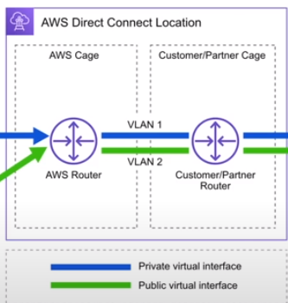

Direct Connect helps reduce network cost with better throughput and provides a more consistent network experience than internet based connection. (Reliable, secure, great for high traffic)
Direct connect location is trusted partnered data-centers for connection b/w on-prem and aws infra.

AWS provide local zones service in some densely populated areas for super low latency performance. These zones can be utilized by talking to AWS on support, there are not publicly available.
Some AWS services are provided in these zones.

AWS wavelength zones allows for edge computing on 5G networks.
You create a subnet tied to wavelength zone and then you can launch VM to the edge of the targeted 5G network. AWS has partnered with Telecom companies for 5G network.

Data Residency: Physical location of where cloud resources reside
Compliance Boundaries: Regulatory compliance by organization or govt that describes where cloud resources are allowed to reside
Data Sovereignty: Jurisdictional control over data about it’s physical location.
Following AWS services can be used for these purposes:
AWS Config: Create rules to continuously check resources configuration. If you deviate then alerts are generated like if someone tries to launch EC2 in different region.
IAM Policies: To deny access to specific regions. Policies can be written for permission setting.
AWS Outposts: Physical rack of servers in your data center. Your data will reside there but you can AWS services.

AWS can be used by governments as they meet the regulatory compliance programs.
Plus, they have special regions for US government (GovCloud)
AWS China is isolated from AWS Global to meet regulatory compliance for China. They have partnered with some local companies to provide 2 regions in china.
You can use closest regions like in Singapore for chinese access but you will have to go through the chinese great firewall.

AWS is sustainable in terms of energy usage, Cloud efficiency and Water management. (Use recycled water and renewable energy)

AWS ground station service can be used to communicate with the satellites reserved by you. You can process the received data using Ground Station’s EC2 and store data in its S3 bucket.

When using AWS Outposts, AWS either deliver 42U server rack to you and installs it or sends 1U or 2U servers to be placed in your racks.

Elasticity is ability to automatically adjust with changing demand while scalability ability to grow with business needs.
Your architecture should be assessed on: availability(launch ec2 in multi-AZ), scalability, elasticity, fault tolerance and disaster recovery (Durability)
Use Auto-Scaling Groups for Elasticity, they add or remove servers based on set metric

For fault tolerance, you must ensure that there is no single point of failure, like if your primary DB is down. You must have a secondary stand-by DB which automatically replaces at the time of failure. Use RDS Multi-AZ for this configuration.
High Durability is about recovering from a disaster and to prevent data loss at time of disaster. You can have backups that can be recovered faster to ensure durability. Live data should also not be corrupted. CloudEndure Disaster Recovery service can be used for this purpose, they continuously replicate your machines into low-cost staging area in preferred region to recover in case of IT failure.
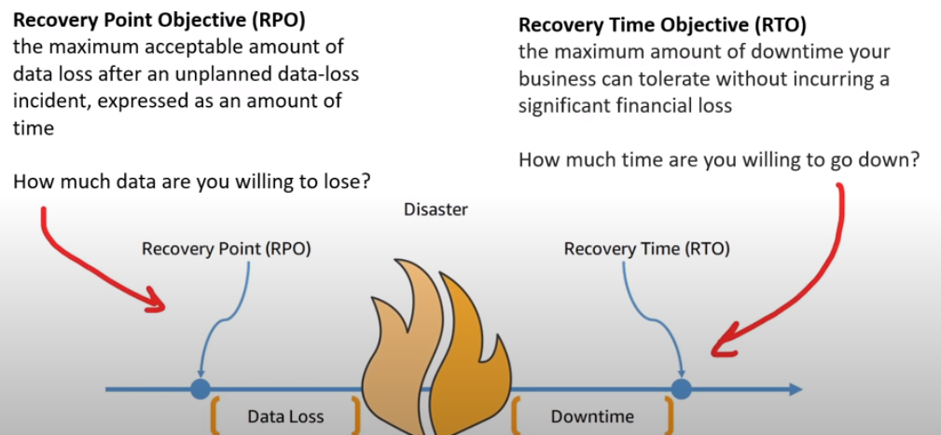
The left picture is about Business continuity plan that how a business will operate during unplanned disruption.

S3 is highly available by default as it replicates data across multi-az

You have to set high availability in elastic beanstalk while creating.
RDS is also NOT highly available by default.

AWS CLI, AWS Console, AWS SDK and HTTP requests, these all interact with AWS API.
You need account id, along with username & password, when logging in as non-root user. Instead of using account id, you can set up alias name

You can grant cross-account access using IAM roles with specified account ID. Incase of S3, since it is a global service, you can access individual access to another account by adjusting the bucket-policy to allow that specific account id.

You need to install AWS tools before accessing AWS resources on powershell, even if you are using cloudshell.

ARN stands for Amazon Resource Name. Used to uniquely identify a resource across AWS.
ARN can use wild-card *, when writing policies.
AWS CLI is a python executable program, which means that you will need Python to install it.
You can use AWS Cloud9 for coding as it is a cloud IDE, with support of multiple languages. AWS credentials are already added in Cloud9 IDE.
AWS SDK can be used to interact with AWS resources in your code. Documentation for each language is provided.
IaC tools offered by AWS are: AWS CloudFormation (CFN) (Declarative tool) and AWS Cloud Development Kit (CDK) (Imperative Tool)
In CloudFormation, you can either use JSON or YAML.
CDK also generates out CloudFormation template, so it is important to understand cloudFormation script.
CDK allows you to write infrastructure as code in a programming language
CDK pipelines can be created for CDK projects.

You can also create infrastructure using SDK, but CDK is idempotent of your infrastructure unlike SDK. Plus, CDK also has a testing framework for Unit and integration testing.
You need to download the CDK package in your programming language first.
You can create multiple language environments in Cloud9.
AWS toolkit is an open-source plugin(extension) for VSCode to create, debug and deploy AWS resources.
AWS access keys can be used for programmatic access to AWS user. You can have max 2 access keys. You can deactivate keys at any time.
Shared Responsibility Model is a cloud security framework that defines the security obligations of the customer and the CSP (AWS).
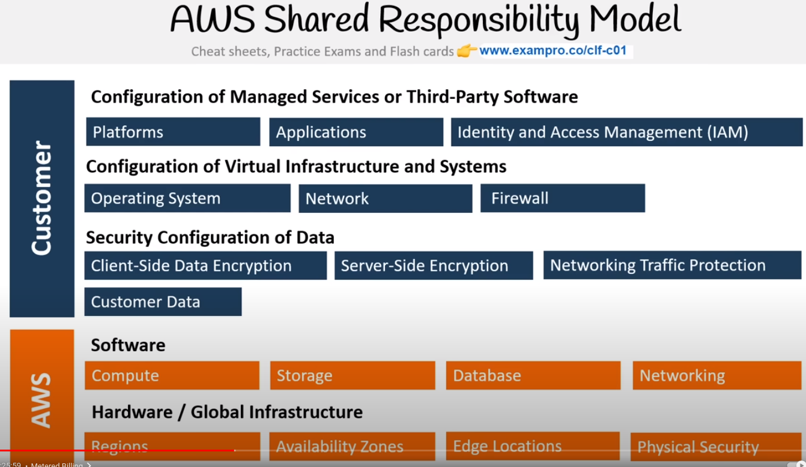
Customers are responsible for the security in the cloud and AWS is responsible for the security of cloud.
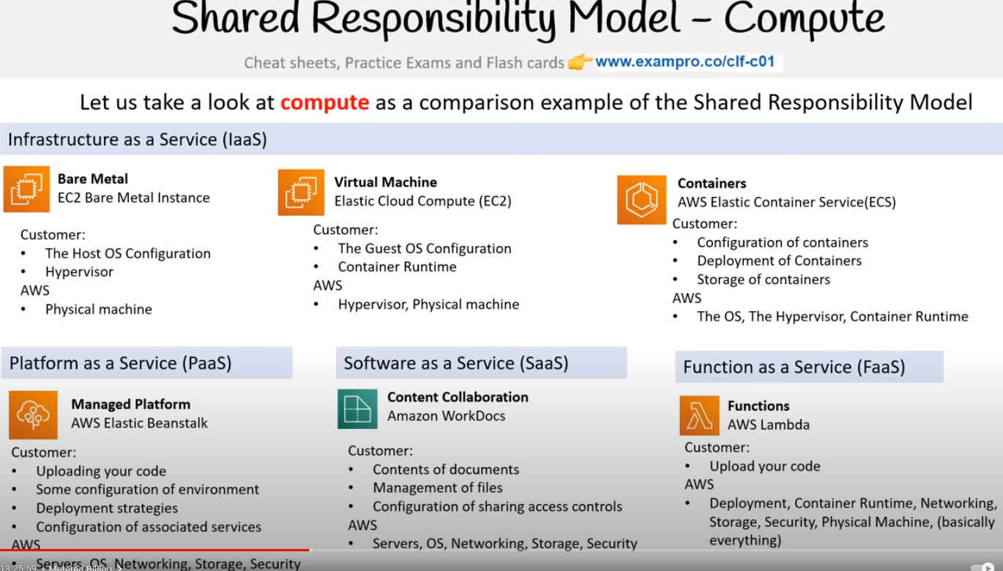
AMI is a predefined configuration for a virtual machine. AMI can effect the amount of CPUs, RAM, Network bandwidth and the OS, and the number of EBS that can be attached.
Server virtualization (EC2) allows you to easily create, copy, resize or migrate your server.
AWS lightsail is the managed virtual server service, which makes friendly version of EC2. With pre-configured load balancers, databases and other resources. It can also be integrated with other AWS services like S3. Plus, it offers a predictable pricing with fixed monthly rates. They provide automated backups/snapshots of instances with built-in security features for like DdoS and SSL.

ECS is a container orchestration service, allows to scale and secure containers. You have to manage the EC2 instances on which these containers are running.
ECS Fargate is a serverless compute engine for containers, you don’t have to manage the instance. Fargate handles the scaling itself. Fargate pricing is based on pay-as-you-go
Both EKS and ECS do the same task but ECS take away the complexity of Kubernetes and allows you to focus more on the containers.
AWS Lambda is a serverless function service. You are charged for how long your function is allowed to run and the memory you chose for your code.
You write task definitions in ECS, it specifies the container information like how many containers are needed and what resources to allocate. In task definition, you choose fargate or ec2 config.
M5 and R5 instances run on bare metal.
Bottlerocket is a linux OS built by AWS for running containers on VM or bare metals.
High performance computing have thousands of servers connected with fast network.
AWS ParallelCluster is AWS open source cluster management tool in form of python package that makes it easy to deploy and manage HPC clusters on AWS. It also uses CloudFormation at backend
VMWare cloud on AWS, allows you to manage on-premises VM as EC2 instances. Data center must be using VMWare for virtualization.
AWS LocalZones are edge datacenters located outside AWS region.
We can also have customized functions (piece of code) in CloudFront.
AWS Batch can be used to plan, schedule and execute batch computing workloads. It will deploy instances and necessary resources on your behalf and can utilize spot instances to save cost.
AWS Compute Optimizer uses ML to analyze your usage history and suggests to reduce cost and improve performance.
EBS only supports one write volume. Virtual hard-drive to your VM.
EFS supports multiple reads, writing locks file.
S3 stores data in objects with data, metadata and unique ID. Supports multiple read/write with no locks. However, it is not suited for high IOPs.
Bucket names shoud be unique and it can have folders. Max object size is 5 TB
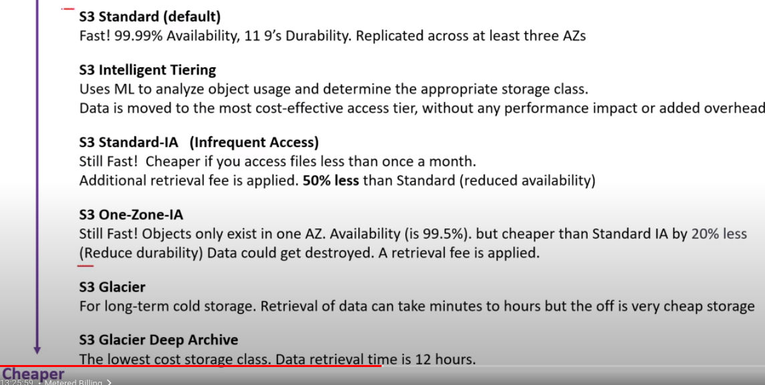
S3 Outposts can be used to store S3 data in your on-premise outpost.
AWS Snow family can be used to move data in or out the cloud. Alternate to migration over internet because it is slow. Data is finally delivered to S3.
Storage gateway is hybrid cloud storage, that extends cloud storage to your on-prem systems.
File gateway extends your local storage to AWS S3.
Volume Gateway caches your local drives to S3, for continuous backups.
Tape Gateway stores files on virtual tapes for cost effective long term storage.
AWS Backup makes it easy to centralize and automate the backup of data across multiple services.
You create backup plans with it.
Amazon FSx is highly performant file system, it can be used for windows (SMB) or Linux (Lustre)
You can encrypt your object using server-side encryption. Either by using Amazon S3 key (SSE-S3) or AWS key management service key (SSE-KMS), but object is decrypted when viewing.
You can set object lock for S3 object, this follows WORM model (write once read many)
You can create life-cycle rules to automatically move your data to different class of S3 storage.
EBS volume is specific to a certain AZ. You can also take snapshot of your volumes.
EFS is serverless but restricted to a certain VPC. You can ensure high availability by choosing the option to store data redundantly on multiple AZ. You have to mount EFS storage to EC2.
AWS OpsHub is a GUI, you can use to manage AWS snowball devices.
Snowball Edge Client is a terminal application for snow devices to set up and administer devices.
Data warehouse is a data-store for analytic workloads and is generally column-oriented. Data warehouses generally perform aggregation of databases.
NoSQL databases uses key-value store and are non-relational. Key-value store interpret data as dictionaries and each column is not needed to be filled. These are faster but dumber. Scaling is easy.
Relational Databases use tabular data.
Document Store is NoSQL DB, it uses documents as primary data structure, document can be in XML or JSON.
DynamoDB is a NoSQL key/value, document DB. Flagship DB service with capability to scale to billions of records. Provide good latency and is cost-effective.
DocumentDB is NoSQL DB, compatible with MongoDB. NOT key/value and follows ACID transactions.
Amazon Keyspaces is Apache Cassandra DB service. Cassandra is NoSQL key/value DB similar to DynamoDB but has some additional functionality.
RDS can be used for relational DB and it supports multiple SQL engines (MySQL, PostGRES, Oracle, MariaDB). Aurora is also a service within RDS. You can create stand-by DB in RDS.
Aurora Serverless, automatically scales DB instances but results in cold-starts.
Aurora only supports MySQL (5x faster) and PostgreSQL (3x faster)
You can also manage RDS on-prem systems using service RDS on VMWare, but VMWare should be used for virtualization.
You need to select RDS instances to run DB.
Redshift can be used for data-warehouse, to do online analytical processing (OLAP). It is a relatively expensive service because it keeps data hot, meaning it runs complex queries on large amount of data for analysis. Quick reports from a large amount of data
ElastiCache is managed DB for in-memory and caching, Redis or MemCached. Used to improve performance by adding cache layer in-front of webserver/DB.
Neptune is managed graph DB. Uses nodes and helpful in understanding connection b/w data (Social media relationships etc)
Amazon Timestreams, time series DB, used by devices that are time-sensitive. Used where you want to know how things change over time.
Amazon Quantum Ledge DB provides transparent, immutable and cryptographically variable transaction logs. (For financial activities that can be trusted.)
Database migration service can be used for homogeneous/heterogeneous migrations, database consolidation(merge) and continuous data replication. Source DB remains operational during migration. Multi-AZ replication is supported and is low cost service with only compute charges.
PrivateLinks (VPC Interface Endpoints) keep traffic within AWS network.

Using NACL you make allow and deny rules, using security groups, you create allow rules only.
You can take decisions based on requests to CloudFront by using a Lambda function.
You can control the items to be cached and block countries that cannot access CloudFront.
Instance families: General Purpose, Compute Optimized, Memory Optimized, Accelerated Optimized, Storage Optimized. (AKA Instance Types)
Dedicated Hosts allow you to bring your own license on machine.
In Dedicated instance, the position of instance stays the same even if rebooted. In shared instance, the position of instance changes after reboot.
You can enter your instance using session manager without SSH and it is the preferred way. It is secured by AWS KMS key and session logs can be stored inside S3 or CloudWatch Logs.
After stopping the instance and starting it again, new IP is allocated
You can create launch templates to automate the EC2 launching process. This includes all the details like AMI, instance type and all the other details when launching an EC2.
We can select only one subnet for each AZ, for ALB, plus you will need target groups of instances.
Reserved Instances depend on Term, Class Offering, RI Attributes and Payment Option.
Class Offering: Standard: 75% savings, modification of RI attributes (can change instance within family), Convertible: 54%, can exchange RI if greater than or equal. Unused RI cannot be sold in reserved instance marketplace but standard RI can be sold.
RI Attributes: Instance type, Region, Tenancy (shared or dedicated), Platform
There are two types of RI reservation (Regional/Zone)
There is a limit of 20 regional reserved instances and 20 zonal reserved instances, we cannot exceed the on-demand instance limit by purchasing regional reserved instances. However, you can exceed on-demand instance limit using zonal reserved instances.
You can reserve capacity for some time period, but you will be charged with the on-demand rate whether it is running or not. You can use RI with capacity reservation to benefit from discounts.
Capacity reservation allows you to reserve capacity for a specific region and AZ.
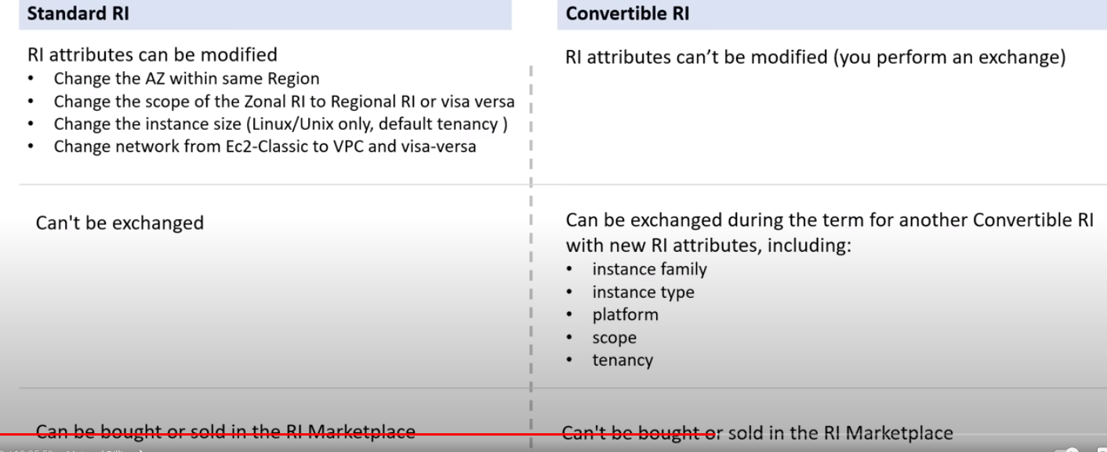
Saving plans offer similar discounts like RI but simplifies the purchasing process.
There are 3 types of savings plan: Compute Savings, EC2 instance savings, SageMaker savings
Compute savings (EC2, Fargate, Lambda), can reduce cost by 66%, most flexible
EC2 instance savings can offer up to 72% off in exchange for commitment to usage.
SageMaker helps you to reduce cost by 64%.
Zero Trust Model, trust no-ne, verify everything. In this model, Identity is the primary security.
Identity security models can be implemented. Tools: IAM Policies, Permission Boundaries, Service Control Policies (Organization-wide Policies), IAM Policy Conditions (restrict on region or IP or if no MFA, time). AWS doesn’t allow intelligent identity security controls.
For more intelligent security, you can use AWS CloudTrail that tracks all API calls, send these to Amazon GuardDuty that detects suspicious activity based on logs, analysis on results from GuardDuty can be done using Amazon Detective. These services can be used individually too.
Use AWS Single Sign On (SSO) for integrating third party intelligent zero trust tools.
Directory Service maps the names of network resources on their network addresses. Well known directory services: DNS etc. AWS directory service can be used to use Microsoft active directory, managed by AWS.
Identity providers lets you authenticate using other services, like Facebook, google etc.
Single sign-on allows a user to log in with a single ID and password to different systems and software.
LDAP allows users to use single ID and password into multiple applications but they have to enter it every time they want to login. Most SSO uses LDAP.
Security key is a second step in authentication typically part of MFA. It can be either a device or virtual device.
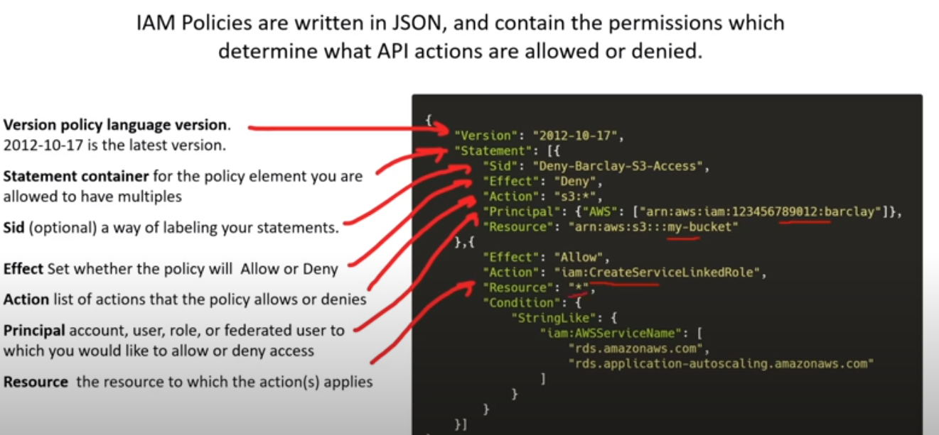
If the EC2 does not have a role attached and you attach a role to it, then a reboot is needed.
Principle of least privilege follows two policies: just enough access(JEA) and just in time(JIT).
Root user cannot be deleted and must sign in using email and password unlike other accounts, its permissions cannot be limited. IAM policies have no effect on it. Only Service Control policy can limit root user permissions.
Tasks that only root user can perform: Close account, change email address/password, register as a seller in RI marketplace, activate IAM access to billing and cost management console, some special powers on S3, sign up for GovCloud and change or cancel AWS support plan.
SSO is where you create, connect your workforce identities in AWS once and manage access centrally. It allows users to sign in once and access multiple AWS accounts and third-party applications without having to remember multiple usernames and passwords. Access can be fine-grained using user roles and groups.
Simple Queuing Service (SQS) enables you to decouple and scale microservices, distributed systems and serverless applications. This actually allow communication between services using messages that are deleted after consumed (Not real time). Send events to queue.
In streaming, multiple consumers can react to messages, these messages live long periods so complex operation can be applied (real time). Amazon Kinesis can be used for collecting, processing and analyzing streaming data in cloud. Output of Kinesis can be sent to other services like RedShift, S3 etc.
Pub/Sub is used in messaging systems, messages are first sent to an event bus, this bus categorizes messages into groups and receivers then subscribe to these groups and are delivered messages instantly. Publisher has no knowledge of subscribers and their messages are sent automatically to Subscribers. Simple Notification Service (SNS) uses pub/sub and can be used to decouple micro-services and serverless applications
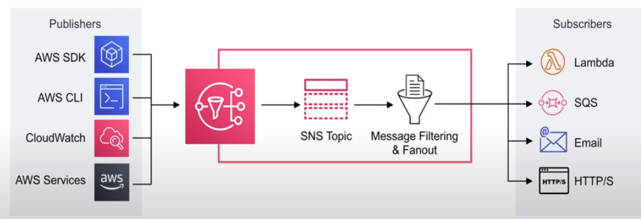
API Gateway sits between a single-entry point and multiple backends. Can be used for logging and formatting of request and response. Amazon API Gateway can be used to create secure API at any scale. You can create API for EC2, Kinesis, lambda etc.
AWS Step Functions can be used to coordinate multiple AWS services into a serverless workflow just like state machines. It ensures that your infrastructure follows the specified steps and if any step faces an error, then it will be re-tried and log of each step will be recorded.
An event bus receives events from a sources and routes them to a target based on some rules.
EventBridge is a serverless event bus service that can be used for application integration by steaming real-time data to your applications. (for various services and third-party apps)
Amazon MQ is a managed message broker service that uses Apache ActiveMQ.
Managed Kafka Service (MSK) is a fully managed Apache Kafka Service. Kafka is used for building real-time streaming data pipelines and applications. Similar to Kinesis but more robust
AppSync is a managed GraphQL service. GraphQL is query adaptor that allows you to query data from different data sources.
Container is a better option than VM because it does not waste space. Because if you make a VM for your app in your EC2 and you are unable to use the whole space of VM, then that space is wasted. Inside in containers, they only take up space that is required by it.
ECS has a small advantage over Fargate that you don’t get a cold start when scaling because EC2 is always running and managed by us.
Elastic Beanstalk, ECS on training wheels and handles the load balancing and automatic scaling. App Runner, platform as a service for containers. AWS Copilot CLI can be used to build, release and operate production ready containerized applications on AWS app runner, ECS and Fargate.
ECR is for docker images. X-Ray analyze and debug between microservices. Step Functions stitch together Lambdas and ECS tasks.
AWS Organizations allow the creation of new AWS accounts. Centrally manage billing, control access, compliance, security and share resources.
Organization units are group of AWS accounts within an organization that can also contain other organizational units. You can use Service Control policies to centrally handle permissions for all accounts in your organization.
Once AWS organizations has been turned on, you can’t turn it off and can create as many accounts as required.
AWS Config is a Compliance as code (CaC) framework that allows us to monitor and manage the changes made in your AWS account on per region basis. CaC is when we utilize programming to automate the monitoring and enforcing tasks. We can use AWS Config to stay compliant with my policies, keep track of configuration changes, list of all resources within a region
AWS Quick Starts are pre-built templates by AWS and its partners to deploy wide range of stacks
It contains a reference architecture for deployment, AWS cloudFormation templates and a deployment guide explaining the architecture.
A tag is a key and value pair that you can assign to AWS resources.
Resource Groups are a collection of resources that share one or more tags. It helps you organize and consolidate information based on your project and resources that you use. You can mention resource groups in IAM policies.
Simple Email Service is a service that can be integrated in applications to send emails.
QuickSight is Business intelligence service from which you can visualize data from multiple datasources without any programming. Creates business dashboards. It is very fast and you can have QuickSight ML Insights to detect anomalies and perform accurate forecasts with NLP narratives. Use quicksight Q to ask questions to NLP model about your data.
AWS OpsWorks is a configuration management service like ansible.
AWS Amplify is a mobile & web-app framework that will provision multiple AWS services as your backend.
E beanstalk uses cloudformation template for setting up aws resources. Can run containerized apps
Amazon Workspaces allows you to run a virtual windows desktop to provide a workstation.
Amazon License Manager allows you to run different softwares on cloud servers. Especially for dedicated hosts.
CloudTrail logs all API calls from SDK or CLI between AWS Services (good for tracking activity)
CloudWatch Logs stores logs, CloudWatch Metrics respresents a time-ordered set of data points, EventBridge triggers event on a condition.
CloudWatch alarms trigger notifications on metrics. It monitors on some threshold.
AWS X-Ray is a distributed tracing system. For microservices to pinpoint issues like data communication between services and time taken to deliver messages across each other.
CloudTrail logs by default and will collect logs for last 90 days. You can use AWS Athena to analyze a Trail. You can create a Trail for more than 90 days.
CloudWatch Insights enables you to interactively search and analyze CloudWatch logs and has better filters than in Log streams and less burdensome than having to export data to S3 for analysis on Athena. It follows its own Query lanuage. Query results are available for 7 days.
CloudWatch Metric represents a time-ordered set of data points. Variable over time. Network, CPU Utilization, DiskReadWrite etc.
ML Services:
Sageworker builds, trains and deploys ML models at scale. It uses Apache MXNet, TensorFlow, PyTorch framework
SageMaker GroundTruth is a data-labelling service. People do this labelling.
Amazon Augmented AI human-intervention review service. SageMaker prediction is reviewed by humans.
AWS CodeGuru is a ML code analysis service for analysis of code. AWS Lex is a conversation interface service for building voice and text chatbots. AWS Personalize is a real-time product recommendation service. AWS Polly is a text-to-speech service. Rekognition is a image and video recognition service. Transcribe is a speech-to-text service. Textract is an OCR service. Translate is ML translation service. Comprehend is NLP service to produce insights from text like emails etc
Forecast is a time-series forcasting service that forecasts product demand and resource needs. DeepLearning AMI are instances with pre-installed DL frameworks. DeepLearning Containers are docker images with Deeplearning frameworks. DeepComposer is ML enabled musical keyboard. Elastic Interface allows you to attach low-cost GPU acceleration on simple EC2 to reduce cost of deeplearning interface by upto 75%. Kendra is enterprise ML search engine.
Big Data and Analysis:
AWS Athena is interactive query service that takes data in form of JSON or CSV and load them into temporary SQL tables so you can run SQL queries.
CloudSearch is when you want to add search to your website.
Elastic Search is more robust than cloudsearch but requires more compute power.
Elastic MapReduce (EMR) for data analysis and processing, creates red
Kinesis Data Streams is real-time streaming service, create Producers which send data to streams, received by multiple consumers. Used for analytics and ingesting data from a fleet of IOT.
Kinesis Firehose is a simpler version of Data Streams, basically it is serverless compared to latter
Kinesis Data Analytics allows you to run queries against data that is flowing through real-time streams, so you can create reports for emerging data
Kinesis Video Streams allows you to analyze or apply processing on real-time video streaming
AWS Data Pipeline automates the movement of data. You can move data between compute and storage devices. AWS Glue is an extract, transform, load (ETL) service. Similar to DMS (database migration service) but more robust. Transports data b/w destinations but allows for data transformation in between. AWS Lake formation is centralized, curated and secure repository that stores all data like a data lake in its raw form. AWS Data Exchange are third party datasets.
Well Architected FrameWorks:
Operational Excellence Pillar: Running and monitoring systems and improving processes. Automating changes, responding to events and defining standards to manage daily operations.
Security Pillar: Protecting information and systems. Confidentiality and integrity of data, managing user permissions and establishing controls to detect security events.
Reliability Pillar: Recover after failure and performance in workloads.
Performance Efficiency Pillar: Structured and streamlined allocation of computing resources. Selecting resource sizes optimized for workloads and monitoring performance and maintaining efficiency as business evolves.
Cost Optimization: Avoiding Unnecessary costs. Controlling fund allocation, spending over time and scaling to meet business needs without overspending.
Sustainability Pillar: Minimizing environmental impacts of running cloud workloads. Following shared responsibility model, understanding impact and utilizing resources to maximum to reduce downstream impact.
AWS has distributed teams unlike centralized teams in most companies. In distributed teams, people have flexible roles and it pose some risks which are controlled by Practices (team experts raise the bar), Mechanisms (Automated checks for standard) and Amazon Leadership Principle
Amazon Leadership principle (ALP) are a set of principles used during the company decision-making, problem-solving, simple brainstorming and hiring.
Operational Excellence: Perform operations as code, make automated small and frequent changes (CI/CD), Refine operation procedures frequently, anticipate failures by killing servers to test recovery, learn from all operational failures.
Security: Implement strong identity foundation, Enable traceability using monitoring and automated investigation, apply security at all layers, automate security best practices, protect data in transit, keep people away from data, prepare for security events
Reliability: Automatically recover from failure, test recovery procedures, scale horizontally, stop guessing capacity, manage change in automation
Performance, efficiency: Use advanced technology, Go global in minutes, use serverless architectures, experiment more often, consider how things work at backend in CSP.
Cost Optimization: Implement cloud financial management, adopt consumption model for resources, measure overall efficiency, stop spending money on IT workloads, analyze and attribute expenditure
AWS Well-Architected Tool is an auditing tool to assess your cloud workloads for alignment with AWS Well-architected framework. Works on regional base.
AWS Architecture Center is a web-portal with best practices and reference architectures for different workloads.
Total Cost of Ownership (TCO) is a financial estimate intended to help buyers determine the direct and indirect costs of a product or service.
AWS Pricing Calculator is free and can be accessed on browser without AWS account. Final estimate can be sent on CSV.
Migration Evaluator is an estimation tool that uses Agentless controller to collect data from on-premises infrastructure based on collected data for comparison with AWS costs. Dashboard view.
You can Import/Export on-prem/Azure windows VM on EC2 using VM images. Place these VM images on S3 and using CLI to make AMI image for ec2 instance.
AWS DMS can be used to convert database to another. Or shift on-prem DB to cloud. It is a very flexible service with many possible sources and many possible targets.
AWS Schema conversion tool can be used to convert source schema to target’s schema.
Cloud Adoption Framework (CAF) is whitepaper to help you decide migration from on-prem to cloud. Focuses on 6 areas 1. Business perspective 2. People perspective 3. Governance perspective 4. Platform Perspective (technical) 5. Security Perspective 6. Operations perspective
AWS supports some free services like VPC and IAM etc, but resources inside them can trigger resources that may cost money.
AWS provides technical account manager at enterprise level support but the minimum cost of that support is $15,000 per month. This manager can build solutions, provide guidance and all other support to make your AWS journey good. He follows amazon leadership principles especially customer obsessed policy.
Support plans: Basic, Developer, Business, Enterprise
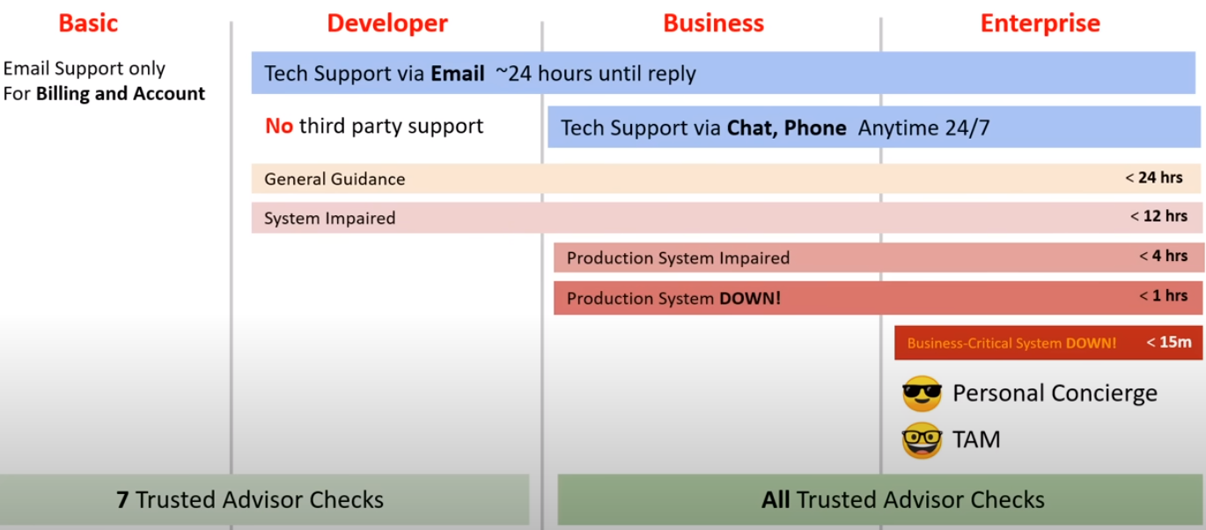
AWS Marketplace has thousands of software listings from independent software vendors.
Buy, test and deploy. Some are free, but the paid ones will appear in bill and once you pay, AWS marketplace pay the provider. You can also sell your solutions to other AWS customers. Products can be AMI, CloudFormation template, SaaS, Web ACL, AWS WAF rules.
Consolidated Billing allows you to pay for multiple AWS accounts in one bill. One becomes a master account that pays the bill. AWS Cost Explorer can be used to visualize usage for consolidated billing. Consolidated billing is free
AWS has Volume discounts for many services. Consolidated billing is a feature of AWS organizations and it can help you take advantage of volume discounts.
AWS Trusted Advisor is a recommendation tool which automatically and actively monitors aws account to provide recommendations. Find holes for AWS best practices. There are multiple trusted advisor checks.
Service Level Agreements (SLA), it is a formal commitment of expected level of service between a customer and provider. Compensation will be received if customer has abided but CSP is unable to provide that level of service. Service Level Indicator (SLI) indicates what measure of performance a customer is receiving at a given time, like throughput, latency, error rate etc.
Service Level Objective (SLO) objective that CSP has agreed to meet, SLO are represented as specific target percentage over a period of time.
Service Health Dashboard shows the general status of AWS services. Personal Health Dashboard can be used for alerts and guidance for AWS events that might affect your environment.
It shows recent events to help you manage active events so you can plan for scheduled activities. Like if your persistent instance is to retired.
AWS Trust and Safety is a team that specifically deals with abuses occurring on AWS platform. Like Spam emails, Port-scanning by AWS IP, DoS by AWS IP, Intrusion by AWS IP, hosting prohibited content on AWS service, Distributing malware using AWS service. AWS Support does not deal with Abuse Tickets.
Free tier services are usually for 750 hours per month for 1 year.
AWS Credits are equivalent to USD and they can be earned several ways like Hackathon etc.
AWS partner network (APN) is a global partner program for AWS, you can either be a Consulting partner or Technology partner.
AWS Cost and Usage Report (CUR) is a feature that generates a detailed spreadsheet for better analysis of aws costs. Places reports in S3, then you can use athena to turn report into queryable DB and then quicksight can be used to visualize billing data. You can use Cost Allocation tags to resources for better analysis with CUR.
AWS Cost Explorer lets you visualize and manage AWS costs and usage over time. Forecasting is available and checkpoints can be set at monthly or daily etc level. Cost-Explorer shows up in US-east-1
You can programmatically access pricing using Pricing API. SNS can also be used for prices chane
There are 7 layers of security:
Data: access to business and customer data and encryption usage.
Application: App is secure and free of security vulnerabilities.
Compute: Access to virtual machines (ports etc)
Network: Limit communication between resources using segmentation and access controls.
Perimeter: DDoS protection to filter large-scalee attacks
Identity and Access: controlling access to infrastructure and change control.
Physical: Limiting access to datacenter to only authorized personnel.

