HashiCorp and Terraform community has already written thousands of providers to manage many different types of resources and services. We can find them at Terraform Registry.
Providers are plugins that define and manage the lifecycle of a particular infrastructure platform.
Terraform is declarative which means that you don’t need to specify the step-by-step instructions. Terraform handles the underlying logic.
Refreshing state in terraform logs refers to the process of comparing the current state of infrastructure with the actual stage of resources in cloud.
Configuration management tools like Ansible, server templating tools Docker and Provisioning tools like Terraform all are examples of IAC tools.
Configuration management tools are idempotent, maintains standard structure and helps in version control.
They are designed to install and manage softwares.
Server Templating tools provide you with pre-installed dependencies and softwares. Common examples are virtual machine templates and docker images. Makes immutable infrastructure, you will need to have a new image for change in infrastructure.
Terraform can be used to manage infrastructure on private and public clouds.
Uses HashiCorp Configuration Language, HCL.
Terraform is declarative which means that it will be responsible for establishing the desired state.
Terraform manages the lifecycle of provisioned resource from commissioning, configuring to finally, decommissioning.
Terraform stores the state in terraform.tfstate file
Terraform can also import resources which were provisioned manually.
Everything created by terraform is called a resource, let it be a bucket or even a role.
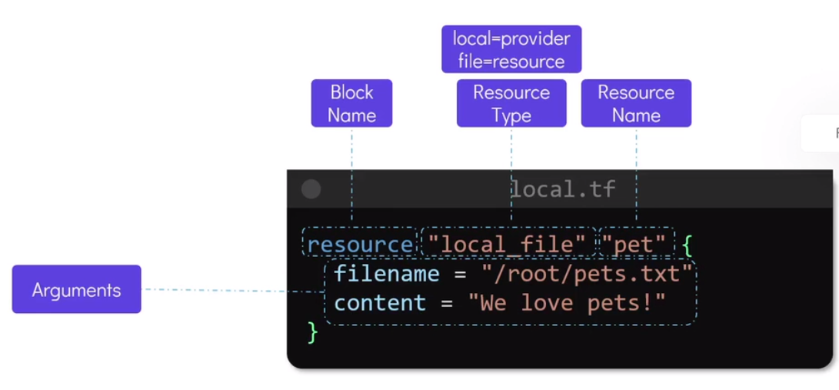
Terraform init initializes the working directory containing terraform configuration files. It should be run when writing new configuration files or cloning from git.-
-from-module=MODULE-SOURCE flag can be used to initialize terraform directory from remote version control directory containing terraform configuration files or from another folder in local.
This command also initializes backend. Backend means the place where terraform stores its state files.
You can change the backend using -reconfigure or -migrate-state flags. Migrate-state will copy existing state to new backend. However, reconfigure flag will disregard any existing configuration and will make a new backend.
Terraform show command can be used to get details of the resources created by terraform. Data is taken from state files.
We can check the resource types for a particular provider using the terraform documentation with all the necessary arguments.
If we make changes in the configuration file for a resource, then that particular resource is first deleted, then replaced with the new one. This is why terraform was called immutable.
With terraform init, terraform download and installs the mentioned plugins for cloud providers
These providers are available at registry.terraform.io
There are 3 tiers of providers: 1) Official, these are owned and maintained by HashiCorp
2) Partner, these are owned and maintained by HashiCorp partners like heroku etc
3) Community, owned and maintained by individuals
If we do not mention version of plugin, then the latest version will be installed automatically.
Terraform supports use of multiple providers in the same configuration file.

Variable block has three parameters, 1) Default: default input into the parameter 2) type: Number/String/bool/any 3) description
We can have a list type too in variables
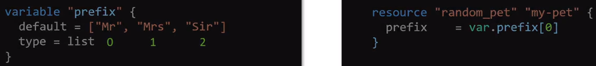
Map type:
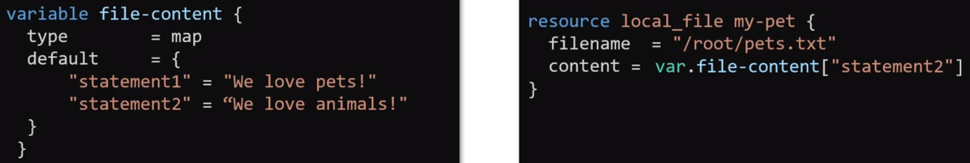
we can restrict the data type in list and map by setting the type parameter in variable block like:
1) list(string) 2) map(number) etc
In the list we can duplicate values, but we can control this using the set variable type.
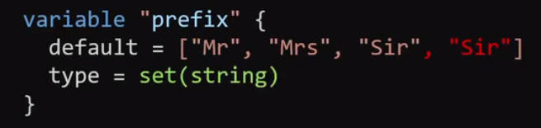
We can create objects too in terraform
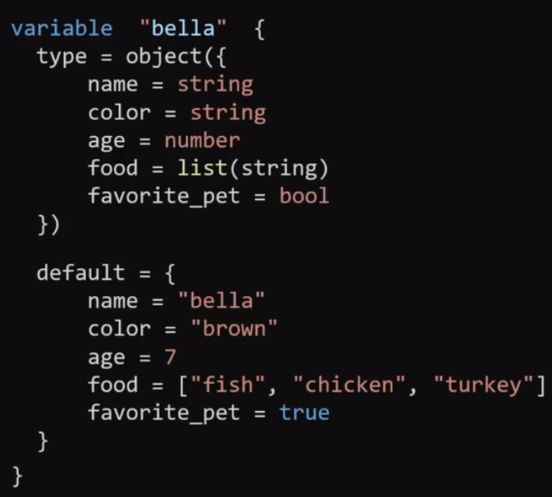
If we want to use different variable types in list, then we can use tuples instead of lists.
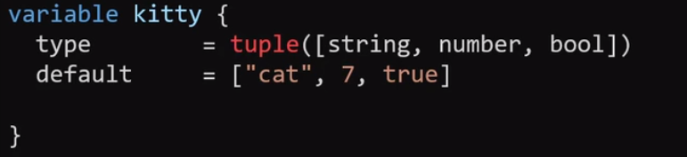
If we leave the variable block empty, then terraform will ask us for variable values in interactive mode when terraform apply/plan command is ran.
We can export variables using CLI by TF_VAR_filename, here filename is the variable name.

If we have many variables then we can use .tfvars or .tfvars.json file to assign variable values.
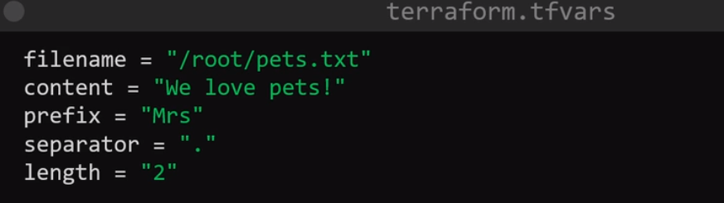
But then the applying command will be terraform apply -var-file variables.tfvars
For automatic loading of variables, use .auto.tfvars or .auto.tfvars.json extension.
Preference order:
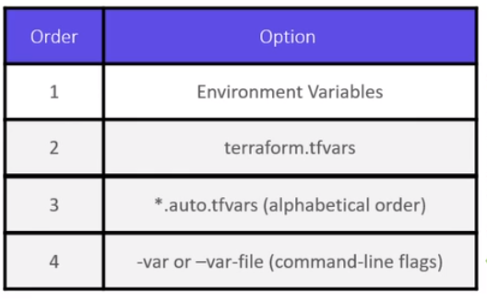

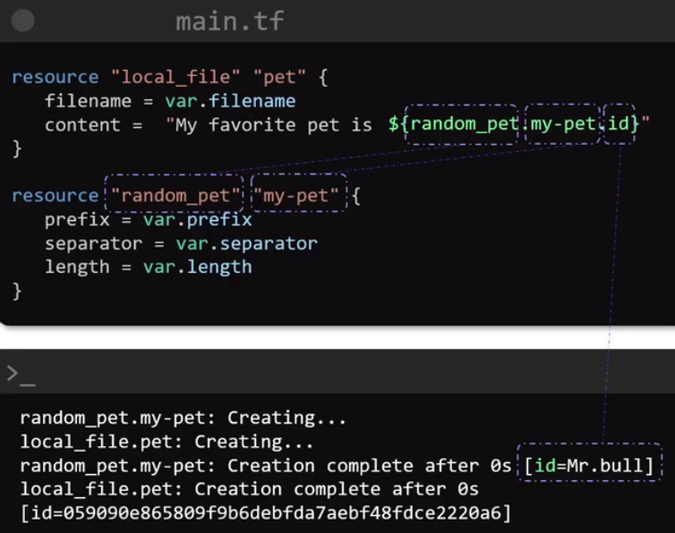

Here first the random_pet resource will be made first, then the local_file resource will be created. When destroy command is executed, the destruction is done in reverse order, first the local_file is deleted then the random_pet is deleted.
This is called implicit dependency ^.

We can add explicit dependency by:
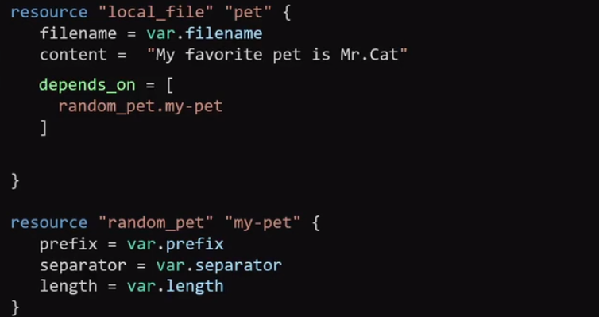

We can store output values inside an output block in terraform. It has a mandatory parameter of value.
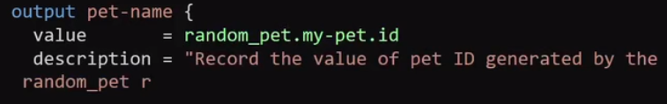
Terraform output command can be used to see the values stored inside output block.
Output variables are used to quickly print the required values or export these values to other IaC tools like Ansible or use it in shell scripts.
Terraform apply command creates the state file (terraform.tfstate)
Every time we run terraform apply or terraform plan command, the state file is refreshed and compared with the current infrastructure.
Any implicit or explicit dependencies are mentioned inside state file.
Terraform compares your infrastructure with its state file at every terraform plan/apply, so if you have made any changes to infrastructure deployed by terraform, then it will point it out and will ask for replacement. Like if you delete EC2 instance, then it will suggest to deploy again.
Refreshing state everytime can be slow, so we can use the flag -refresh=false, this will ask the terraform to only look at its state file and make the decision on configuration file. This skips the step where terraform checks the current infrastructure.
State files also helps in collaboration when working in a team.
We cannot disable state and state is written in JSON format.
Manual editing of the state file should be avoided, instead state commands should be used to make the necessary change.
Terraform validate command can be used to check the syntax of our configuration file.
Terraform fmt command can be used to do formatting of your code for better readability.
Terraform providers command can be used to check providers being used.
We can mirror these provider specs in a different directory other than .terraform by using the following command: terraform providers mirror ~/directory/another_directory, it will download the providers and will copy them into a directory in local system.
Terraform refresh command can be used to sync state file with the infrastructure and this command make changes in the state file.
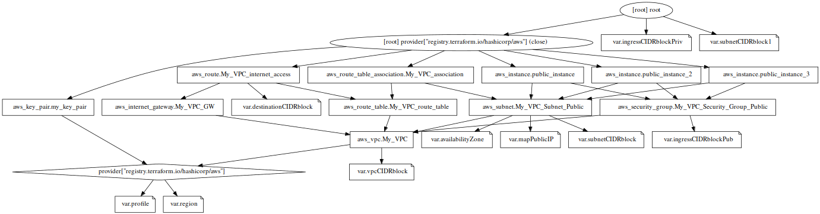
Terraform graph command generates a document graph called DOT, this operation does not need the state file and shows the dependencies between resource blocks. We can further use ubuntu tools like graphviz to generate a proper visual graph.

When a software inside a server is updated without taking the server down, then it is called in-place update.
In immutable infrastructure, we cannot do in-place updates. If the update failed, then the old server will be spun again and the new server will be removed. Re-spinning of old server is needed, because terraform first destroys the server to replace it.
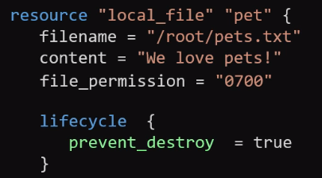
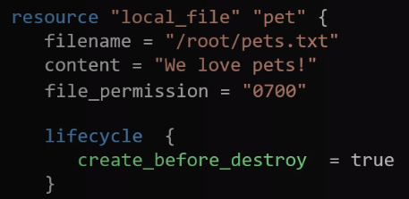

We can add lifecycle rules for our resources.
create_before_destroy is self-explanatory, while prevent_destroy will prevent destruction but NOT from terraform destroy command.
There is another argument in terraform lifecycle “ignore_changes”, we can write attributes which we want terraform to ignore if they are changed manually from AWS console or CLI. We can also use the key word “all” to any change to the instance to be reverted.
If we have created a resource manually and we want it to be a datasource in terraform configuration file, then we can use the data resource block. In this case, terraform won’t be able to change this resource.
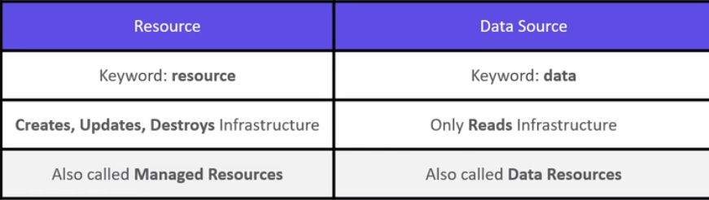
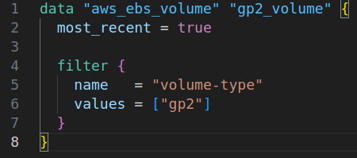

depends_on and lifecycle blocks come under the category of meta arguments. They are used to change the behavior of resources.
There is another meta_argument, count, this is to replicate a resource.
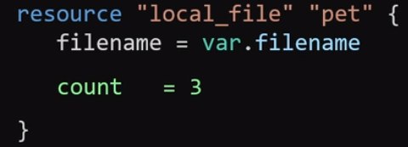
Here the resource named “pet” will created thrice, though actually a single file will be made due to same name.
To make three files with count with different names, we can write multiple file names in the variable block for filename:

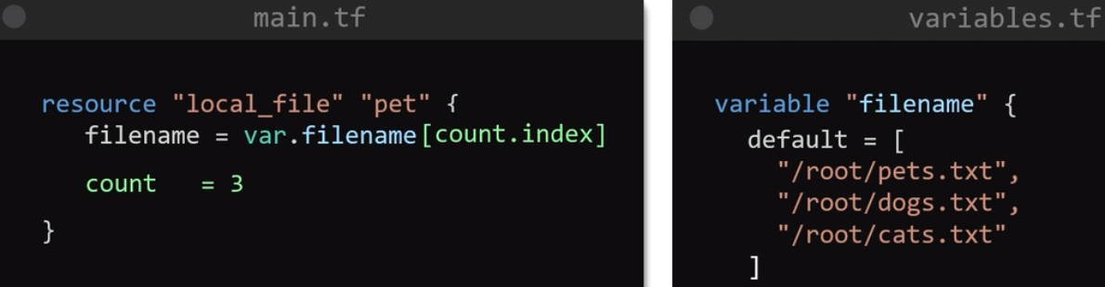

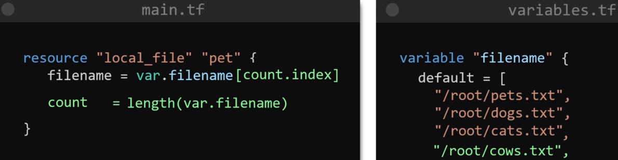
To automatically increase the count number with the change in variable file, we can do:
To access this resource within configuration file, we will use pet[0], pet[1] and pet[2].
If we delete the first name (pets.txt) of the filename in resource block, then terraform will replace the first two indexes of the list “pet” and will destroy the last element in list.
This destruction can be addressed by using for_each meta argument. for_each works with set or map data type, not lists unlike count. We can either change the type of variable “filename” from list to set or use the converter “toset” to change the input into for_each to set from list.
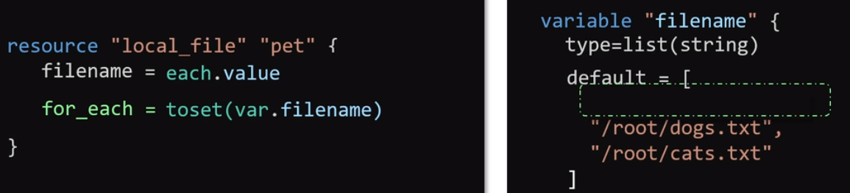
for_each identifies each resource with “filename”, so this takes each resource like a map.

Though, some services of AWS are not dependent on region but terraform makes it compulsory to declare region and profile in provider block of AWS.
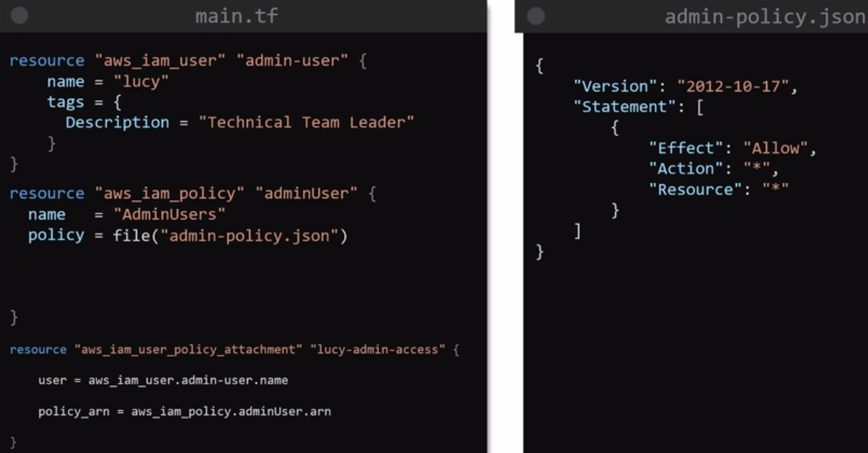
S3 bucket name in terraform configuration file is optional. Terraform can set bucket name automatically.
Data columns can be defined in attributes block of DynamoDB. Though multiple attributes blocks can be set. Primary key is mandatory to be specified in case of multiple attribute blocks. Use key_schema block to specify primary key.
Terraform state file helps in 1) Mapping configuration to real world 2) Tracking MetaData
3) Performance especially when dealing with multiple cloud providers 4) Collaboration
Version control like github, does not support state locking.
For remote state locking, use DynamoDB with the primary attribute “LockID” and type “S”, S here represents string.
Instead of handling the terraform state manually we should terraform state commands.
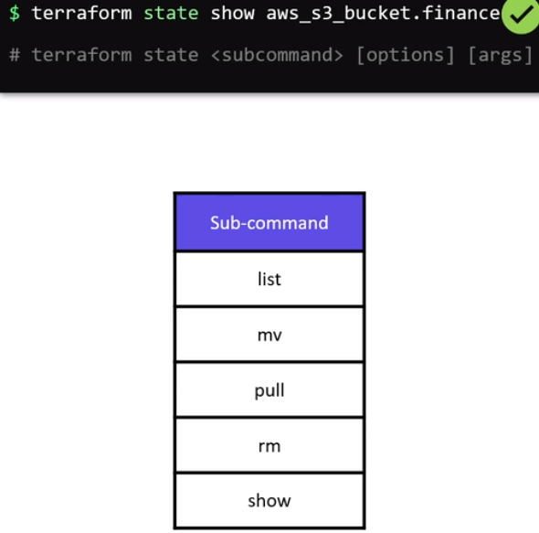

We can use terraform provisioners to execute commands on a remote resource after it is provisioned. Here the remote-exec type is used, while connection block is made for ssh into ubuntu instance.
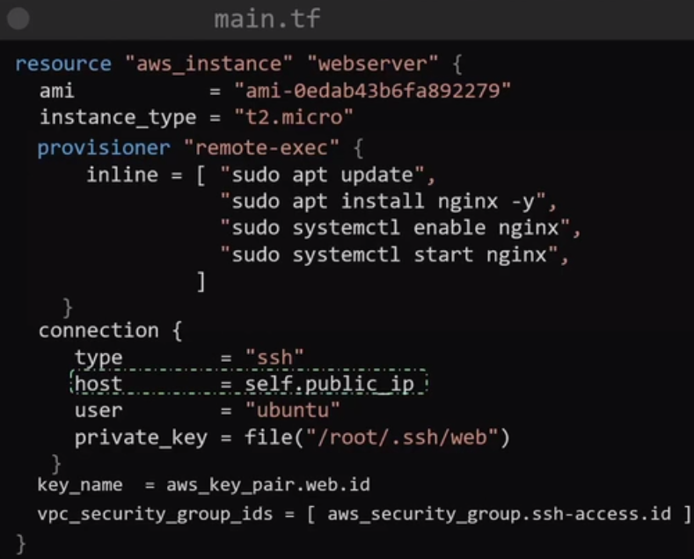
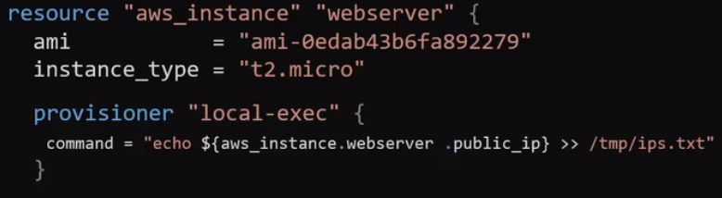
We can also have local-exec provisioners, these commands are executed in the local machine after the remote resource is provisioned.
These all provisioners are called create time provisioner because they are executed after creation.
We can also create destroy time provisioners these are provisioners that are executed before a resource is destroyed. Only need to add when = destroy attribute in provisioner block.
We can use the on_failure attribute in provisioner block to handle failure of provisioner due to incorrect commands. By default, it fails the apply command but with on_failure = continue, the apply command won’t fail, the provisioner error will be skipped.
Terraform rbecommends to use provisioner sparingly because:
1) Terraform can’t plan how to execute these commands and adds to complexity of conf file.
2) Connection has to be established for executing these commands like ssh connection
3) No provisioner information in Plan
4) Network connectivity and Authentication

It is better to use user data or customized AMI.
Terraform marks a resource taint, if there was any error during provisioning. Like, if the provisioner failed, the resource will be marked tainted, but the resource will be provisioned.
Terraform will attempt to recreate the resource on next terraform apply.
You can manually taint a resource too due to any reason like manual changes. Similarly, can untaint it too.

There are 5 different logging levels in terraform: 1) Info 2) Warning 3) Error 4) Debug 5) Trace
Trace is the most detailed level. You can set the level by using an environment variable.
(export TF_LOG= TRACE)
Can save these logs in a file by export TF_LOG_PATH=/tmp/terraform.log

To make a resource created manually or any other source to be completely controlled by terraform, we can use terraform import command.
(terraform import <resource_type>.<resource_name> <attribute>)
You will need to configure resource block for the imported instance by manually writing the resource arguments. These resource arguments can either be written from AWS console or by looking at state file.

Terraform will consider all the configuration files inside the main configuration directory.
A module is a collection of configuration files inside a directory.
The directory in which we run the terraform commands is called the root directory.
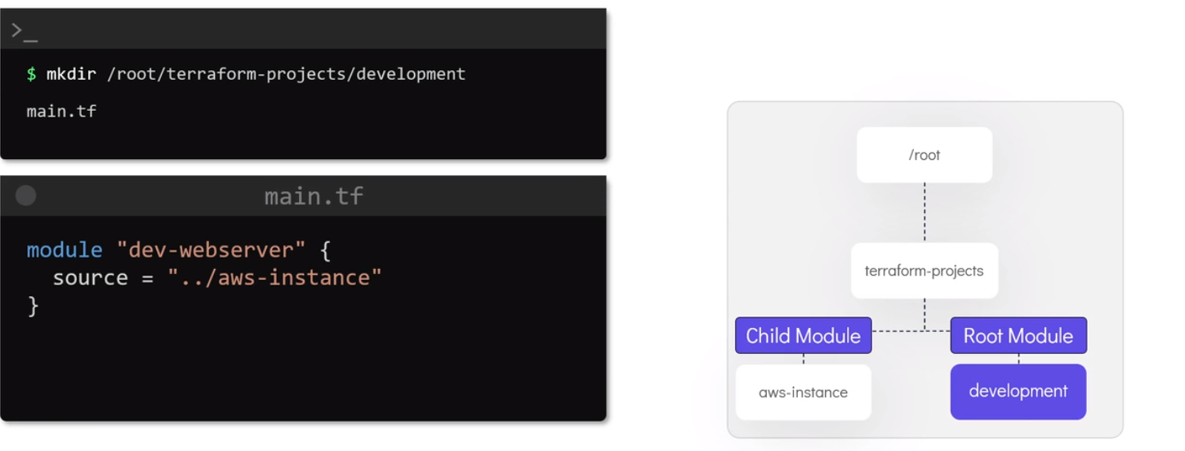
Since, we have provided the path of aws-instance directory in the development module and now will be running the terraform commands in development directory. So, development is now the root module, while aws-instance which was previously a root module now becomes the child module.

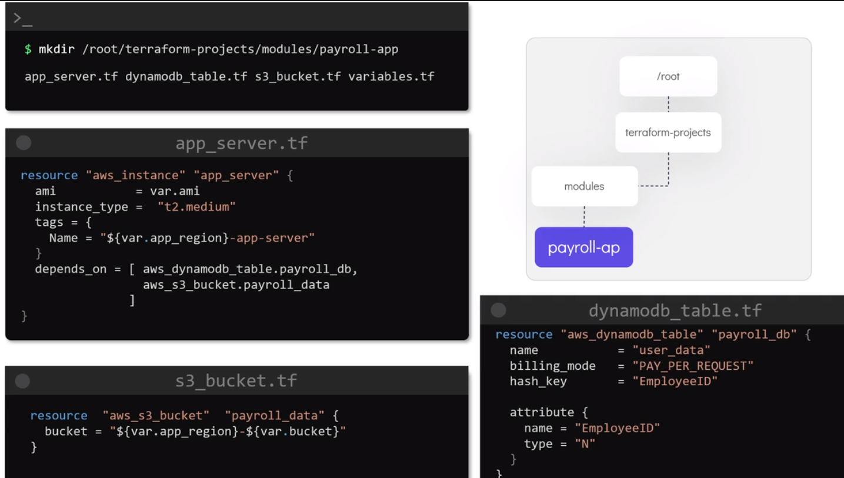
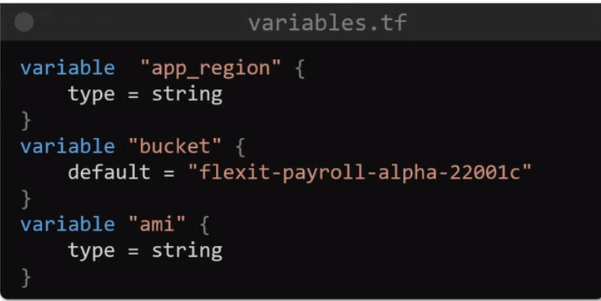

The above files are of payroll-ap directory.
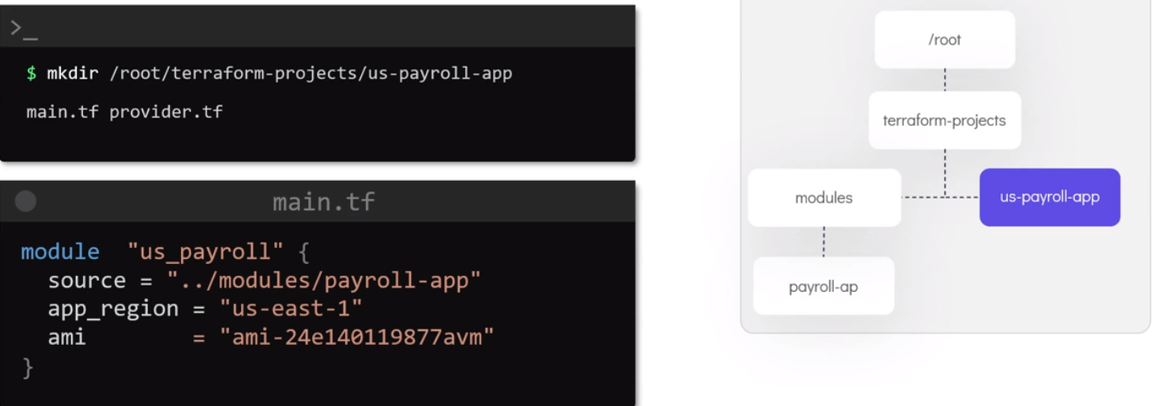
The above files are of us-payroll-app. The set values of app_region and ami will be used to fill the values of variables.
Here the root directory is us-payroll-app. Modules make the configuration files simpler, reduces risk, encourage re-usability and team work.
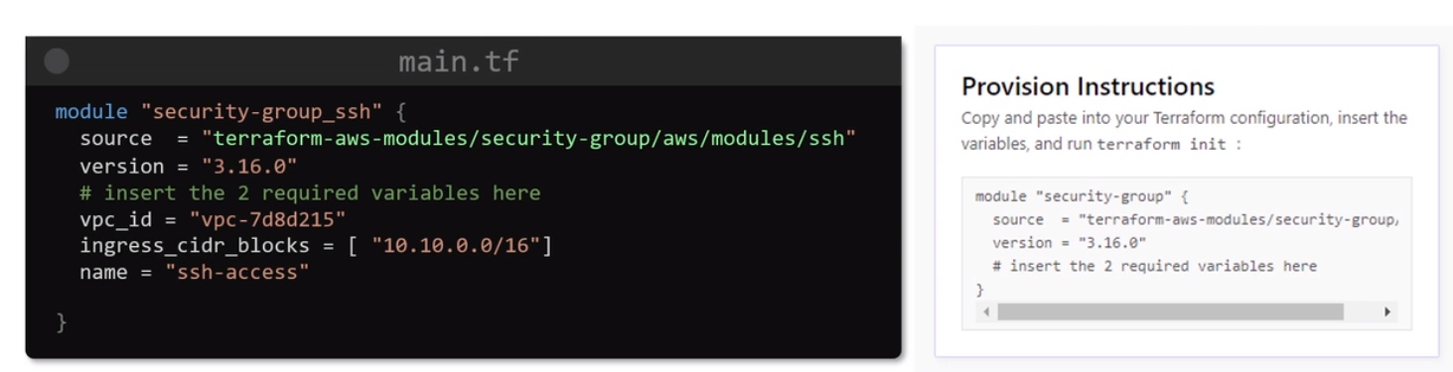
We can directly use the modules saved terraform registry. The source is the short URL from where the module will be downloaded.
Use terraform init or terraform get to download these modules for your configuration file.

