30 AWS services.
Each region is connected with AWS private network.
Most AWS services are region-scoped.
Choosing AWS Region:
1) Compliance: Data governance and legal requirements. Data never leaves a region without explicit permission.
2) Proximity to customers: Reduced latency.
3) Available services within region: new services and features aren’t available in every region.
4) Pricing: prices varies region to region. Service pricing page can be used.
Minimum AZs in a region is 3 and max is 6.
AZ are seperate from each other, so that they’re isolated from disasters.
They are connected with high bandwidth, ultra-low latency networking.
Global AWS services: IAM, Route 53, CloudFront, WAF.
Lambda is function as a service.
IAM groups can only contain users, not other groups.
User can belong to multiple groups.
Users and groups can be assigned JSON documents called policies.
Account alias must be unique globally. Alias changes the sign-in URL.
We can attach policies at group level or to individual user aka inline policies.
Inline policies maintain a strict one-to-one relationship between a policy and an identity (User, Group, Role).
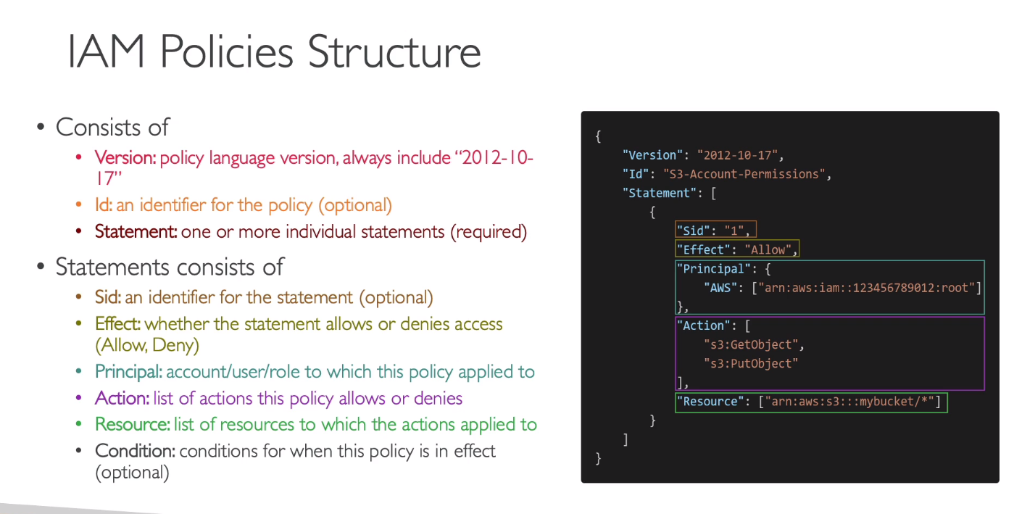
If a user attached with multiple policies has access to a resource in one policy and is denied access to the same resource in another policy. Then, principle of least privilege will be followed. It will be denied access.
Attaching policies to a group instead of individual user is the best practice.
We can set a password policy by ourselves in AWS, like minimum password length and requirements regarding special characters. Password expiration policy can also be enforced.
Use MFA for root account and IAM users.
Virtual MFA device like Authy or U2F security key can be used. U2F is a hardware device with support for multiple root and IAM users using a single security key.
We can register upto 8 MFA devices for an AWS user.
We can access AWS from Management console, CLI (protected by access keys), SDK (protected by access keys)
CLI and SDK access uses public APIs of AWS services. CLI is open-source on github.
Cloudshell CLI works according to the region, you are operating from.
Example: aws iam list-users
CLI: will list all users irrespective of their regions
Cloudshell CLI: will list only users in the region you are operating from.
All files created by cloudshell CLI will remain until the IAM user is not deleted.
Cloudshell has a persistent storage of 1GB per user and permissions can be set for it using policies.
Files created in cloudshell undergo automatic cleaning after 120 days.
Each region will have one virtual machine of cloudshell per region.
IAM Security Tools:
1) IAM Credentials Report (Account-Level): Report that lists all your account’s users and status of their credentials.
2) IAM Access Advisor (User-Level): It shows the service permissions (and the level of permission) granted to a user and when those services were last accessed.
Administrator access does not allow you to access billing and cost management dashboard.
You need to give permission to billing and cost management tools through root user.
You can charges per service.
You can create alerts using AWS Budgets which will send you an email whenever any set condition is satisfied. It can also forecast your budget and send you alerts on forecasted spending.
Configuration Options of EC2:
1) OS 2) CPU 3) RAM 4) Storage (EFS/EBS/EC2 instance store) 5) Network Card (Speed of card) 6) Firewall rules (security group) 7) Bootstrap script (EC2 User Data)
EC2 User Data Script runs with the root user.
One vCPU of AWS is equal to half a physical core.
If you have linux, MAC or windows 10 or greater, then you can use .pem key, otherwise use .ppk key.
.pem key is used with openSSH and .ppk is used with PuTTY.
We don’t pay for stopped instances.
When we start a stopped instance, then the private IP address stays the same, while the Public IP address changes.
There are 7 different types of EC2 instances, each optimized for a different purpose.
M5.2xlarge, here represents m = instance class, 5 = generation and 2xlarge = size within the class.
General Purpose instances provide a balance of compute, memory and networking resources. Can be used as web servers and code repositories etc.
Memory Optimized instances can be used for high performance relation/non-relational databases, distributed web scale cache stores, in-memory databases for BI and for applications performing real-time processing of big unstructured data.
Storage Optimized instances are used in tasks where you require high, sequential read and write access to large data sets on local storage, cache for in-memory databases (Redis), Data warehousing applications and distributed file systems. They deliver really good I/O operations per second (IOPS).
Security groups only contain allow rules and these rules can be referenced by IP or by another security group. If we allow an inbound traffic from a certain IP, then outbound traffic to that IP is automatically allowed due to stateful nature.
A single instance can have multiple security groups attached.
SG are also limited to a VPC/region.
It is good practice to set up SSH SG separately.
Time out is usually a security group issue.
Connection refused error is an application level error.
All inbound rules are blocked by default, while outbound rules are allowed by default.
If we allow inbound of SG 2 in SG1, then all the EC2 of SG 2 can communicate with the EC2 of SG 1 with the specified inbound rule of SG1.
The PuTTY key also uses the SSH protocol to connect to the server, though it allows connection with windows servers only.
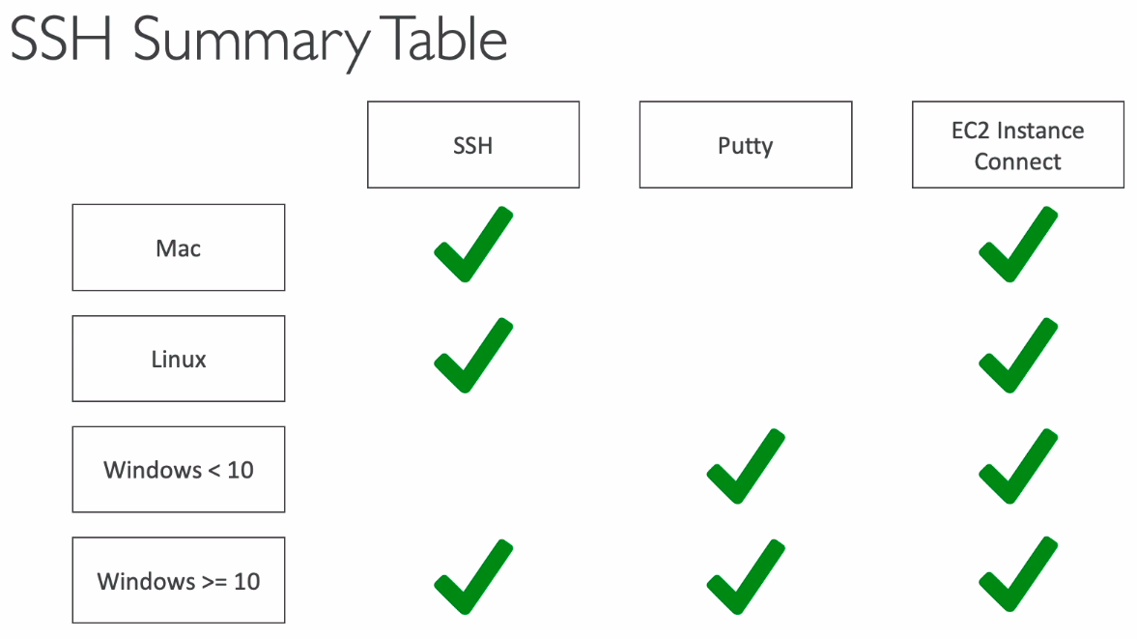

ssh ec2-user@<public_IP>, here ec2-user represents a user already set by Amazon Linux. We will perform activities as ec2-user.
For PuTTY, you first need to download it as a client and install it in windows.
You can convert your private key in .pem format to .ppk format using PuTTY keygen
PuTTY is used to ssh into a Linux server from windows.
There must be no spaces in the name of .pem file.
If your connection timeout error is not going even after correcting the security group configuration, then it means some firewall is causing that issue.
If you are getting the error of permission denied, then it means that you are using the wrong security key or no security key.
EC2 instance connect uses temporary keys to SSH into your server.
Best Practice: Never use aws configure in your EC2 instance, because anyone can access them later. Instead use, roles to access other AWS services in your account.
In reserved instances, you reserve instances, while in saving plans, you commit to an amount of usage.
In on-demand plan, you pay for each second after the first minute. For OS, you are charged per hour.
In reserved instances, you reserve specific instance attributes: instance type, region, tenancy, OS, the scope is also specified regional or zonal. Discount is upto 72%.
We can also buy and sell in the reserved instance marketplace.
Convertible reserved instances give you flexibility to change instance type, family, OS, scope and tenancy but reduces the discount to upto 66%. This category is not eligible for buying and selling in reserved instance marketplace.
EC2 saving plans, you commit for a certain usage type, like $10/hour for 1 or 3 years. It is locked to specific instance family and AWS regions. However, it is flexible across instance size, OS and tenancy.
Spot instances are good for batch jobs and distributed workloads etc.
EC2 dedicated hosts is the most expensive option and used when you need to meet compliance requirements.
EC2 Capacity reservations takes place in a specific AZ for any duration. There is no time commitment in it, just cancel the reservation when not needed. You get no discounts, it just confirms that you get the capacity in the specified AZ.
We can combine capacity reservation with regional reserved instances and saving plans to benefit from billing discounts. You are charged if you use the instances or not, it is suitable for short-term, uninterrupted workloads in specific AZ.

To get the spot instance, we define the max spot price and the instance works for us until the current spot price < max.
If the current spot price exceeds your set max price, then you are given a grace period of 2 minutes, where you choose to stop or terminate it.
Spot prices differ from AZ to AZ.
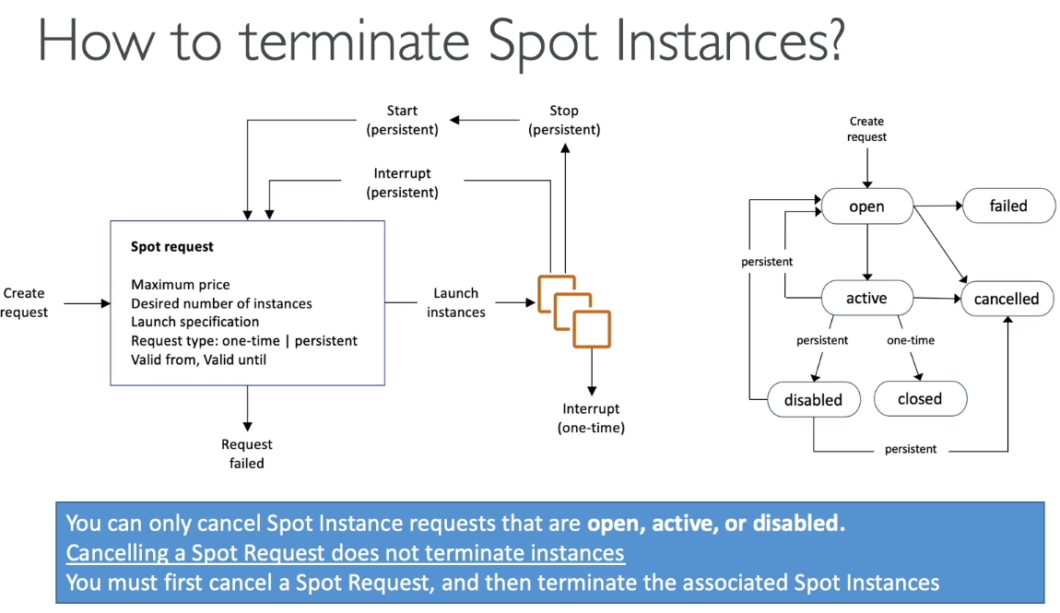
Spot fleets = set of spot instances + Optional On-demand instances
Spot fleet automatically request spot instances to meet the target capacity with price constraints. You need to specify possible launch pools for fleet to choose from, you mention instance type, OS and AZ in its specification.
Strategies to allocate Spot Instances: 1) LowestPrice=lowest price pool 2) Diversified=distributed evenly across all pools 3) Capacity optimized=pool with optimal capacity 4) priceCapacityOptimized=pool with highest capacity, then select from lowest price pool
It selects pool from strategies mentioned above.
With an elastic IP, you can mask the failure of an instance by rapidly remapping the address to another instance in your account.
You can have only 5 elastic IP in your account, though request can be made to AWS for increase.
Use of Elastic IP should be avoided instead use random IP and register a DNS to it, or use Load Balancer with private IP of instances.

