Due to Jenkins being open-sourced, there are a lot of plugins developed by different people.
We can manage roles of users in Jenkins using the role plugin.
Pipeline Syntax:
1) Scripted
- Groovy engine
- first syntax
- advanced scripting capabilities and flexibility
- difficult to start
2) Declarative
- Recent addition
- easier to get started but not that powerful
- predefined structure

Jenkins Credentials:
1) System: Only available on Jenkins server (NOT for Jenkins job)
2) Global: Everywhere accessible
3) Project: Only for multi branch pipelines
ID = reference for credentials in Jenkins
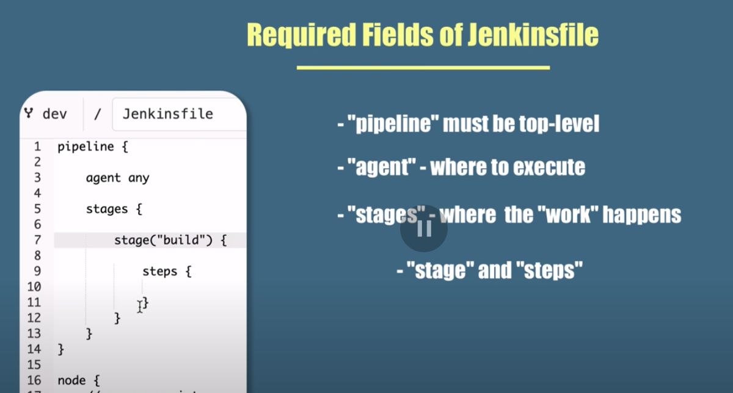
Jenkins Infrastructure:
1) Master Server:
- Controls Pipeline
- Schedules Builds
- Distributes builds across multiple slave nodes.
- Monitor the slaves
- Can execute build jobs directly.
2) Slave server:
- hear requests from master server
- slaves can run on a variety of operating systems
- Each build requires different environment so multiple slaves are needed with different environments like linux, windows or mac
Slave server/Node can have multiple executors which is proportional to the number of jobs it can run in parallel.

There are two types of nodes:
1) Agent
2) Built-in Node (master)

An agent can have multiple executors but having a single executor is the safest configuration.
Default number executors in built-in node are 2.

Executor:
A thread in an agent
Number of executors represent number of concurrent jobs an agent can execute concurrently.

Jenkinsfile:
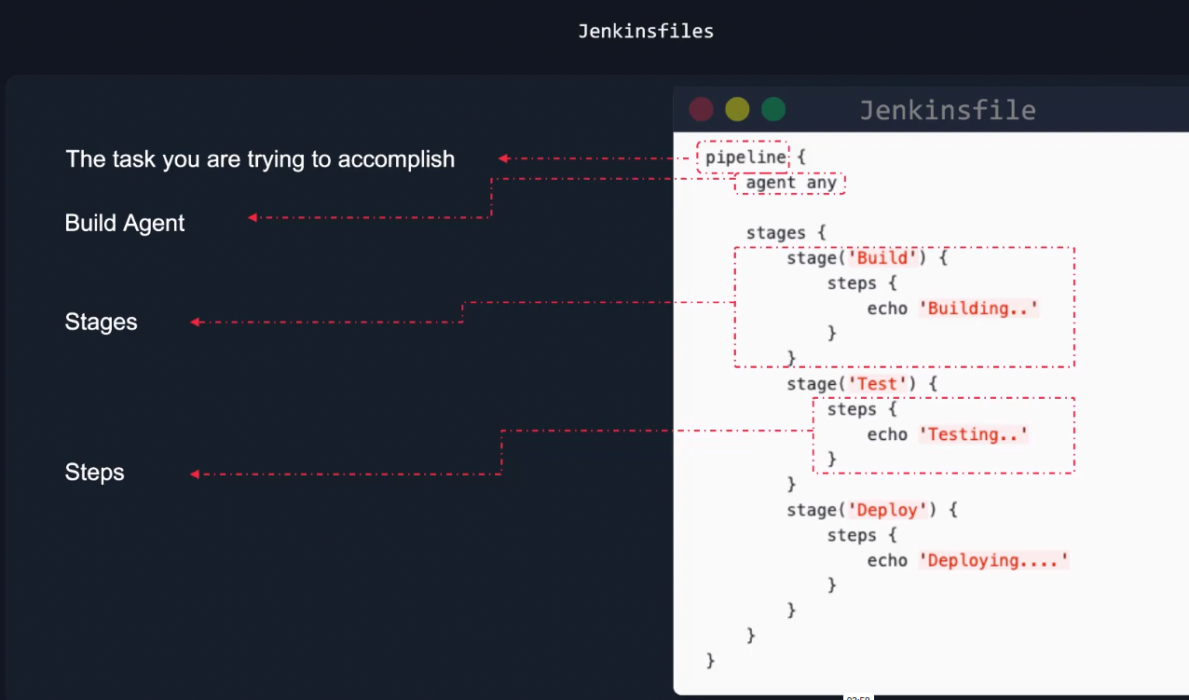

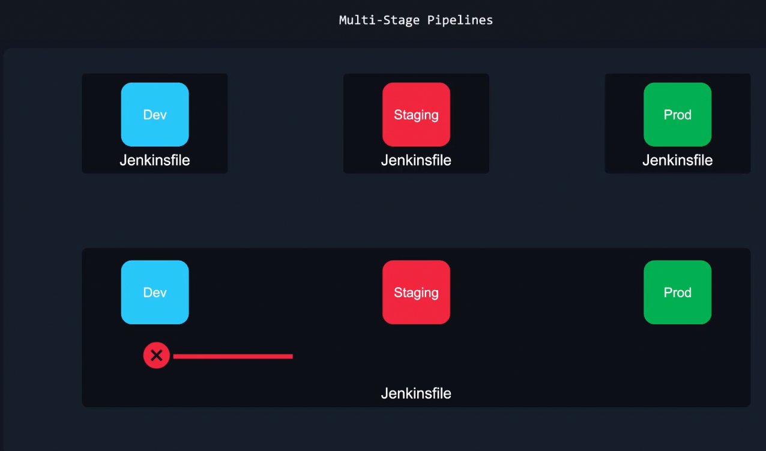
We can have a multi stage pipeline with a single jenkinsfile with stages of dev, staging and production or seperate jenkinsfile of each stage.
The benefit of having a single JenkinsFile is that if the initial stage like dev fails, then it will not move onto the next stage.

Script tags in the Jenkinsfile are for the groovy language. This tells that we are using groovy language in the declarative syntax. These tags give you direct access to the Jenkins API which means that we can have complete access of jenkins

By default, the github repo is cloned into var/lib/jenkins/workspace directory.
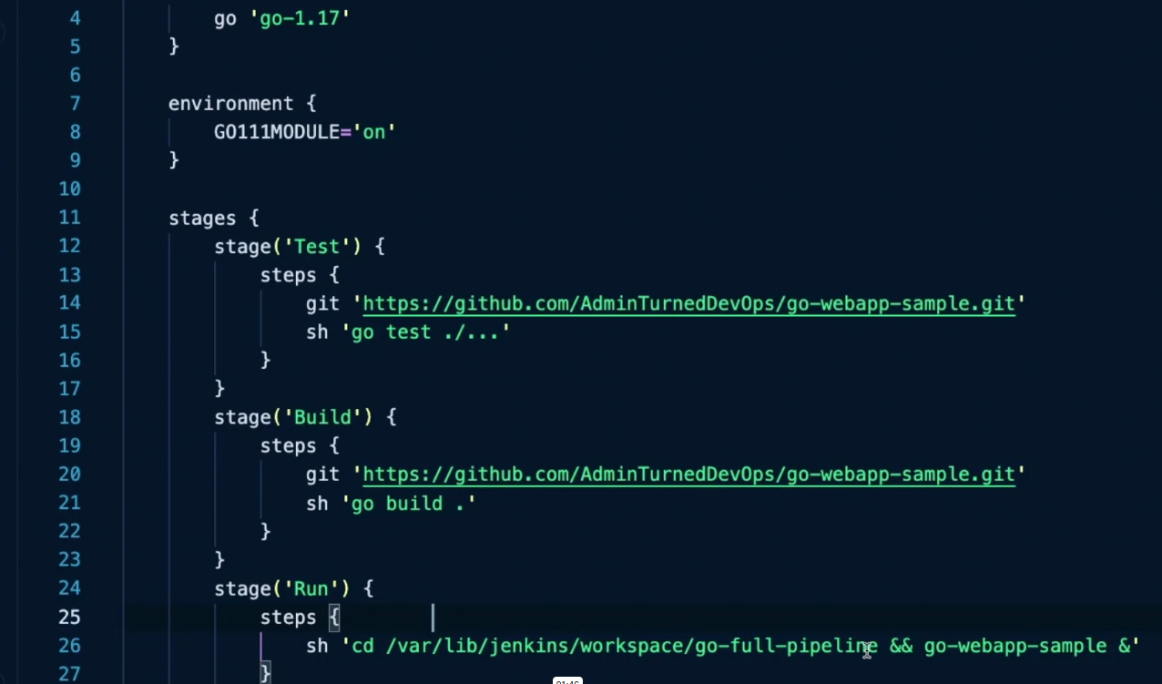
Build agents need Java to work.
It is recommended that the build server is separate from the Jenkins Server:
- Scalability of Build agents
- Security of Jenkins server
- High Availability of Jenkins server
- Better performance of Jenkins server
- Isolation of environments like we would need different environments in Build agents like windows agent, linux agent etc.

We can use a docker container instead of a whole VM as a build agent. Benefits are:
- Resource Efficiency: Docker containers are lightweight and can be scaled easily.

When you specify a separate agent in a step, then it dedicates a new executor of that agent for that step.

