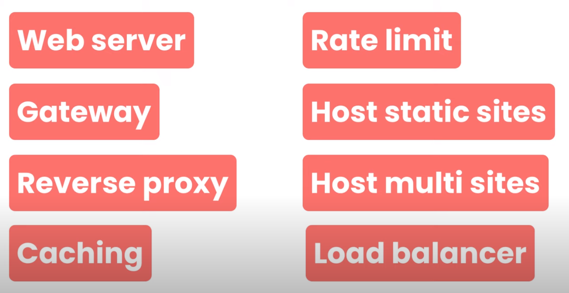
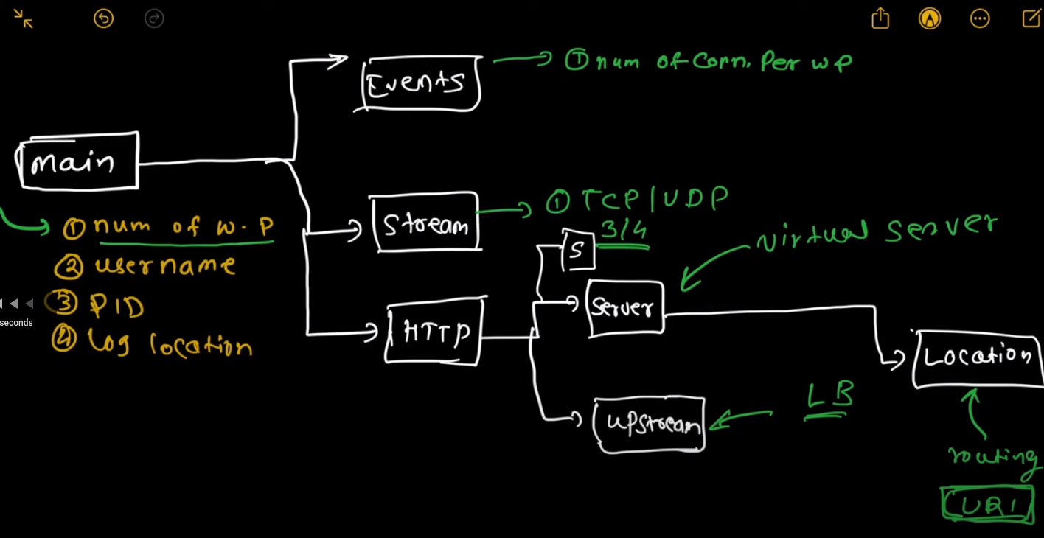
Reload (sudo systemctl reload nginx) Nginx whenever configuration files are edited. Restart is not recommended because it will cause some downtime.
Validate configuration file editing by sudo nginx -t

Forward Proxy:
- Works for client side devices
- Placed before the firewall, enhances security by adding an extra layer before firewall
- requests for clients are send from the proxy itself. No direct communication between the external servers with client devices.
- Keep track of requests and destinations
Reverse Proxy:
- Works for the server side
- Placed after the firewall
- Services from servers are directed from reverse proxy server
- Provides a single point of access and control for all servers
- Acts as a load balancer, when a number of requests are sent to the server side. It distributes the requests among the servers.
- Client cannot see the actual server providing the service, instead the reverse proxy server is only visible
- In case of Nginx, if a single server is hosting multiple applications, with each application having a dedicated port. The client will only hit the Nginx port 80, and then the Nginx will route it to the actual port of the application requested.

