Distributed version control system means that the files are stored in local system as well as on a remote server
Commit means storing changes in local repository
There are three stages in local git: 1) Working area 2) Staging area 3) Committed files
We add the file to staging area by using the command git add .
When we do git commit, then the files committed are stored inside .git folder

git restore “filename” restores the file from the staged file.
There are two modes in working area untracked and modified
Good practice is that each commit should have only problem fixed
We can restore the files in stage mode from the files stored in commit mode
Use git restore –-staged <file> to restore changes in staged from commit stage

We can use git rm –cached <file> to move file from staging area back to working area.

Branches are just like pointers to a certain commit.

HEAD is where you are right now in the git repository, at the last commit in a branch.
If you checkout to another branch, then the HEAD moves to the last commit of that branch.

Merge:
1) Fast-forward:
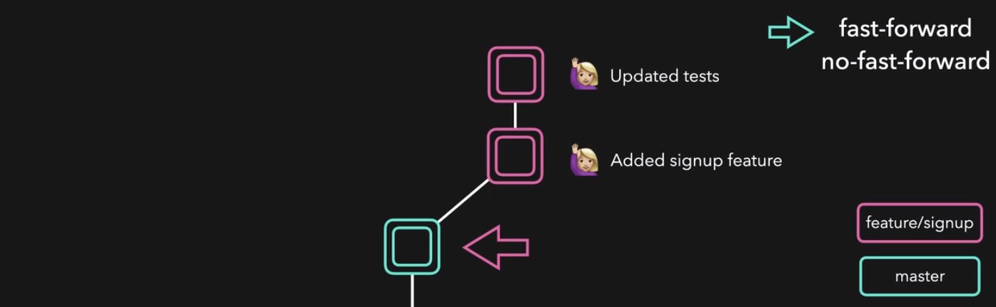
No extra commit for the MERGE is made in the branch.
Fast-forward is done when the master branch has no extra commit that weren’t in the feature branch.
2) No fast-forward:
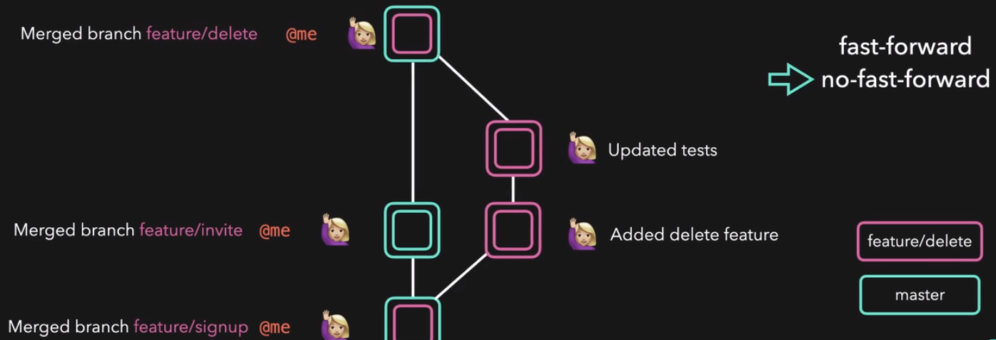
This happens when the master branch has extra commits that weren’t in the feature branch.
In this case, git will make an extra commit for MERGE in the master branch and then merge the feature branch. NOTE THAT IN BOTH CASES YOU SHOULD BE ON THE MASTER BRANCH FOR MERGING.

We can access a remote repository using a connection link, the link which usually ends with .git.

Git remote add origin <url>, here origin is the name of the remote repository, you associate the name of the remote repo with origin.
Git push origin sarah, here sarah is the branch name and origin is the name we associated with the remote repo in our local system.

Pull request:
we use pull request to merge our code with the main branch.
We work in our branch and open a pull request, this pull request can be seen by people, maintainers can authorize the merging of our pull request with the main code.

In remote repo, we can fork a repo, make changes in our local repo and then push it remote on our forked repo. We can then open a pull request, for merging with the original repository aka upstream repository, maintainers can review and merge it in their repo.

GIT Fetch:
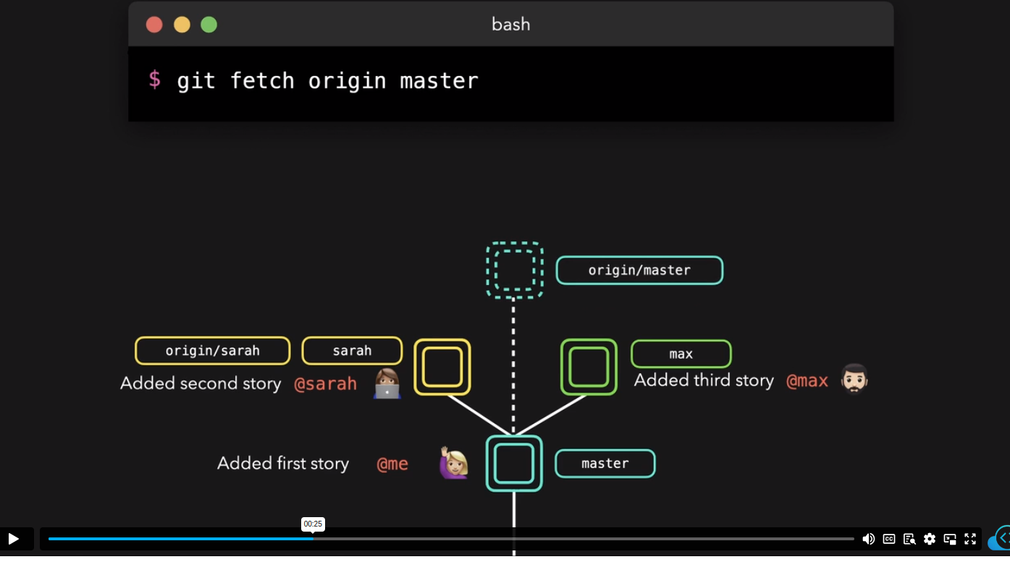
Fetch command clones the specific branch on your local repo. We can later merge it with our local branch.
Difference between cloning a specific branch, fetching a specific branch and pulling a specific branch:
1) cloning will make a separate directory with the entire file structure, it is used when you only want to work in a specific branch.
2) Fetching is used when you want to get a specific branch to update your local code, you can later merge your local branch with the fetched branch later on.
3) Pulling will do the fetching job as well as the merging job. 2 in 1 command.

Rebasing:
Rebasing is used when you want your branch to have all the latest commits in the master branch.
This can be achieved by merging too, but the difference is that rebasing changes the git history and gives a new hash to your commit.

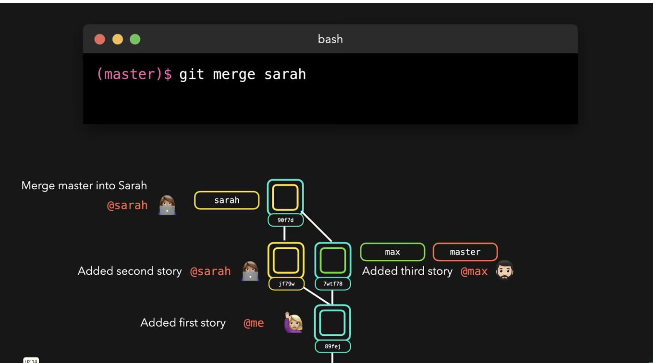
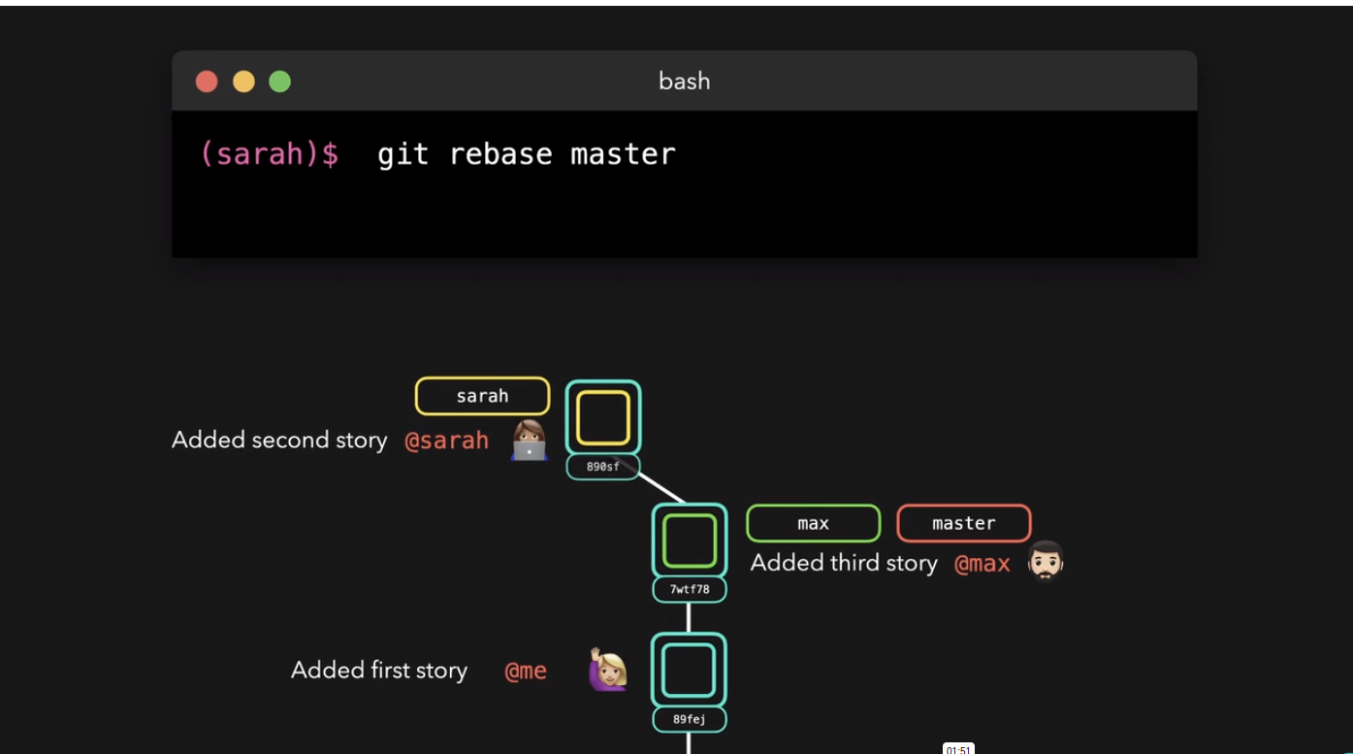

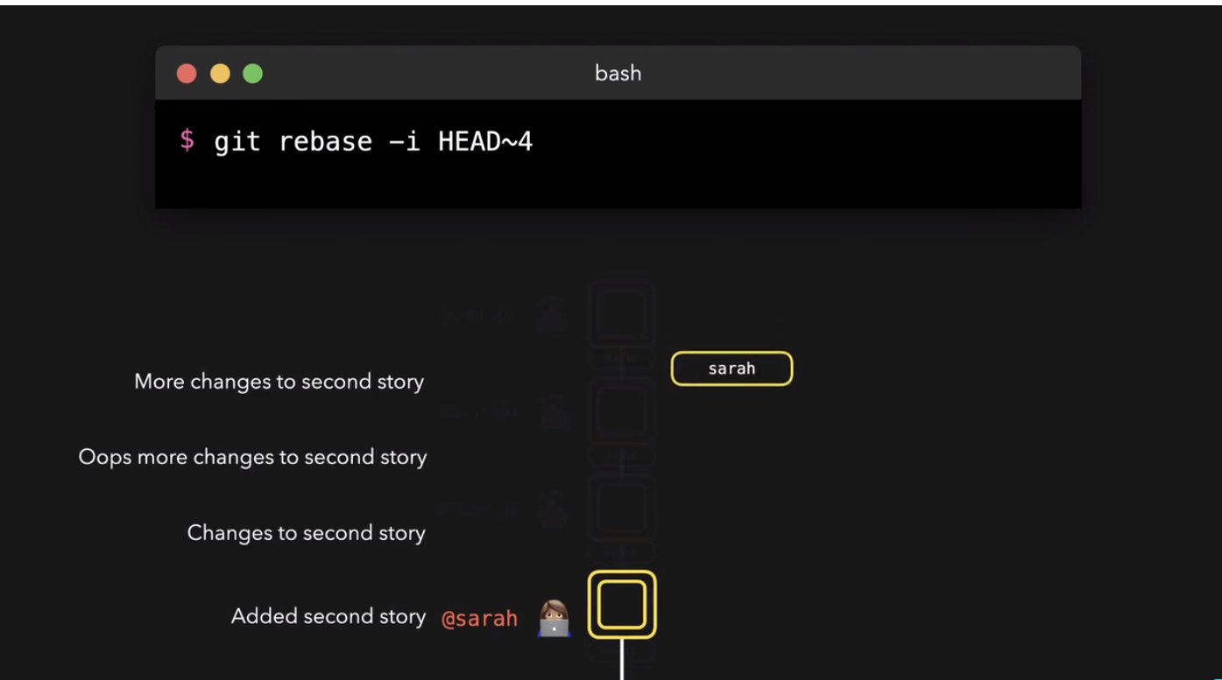
We can also use rebasing to merge multiple commits into a single commit, above it can be seen that we are adding the latest 4 commits into “added second story” commit, this will be a new commit with all the previous commits. The “added second story” was picked and the remaining above 3 were squashed. Pick and squash are rebasing option when you start rebasing.

Cherry-Pick:
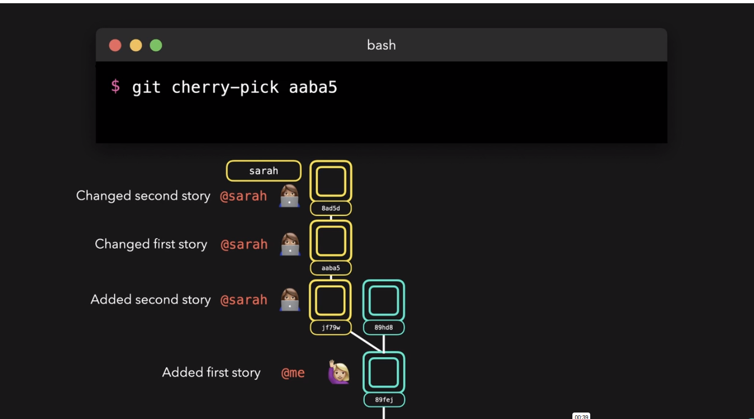
Cherry pick is used to apply the changes of a certain commit in a different branch into another branch.

We can revert a commit using git revert <hash of commit>, but this will add a commit of reverting.
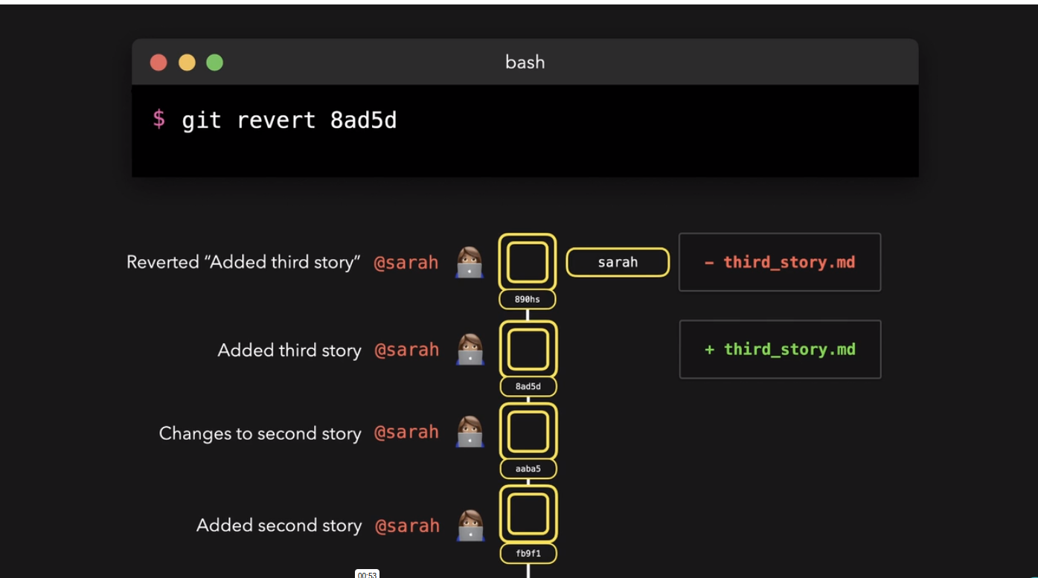
We can reset in two ways, hard or soft, in soft we retain the changes but the commit is deleted.
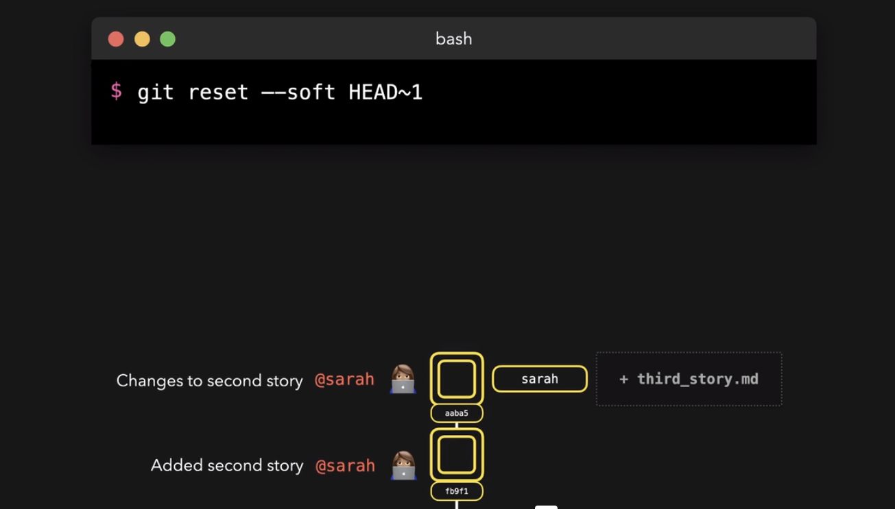
Git stashing:
We use git stashing to save our work without committing. This is done when you want to switch to a different branch and have uncommitted work on the current branch. This way your work is saved in the stash memory.
Use git stash list to see all files in stash. And git stash pop stash@{1} to pop a file into work directory.

Git reset –hard HEAD~12 means that the pointer will be moved to the 12th commit below the HEAD pointer.
We can use git reflog to even undo the hard reset by adjusting the head pointer.
Git log only shows you the commits but git reflog shows you the state of repo with time. Which means past files will be visible

Git:
Key value store. Hash is the key name of the folder.
Git has two commands:
1) Porcelain 2)Plumbing
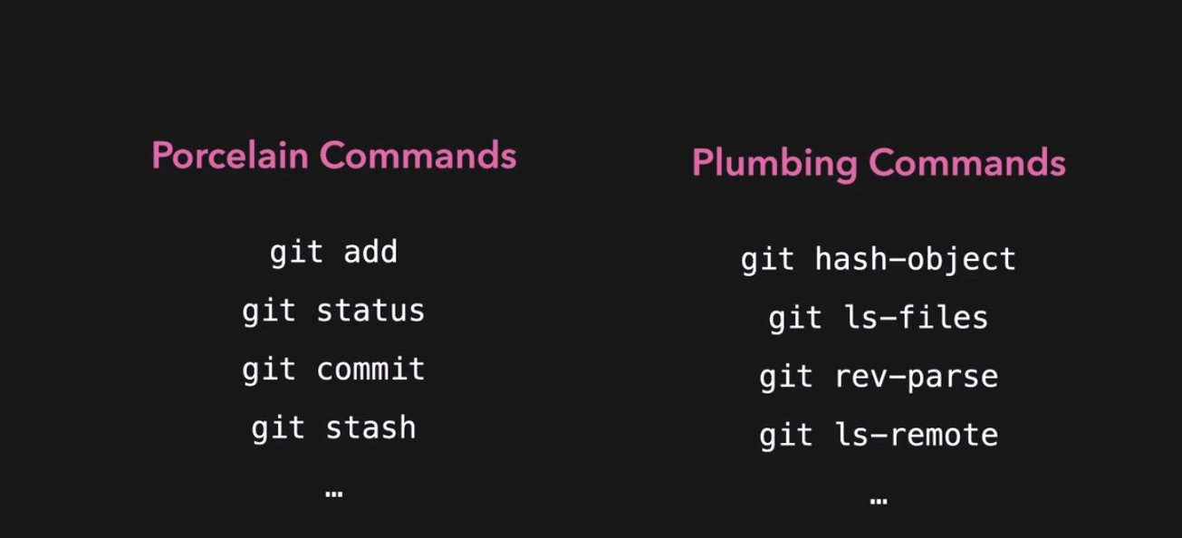
In plumbing, we use git at the hash level.
Git objects can be of three types:
1) commit 2) tree 3) blob
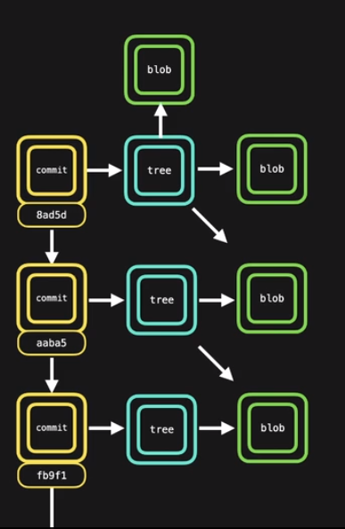
Tree is a folder of your repository at a specific point of time and blobs are pieces of data. Each blob has a unique hash. So files in different trees will have the same hash, this way replication is avoided.

