

**Project Title**

**Library/Book Store Management System**

**Final Report**

**Group-B Members**

* **Abdul Rehman Harris SP19-BCS-101**
* **Armughan Ahmad SP19-BCS-002**
* **Zagim Murtza SP19-BCS-148**

Submitted to:

**Dr. Hamid Turab Mirza**

Submitted on:

**January 02, 2021**

**Department of Computer Science**

**COMSATS University Islamabad**

**Lahore Campus**

_________________________________

**Library Management System**

_________________________________

**Abstract:**

This Library Management System Project aims to develop a computerized digital system to easily maintain all the work of a library. This Project has many features which makes it easier to

use and understand other management systems i.e., Readers can read, issue. It has different sections of books from which the readers can find books easily and it gives users and staff a clear track and detail of all the available and accessible books. Books and user/reader maintenance are also included in this system which would keep record of the user/reader using the library and also a detailed description about the books a library contains. With this computerized system, there will be no loss of book record or member record which generally happens when a non- computerized system is used. This system will reduce physical work and provide a continuous flow of operations of library. This project of ours is being developed to help the readers as well as staff of library to maintain the library in the best way possible and also reduce the human errors and efforts.

**Domain Description:**

Library Management System is a system which is used to help the user in managing the daily activities of the library in digital and easy way. It monitors and controls the transactions in a library and helps in saving the records of entire book transactions. It is Time-Saving as it reduces the time spent on paper-work and file work. Everything is digitized and backed up so that the data is not lost.

It provides a complete interface to smoothly run the management system for the library which facilitates both admin and users of the system. The system will be responsible for providing timely access of requested materials.

It stores information such as username, e-mail, contact and address of library members and users. Also holds the book details such as book title, publisher, status and number of books available in the library. Also, it will regularly check the status of books.

### 

### **Modules:**

* **Admin login**

Admin is the person who oversees the system by adding or removing books in and out of the system, admin has the most access to the system to perform changes. Admin panel has a number of sub modules

* **Register New Member**

Admin can Add / Remove members and have access all of their information.

* **Register New Employee**

Admin can Add / Remove Employees and have access all of their information.

* **Register New Publisher**

Admin can Add / Remove Publishers and have access all of their information.

* **Add New Book**

Admin can add / remove books in existing record.

* **Accounts Details**

Admin has access all of the payment records. He can perform transactions to employees and Publishers.

* **Staff login**

The staff can also login into the system by providing their required username and password.

* **Member login**

To create an account, users must sign up into the system. They can therefore log in to the system after effectively registering by providing required credentials.

* **Search book**

Everyone can search for the book by specifying any specific detail of the book. In return, the system will provide the shelf and rack no of the book to the user along with complete details of Book.

* **Book issues**

The system maintains a record of the issued books.

* **Issue/Return book**

The members can issue or return books. When they do, the quantity of the requested book will be increased or decreased, simultaneously updating the record of the database. The due date fee is also provided at return time.

**Requirements Specifications:**

These requirements were needed in a non-computerized management system:

* **Lost Files:**

When no computerizes system is implemented, the file always lost because of human and environment. Sometimes librarian didn’t keep the record to its original place because of a lot member queue up to borrow books. After that the file was missing due to messy environment.

* **Time Consuming:**

Without computerized system, when member wants to borrow a book, librarian hard to search for the member’s record. It will cause time-consuming when a lot member is waiting to borrow the books.

* **Memory Consuming:**

After long operation time of the library, the records are getting more and more. Finally, the physical record was space-consuming and no place to keep the file.

* **Damaged Data:**

In the other possibility, the file/record will be damaged due to accident. For example the librarian accidentally hit a glass of drink and pours onto the paper file. The record will be damaged. Besides this, natural disaster such as flood also will cause damage to the file record.

* **Costly:**

Paper is needed to add every new record. After a long period of time, the cost to buy a paper can be high. On the other hand, library needs to employ more staff to solve the long queue problem. If the library only has one staff, it is not enough time to process the book transaction.

**System objectives:**

* Improvement in control and performance
* The system was developed to overcome the current problem occurred in library. The system must be able to validate the user, store the record and bug free.
* Save cost
* After implementing the computerized library system, library can only hire 1 or 2 staff to handle the book transaction process. With the aids of computerized system, library can save the cost of hire employee and also save the paper-cost.
* Save time
* Librarian is able to search the record in short time by pressing only few keys. Compare to previous time before implementing the system, librarian can save a lot time.

**Software/Hardware Requirements:**

* Operating System: Windows
* Processor: Pentium IV or higher
* RAM: 1GB
* Hard Disk: 60GB
* Optical Mouse
* Keyboard

**Assumptions:**

1. Customized data will be used.
2. This management system can be used by any library to automate the process of manually maintaining the records related to the subject of maintaining stock as well as book issue.

**Tools and Technologies:**

**Database Design (Backend):** Microsoft SQL Server Management Studio Microsoft SQL Server Management Studio is a relational database management system. As a database server, it is a software product with the primary function of storing and retrieving data as requested by other software applications. APEX SQL is used for generating test data.

**Entity Relationship Diagram (ERD):**

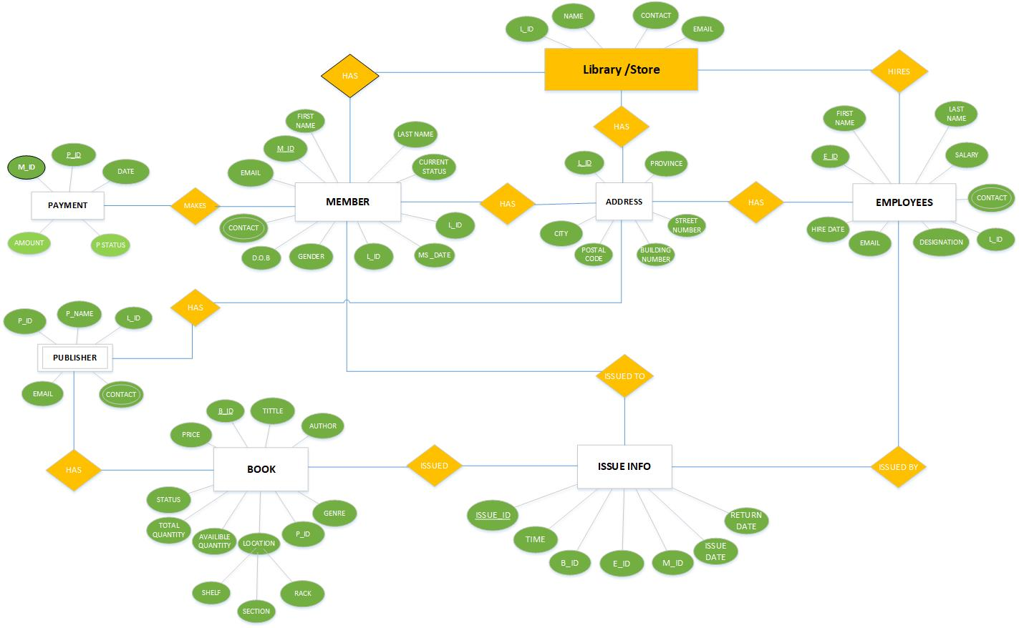

**Entities and their attributes:**

**Member Entity:** Attributes of the Member are:

* M_ID (Primary Key)
* F_NAME
* L_NAME
* Email
* Contact
* MembershipIssuedDate
* MembershipExpireDated
* MembershipStatus
* DOB
* L_ID (Foreign Key)

**Employees Entity:** Attributes of Employees are:

* E_ID (Primary Key)
* F_Name
* L_Name
* Gender
* Contact
* Salary
* Email
* Designation
* Hire Date
* Date of Birth
* L_ID (Foreign Key)

**ADDRESS Entity:** Attributes of Location are:

* L_ID (Primary Key)
* City
* Province
* Postal Code
* Area
* Street Number
* Building Number
* Updated

**Book Entity:** Attributes of Book are:

* B_ID (Primary Key)
* Title
* ISBN
* Edition
* Author
* Publisher
* Price
* Location (Composite Attribute)
* Section
* Shelf
* Rack
* Available Quantity
* Total Quantity
* Genre

**Issue Info Entity:** Attributes of Issue Info are:

* Issue_ID (Primary Key)
* B_ID (Foreign Key)
* M_ID (Foreign Key)
* B_ID (Foreign Key)
* Time
* Issue Date
* Return Date

**Publisher Entity:** Attributes of Publisher are

* P_ID (Primary Key)
* P_Name
* Contact
* Email
* L_ID (Foreign Key)

**Payment Entity:** Attributes of Payment are

* P_ID (Primary Key)
* Date
* Amount
* P_Status
* M_ID (Foreign Key)

**Validation:**

In accordance with the user requirements, it can be clearly seen from the above description of entities and their relationships that the model is capturing all the information that is of interest to the business; hence the completeness of the conceptual model can be validated against the set of Customer requirements. All the relations have been implemented and the interaction with other.

**Description:**

Entity relation diagram (ERD) shows that the whole Library Management system is implemented accordingly.

**Screenshots of developed frontend/GUI:**

**Database Schema:**



**Issued Book Table:**

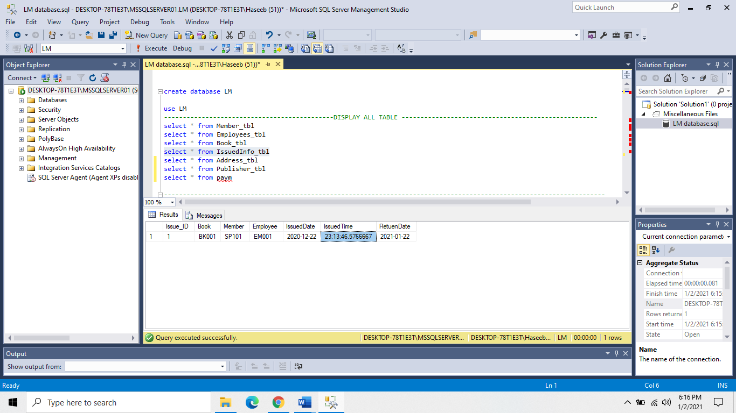

**Members Table:**

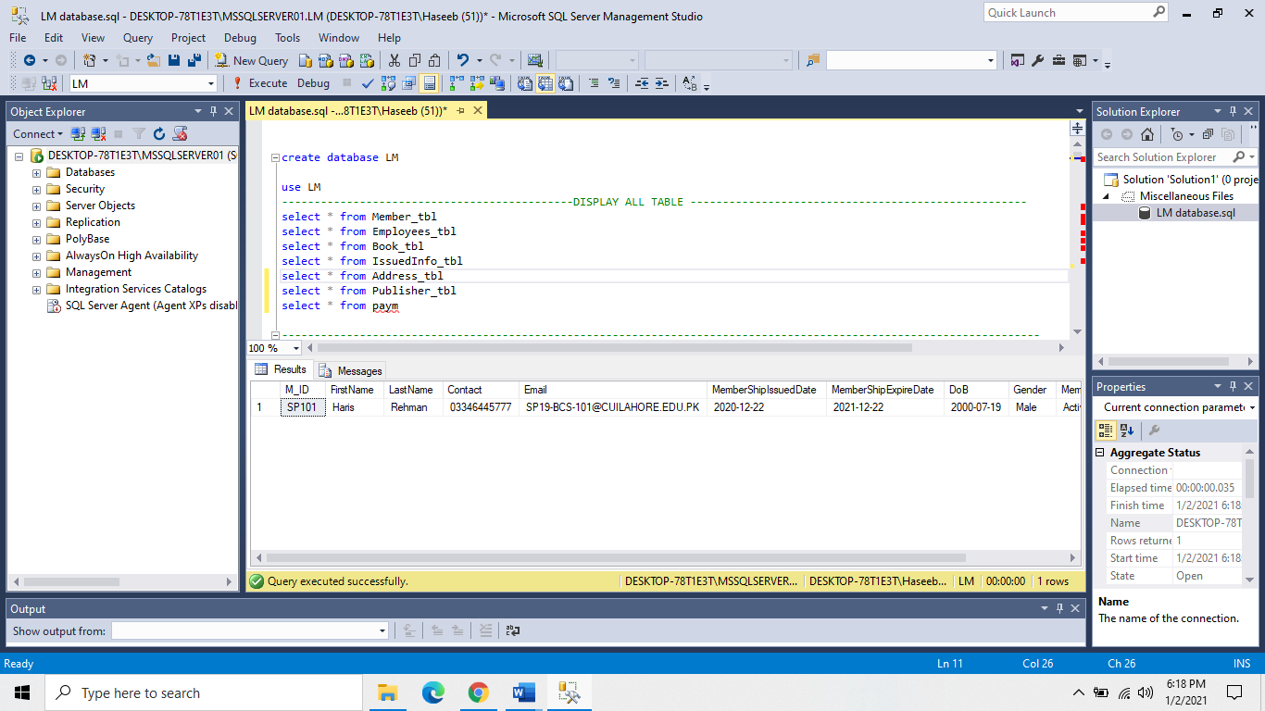

**Employee Table:**

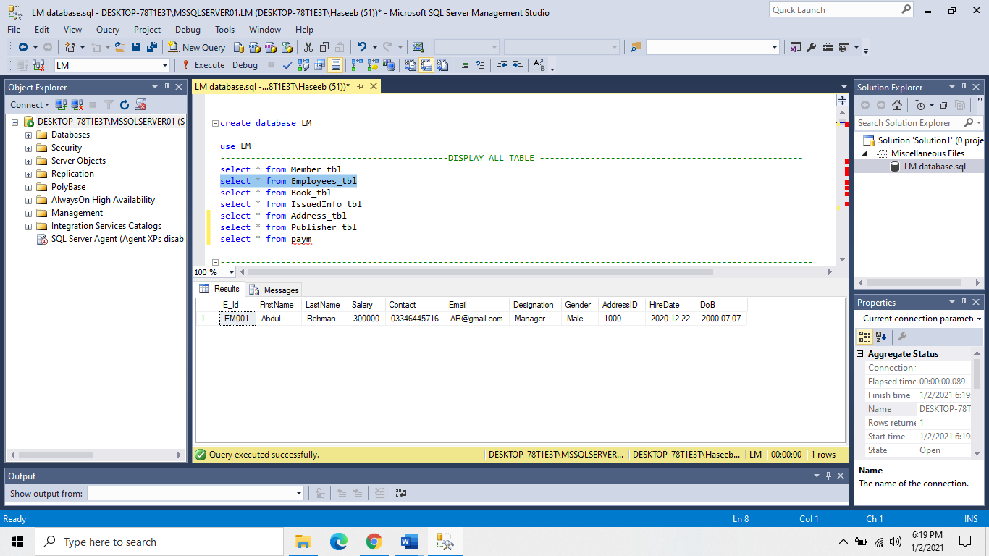

**Books Table:**

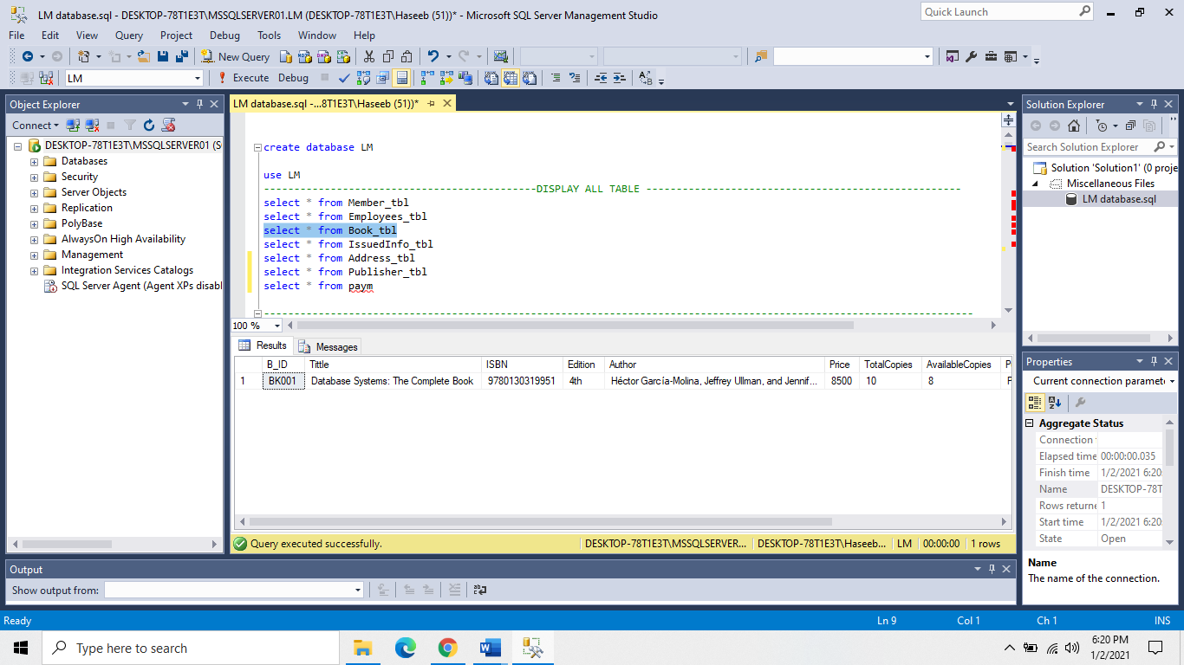

**Address Table:**

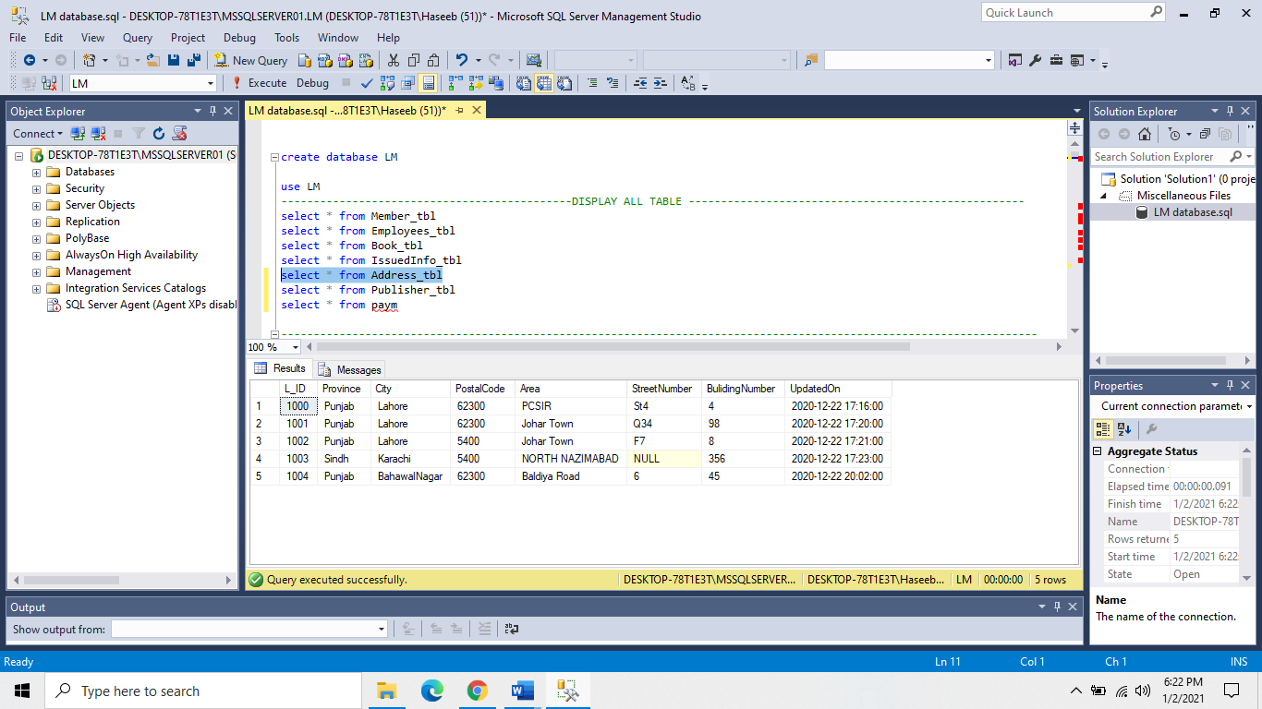

**Publisher Table:**

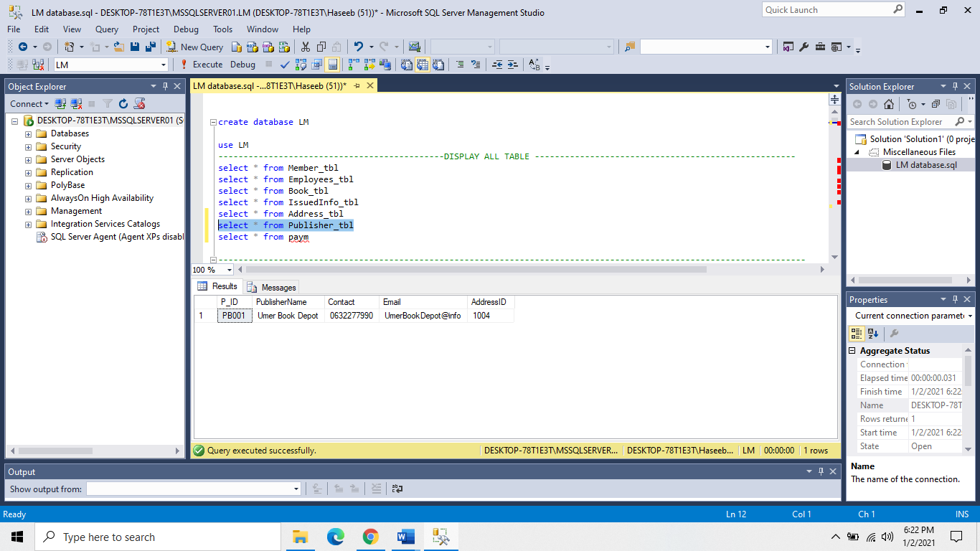

**Conclusion:**

This Library management system which will benefit the students as well as the staff of the library. It makes entire process online where student can search books, staff can generate reports and do book transactions.

**Recommendations:**

A Central database server must be installed at Library. The records of transaction must be updated on server hourly bases. Database should have an Application based interface. These all steps will affect the overall performance rate, security and data redundancy.

_____________________