The Zadoks decimal growth stages
Growth is a complex process with different organs developing, growing and dying in overlapping sequences. However, it is easier to think of it as a series of growth stages as in the Zadoks scale. This has 10 main stages, labelled 0 to 9, which describe the crop. These are named in the following table.
Table of the Zadoks decimal growth stages (Z0.0 to Z9.9)
main  stage | DESCRIPTION | sub-  stage | main  stage | DESCRIPTION | sub-  stage
0 | germination | 0.0-0.9 | 5 | heading | 5.0-5.9
1 | MS leaf production | 1.0-1.9 | 6 | anthesis | 6.0-6.9
2 | tiller production | 2.0-2.9 | 7 | grain milk stage | 7.0-7.9
3 | MS node production  (stem elongation) | 3.0-3.9 | 8 | grain dough stage | 8.0-8.9
4 | booting | 4.0-4.9 | 9 | ripening | 9.0-9.9
MS = main shoot or parent shoot
Growth stages follow Zadoks, J.C., Chang, T.T., Konzak, C.F. (1974)
Decide first which of the main stages best describes your crop. This description is often all you need. But look more closely and give the crop a decimal value sub stage as well. These sub stages depict the degree of completion of the main stage. For ex-ample, stages Z1.1 to Z1.9 are when main stem (MS) leaves 1 to 9 become visible. Similarly, Z2.1 to Z2.9 cover the appearance of 1 to 9 tillers on the plant, and Z3.1 to Z3.6 the presence of 1 to 6 nodes or joints (p 88) on the main stem.
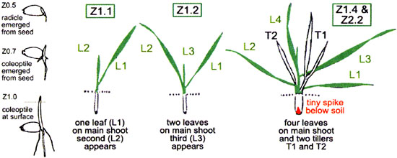
Main stages 1 and 2 describe leaf and tiller production that actually occur in parallel, not in sequence. Similarly there is some overlap of main stages 2 and 3. This overlap means that your crop can have two or even three Zadoks stages at the one time. The drawings illustrate germination and 3 stages during vegetative growth with their Zadoks decimal codes (identified as Z in this booklet but elsewhere often abbreviated to DC for Decimal Code). Notice that the drawing on the right of the illustration has two Z codes describing its four main stem leaves (Z1.4) and two tillers (Z2.2).
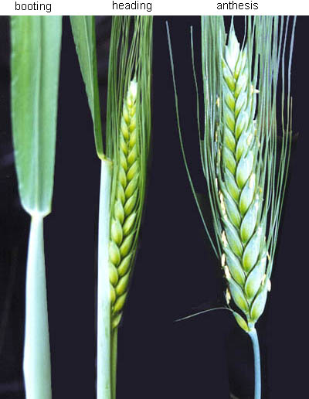
HM Rawson
Booting, heading and anthesis
These stages are easily identified (see photos). As with earlier stages, the number following the decimal point denotes the degree to which the process is complete. So Zadoks 5.1 is when the tip of the average spike in the field is 0.1 or 10% emerged (ear peep) while Z5.9 is when 0.9 or 90% of the average spike is above the flag leaf collar. Anthesis stage or flowering marks the beginning of grain setting and filling. When the anthers are freshly displayed they are bright yellow. They bleach white within 3 or 4 days (mid anthesis or Z6.5). Most of the main stages are shown on the diagram on page 8 where they are associated with other developmental processes (shaded green) and with the components of yield.

The internal stages that drive development
Zadoks stages describe what you can see with the naked eye, but it is the apex, spike or growing point of the plant, which you can’t see enclosed inside the leaf sheaths, that is the first indicator of when the plant steps through its main stages. It is the control room of the plant. Two important stages of the growing point are double ridge and terminal spikelet. Double ridge stage (p 88) signifies that the plant’s main growing point will produce no more primordial leaves, and instead will produce primordial spikelets of the young spike. At that time, the enclosed growing point is still at the crown of the plant below the soil surface. Terminal spikelet (p 90) is when the tiny spike has produced all its spikelets. Then that spike, which is only 2 mm long, will dominate less advanced growing points in the tillers; some will die, as will their tillers. To see that tiny spike, split a shoot with your thumb nails about 1 cm above the crown and peel off the little leaves. Though it is tiny, it already looks much like an emerged spike. The next figure shows when double ridge and terminal spikelet occur in relation to the Zadoks stages.
Double ridge stage
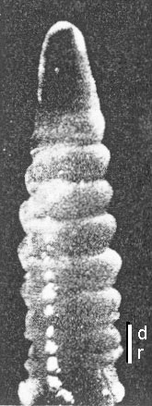
HM Rawson

External & internal stages and when yield is formed
The following figure relates the external Zadoks stages of the plant (red) and the two internal stages, double ridges and terminal spikelet (check the vertical text). It shows when the shoot components are initiated, grow and die (green boxes) and when the yield components are formed (bars). This figure will help you decide what components you are affecting by your field practices at particular times.
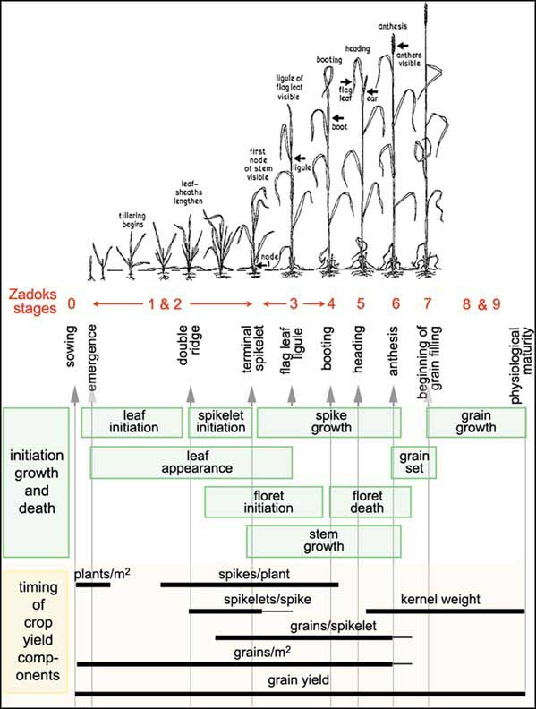
HM Rawson

Pictures to help identify all the Zadoks (Z) growth stages
