Environmental factors

Temperature effects
The most important effect of temperature is that it affects the rate at which plants develop through their stages (p 8) and produce their leaves, tillers and other components. Everything goes progressively faster as temperature rises between a base and an optimum temperature (p 81), and similarly development slows at lower temperatures. Calculating the size of these effects is discussed later (p 81). Good farm management can do more to counter the negative effects of high temperature than it can with low temperature and particularly frosts.
Frost on a crop
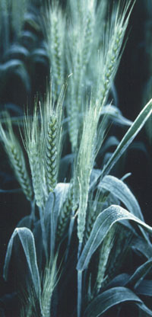
AF van Herwaarden

Low temperature
Development slows at lower temperature. But when temperatures are low enough for frosts, severe damage is done to young tissues. Vegetative shoots can be killed below -5° C. The consequences to yield of two or more successive frosts from spike emergence (Z5.1) through anthesis into early grain filling (Z7.1) can be severe. Official Stephenson Screen temperatures (p 90) of 1.5° C measured at 1.5 metres above the ground are cold enough for effects. This temperature is equivalent to 0° C on the crop surface. A single night frost during this period may not be overwhelming because only the new tissue that has been exposed to the air during the last few days is killed. This is seen as banding of dead and live spikelets on the spikes. All tissues become more frost resistant after exposure to the air.
Frost bands
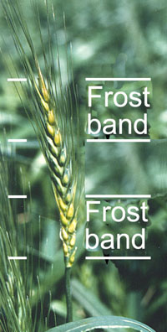
AF van Herwaarden
Is frost or low temperature a problem?
Look for vegetative plants with dead shoots. Temperatures have been well below -5° C. This problem will apply only at higher latitudes and altitudes and in areas with extreme temperature changes between seasons and between day and night. A lighter coloured stripe across expanding leaves is a symptom of less severe frosts. This will generally disappear as the leaves age. However, plant photosynthesis (p 89) is reduced and growth may stop for 1-2 days after such frosts.
During spike emergence to grain filling, look for a band or bands around the spike (see photograph). Are the spikelets empty? Is the banding in a similar position on many spikes? Each small band is caused by one frost.
Look for spikes that are dark coloured, even black, without grains. This can be a consequence of sequential severe low temperatures during anthesis or early grain filling. At high altitudes in the subtropics (e.g. Nepal) sterility in spring wheat can result from 3 or more consecutive nights of non-frosting temperatures lower than 5°C between stages Z4.9 and Z5.9.
Are there one or two completely dead spikes on most plants but other spikes are normal?
Are there florets gaping open with shrivelled anthers? This may be frost damage but can be confused with boron deficit.
Spikes in Nepal blackened and sterile after low temperature - not frost
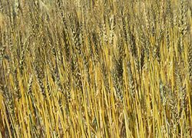
KD Subedi
Can you do anything about frost?
The only economic way to deal with frosts in wheat is to ensure that the whole crop is not at sensitive stages when frosts are most likely to occur.
Plant earlier or use later varieties that reach the most frost-sensitive stages (around an-thesis) when the likelihood of frost is very low. Frosts to -4° C at earlier vegetative stages are not critical to yield.
Plant varieties in which heading is not synchronous amongst shoots. Having spikes at different stages and different heights means that not all parts will be damaged during a single frost.
Plant varieties derived from winter x spring crosses that have greater cold tolerance (see Subedi et al 1998).
Winter temperatures well below freezing can kill vegetative growth
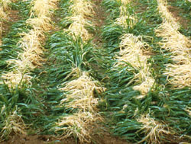
H Gomez Macpherson
High temperature
To keep pace with increasing temperature, the crop requires more of everything (nutrients, water, sunlight) each day. So to avoid significant yield losses as temperature rises, farm management must become increasingly precise. With water and supply of nutrients optimised, high yields can still be achieved at high temperatures. During grain filling, development accelerates faster than growth as temperature rises. Consequently, even if management is optimum yield can decline by up to 4% for every 1° C rise in mean temperature at higher temperatures (Stapper and Fischer 1990) because the grain filling period becomes very short.
High temperature damage is commonly associated with water stress so water management is critical. As long as plants can transpire freely they cope with high temperature. Field crops provided with sufficient water can withstand air temperatures to 40° C. But if water is limiting, 40° C will kill leaves. The reason for this is that water-stressed plants attempt to conserve water by closing their stomata (p 90). As a consequence evaporative cooling diminishes and, without that cooling, leaf temperatures might approach 50° C. At such temperatures plant processes break down. Seedlings in very hot dry soils can readily reach those critical temperatures.
Is high temperature a problem?
During the seedling stages look for poor emergence or for seedlings with dried or dead leaves. Emerging seedlings can rapidly become desiccated if soil temperatures reach 40° C or greater. If it is hot and there is bright sun-shine, solar radiation will heat a dry soil up to 50° C, particularly if the soil is dark coloured. Peacock et al (1994) found a 30% reduction in seedling emergence and survival as soil temperature at 5 cm increased from 37 to 45° C.
Is anthesis and grain filling occurring during the hottest part of the year? Is the grain filling period very short?
Are grains shrivelled? Have there been frequent hot desiccating winds during grain filling?
What you can do about high temperatures
Use a mulch to protect seedlings. This keeps soil temperature down during the day by insulating it from incoming solar radiation and conserving water. Mulch also reduces soil cooling at night.
Sow as soon as possible after seedbed preparation so that water losses from the freshly turned soil are minimised. Planting into moisture can then be achieved with shallower seeding ensuring plants emerge more rapidly. Seed-beds will also be cooler.
If sprinkler irrigation is available, reduce high soil temperature during seedling emergence by irrigating at that time. Irrigate during the evening.
Minimise the effects of high temperature at other times by ensuring that the crop is not water stressed. Evaporative cooling by the crop via transpiration (p 91) can reduce crop temperature below that of air temperature by more than 5°C in conditions of low humidity (some claim 10-15° C).
Select the optimum planting time, avoiding high temperature during anthesis and grain filling. High temperature at that time shortens the season and reduces yield. Avoid timing grain filling for periods when there are frequent hot and strong desiccating winds. Then the crop can not transpire fast enough to keep cool.
Choose a variety that makes optimal use of the available season; one that allows planting at a time that the field is free, but avoids high temperature during anthesis and grain filling (see p 42 for optimum sowing time).

Sunlight effects
Crop growth is primarily determined by the amount of sunlight (solar radiation) that the crop can intercept and use during its life. Too much radiation is rarely a problem as long as water and nutrients are in adequate supply. To get high yields, leaves should expand to cover the ground surface as soon as possible after planting. With delay, solar radiation is wasted just heating up bare soil and evaporating soil moisture. Solar radiation is particularly important to yield during the period from late stem elongation to one week after anthesis (Z3.3 to 7.05). Low solar radiation accompanying hot weather during this period reduces the numbers of grain sites (p 8) and severely limits potential yield.
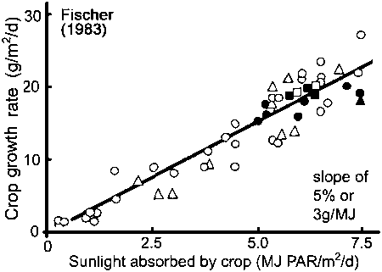
Crops grow
faster with
more solar
radiation
(sunlight)
as long as
the crop has
enough water

Has the sun been hidden by clouds or fogs?
During early tillering check for numbers of tillers. Are they what you would expect for a normal crop? Compare your counts for main shoot leaf number and tillers per plant with those on the graph on page 43. Tillering is suppressed if the weather is dull but hot. Tillering is also suppressed when it is hot and plants are short of water.
Look for weak shoots during the late tillering phase (Z2.4 - 3.5).
Following anthesis, are there fewer grains per spikelet than you would expect? Was it over-cast or misty but warm during the two weeks or so before anthesis? During this time, per-cent reduction in grain numbers almost equals percent reduction in solar radiation.
After anthesis are florets still gaping with the anthers pale coloured or misshapen? Was solar radiation low between Z3.9 and Z5.0 because of clouds or fogs, though it was warm? If your field is marginally low in boron this sterility is probably due to that. Soil-based boron effects are exacerbated by dull, low-light conditions and high humidity at this stage. These conditions reduce transpiration rate (p 91) and associated uptake of boron from the soil (see Rawson and Subedi 1995 for more detail).
Sterile spikes in boron-deficient soil. The spikes appear to be translucent but other parts of the crop will seem normal
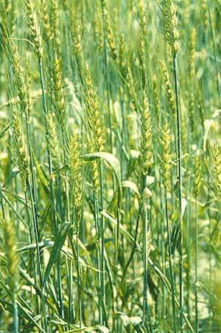
KD Subedi
Can you do anything about solar radiation?
Irrigation should be managed to avoid water stress during periods of high solar radiation and high temperature. Then those weather variables will be used positively in the production of biomass and yield.
If it is likely that radiation will be very low between the time that the flag leaf collar appears and anthesis and your soil is low in boron, avoid low-boron sterility by applying boron at sowing (1 kg/ha). This is good insurance. Additionally, plant a variety that is tolerant of low boron.

Acid or alkaline soils
Acidity or alkalinity is measured in pH units on a scale of 1 to 14 though the extreme values do not occur in agricultural soils. A pH 7 is neutral. Values from 7 to 4 are increasingly more acid and from 7 to 10 increasingly alkaline. Wheat grows best between pH 5.5 and 7.5, shown as a green zone in the figure, but can grow well beyond this range with additives to the soil.
This figure shows how soil pH affects nutrient availabiity. The green zone from pH 5.5 to 7.5 is most suitable for wheat. Narrower red bars mean less availability of the nutrient.
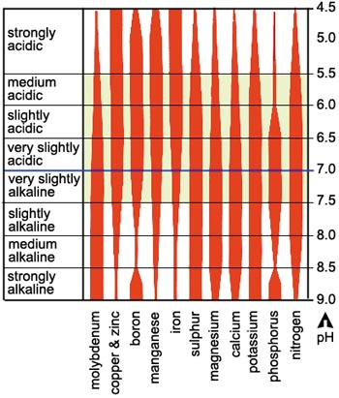
Figure based on Pratt (1965)
A main effect of too high or too low pH is that certain nutrients become too available and toxic to the crop while others become less available and show up as crop deficiencies (symptoms on p 52). In the figure the deficiencies are where the red bars are narrow.
In acid soils aluminium and manganese can become very soluble and toxic, but additionally, they reduce the plant’s ability to take up calcium, phosphorus, magnesium and molybdenum. Phosphorus in particular is unavailable to the plant in acid soils. If boron, copper and zinc are present in the soil, they too can become toxic at low pH. In medium alkaline soils boron, cop-per and zinc become deficient and phosphorus again becomes unavailable. Soil pH has relatively little direct effect on nitrogen.
Substituting acid-tolerant species for wheat can boost productivity in acid soils. How-ever, gains may be relatively short-term as these species can further acidify the soil until it becomes limiting for them also. Soil amelioration is a preferred approach.
Is your soil too acid or too alkaline?
Take soil samples from different depths in the rooting zone and test for pH. This can be done with pH (litmus) paper or with a pH kit. Look particularly for values below pH 5.5 and above pH 7.5.
Is the crop showing symptoms of deficiencies of either phosphorus or magnesium on older leaves (p 54) or of calcium on younger leaves (p 56)? These all indicate an excessively acid soil.
Look at neighbouring crops such as legumes and rapeseed that are more sensitive to acidity than wheat. Are they performing poorly?
Are symptoms of deficiencies evident for zinc on older leaves (p 54) or of copper or iron on younger leaves (p 56)? Is boron deficient as shown by failure of grain setting apparently randomly within spikes? These indicate an excessively alkaline soil.
Is your soil highly impermeable, crumbling and cracking when dry, collapsing when wet and difficult to drain. It may be alkaline and sodic.
Causes of extreme soil pH
- The soil is geologically very old and heavily leached, with high levels of aluminium and iron oxides. These soils are acid.
- Acidifying fertilizers have been applied to the soil for many years. These include those with ammonium nitrogen and superphosphate.
- Large amounts of organic matter have been added to a very wet soil over many years with resulting acidification.
- The soil is inherently alkaline being derived from limestone parent materials.
What you can do about acid or alkaline soils
Apply agricultural lime to acid soils and incorporate it to at least 15 cm. Use the finest particle size available that you can afford. Particles must always be smaller than 2 mm. Good mixing is important to avoid highly alkaline pockets over an acid soil which could kill seedlings. High quality lime at 1 t/ha will increase pH by between 0.3 and 0.7 units. The effect will last about 10 years. Do not apply more than 2.5 t/ha initially as this may induce zinc and manganese deficiencies and in boron-deficient soils, further limit boron availability.
Apply large amounts of organic manure to buffer soil pH particularly where application of lime is not an option, as in subsistence farming.
Avoid the use of acidifying fertilizers in acid soils. Increase their use in alkaline soils.
If the alkaline soil is sodic, improve drainage, incorporate gypsum and use deep-rooted crops such as legumes and canola in the rotation to move the gypsum down the soil profile. Sulphur is also used to acidify the soil. The gypsum supplies calcium to replace excess sodium.
Add the macronutrients or micronutrients that are showing up as plant deficiencies. Band phosphorus in alkaline soils with ammonium nitrogen to help make the phosphorus more available.

Saline soils
All soils contain salts, but salinity becomes a problem only when certain salts concentrate in the crop’s rooting zone. Sodium chloride or table salt is sometimes the problem but other salts can be. Salt can destroy soil structure causing swelling of clays and dispersion of fine particles that then clog the pores in the soil through which oxygen and water move. It also encourages crust formation.
Salt on the soil surface
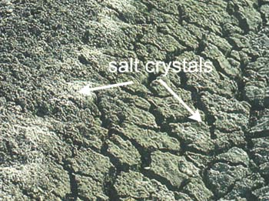
The key to control of salt in agricultural soils is to hold or leach the salt below the root zone. Keeping a net downward movement of water through the soil does this. Even slightly saline water can be used for leaching purposes. Problems occur when the direction of water flow reverses to an upward movement as occurs with rising water tables. Salt can also migrate upwards to the surface by capillarity, climbing slowly through the fine pores. This is a particular problem if the water table is already high and is salty, as the salt does not have far to creep to destroy the whole rooting zone. White salt crystals can be seen at the surface when the soil dries.
When plants grow in salty soils their growth is reduced; leaves and tillers do not expand. As salt accumulates in tissues it kills the leaves and eventually whole plants. The higher the salinity level the more rapidly effects become obvious and the lower the yield. The accompanying photograph shows poor growth and early death of plants in a salty patch in a wheat crop. Salt crystals are on the soil surface.
There are considerable variations in tolerance to salt. Bread wheat is more tolerant than durum wheat and than species such as rice and maize. Some varieties of bread wheat are more tolerant than others and plants filling their grain are more tolerant than seedlings (Rawson et al 1988).
A salty patch in wheat in Australia
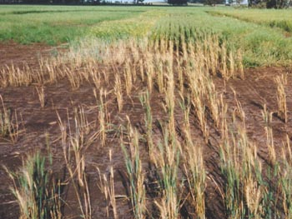
Rana Munns
Sodic soils deserve a mention here. They are not saline as such but do contain relatively high levels of sodium. This causes them to be physically unstable, crumbling and cracking when dry and collapsing when wet. They set hard and are relatively impermeable to water so that run off is a problem carrying with it suspended clay, organic matter and nutrients. High sodium irrigation water should not be used if these soils are highly impermeable and care should be taken not to over water otherwise the soil will rapidly worsen (Russell 1961). One way to improve these alkaline soils is to add gypsum and use deep-rooted crops such as legumes and canola in the rotation to move the gypsum down the soil profile and improve drainage. Sulphur is also used to acidify the soil.
Is your soil salty?
Look for whitish salt crystals on the dry soil particularly on tops of ridges (see picture). Touch with a dampened finger and taste it to confirm salt.
Are there bare soil patches that remain wet or boggy for days after irrigation?
Are there patches of crop with reduced growth and yellowing leaves?
Check for groups of plants that appear limp in spite of having adequate water, and with leaves that are dull (p 54), lacking the shine of healthy leaves.
Is tillering reduced and is there an unusually high proportion of dead older leaves? Check how many tillers there should be on a normal crop (p 43).
Do you have a rising water table less than 2 metres from the surface? Is the water salty to taste? Dig to the water table for a sample and keep a handful of soil from every 30 cm as you dig down. Label samples with their depth and do the taste test on each sample (see solutions to problems on p 34).
Causes of soil salinity
- Your soil is inherently saline.
- Your irrigation water is saline and has been applied in too little quantity to flush the soil.
- Drainage is inadequate so that a net downward movement of water through the soil is not achieved.
- Too much irrigation water is used and this accumulates as a water table over a shallow impermeable subsoil.
- There is a high and rising water table lifting salt from depth
- High-transpiring, deep-rooted plants have been cleared from the vicinity allowing water tables to rise, bringing salt with them.
Salt causing yellowing of a crop and death of leaves in Haryana
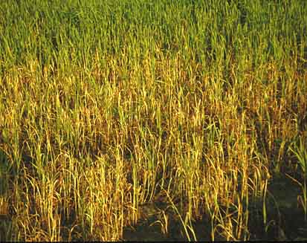
H Gomez Macpherson
What you can do about salty soil
Taste your irrigation water. If it is not salty or slightly salty, it should be OK to use as long as drainage is good. If you are worried, send a sample away for measurement of electrical conductivity (EC) to indicate its level of salinity.
If you suspect salinity because of areas of poor growth in your crop, put some soil in a container and add some clean water to more than cover the soil. Shake it up. When the water above the soil clears, taste it. If it doesn’t taste at all salty or very slightly salty, the problem is not salt. If it extremely brackish, you certainly have a problem. See whether any of the following solutions can be used. (Taste test from Rana Munns.)
Flush the soil system with heavy infrequent irrigations rather than light frequent applications. If the soil is already very saline, fresh water should not be used for leaching. Water without salt could destroy soil structure with formation of crusts over a soupy soil that forms cracks on drying.
Improve drainage by deep cultivation and incorporation of organic matter to ensure a net downward flow of the irrigation water to leach salts.
Check whether your water table is saline by the taste test. Do your samples indicate it is getting less or more salty towards the surface? If it is not more salty, work on lowering the water table. If it is more salty, concentrate initially on flushing the salt downwards.
If soil tests show that the soil sodium concentration is high, add calcium, usually as gypsum, to replace the exchangeable sodium in the soil.
Level the field so that particular areas do not remain wet for prolonged periods.
Use mulches to reduce evaporation from the soil surface.
Do the above but also change to a more tolerant genotype or crop species.

Taste your irrigation
water and a water extract of
your soil. Slight
saltiness or no salt taste is
fine. Strong taste indicates
a problem.

Management factors
Wheat is grown from the equator through to 60° latitude. It will yield over a wide range of temperatures rising as high as 40° C, though yields decline outside the ranges of its base and optimum temperatures (p 81). As temperatures rise closer to the optimum, management has to become more stringent, more timely and more precise for yield to be maintained. This is because the crop grows faster so daily demands on resources are greater. Any minor delays in providing the resources when the crop needs them, or minor delays in removing competitors for those resources, such as weeds and disease, will have big negative impacts on yield.
Crop yield begins at Day One, the day the seed is sown (see yield components in figure on p 8), but good management starts before that.
A uniform crop
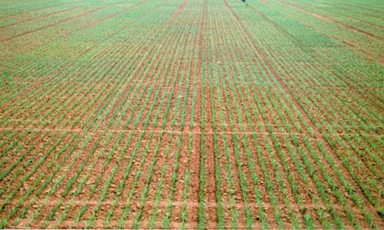
AF van Herwaarden

Poor crop stands. Why?
Wheat has the useful growth habit that it tillers. A few plants can therefore produce many leaves in a relatively short time to exploit the resources of a land surface. This means that seedlings do not have to be spaced perfectly as tillers will eventually fill most of the gaps in a crop canopy. However, it takes longer to fill gaps by tillering than if all seedlings emerge at the same time and at uniform spacing, and time can be important to yield. Poor crop canopies are the major constraint to yield, particularly in warm areas (Ageeb 1994, Olugbemi 1994). Poor canopies result from one or more of the following: poor seedbeds (inadequate land preparation); seedbed too dry; poor seed (viability) and poor planting technique. Planting at the ‘wrong time’ can make these problems worse.

Land preparation
Preparing your land prior to sowing should have the following aims.
- It should create a soil structure that encourages the seedlings to emerge rapidly and uniformly and allows the young plants ready access to the vital resources of nutrients, water and aeration. Both full tillage (also called conventional or clean) and minimal tillage systems have this aim, but minimal tillage (p 84) limits soil disturbance to the surface layers or just a shallow slot for each crop row. Because minimal tillage often uses light machinery that can be taken into the field when the soil is wet, as perhaps after a previous rice crop, it has the prime advantage that it commonly shortens the time between successive crops/rotations. This can be critical for maximising yield per year.
- It should aim to incorporate any additives such as lime, compost, farmyard manure and chemicals for plant nutrition and pest control and, depending on location, may incorporate residues remaining from previous crops.
- It should control weeds, pests and diseases.
- It should aim to shape the land so that irrigation water can be applied efficiently and drained effectively and so that waterlogging is avoided or minimised. This may involve levelling, preparation of furrows, beds and so on.
Using a laser plane to level land in the Punjab of Pakistan
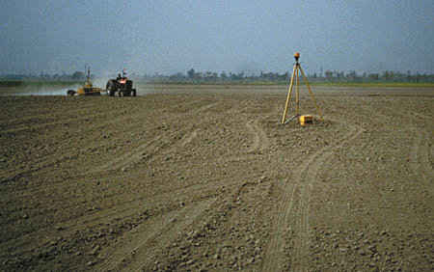
H Gomez Macpherson
If you have little or no equipment or have limited access to equipment for timely and quality land preparation, perfect seedbeds may not be possible, particularly if the farming system uses flood or furrow irrigation.
Drilling seeds directly into the stubble of the previous crop (zero tillage) in Pakistan
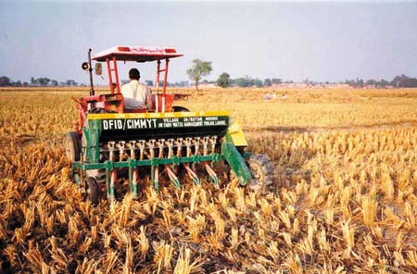
Hafiz Mujeeb
That system depends on multiple tillage operations and levelling, with construction of borders to channel and contain the irrigation water. It may be beneficial to use minimal or zero (no) tillage (p 84) or to spend time developing a permanent raised bed system (p 84). If raised beds are used, the process of forming the soil is more complex. Here the field is formed or reformed into long levelled raised beds, 60-80 cm wide with two or three defined planting rows, the beds separated by irrigation/drainage channels. However, in later years when the bed structure is well established and undamaged from the previous crop and residues/mulches are thick, only the predefined planting rows need to be cultivated, similar to minimal tillage farming on flat land.
A raised bed system in Mexico with two rows of seedlings on each bed
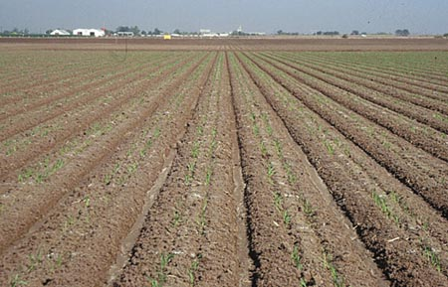
H Gomez Macpherson
Problems of land preparation
Before sowing, note the size of clods remaining after cultivation. If they are dense and greater than 5 cm in diameter, they could cause variations in seeding depth or physically prevent seedlings from emerging. Fix the problem now.
Before sowing, check for signs of waterlogging. Are there wet patches in low areas perhaps slightly green with algal growth or if dry, a silty crust on the soil surface? Waterlogging can cause death of seedlings and tillering plants.
Before sowing, check where the soil moisture is by scratching into the surface soil until the colour darkens or the soil feels damp. Is it too dry for germination?
Before sowing, check if the residues from the previous crop that remain on the surface are thin enough to allow your planter to penetrate and sow at uniform depth. Are the incorporated residues bulky so that they create large air gaps in the surface soil that could preclude uniform planting?
A week or two after planting, check for crusting (p 87). Dig up seedlings where crusting occurs or where emergence is variable. If unemerged seedlings are bent and twisted and have long yellow leaves, they failed because they could not penetrate the crust.
Are many seeds dry and not germinated? The soil was too dry at planting.
Is the field weedy? If the weeds are larger than the crop seedlings, the weeds were either not killed by pre-sowing cultivations or the cultivations were done too long before sowing, and the weeds grew back.
Clods resulting in uneven seedlings
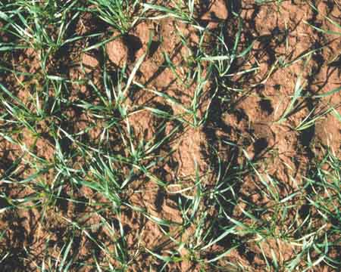
AF van Herwaarden
Causes of poor seedbeds
- Cultivation occurred when the soil was too wet, resulting in clods.
- Cultivation occurred when the soil was too dry and/or there was too much secondary cultivation, causing loss of structure. If this is followed by excess rain or irrigation a surface crust will form (p 87).
- Soil structure is poor because of salinity or sodicity (p 33).
- Residues were not incorporated sufficiently or excesses were not removed prior to land preparation.
- The gap between cultivation and sowing was too long and the seedbed dried.
How to improve your seedbed
Reduce clod size by secondary tillage. But beware of overdoing this if the soil is very dry as this could destroy soil structure and result in crusting later. Also develop guidelines for when to cultivate in relation to moisture content (p 16).
Minimise crusting (p 87) by reducing the number of secondary cultivations that might be pulverizing the soil, and leave some crop residues in the surface soil layers. If sprinklers are available, sprinkle-irrigate prior to seedling emergence to soften the crust.
If reduced tillage practices follow high-yielding rice, maize or soybean crops, remove excess residues so seeds can be sown accurately at uniform depth. Alternatively, use equipment that can sow accurately into heavy crop residues.
Time cultivations so they are not too long before planting. Aim to give the crop seedlings an advantage over germinating weeds and weed regrowth.
Use minimal or zero tillage so that all operations can be done at the optimum time and completed quickly. This can avoid overworking the soil and consequent loss of soil structure, avoid clods, and avoid wasting water because a minor proportion of bare soil is exposed to the drying air.

Seed viability
Is the seed poor?
A few days after the first seedlings emerge, count them (p 13) to check if there are far fewer seedlings than expected from the number of seeds sown. If some of the seeds were dead, this will not show as a patchy crop but as a thin crop, as the dead seeds will have been mixed amongst the good seeds.
Are seedlings still emerging ten days after the first seedlings appeared? Do the late seedlings appear weak? Seeds that are old can produce weak seedlings. Dig up some of the weak seedlings. Are they showing symptoms of disease (p 76) or indications that they have grown around clods (p 37)? If not, the seed source is probably poor.
Causes of poor seed
- Seed was stored at high temperature, high humidity or near chemicals. Chemicals diffusing from some manufactured woods and soft plastics can be a problem in unventilated stores.
- Seed for planting was harvested when the crop was very dry, leading to a high proportion of cracked and broken seed that is dead or, if alive, has too little reserves to grow to the soil surface.
- The seed was harvested too early and still retained some dormancy. If this is the case, the later seedlings to emerge will appear strong and healthy.
- Seed was infested with insects or disease.
What you can do about poor seed
Do a germination test before planting. Adjust the amount of seed sown up-wards to allow for the percentage of bad seed in the sample. Sown amount = required amount x 100 divided by percentage germination.
Store the seed in a cool, dry and well-ventilated enclosure.
Harvest seed at a time and by a method that causes it least physical damage.
Remove any damaged seed from the sample sown.
Do not sow seed that is more than a year old unless a germination test shows it is still good.
NOTE: Do a germination test by counting out several lots of preferably 100 seeds taken from well inside the seed sacks keeping each seed lot separate. Dampen squares of paper or towelling and spread each group of seeds on a towel so the seeds are not touching each other. Cover them with a second damp paper towel. Roll up each sandwich of seeds and put in a plastic bag to prevent the towels from drying out. Keep the bags at room temperature. After 4-5 days count how many seeds have germinated in each lot. Percentage germination is the number of germinated seeds divided by the number of seeds in the sample x 100.

Planting depth and method
The shallower the planting depth, the sooner the seedlings can emerge and commence photosynthesis (p 89) and the earlier tillering can start. Healthy seedlings can be produced from seed laid on the soil surface. The correct planting depth is one that places the seed where it can imbibe water for germination but not desiccate thereafter. It is often necessary to plant deeper to protect from birds. Though seedlings of some genotypes can emerge from below 5 cm, this is too deep for many modern genotypes that have short coleoptiles. The plants in the photograph were sown on the same day but at different depths. It shows that at the same age, seedlings planted shallowly are larger than those emerging from depth. They have many more leaves (15 vs 5) that are shorter and broader, more main shoot leaves (5 vs 3) and more tillers (4 vs 1). Later, these differences will be reflected in spike numbers and yield.
Shallower sowing speeds seedling and increases tillering
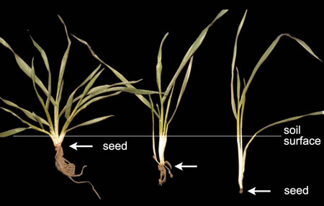
M Stapper
Are the seedlings uniform?
Look over the field within 2 weeks of planting. Do there look to be enough seedlings emerged? Confirm your assessment by using your 1m stick to count seedlings following the methods on p 13.
Is emergence uniform? If not dig up a few seeds where it is patchy. Have the seeds germinated? If not check the section on seed viability (p 39). Are they healthy (see p 76 for disease problems)? Measure the length of the white, be-low ground section on emerged plants (see sowing depth photo). This should differ by no more than 1 cm if seeds were planted at uniform depth.
Is the spacing of seedlings uniform? The mechanical planter may have blocked or over-planted.
Have any seedlings been uprooted? Look for signs of birds, rodents or in-sects.
Check all the suggestions under Poor Seedbeds (p 37).
Causes of planting and emergence problems
- Many of the seeds were dead before planting or had low vigour. Check all the causes under poor viability (p 39) and poor seedbeds (p 38).
- Too few seeds were planted. If broadcasting, many more seeds are required to allow for irregular distribution.
- Seeds were planted too deep for the genotype. i.e. coleoptiles were too short to reach the surface. Measure the length of the shoot between the seed and soil surface. Check this against the recommended depth for the variety.
- Seeds were planted into a seedbed that had dried out leading to uneven germination.
- Seeds were not uniformly distributed, perhaps hand broadcast by an inexperienced worker prior to covering with soil.
- Seeds were planted too shallow and dug up by birds or moved by insects.
- Sowing occurred too long after cultivation allowing weeds (p 58) to establish and compete with crop seedlings for resources.
- Heavy rain fell after sowing and the soil surface crusted.
What you can do to fix emergence problems
Overcome any seedbed (p 38) and seed (p 39) problems.
Follow the recommendations for seed rate (p 42) for the region.
Ensure the depth setting on the seeding device is set correctly for the variety.
Use reduced tillage methods or plant direct into residues of the previous crop.
In the absence of cultivation and seeding machinery, and to achieve good establishment, pre-irrigate the soil, carefully broadcast the seed and fertilizer and cover with a mulch of straw rather than soil (Jongdee 1994).
Apply mulch (disease-free residues) to keep the soil surface moist and cool during seedling emergence and prevent formation of surface crusting. This may also reduce losses to foraging birds, insects or rodents. Mulch is likely to increase yield by around 10% (see Badaruddin et al 1999) but may not be physically feasible or economically viable.

Optimum sowing time
There is an optimum time for sowing for every location determined primarily by weather and availability of the field and irrigation water, but also by the variety that is being used and the likely timing of serious disease in the area. The best sowing time is that which gives the highest yield within the local limitations. It is usually decided on by working backwards from the date that is best for anthesis (see dot points below). Once the best sowing time has been determined, any delays in sowing at that date can reduce yield. Yield loss from delays will generally be greater in hotter regions.
The most suitable variety will be one that fits its growth stages into the available time or growing season. When deciding on variety and calculating your sowing date you should bear in mind the following risks:
- Frost from spike emergence (Z5.1) through early grain filling should be avoid-ed.
- High temperature during anthesis and early grain filling is best avoided.
- Avoid very overcast and misty conditions during 2 weeks before to 1 week after anthesis - solar radiation should be high for this period.
- Irrigation water should be available from stem elongation through anthesis to early grain filling.
- Avoid varieties that run to head too quickly before producing tillers unless the available season demands a very short duration crop.
Think not only of the current crop. Work out the best compromise planting times for all sequential crops in the rotation so that annual production is optimised.

Optimum seed rate
Numbers of plants in a crop depends on seed rate, seed viability, percentage seedling emergence and plant survival. However, plant numbers can often vary widely without appreciably affecting yield in irrigated crops. This is because wheat plants produce tillers (p 90), which themselves can produce leaves, spikes and grain. So seed rate is commonly less critical to final yield than many of the other factors dealt with in this section.
This figure shows seed rate may have a small effect on yield because as plant numbers decline, each plant yields more
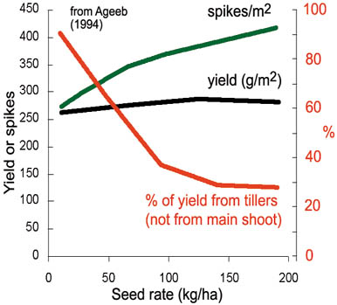
For example, in the study from Sudan shown in the figure, yields did not change much over a 15-fold range of seed rate, because at low seed rates each plant produced more tillers and spikes. But note that final yields were also not very high.
Recommendations for seed rates are usually between 100-150 kg/ha, which is higher than necessary but allows for losses due to poor preparation of seed beds, poor seed, and poor distribution of seed as occurs with hand broadcasting (p 37). Very high plant populations can encourage disease (Du Daiwen 1994) but do reduce the effects of weeds by competing better, a more important consideration in some areas. Some consider that very high seed rates lead to a higher chance of lodging (p 49).

The crop canopy: control of tillers and spikes
A good crop of 4 t/ha has to produce more than 400 spikes/m2 as, on average, each spike produces 1 g of grain. With normal sowing rates of 100 kg/ha (10 g/m2), which is 200 viable seeds/m, these spikes could all be from plants with a main shoot and one tiller. But main shoots have few leaves, so do not capture enough solar radiation early enough to produce a good crop (p 28). Using its tillers a plant can produce many leaves quickly. These in turn capture the radiation needed for rapid crop growth.
Wheat plants can produce a tiller in the axil of every leaf (drawings on p 9) and a tiller bud is ready to grow into a tiller shortly after its surrounding leaf is fully expanded. The first tiller usually appears in the axil of leaf 1 when there are 2.5 leaves on the main shoot (check this out for a normal crop on the following figure).
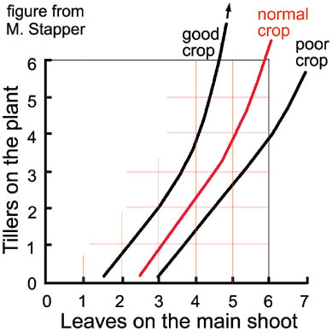
Count your main
shoot leaves and
check from this
figure if your plants
have enough tillers
for a good crop

Any tillers can be missing from the normal sequence. If water or nitrogen are limiting at the time the tiller bud is ready to grow, or if light is very low, that tiller bud will not grow and will not be used by the plant. Missing tillers, by their position, tell when the problem occurred.
Once the developing spike on the main shoot of the plant reaches Z3.0, few further tillers will start; maximum shoot number per m2 has been reached (figure on p 8). If conditions have been poor until then, fewer shoots will have been produced.
Growing conditions after Z3.0 determine how many of the shoots or tillers survive to produce spikes. Even if you do everything right, some tillers will die, but with poor management many tillers will die without bearing a spike. Greater death means less interception of solar radiation during the important period leading up to anthesis. As importantly, it means less spikes and grains.
Is the crop producing enough tillers and spikes?
Pull up some plants at several stages during tillering. How many leaves are there on the main shoots and how many tillers are there? Check the previous figure to see how your crop rates. For example, if your plants have 3.5 main shoot leaves, and no tillers, your crop is poor. If your plants have 3 tillers, it is a good crop. Do your records on the field sheets indicate that tiller numbers are increasing? The numbers of tillers per main shoot leaf shows whether the crop has problems that should be fixed.
When the flag leaf has emerged, check spike numbers as described on p 13. Do you have the 400 spikes/m2 required for a 4 t/ha crop (80-100 /m row if using a 7” or 18 cm row spacing)?
As your crop grows, estimate the percentage of ground covered by the crop (method on p 14) or measure it with a light bar as radiation interception. Both numbers are similar and essentially interchangeable. Compare ground cover (i.e. radiation interception) for your crop with that on the accompanying graph for the same Zadoks stage. If you are hoping for a yield of more than 4 t/ha your crop should cover about 80% of the ground by stem elongation (Z3.0 or jointing). For even higher yields you should be able to see almost no soil surface through the crop by flag leaf appearance (Z3.7). That crop is in the right hand pane of the previous photograph. All the light is being captured and used by the crop in producing growth. The three crops in the graph were grown at the same place but were different because they had different amounts of nitrogen applied at sowing (0, 80 and 240 kg/ha). Nitrogen in-creased radiation interception by making more leaf area, and yield responded in proportion.
Ground cover for three crops estimated at 25%, 45% and 90%
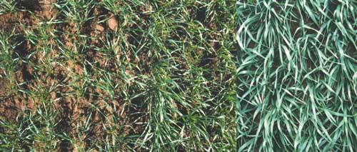
AF van Herwaarden
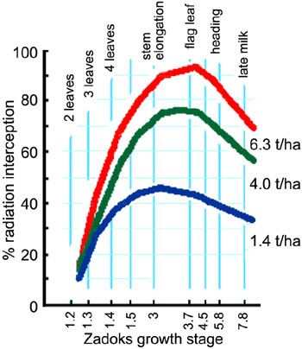
More ground cover
by the crop at each
Zadoks stage
means more
radiation interception
and higher yield.
Compare ground
cover for your crop
with these three
crops. They yielded
1.4, 4.0 and a high
6.3 t/ha.

from data of AF van Herwaarden
Causes of low tiller and spike populations
- Seeds were planted very deep. If the first one or two tillers are absent and the sub crown stem section is very long, this is the likely cause (compare the photos of shallow and deep sown plants on p 40).
- Basal fertilizers were inadequate to stimulate tillering. Check how much nitrogen was used and when it was applied. Pull up some plants and assess whether some tillers in the tillering sequence are absent in spite of correct sowing depth. An absent position will indicate the problem occurred when that tiller was ready to grow.
- Death of tillers has resulted in low spike numbers. Was nitrogen provided at node 1 (Z3.0)? Count spike numbers (p 13) and compare with earlier tiller counts. Did many tillers abort?
- Irrigations were inadequate (p 64) during tillering? Did the wilting score (see p 15) fall to or below 1 at the time of irrigations? Again check the timing of the problem by noting which tillers are absent or weak.
- Waterlogging occurred in association with hot weather during early tillering. Two or more days waterlogging will kill tillers if temperatures exceed 30° C.
- Solar radiation was low and it was hot. Were there several days of very over-cast or foggy weather during tillering?
- Stem borers, root rots (p 76) that reduce green area have suppressed tillering.
- A variety with genetically suppressed tillering may have been used.
- The seed rate was too high.
- Planting was late during rapidly rising temperatures with long days. This caused the crop to rush through to heading quickly (see p 81 for explanations) leaving no time for tillering (see photo on p 58).
What you can do to increase tiller and spike number
Plant as shallowly as is practicable (see p 40) using the recommended seed rate (p 42) for the area.
Ensure that nitrogen and other fertilizer recommendations for the area are followed to optimise tiller production and then keep them alive to produce spikes (see preceding graph which illustrates the effect of 3 levels of nitrogen applied at sowing on ground cover and yield). Consider split applications of nitrogen and placement (banding) rather than broadcasting.
If irrigation water is very limited, at least apply water at crown root initiation (Z1.2 – Z1.3), around 21 to 30 days after sowing in warm areas.
Preferably apply irrigations at the frequencies recommended locally and whenever the wilting score of 1 is reached (p 15).
Reduce water logging following the recommendations on p 69.
Keep populations of pests and disease under control (p 73).
Choose the right variety, which does not develop too rapidly towards heading.

The crop canopy: green leaves after heading
The crop fills its grains by using carbohydrates from two sources, either produced freshly from photosynthesis (p 89) in the green leaves or from storage in the stem. Stored material alone can only produce a small grain yield of less than 1 t/ha, so for high yields it is important to keep several leaves green and active on each shoot during the grain filling process.
Growing grains need nitrogen as well as carbohydrates. The plant extracts little nitrogen from the soil after anthesis so the developing grains, which grow entirely after anthesis, have to get virtually all their nitrogen from storage in the plant. An important store is the green leaves.
A main reason that leaves lose their green colour and die is because their nitrogen is removed and redistributed to the grains. The less nitrogen stored, the more quickly the leaves die. How much is stored depends on how much was available in the soil before anthesis, as determined by management.
Your yield will be higher if you have more green leaves on shoots during
grain growth. Disease that reduces leaf greenness will quickly lower yield
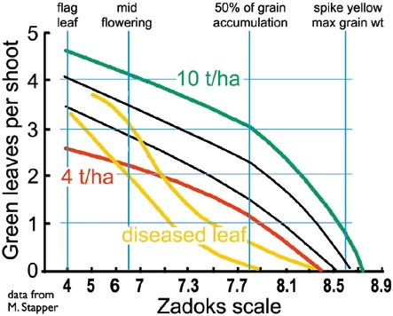
The figure indicates how many green leaves each shoot should have at each stage of grain growth to achieve yields ranging from 4 to 10 t/ha. Any diseases such as rusts and leaf blights (p 75) that reduce the number of green leaves and the green leaf area at this time also reduce yield. The field sheets (p 17) have a column for recording green leaf number.
Does the crop have enough green leaves after heading?
Count how many green leaves there are on average shoots and add the number to the appropriate column in the field sheets. Check your count against the figure to see what your crop can yield. For example, if shoots have three green leaves at mid flowering, the potential yield of the crop is around 6 t/ha. If your crop has one or less green leaves at this stage, yield will be very poor. The crop to this stage has been limited by nitrogen, soil conditions, disease or water (too little or too much).
Have the upper leaves lost green colouration? Are the symptoms caused by leaf diseases (p 75) or poor nutrition (p 52)? Count the green leaf number on the average shoot (p 14) and assess whether the leaves are diseased. From the above figure estimate the impact of disease on yield. The figure shows how quickly disease can reduce potential yield.
Causes of leaf death after heading
- In nutrient-poor soils, nitrogen was not applied at first node (Z3.0) or later.
- The crop is short of water or waterlogged.
- Leaf diseases, root rots or insect attacks have caused leaf death.
Making sure there are enough green leaves
Apply nitrogen to the soil. If nitrogen is readily lost through leaching as from a sand loam (p 15), split the applications between sowing and first node.
Ensure that irrigation is done at recommended or calculated intervals (p 64), supported by the wilting score (p 15).
Control diseases and pests. Next season use a more disease-resistant variety.

Lodging
Lodging is when the crop falls over. A normal vertical crop is finely balanced, so anything that upsets the balance will cause it to lodge: strong winds, heavy rain, very wet soil during late grain filling, tall thin stems that bend, root or stem rots that weaken the plant base. Winds associated with excess water are the worst combination.
Lodging destroys the canopy structure. Solar radiation is no longer intercepted efficiently with high light to young upper leaves and low light to old leaves. Heads are covered in the tangle and the collapsed crop becomes more susceptible to pests and diseases.
Lodging during early stem elongation has a relatively small effect on yield as the crop will right itself and reform the canopy. The stem nodes alter the angle of extension making new growth vertical (see the nodes in the centre of the adjacent photograph).
Lodging in wheat. The worst lodged stems here have fallen about 60° from the vertical
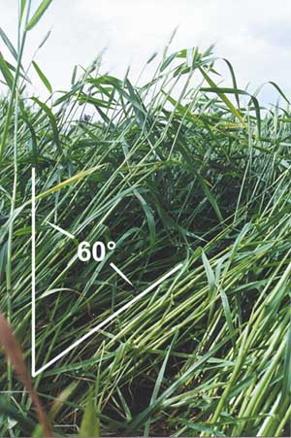
HM Rawson
From anthesis onwards the effects of lodging are large. For every day that the crop is lodged yield declines by more than 1% (Stapper and Fischer 1990). So for crops severely lodged shortly after anthesis and remaining so, final yield may be less than half that of the upright crop.
Any lodging also makes harvesting more difficult and increases the likelihood of losing grain during harvesting.
Has your crop fallen over?
What percentage of the field is lodged? 10%, 50%, the whole field?
Was lodging early or late? You will probably be able to tell by the extent to which the stems have righted themselves. Yield loss will be minor if lodging was during early stem elongation.
Look closely for disease on the stems. Are the lower internodes light brown with necrotic eye-shaped patches? This is probably the foot rot eyespot (Pseudocercosporella herpotrichoides) that eventually rots through the stem.
Look at each lodged area and estimate the average angle of lodging. That is, how far have the stems fallen from the vertical. In the photo the worst lodged stems have fallen about 60° from the vertical. Calculate a lodging score for the field by dividing the angle of lodging by 90 (e.g. 60°/90), then multiply that by your estimate of the area of the field affected (say 10% =10/100). Multiply that lodging score by the number of days the crop is lodged to give you lodging duration. Yield falls by 1% for every 2 units of lodging duration at the grain milk stage.
Why has the crop fallen over?
- There were high winds and heavy rain after stem extension began or it was windy while irrigations were in progress during grain filling.
- Excess nitrogen was applied resulting in too much top growth and top-heavy plants. Are other farmers having similar problems with different varieties?
- A tall, unimproved variety was used, unsuited to high nitrogen nutrition.
- Eyespot, root or crown rots (p 76) weakened the stem or base of the plant.
- Low potassium availability.
- The seed rate was too high, preventing tillering and resulting in weak stems.
- Machinery or animals in the crop caused physical damage.
What you can do to stop it falling over
Do not irrigate when you expect winds. Irrigate in late afternoon when winds tend to subside, or early morning if that is the calmest time of day in your area. Particularly avoid irrigating if high winds are forecast. The yield loss associated with extensive lodging is greater than a day of water stress.
Avoid over wetting the soil during late grain filling.
Change to a shorter variety if your area is prone to high winds or rainstorms during the later stages of growth.
Reduce nitrogen applications to unimproved, tall varieties, particularly very late applications. Split your nitrogen applications between planting and first node (Z3.1).
Reduce seeding density (see p 42) and/or planting depth (p 40) to encourage early tillering and crown root production. This can give plants a stronger base.
Control crown and root diseases by appropriate agronomy and/or seed dressings (p 76). Spray at Z3.0 if there are signs of eyespot.
Use a potassium fertilizer.
Adopt the raised bed planting system. Irrigation in this system does not wet the soil around the base of the plant to the same extent as flat plantings.
Check fencing to ensure animals are kept out and use machinery carefully.

Mineral nutrition
For best growth, wheat needs many nutrients, in particular, the macronutrients oxygen (O; about 48% of dry matter), carbon (C; 42%), hydrogen (H; 6%), nitrogen (N 2%), potassium (K), phosphorus (P), calcium, magnesium and sulphur. The amounts of each steadily accumulate in the crop as it grows but their concentrations decline (see figure) as the crop accrues old tissues. Old tissues have lower concentrations of nutrients than young ones. Wheat also needs very small amounts of the microelements iron, manganese, boron, zinc, copper, sodium, molybdenum, chlorine, cobalt, and silicon. Apart from the first 3 elements (O, C and H), which come from the air and water, the remaining 16 can be managed to some degree by soil or crop treatments.
The concentration of nutrients declines in the crop as a whole as it develops and accumulates more old tissues
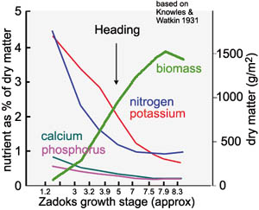
Recommendations for applications of N, P and K differ widely with soil type and fertility and expected use of the fertilizer by the crop. A very short duration crop may not have sufficient time to use as much fertilizer as a long duration crop. Fertilizer policy must be based on local practice, your target yield and crop rotation. Bigger crops need more fertilizer (see discussion and graph on p 45). Be cautious though, an excess of nitrogen may result in ground water pollution and lodging (p 50). If nitrogen is limiting, yield and probably grain protein will be reduced. Applying nitrogen after spikes emerge generally increases grain protein.
As a rough guide, a 7-t/ha crop removes from the field as grain 150-190 kg N, 25-35 kg phosphate and 45-60 kg potassium. These nutrients must be returned to the soil after every big crop to avoid depleting reserves. Work out the approximate amounts removed for your target yield. For a 4-t/ha yield for example, about 150 x 4/7 kg N would be removed (85 kg N).
When plants do not receive enough of a nutrient to satisfy their requirements, or receive too much, they grow poorly and, if the imbalance is large enough, they show symptoms of the problem. Symptoms for most deficiencies or toxicities are generally most obvious on the leaves.
If a soil nutrient is being progressively depleted by the growing crop, and the nutrient can not be moved from older to newer leaves, the symptoms will be more apparent on young leaves. If the nutrient is mobile, the plant will extract it from the old leaves for use in the young leaves. Then the old leaves will show the symptom. Be careful with boron however, which shows no significant symptom on the leaves. Only at anthesis, when the sterile florets of heads gape, does the deficiency become apparent.
Be careful also that you do not confuse these symptoms with similar ones due to disease. If the cause is nutritional, symptoms will occur in large areas of the field. If it is disease, the symptoms are likely to be on isolated plants or in patches in the crop.
First check whether the symptoms are on older or younger leaves and then use the appropriate flow chart and photographs (old leaves p 54, young leaves p 56) to make a first-order identification of the problem (checklists and photographs are based on those in Grundon 1987).
Is mineral nutrition a problem?
Walk through the field at different growth stages. Look for large areas of poorly grown or pale coloured plants with poor growth. Look more closely and decide whether the old or young leaves are most affected. If you see any of the symptoms described on pages 54 to 56, you can be fairly sure that the problem is already reducing yield.
Causes of nutrient problems
- Soil has a long history of heavy cropping without sufficient replacement of nutrients (not enough fertilizer was applied). Check the cropping history and fertilizer applications of this and earlier years. Calculate whether nutrients are likely to be limiting from the difference between nutrients removed in yields and fertilizer applied.
- Soil is low in organic matter (or insufficient fertilizer was applied).
- Fertilizer was lost due to leaching from heavy rain or over irrigation, run off or volatilisation or lost to competing weeds or an intercrop.
- Fertilizer was applied when the crop could not use it optimally. What was the crop stage (p 6) when the fertilizer was applied, its type and amount and was it broadcast or banded?
- Soil pH is such that certain nutrients were unavailable (p 30). Test soil pH. If it is less than 5.5, magnesium deficiency is possible and phosphorus may be unavailable. If greater than 8, deficiencies of zinc, iron, copper and boron are possible. Compare with assessments already reached from the photo keys.
- Waterlogging occurred from heavy rainfall, over irrigation and/or poor drain-age on heavy soil. Check for symptoms of waterlogging (p 68), soil type (p 15) and check rainfall and irrigations.
- Wheat or maize straw was used as a mulch or large amounts of residues were incorporated. Some reports suggest nitrate may be lost with this practice under high temperature (p 62).
- Soil is saline (see p 33).
- Check soil depth (p 17) as a plough pan or other restriction may be limiting roots to the upper soil profile so nutrients in deeper layers are unavailable.
What to do about nutrient problems
Before planting get soil tests done to check for deficiencies of zinc, phosphorus or potassium particularly if your last crop had deficiency symptoms. Nitrogen is best monitored during the season using tissue analysis.
Phosphorus is not mobile in the soil so place it with the seed at sowing. If your wheat follows a rice crop, phosphorus is probably required. Be aware that diammonium phosphate may injure the seed.
Increase rates of fertilizer for the limiting nutrient. Consider foliar application if a rapid response is required though the effects are usually of short duration e.g. for nitrogen use urea, for manganese use manganese sulphate, for iron use inorganic salts or chelates and for copper use copper sulphate.
Consider adding farmyard manure if available as this contains most micro and macro nutrients and incorporate stubble from the previous crop to build up organic matter and improve aeration. The stubble contains lots of potassium that may be limiting in an acid soil. Alternatively, grow and incorporate a green manure before next season to improve soil organic matter.
Change fertilizer application method and/or timing so that less is lost by run off, leaching or volatilisation. About 65% of nitrogen applied at planting may be lost, but losses of only 35% occur if fertilizer is placed at the first node stage (Z3.1, p 9) (Sayre and Moreno Ramos 1997). Generally it is best to split your nitrogen applications between planting and first node. Top-dress fertilizer just before irrigations or before rain to aid infiltration.
Improve drainage. Consider using a raised bed system for next season with its inherently better drainage and more efficient use of water (p 84).
Remove weeds to make more nutrients available to the crop.
Before next season increase soil pH towards 6 (p 30) in very acid soils by adding lime or limestone and dolomite but care should be taken not to over-lime as deficiencies of potassium, magnesium, iron, manganese, boron, zinc or copper may result (p 52).
Apply micronutrients if indications from plant symptoms and pH measurements (p 30) suggest they are limiting. If your field is sulphur-deficient, use a fertilizer that contains sulphate sulphur at planting.
Symptoms on fully expanded and older leaves
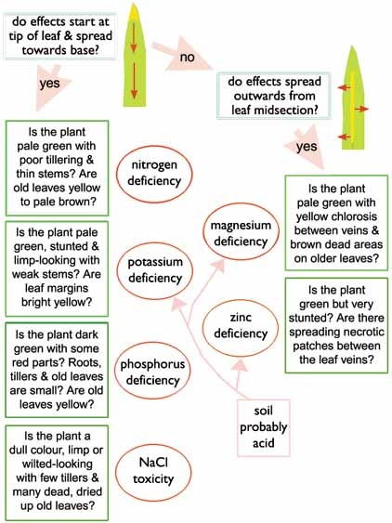
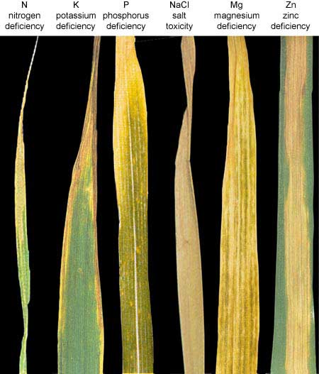
Adapted from NJ Grundon
Symptoms on young leaves, recently expanded and expanding
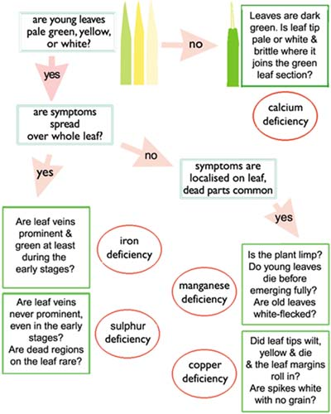
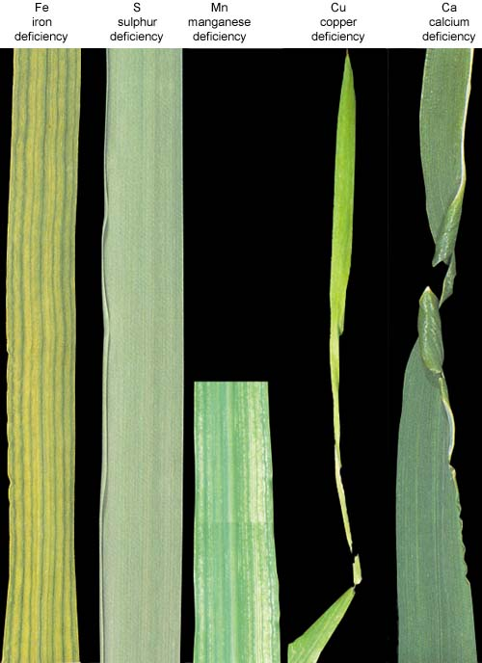
Adapted from NJ Grundon

Weeds
Weeds compete with the crop for light, nutrients, water and root space. Some weeds can damage the crop by producing toxic substances or acting as hosts for diseases. Annual weeds compete most effectively with wheat during the seedling stages and early tillering. So this is the critical period for weed control. Once the crop is covering 50-70% of the soil surface at jointing, it will dominate most newly germinating weeds.
Early wheat sown too late to tiller dominated by broad leaved weeds
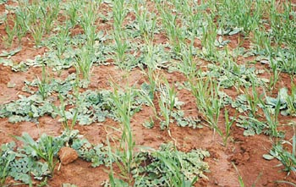
H Gomez Macpherson
Many selective herbicides are highly effective against weeds in the crop but they may cause some damage to the crop, as may manual or mechanical weed control methods. The likely yield loss from chemical or mechanical damage should be assessed against the yield loss from the weeds. Pre-emergence herbicides cause little or no damage so often result in better yields than later sprays.
Weeds can be a problem during harvesting; weed seeds can contaminate the grain and the green matter from late maturing weeds can contaminate the straw. Herbicides and desiccants can be used at this late stage, but only in particularly weedy situations and then with great care.
Conventional tillage if shallow and done hurriedly during seedbed preparation can exacerbate a weed problem. It can break up and spread the propagating root systems of some perennial weeds and bring buried seeds of annuals to the soil surface where they can germinate. Consider whether the option of minimum or zero tillage (direct drilling, p 84) may better suit your requirements in some years. If there is a well-established problem of perennial weeds (p 89), deep tillage to undercut and expose the deep propagating roots may be the first step towards control.
Wheat in Nepal completely suppressed by the grass weed Phalaris minor
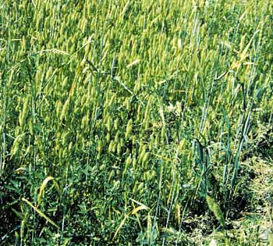
KD Subedi
Is the crop weedy?
Check the crop within 2-3 weeks of crop emergence.
Are many of the weeds as large or larger than the crop plants? Any weeds that are similar in size to the crop at this stage will soon dominate crop plants if not removed. They will intercept the light and take up water and nutrients.
Look generally at the crop. Does the crop cover much more or less ground surface than the weeds (p 13)? Remember that the percentage of ground covered by weeds is the percentage of resources not available to the crop.
What are the dominant weeds in the crop? Try to identify them so that you can check on their vigour and methods of control.
Are wheat plants in the weedy areas smaller or less developed than in clean areas of the field? If so, weeds are already dominating resources.
Causes of weed infestation
- Your wheat seed was contaminated with weed seeds. Always examine your seed before sowing. Machines used for harvesting and tillage are a source of weed seeds and should be cleaned before leaving each field.
- Weed removal by hand was not effective. Check on its timing and frequency.
- Herbicide application was ineffective. Check what herbicide was used, its concentration and whether there was rain or heavy dew during application. Were the manufacturer’s recommendations on the label followed?
- Monoculture and repeated use of herbicides with the same mode of action led to herbicide resistant weeds as reported in Malik et al. (1998) in South Asia.
- Perennial weeds propagating from broken roots or underground stem sections are difficult to control manually. Was a herbicide used? Is it effective against perennial weeds?
- Planting was delayed too long after seedbed preparation. Check the field sheets for dates of land preparation and planting. Did rain occur at this time encouraging weeds to germinate? Use minimum tillage (p 84) if a fast turn around between crops is essential.
- Each crop species has its own set of cultural practices that create niches for certain weeds. If the land has been used continuously for wheat, a bank of weed seeds may have built up in the soil. As some weed seeds can lie dormant for many years, the problem will continue annually for some time despite control methods.
What you can do about weeds
Make sure that your wheat seed for sowing is not contaminated with weed seeds. Buy good quality seed if possible. If you are using your own seed and your seed samples commonly have weed problems, consider preparing a small weed-free area on your farm solely for producing seed for planting next season. This will save work in the long term.
A crop that emerges quickly and is vigorous and dense will dominate most weeds. Assist the crop by preparing a good seed bed.
The weeding operation should be done closer to crop seedling emergence and/or the method should be modified. Remove weeds when they are most susceptible to damage, when they are small.
If a few weeds escape earlier control, remove them prior to flowering to avoid seeding, but do not damage the crop. Weed seeds mature extremely quickly.
In the case of herbicide use, identify the weed before choosing the herbicide. Follow the directions on the label closely. Never exceed the recommended dose. A strong mix may damage the crop. Apply the herbicide uniformly with a calibrated sprayer. Do not use the same herbicide year after year.
Check on alternative herbicides that can be used to control difficult weeds. Post-emergence herbicides that are absorbed by leaves work better when the weeds are growing actively. Spraying early morning after dew has lifted may be better than late afternoon. Do not spray if it is raining or about to rain.
If perennial weeds cannot be controlled, increase the seeding density of the crop to achieve ground cover more quickly after sowing and out-compete the weeds. Consider deep cultivation to control them.
Rotate with a crop that will dominate the weeds or leave fallow and cultivate. Rotation changes the conditions to which the weeds are specially adapted.
If the preceding crop (e.g. rice or maize) has left residues that are free of disease, and the land is not weedy, consider sowing the wheat crop through these residues with minimum-tillage implements (p 84). The residues will help to suppress annual weeds and turn around time between crops will be short.
If you have an herbicide resistant weed, try a shorter duration crop variety or species that allows you to leave a 1-2 months fallow between crops. During that break irrigate, then control weeds mechanically or with a non-selective herbicide. Consider using bed planting (p 84) as mechanical weed control is possible in the channels between beds. Use competitive varieties.
Late removal of weeds by hand is possible but hard
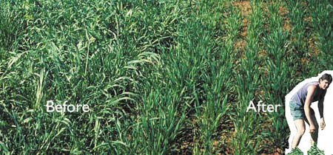
H. Gomez Macpherson

Crop Residues
Many farmers in Asia remove crop residues for livestock fodder and for cooking fuel. Others incorporate the residues during initial tillage operations or later, after they have been passed through animals to become farmyard manure. Burning is becoming more popular as it shortens turn-around time between crops. However, burning leads to reduced soil organic matter and degradation of soil physical properties, in turn increasing the likelihood of waterlogging, crusting and disease.
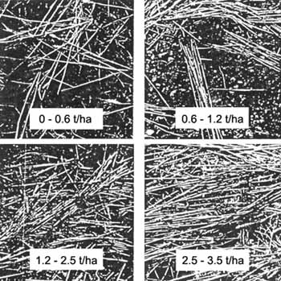
Different yields of
wheat stubble
spread on the soil.
Residues of 3.5 t/ha
t/ha just cover the
soil with a thin layer
when spread
uniformly

Felton et al 1987
Residues up to 9 t/ha can come from a preceding rice or maize crop and this amount completely covers the soil with a layer several centimetres in thickness. As shown in the photos, 3.5 t/ha of residues will just cover the soil surface when spread uniformly. Zero and minimum till equipment is available to sow through deeper layers of residues and still achieve uniform seedling emergence.
The positive attributes of crop residues should not be overlooked. Used as mulch they conserve water, keep the soil cool and free from crusting. They also increase soil microbial activity and maintain or increase populations of earthworms, which in turn increase soil aeration. Retained stubble reduces wind and water erosion and can be grazed by animals, though not when the soil is wet as this can lead to the formation of a soil pan. The negative attribute of crop residues is that if managed incorrectly in wet soils they increase the incidence of disease, which may reduce yield. Root rots such as Rhizoctonia (p 76) and Pythium species (p 80) can be a problem. Furthermore, if trash from the previous crop was full of weeds the incidence of weeds in the current crop will also be significant.
Are crop residues a problem?
Is plant emergence not uniform with sections of seedlings absent from the rows? Is the stubble or residue particularly thick in those areas?
Is the crop pale with symptoms of nitrogen deficiency (p 54)? Reports indicate that straw residues may immobilize nitrogen as they decompose, especially when incorporated.
Are seedling diseases more in evidence than usual? Dig up some seedlings and check their roots. If they are brown or stunted, refer to the section on diseases (p 76) to identify the problem.
Causes of residue problems
- Too great a thickness of residue remained on parts of the soil surface during seeding which the planting machinery could not penetrate. What method was used for planting and for spreading the residues from the previous crop? How thick were the residues?
- The stubble was diseased. Were there disease problems in the previous crop? Has the soil been wet for a long period, conditions that encourage take-all disease and Pythium and Rhizoctonia root rots? This may have shown as stunting and uneven height of the crop, poor tillering for the leaf number (p 43) and yellow leaves.
- The planting machinery was not suitable. Did it block frequently?
Doing good things with residues
Remove any residues that exceed 4 t/ha, equivalent to a thin uniform cover of the soil. Excess residues can be used to stabilise furrows and for general control of erosion as well as for animal fodder and cooking fuel.
Use machinery that has the capacity to sow through thick residues of greater than 4 t/ha.
If diseases have caused problems in the previous crop either incorporate the residues a long time before sowing to allow full breakdown of the straw or remove the residues, or in extreme cases, burn them on site.
Include a crop in the rotation that breaks the disease cycle.
A crop in Pakistan drilled directly into the residues of the preceding rice crop
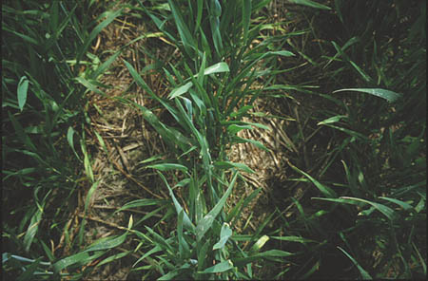
H Gomez Macpherson

Irrigation timing and moisture stress
If you are irrigating your crop at the recommended intervals for your region and making frequent assessments of the water status of the crop using the wilting score (p 15) and using that score to confirm when you should irrigate, moisture stress should not become a problem. Irrigation frequency and amount will differ depending on many factors, but there are four stages additional to sowing when water should not be limiting. These are crown root initiation when tillering is starting (Z2.1 to Z2.2), the jointing stage (Z3.0), anthesis (Z5.0) and the grain milk stage (Z7.0). Of the four stages, tillering and anthesis are most sensitive to water stress.
Is moisture stress a problem?
A stressed crop rapidly loses potential yield. When a young crop has too little water its first response is to conserve what water there is by closing its stomata (p 90). These are small pores all over green surfaces that let water out and carbon dioxide in. Without carbon dioxide photosynthesis (p 89) stops and so the sugars it normally makes from the carbon are no longer available for growth. So growth stops. The first growth response to water shortage is that leaves stop expanding. The tiller buds that are ready to grow into tillers remain as dormant buds. Usually the main shoot struggles on with its development. If moisture remains limiting, the crop eventually runs out of time to produce leaves, tillers and spikes and the consequence is a thin canopy with few small spikes, few grains and low yield.
If moisture stress occurs after anthesis the grains are affected, as they are now the growing part of the crop. Again the stomata close, the leaves roll and die from oldest to youngest and the plant rushes to move as much material from storage into the grains to fill them as full as possible before everything dies. The consequence of post-anthesis stress (milk stage) is that grains are pinched, shrivelled and small.
Estimating how much soil moisture is available to the crop
You can work out how many days it will take before your crop is short of water if you do not irrigate or if it does not rain. If around 50% of the water that the soil can hold has already been used, the crop is probably already stressed and potential yield is declining. To make the calculation you need to use soil moisture content (p 16) for your soil textural class (p 15) and weather data. The following three step method is adapted from Lafitte (1994).
·Step 1. How much water does the non-stressed crop use each day?
water use per day  by the crop  (mm) | = | evaporative demand  (from Table 1) | × | crop coefficient  (from Table 2)
The number you calculate in Step 1 approximates the amount of water you would need to apply as irrigation to replace each day’s loss.
Evaporative demand in mm/day (evapotranspiration) can be taken from Table 1 or weather data, or from your local pan evaporimeter (p 89).
Table 1. Evapotranspiration values for different environments (mm/day)
mm evaporation | Average daily temperature (°C)
per day in the: | 10-16 | 17-23 | 24-30
Humid tropics | 3-4 | 4-5 | 5-6
Subhumid tropics | 3-5 | 5-6 | 7-8
Semiarid tropics | 4-5 | 6-7 | 8-9
Arid tropics | 4-5 | 7-8 | 9-10
From FAO Irrigation and Drainage Paper 24
Use the larger value of each pair if the area around the crop has no transpiring vegetation
Table 2. Evapotranspiration Crop Coefficient for crops reaching 80-90% full ground cover by heading. Reduce the coefficients for crops with less ground cover*
Growth stage | Zadoks  code | crop  coefficient | crop ground  cover
early vegetative growth | Z1.0 - Z1.3 | 0.3 | 10-30%
tillering | Z1.3 - Z3.0 | 0.8 | 30-80%
stem elongation to flowering | Z3.0 - Z6.8 | 1.0 | 70-100%
grain filling | Z6.8 - Z8.7 | 0.5 | 50-20%
* See p.6 for information on ground cover
Coefficients from Wright 1981
·Step 2. How much water in your soil is available for crop use before stress begins? (Calculate for the current rooting depth of the crop-see p 17.)
water  available | = | mm soil moisture present now (see table on p 16)  minus  mm soil moisture present when 50% soil moisture is  available (ie 50% of field capacity in table on p 16)
·Step 3. How many days can the crop go without irrigation or significant rainfall before stress begins?
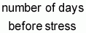 | = | 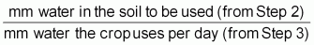
This calculation may seem fairly difficult so try an example to give yourself confidence. Pretend your crop is at heading and growing on a clay-loam soil in the semiarid tropics where mean temperature is 20° C.
According to Table 1 the evapotranspiration for that environment is 7 mm water per day. Because the crop is at heading (Z3.0-Z6.8), it has a crop coefficient of 1.0 (Table 2, column 3) so is losing 7 mm water/day (i.e. 7 mm x 1.0, from Step 1).
Your soil is a clay loam (p 15) that forms a ball when you squeeze it, but the ball breaks easily. According to that description in the table on p 16 your soil contains 110 mm water. And assuming the crop roots reach down to 1 m all that 110 mm water is available for crop use (p 16).
The table on p 16 also shows that at 50% moisture, when stress becomes important, your soil holds 80 mm of available water, so the crop can use 110 - 80 = 30 mm before stress. At 7 mm per day water loss, you do not need to irrigate for 4 days (i.e. 30/7 days).
Is the crop short of water?
Is the wilting score more than 1? A score of 1 means that yield potential will not decline if water is applied today (see p 15). Higher scores mean that potential yield is already declining due to water shortage
Count the number of tillers on average plants and the number of main shoot leaves as described in the field sheets. The drawings of the Zadoks stages (p 9) will help to identify tillers and main shoot leaves. Are there sufficient tillers for the number of main shoot leaves in accordance with the graph on p 43? Too few tillers indicates that irrigations have been too far apart.
After heading (Z5.0), are numbers of green leaves on average shoots as high as expected? The relationship for a high yielding crop is shown on p 48. A stressed crop loses green leaves very quickly during grain filling.
Are leaves warm to touch or hold on a sunny day? Leaves that are not stressed transpire rapidly (p 91) when the sun is shining and on hot days cool themselves below air temperature. Stressed leaves close their stomata (p 90), stop transpiring, and heat up.
Causes of water shortage
- Irrigations were too far apart for the water holding capacity of the soil (p 16) and the demands of the crop.
- Rain may have fallen that was overestimated in its useful quantity because of incorrect measurement or run off.
- The roots of the crop may be restricted to a part of the soil profile by a plough pan, or shallow or compacted soil (p 17).
- The roots may be diseased with rots limiting water uptake (p 76).
- The soil or the irrigation water may be saline resulting in the crop limiting its water uptake (p 33).
- The soil may be poorly aerated/waterlogged (p 68) preventing water uptake.
- Irrigation water was not available when it was needed.
Solutions to crop water shortage
Follow recommended irrigation scheduling for the region. Use the wilting score to time irrigations (see p 15). Calculate when water should be applied by using the three step method on p 64. Measure rainfall yourself with a rain gauge and measure pan evaporation with a homemade evaporimeter (p 89).
Check your calculations for when you should irrigate by regularly measuring whether the stomata are closing. Stomatal closure is a very early sign of water stress. It can be measured quickly and simply by a viscous flow porometer.
Check for plough pans and soil depth (p 17). Cultivate accordingly.
Look for root rots (p 76) and apply the appropriate treatment.
If the soil is saline, apply water in greater quantity than previously each time you irrigate to ensure that the salt is leached below the rooting zone. Also ensure that drainage is adequate so that salt is removed from the system. This applies particularly if the irrigation water is saline (see p 34 for details).
Improve drainage if waterlogging is a problem (see p 68).
If too little water is available either increase on-farm storage or plant less area to crops that require irrigation.
Conserve moisture by spreading a mulch on the soil.

Waterlogging
Waterlogging occurs when the soil is saturated with water. Heavy soils are most likely waterlog. They have limited pore space through which water and air can move only slowly. If the soil is saturated for too long oxygen is used up. Then roots stop growing and absorbing nutrients, stomata close preventing photosynthesis (p 89) and soil denitrification commences. Because plants cannot absorb their nitrogen from the soil, they have to extract it from older leaves to support the growth of new leaves. During this extraction, old leaves become ‘nitrogen deficient’ and yellow during a period of waterlogging. Generally there is not enough nitrogen available in old leaves support new tiller growth, so tillering does not occur.
Nitrogen deficient leaves
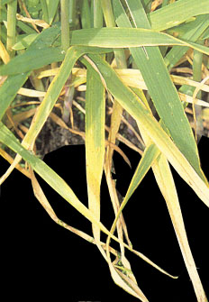
HM Rawson
Wheat deteriorates rapidly in waterlogged soils if temperatures are high; seedlings within as little as 2 days. Later stages are more tolerant but can still lose a high proportion of their leaf area and yield. Waterlogging is avoided by ensuring that any water drains through the soil before it has time to stagnate. Wheat growing acceptably in mildly saline soils will not survive if waterlogging occurs.
Do you have too much water?
After rain, do water puddles remain in the field for more than 12 hours? Examine the soil surface in areas where crop growth is poor. Is that soil very wet, perhaps covered with green patches of algae?
Are some plants wilted at midday even though the soil is wet? Do those in the lower or damper areas look pale with yellow tips on older leaves? Does the crop appear to be nitrogen deficient even though fertilizer was applied?
In those areas that have poor growth are the weeds a different species from those in apparently drier areas?
Scoop up a handful of soil. Does it smell stagnant or fresh?
Causes of waterlogging
- The soil is inadequately drained. Is the seedbed above the level of the drain-age channels and are any tied ridges allowing water to drain away?
- The field is not level. Can you see that there are low spots? Are these areas of poor growth?
- Too much irrigation water has been applied which cannot drain sufficiently quickly. Check records for amounts and timing.
- The soil is naturally heavy with poor structure and inadequate pore space.
- Rainfall has been heavy. Was the irrigation regime altered to allow for this?
- After heavy rainfall waterlogging can occur even in light soils because crusting seals the soil surface and prevents air from entering.
What you can do about waterlogging
Apply nitrogen after a period of waterlogging. It will make nitrate readily available and accelerate plant recovery.
Keep the field free of weeds to reduce competition for oxygen in the root zone.
Consider a light cultivation if crusting occurs after intense rainfall. This will help aerate the saturated soil.
If the soil is prone to waterlogging, consider adopting the raised bed system with its intrinsically good drainage (p 84).
Level the field, improve the drainage channels and put them closer together.
Adjust the irrigation timetable to allow for rainfall events.
Use deep cultivation to increase soil pore space and break up any hard pans that might have developed. Pore space should be around 10% to avoid waterlogging.
Next season, grow and then incorporate a green manure crop to improve soil organic matter and pore space. Alternatively incorporate farmyard manure or crop residues.
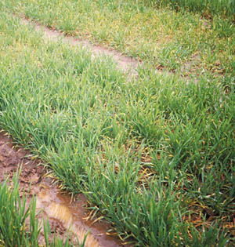
Waterlogging causes
lower leaves to turn
bright yellow then die
and upper leaves to
turn pale yellow
through nitrogen
shortage

H Gomez Macpherson

Biotic factors

Above-ground insects
Worldwide hundreds of insect species feed on wheat. Some are adapted specifically to wheat and the conditions in which it has been grown historically. They are generally in balance with the system. But with the spread of wheat into new regions in recent years, particularly regions with hotter, wetter and more humid conditions than traditional areas, populations of many new and old pests have erupted into significant out-breaks. It will take time for predators to build up to control pest levels in these regions, and to develop varieties resistant to all pests. Until then, crop rotations, careful selection of planting time to put the crop out of step with the pest, the use of resistant varieties when they are available and chemical approaches to control are required. These break the cycles of the pests. This discussion will focus on a few of the problem insects in the new wheat zones. The pests described do not occur in all wheat areas.
Adult sawfly. Sawflies are a widespread and serious pest of wheat and barley
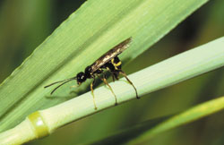
RM Miller
Sawfly damage
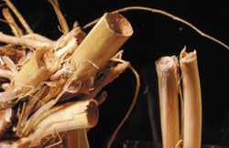
ICARDA collection
Are above ground insects a problem?
Are stems of plants neatly severed with consequent death of the spike? This could have been caused by the innocuous-looking sawfly (Cephus pymaeus) illustrated in the previous photograph
Are there sections of crop with extensive brown dried up patches. Look closely at individual plants. Are leaves and stems covered with aphids (green-bugs) and their sticky secretions?
Look for signs of longitudinal yellowed streaks on the stem and leaves, severe rolling of the leaves and curling of the rachis (p 89). Unroll the leaves. Are aphids feeding there? These are likely to be Russian wheat aphid (Diuraphis noxia). Heavy infestations in dry seasons can cause 80% crop losses.
Check the crop for areas of low vigour. Look more closely for dead areas on leaves and stems. This could be due to one of the suni or wheat shield bugs (Eurygaster integriceps) that extract fluids from leaves and stems, and from grains in the milk stage. Look for the tiny feeding nymphs.
Are some spikes dead and white? Look for signs of stem borers, but be aware that crown rot disease (p 76) and take all (p 74) can cause white heads also.
Are there areas of plants that are stunted and dull green, such as occurs after water stress? Pull back leaf sheaths and check there and at the base of stems for pale red or white larvae about 1.5 mm long. Check also for dark coloured ‘flax-seed’ puparia that can easily be pulled away from the plant. These are the stages of the hessian fly (Mayetiola destructor)that can cause large crop losses particularly in North Africa. The fly resembles a mosquito in size and shape.
Mosquito-like hessian fly
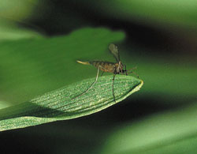
RH Miller
Adult suni bug on a spike
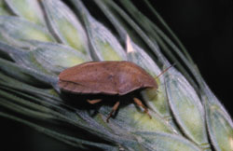
RH Miller
Suni bug nymphs on a leaf
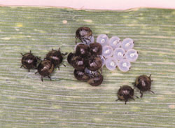
RH Miller
Flax-seed puparia of the hessian fly
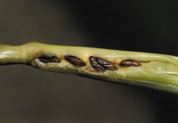
RH Miller
Causes of insect problems
- Continuous wheat cropping or rotating wheat with alternative host crops allows insect populations to build up in the locality. What rotations are used in the area? Is it feasible to alter them to include a non-host crop?
- Are fallows used in the area? Were isolated self-sown wheat and barley plants rogued from these fallows? If not, these could be infested with Russian wheat aphid and be the source of the pest re-infecting cropped areas.
- Insects have been blown in or migrated from outside the region such as might occur with locusts. When were the symptoms first noticed and were they a problem last year?
What to do about insect problems
Crops that are healthy are more tolerant of pests and will remain pest-free most of the time. Minimise problems by following normal practices for good crop production. Chemical control, while effective, is often not economically feasible and if used imprudently may cause more problems than it solves. It should always be the last resort.
Minimise sawfly and hessian fly problems by using recommended best practices for crop production for your area. Use clean tillage and ensure crop residues are fully turned in after harvest. For hessian fly, use resistant varieties when available. Check whether it is feasible to delay or advance planting to encompass a fly-free period.
Aphids in Egypt and Sudan (probably Rhopalosiphum padi and Schizaphis graminum respectively) can cause 20-30% yield losses if infestation is heavy. Monitor populations regularly. Once more than 35% of plants are infested, spray the recommended chemical. Control of lower infestations is not worthwhile.
Russian wheat aphid does not proliferate in humid areas or where there is heavy rain. Wheat varieties that are resist-ant to Russian wheat aphid are available. These should be used in areas known to have the pest to reduce or eliminate the need to spray.
Count feeding nymphs and adult suni bugs. When nymph numbers average 6-12/m2 or adults 2-3/m2 throughout the field alert the local authorities. Control programs by aerial spraying are often in the hands of government.
Use crop rotation to control stem borer. Generally infestations of stem borer cost more to control than the yield benefits from extermination.
NOTE. Litsinger & Barrion, 1988 and Miller & Pike 2000 have more detail on the insects discussed and extensive information on other insects.
Oat bird-cherry aphid (Rhopalosiphum padi) and greenbug
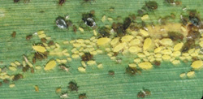
RH Miller
Greenbug (Schizaphis gramium) proliferating on a leaf
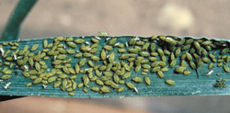
RH Miller

Soil pests
Soil pests such as termites, ants, mole and field crickets, ground beetles, white grubs, wireworms, root aphids and root bugs usually pose a major problem only in dryland agriculture. Under irrigation crop growth is faster and more regular and so the crop has greater capacity to grow through any damage by pests. Tillage also protects the crop from soil pests. It exposes soil pests to dessication and disrupts their food sup-plies while regular flooding disturbs their habitat. Removal or incorporation of crop residues further limits habitat and food resources. Under minimum tillage or direct drill practices some of the soil pests may build up over the years.
What to do about soil pests
If problems do arise, try the following after the pest has been identified
Crop rotation using a break crop (or fallow) that the pest does not feed on.
Cultivation, concentrating on removal or complete incorporation of residues, and removal of weeds.
Improve crop nutrition and optimise flood irrigation to keep the crop growing quickly to outgrow the pest.
Time planting to b out of phase with the growth cycle of the pest.

Diseases
There are many diseases that attack wheat some causing seedlings to die even before emergence (bare patch) or shortly thereafter (damping-off). Infections can continue throughout crop growth and impacts be seen right through to harvest.
Fungal diseases are the most common and widespread diseases. They have distinctive symptoms that can appear on spikes as well as on leaves and stems when the infection is severe. Symptoms on leaves range from small, infected patches (necrotic lesions) to discolouration and premature drying of whole leaves. Flat spots and blotches that progressively increase in size and spread from lower to upper leaves are generally due to fungal diseases that are transmitted in stubble or splashed up by water. These include septoria and tan spot. Rust spores cause protruding dusty spots or streaks on the surface of leaves, stems and spikes. The colour of the spots or pustules indicates the type of rust present. Rust spores leave a coloured smear on fingers when touched.
White heads in wheat
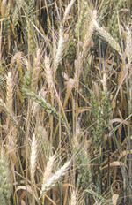
HM Rawson
Appearance of whitened spikes in the crop commonly indicates the presence of root rot pathogens such as take all, a Fusarium disease or Bipolaris sorokiniana. These white heads are completely dead having had their vascular links to water and nutrients completely severed by the root or crown rot disease. The plants have probably been diseased for some time prior to heading. Symptoms associated with seed and soil-borne diseases also usually become apparent on the crop after heading. Smut diseases for example are seed borne and very common in areas where farmers recycle their own seed.
Considering the diversity of wheat diseases, it is critical to keep an eye open for problems right from the beginning. Loss of plants and loss of green leaf area reduce the potential yield of a crop (p 44). Many of the problems are seed borne, while others are already in the soil at planting, carried over from the previous crop or in residues, or even associated with perennial weeds (p 89). Conditions that are less than optimal for the crop are often better for disease infections. Poor aeration, poor nutrition and water logging are examples. However, dense crop canopies necessary for highest yields are also perfect for rapid spread of diseases (and pests). Consequently, good management with regard to disease is a continuous balancing act. It starts before the crop is sown with a clean field and choice of the most disease resistant wheat variety. It demands vigilance right through until harvest as the crop is continually exposed to new disease threats as it develops. Finally, it requires thought and action about the crop rotations best able to prevent build up of diseases across seasons.
Are leaf diseases a problem?
Symptoms associated with leaf diseases are sometimes similar to those resulting from nutritional imbalance. However, many of the following symptoms cannot be confused.
Look for coloured spores on the surface of leaves or spikes that rub off with a
finger. These are rusts. White or grey patches are mildew

Yellow rust (Puccinia striiformis fsp.tritici) has bright yellow spores that appear as stripes on the upper surface of leaves. It prefers moist conditions and low temperatures (8-15° C), particularly cool nights (<10° C).
Stem rust (Puccinia graminis fsp.tritici) has dark brown pustules that can tear through either leaf surface and spread to stems and spikes. It appears late in the season particularly in humid, warm areas (15-30° C).
Leaf rust (Puccinia recondita) produces light brown spores mostly on the upper surface of the leaf. It causes no rupture of the epidermis. As with stem rust, the pustules may spread to stems late in the season. Leaf rust is in all cereal growing areas. It thrives in moist conditions with temperatures of 15-25° C.
Powdery mildew (Erisyphe graminis fsp.tritici) has white cotton-like spots piled in patches on any green surface. Infected areas turn dull grey and may contain black spherical points that are the fruiting bodies. It occurs in damp conditions.
Yellow rust on leaf and crop but not on a row of a resistant variety
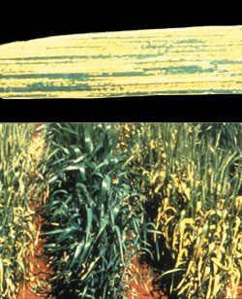
A Yahyaoui
Stem rust
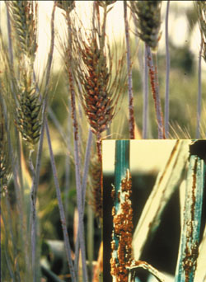
A Yahyaoui
Leaf rust
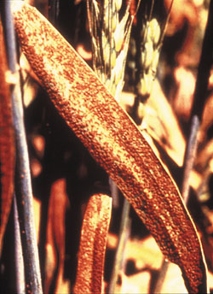
A Yahyaoui
Look for blotches with yellow margins on your crop’s leaves. Blotch diseases
are more difficult to identify than rusts - check the descriptions below

Septoria tritici (blotch) produces irregular lesions with black specks. Septoria nodorum (glume blotch) produces lesions that have no black spot. Late in the season, under humid, warm conditions, the disease infects the glumes and spike causing grey blotching and shrivelled seeds.
Tan spot (Pyrenophera repentis) produces symptoms that are similar to those of glume blotch, but the disease occurs in cool climates and is restricted to leaves.
Spot blotch or leaf blight (Bipolaris sorokiniana) has become significant in the warmer humid areas of SE Asia causing major yield losses in Bangladesh (Alam et al 1994). It can be seen as small blotches with minimal necrosis on the lower leaves of seedlings, but during stem elongation and heading it can spread rapidly up the plant to damage most leaves and eventually infect the seed with black point.
Septoria blotch
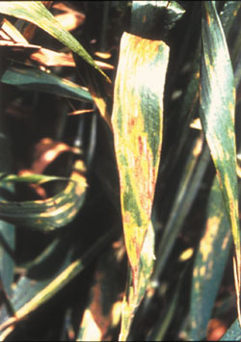
A Yahyaoui
Are root diseases a problem?
Before Z1.3 (seedlings)
Are there sections of crop where plants are missing or seedling leaves look discoloured or weak? Carefully dig up seedlings and wash out their roots. Are the roots stunted, are they discoloured, either brown or grey?
Pythium species cause short stubby main roots with poor development of laterals and brown soft tissue near or at root tips. It occurs in very wet or waterlogged soils and results in poor emergence and seedling death.
Around Z3.3 (jointing)
Check for poor plant vigour in the crop looking particularly for defined patches of low vigour. Are any leaves yellow? Dig up plants and wash out their roots. Are roots stunted with discoloured, sharp tips?
Rhizoctonia sp. can produce bare plant-free patches in the crop (hence its name ‘bare patch’). There may be some surviving plants in these patches but they will be very stunted. Their roots are likely to be brown and spear-shaped and even largely rotted away. Rhizoctonia sp. occurs mainly where weeds had not decomposed before planting. It can be associated with waterlogging and is common in winter rainfall areas and in poor calcareous soils.
Cereal cyst nematodes (Heterodera spp) also cause patches of weak crop growth, often with some yellow leaves, that may be several metres across. Dig up and examine the roots and crown regions of plants. Are the secondary roots white or discoloured; are they short, twisted and knotted in a mass? Cereal cyst nematodes feed on roots and cause these responses. Later, small white cysts develop at the knots or on thickened roots. Cysts finally turn brown.
Check the colour of the crown area. Is it black? Take all (Gaeumannomyces graminis var. tritici) can be confirmed in its early stages by breaking a root. Its core will be jet black. In later stages the lower stem and many roots will be black. Plants can be uprooted easily and the roots are stunted. Take all affects all the tillers of the plant and might infect patches of crop several metres across. It spreads faster under wetter conditions particularly in neutral to alkaline soils. It is also called white heads because dead ears become increasingly apparent in expanding infected patches of the crop as the season draws to a close.
Is the lower stem brown? This can be due to the crown rot Helminthosporium sativum. There may also be pink colouring of sub crown internodes and of the lowest nodes of the stem under the leaf sheaths. It usually affects the primary tillers; one or two shoots on each plant. Pink colour is associated with Fusarium species of the root pathogen complex. It is more evident when plants are water stressed.
Cereal cyst nematode causes roots to appear
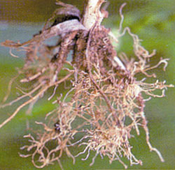
Poor roots due to take all
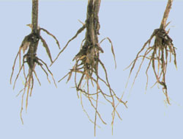
Crown rot causes crown stems with internal pink colour
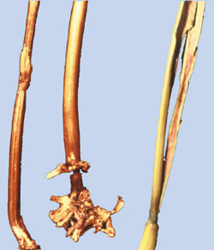
A Yahyaoui
Around Z5.5 to Z6.5 (heading to anthesis)
The symptoms of seed and soil-borne diseases usually appear on the crop
after heading. Smuts are seed-borne
Are some spikes completely white and dead? Take all or crown rot causes this problem. The disease will by this stage have completely destroyed the conducting system of the stems, thus killing and whitening the spikes. See above for earlier symptoms. Severe frost can produce similar symptoms, but then large continuous sections of the crop will be affected.
Other root rots are prevalent in South Asia, particularly when conditions are warm. Bipolaris sorokiniana causes brown necrotic roots and brown subcrown internodes. The root rot Sclerotium rolfsii is also prevalent.
Is one or more spikelets or the entire head bleached or partially dried out? Do these spikelets contain shrivelled and often discoloured seeds? This is likely to be caused by fusarium head scab (Fusarium graminearum) that is common on wheat grown in humid and warm areas. Spikes can be partially pink.
Are plants short with dark green leaves and an unpleasant fishy smell? These plants are infected with bunt (Tilletia tritici, Tilletia laevis). Bunt balls infect grains. At harvest the infected grains burst to release their mass of black spores.
Are plants relatively tall with smutted spikes? This is loose smut (Ustilago tritici). All that eventually remains of infected spikes is the bare central stalk.
Seedlings made brown by Bipolaris
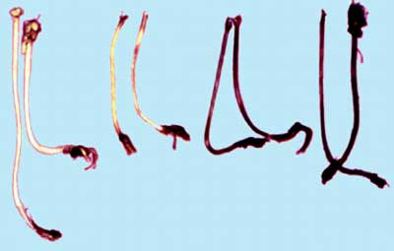
A. Yahyaoui
Head scab - pink spikelets are arrowed
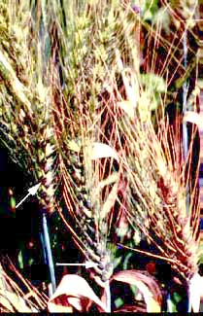
A. Yahyaoui
Ear with bunt - arrows point to the bunt balls
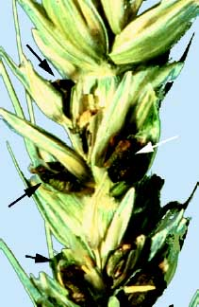
A. Yahyaoui
Causes of plant diseases
- Resistant varieties were not used. Some resistance is available to the rusts, to septoria, to cereal cyst (Heterodera spp) and stem nematodes (Pratylenchus spp) and to a lesser extent to crown and root rots. Check what variety was planted. Were other varieties planted in the area less affected? If so, were the farming methods also different?
- Infected seeds were planted. Was black point apparent in the seed sample? Where did the seed come from? Was it from last season’s crop on that field or purchased from a seed merchant? Absence of black point is unfortunately no insurance that the seed is clean of Bipolaris sorokiniana.
- Diseased standing crop residues were not removed prior to planting in a disease prone area, or an alternate host is present close by (grass species harbour yellow rust while non-grass species harbour leaf and stem rust). Look for remains of crop residues and other plants that could host the disease.
- No seed treatment or an inappropriate treatment was applied. Get details of the seed treatment and check whether it is an acceptable treatment for the disease identified.
- The soil was waterlogged during the seedling stages slowing emergence and early growth. Check the soil type and look for evidence of poor drainage. Was there heavy rain during seedling growth?
- Was wheat planted after wheat or after barley? Is the wheat crop next to a field of corn?
Solutions to disease
Rusts & powdery mildew
Sow more resistant varieties, and change varieties as often as practicable.
Avoid monoculture of a variety over large areas.
Apply fungicides if an epidemic level is reached, particularly for yellow rust.
Avoid excess application of nitrogen fertilizer.
Smuts
Use resistant varieties.
Use only clean seed harvested from a clean field. Ensure the harvester is not contaminated from the previous field.
Use treated seed or treat at the farm using available recommended fungicide.
Avoid deep planting particularly in fields where smut disease was present in previous years.
Pre-irrigate or plant into moist soil. Ensuring fast germination minimises early infection.
Rogue out any infected heads of loose smut and burn them outside the field.
Blotch diseases (Septoriaspp, tan spot)
Use resistant varieties and change varieties as often as realistically possible.
Avoid monoculture of a variety over large areas.
Avoid continuous cropping of wheat on the same field. Rotate wheat with a legume crop.
Avoid planting into the residues of the previous crop.
Use plump and clean seed uncontaminated with plant debris.
Avoid excess nitrogen fertilizer and high seeding rates. Dense foliage encourages faster development and spread of disease.
Root rot disease-complex
Use resistant varieties
Avoid cereal monoculture (wheat after wheat) and rotations that include consecutive host crops for the diseases.
Remove standing crop residues and any alternate hosts for the disease.
Include a legume or biofumigant crop in the rotation. These are not hosts for the disease so avoid build up of disease inoculum. Diseases like take all may require two seasons without wheat to kill all inoculum (pulses, oilseeds and potatoes are not hosts).
Avoid growing wheat after corn or even near a cornfield if Fusarium head scab is present in the area.
Ensure fast crop emergence by avoiding deep planting and by pre-irrigation.
Do not sow into a dry soil and then irrigate shortly after as this encourages Pythium species particularly if the soil remains wet for a long period. Irrigate before sowing and do not irrigate again until the crop is tillering (Z2.1).
Improve crop nutrition by the balanced use of fertilizers. Phosphate and potassium fertilizers will reduce infection.
Improve soil aeration and drainage by cultivation and increased organic matter.
Apply a seed treatment (Meisner et al 1994).



