ALPINE ASCENTS
Aptech eProject — Complete Project Report
Responsive Single-Page Mountaineering Information Portal


1. Introduction
Alpine Ascents is a responsive single-page mountaineering information portal. It organizes educational information about mountaineering and presents history, types/styles, techniques, sheltering, hazards, records, organizations, locations, success stories, gallery material, latest developments and general guidelines.

2. Objectives
Provide a user-friendly portal, organize information into clear sections, demonstrate responsive design, provide visual media, use JSON for structured local data, demonstrate map/geolocation features, and implement the required visitor counter and continuous date/time/location ticker.

3. Problem Definition
The source specification requires a visually appealing and responsive Single-Page Application with detailed mountaineering information and supporting records, organizations/locations, success stories, gallery, latest developments and guidelines. It also specifies hyperlinks, a bottom ticker, visitor count, menu hover/click states and fade effects.

4. Proposed Solution
The project uses HTML5 for structure, Bootstrap 5 for responsive layout, custom CSS for the premium mountain UI, JavaScript for interactions, JSON files for structured data, Leaflet/OpenStreetMap for the map, and the browser's HTML5 Geolocation API.

5. Functional Requirements
Implemented: SPA navigation; mountaineering information; history; types/styles; techniques; sheltering; hazards; records; organization/location map; success stories; gallery and video placeholder; latest developments; guidelines; contact form; visitor counter; date/time/location ticker; hover/active navigation states; scroll/fade animations.

6. Non-Functional Requirements
Responsive desktop/tablet/mobile layout; accessible labels and semantic elements; readable contrast; reduced-motion support; responsive images; organized source code; and graceful fallbacks when JSON or geolocation is unavailable.

7. System Architecture
Presentation: index.html. Styling: css/style.css. Logic: js/script.js. Data: data/*.json. Local assets: images and favicon. External resources: Bootstrap, Icons, Google Fonts, Leaflet and OpenStreetMap tiles. Browser services: HTML5 Geolocation and localStorage/sessionStorage.

8. System Flowchart Description
START → Load website → Display navbar and hero → User selects a section → Content is displayed → User interacts with records/gallery/map/stories → Date and time continue updating → Geolocation permission can be requested → Location or fallback is displayed → Continue browsing / END.

9. DFD Level 0
The User interacts with the Alpine Ascents Website. The website supplies information/guidelines, records/organizations and gallery/stories. Map tiles and browser geolocation act as external support sources.

10. DFD Level 1
Processes are divided into navigation, mountaineering information, records, organization/location management, gallery/stories, and developments/guidelines. JSON files are the local structured data stores.

11. UI/UX Design Specifications
The interface uses deep navy, mountain blue, icy highlights, glass panels, rounded cards, cinematic imagery, sticky navigation, active states, smooth scrolling and scroll-triggered reveal animations.

12. Technologies Used
HTML5, CSS3, Bootstrap 5.3, JavaScript ES6+, Bootstrap Icons, Leaflet, OpenStreetMap tiles, Google Fonts, JSON, localStorage/sessionStorage and HTML5 Geolocation API.

13. Hardware Requirements
The source document lists Intel Core i3/i5 or higher, 8 GB RAM or above, color SVGA, 500 GB hard disk space, mouse and keyboard.

14. Software Requirements
The source document lists Windows and browsers including Edge, Chrome, Firefox and Safari. This implementation additionally relies on modern browser APIs and CDN resources for its demonstration features.

15. Module Description
Modules: Home/Hero, About, Mountaineering Topics, History, Types/Styles, Techniques, Sheltering, Hazards, Records, Organizations/Map, Success Stories, Gallery, Latest Developments, Guidelines, Contact and Footer/Ticker.

16. Database/Data Storage Description
This is a frontend project rather than a database-backed application. records.json stores record entries; organizations.json stores organization/location entries; stories.json stores fictional educational stories; mountains.json stores sample mountain data; localStorage stores the browser-local visitor demonstration count.

17. Geolocation Feature
navigator.geolocation.getCurrentPosition is used. With permission, approximate coordinates are displayed and a map marker can be added. On denial or failure, a fallback message is shown and the site remains usable.

18. Visitor Counter
A front-end demonstration uses localStorage and sessionStorage. A first visit in a browser session increments the stored value. A true global visitor counter would require a backend or analytics service.

19. Date/Time/Location Ticker
The fixed bottom ticker updates every second with JavaScript Date API data and either approximate coordinates or a location-unavailable fallback.

20. Testing Strategy
Test navigation, mobile menu, active states, animations, JSON data, map markers, geolocation, gallery filters/lightbox, modals, visitor counter, ticker, form validation, images, links and responsive breakpoints.

21. Test Cases
18 test cases are included in docs/Test_Cases.docx.

22. Test Data
Sample data is included in data/records.json, data/organizations.json, data/stories.json and data/mountains.json.

23. Installation Instructions
Extract the ZIP and open index.html. For full JSON fetch behavior, use a local server such as VS Code Live Server. Internet access is required for CDN libraries and OpenStreetMap tiles.

24. User Guide
Use the navbar to jump to sections. Use the Mountaineering dropdown for subtopics. Read More opens information modals. Filter and click gallery images for the lightbox. Click an organization card to focus the map. Use My Location to request geolocation. Submit the contact form to display a frontend success toast.

25. Assumptions
The project is an educational frontend demonstration. Some records and organization entries are sample data. The visitor count is browser-local. The contact form does not send data to a real server. External CDN/map resources require internet access.

26. Limitations
No real global visitor analytics, backend message delivery, secure server storage or verified live organization directory is included. Map tiles depend on external service availability.

27. Future Enhancements
Add a backend/API, database, authenticated administration, verified organization directory, real expedition media, global analytics, live weather, richer map layers, search and multilingual support.

28. Conclusion
The completed Alpine Ascents portal implements the core requirements of the source specification as a polished responsive SPA while keeping the architecture understandable for a student eProject.

29. Flowchart
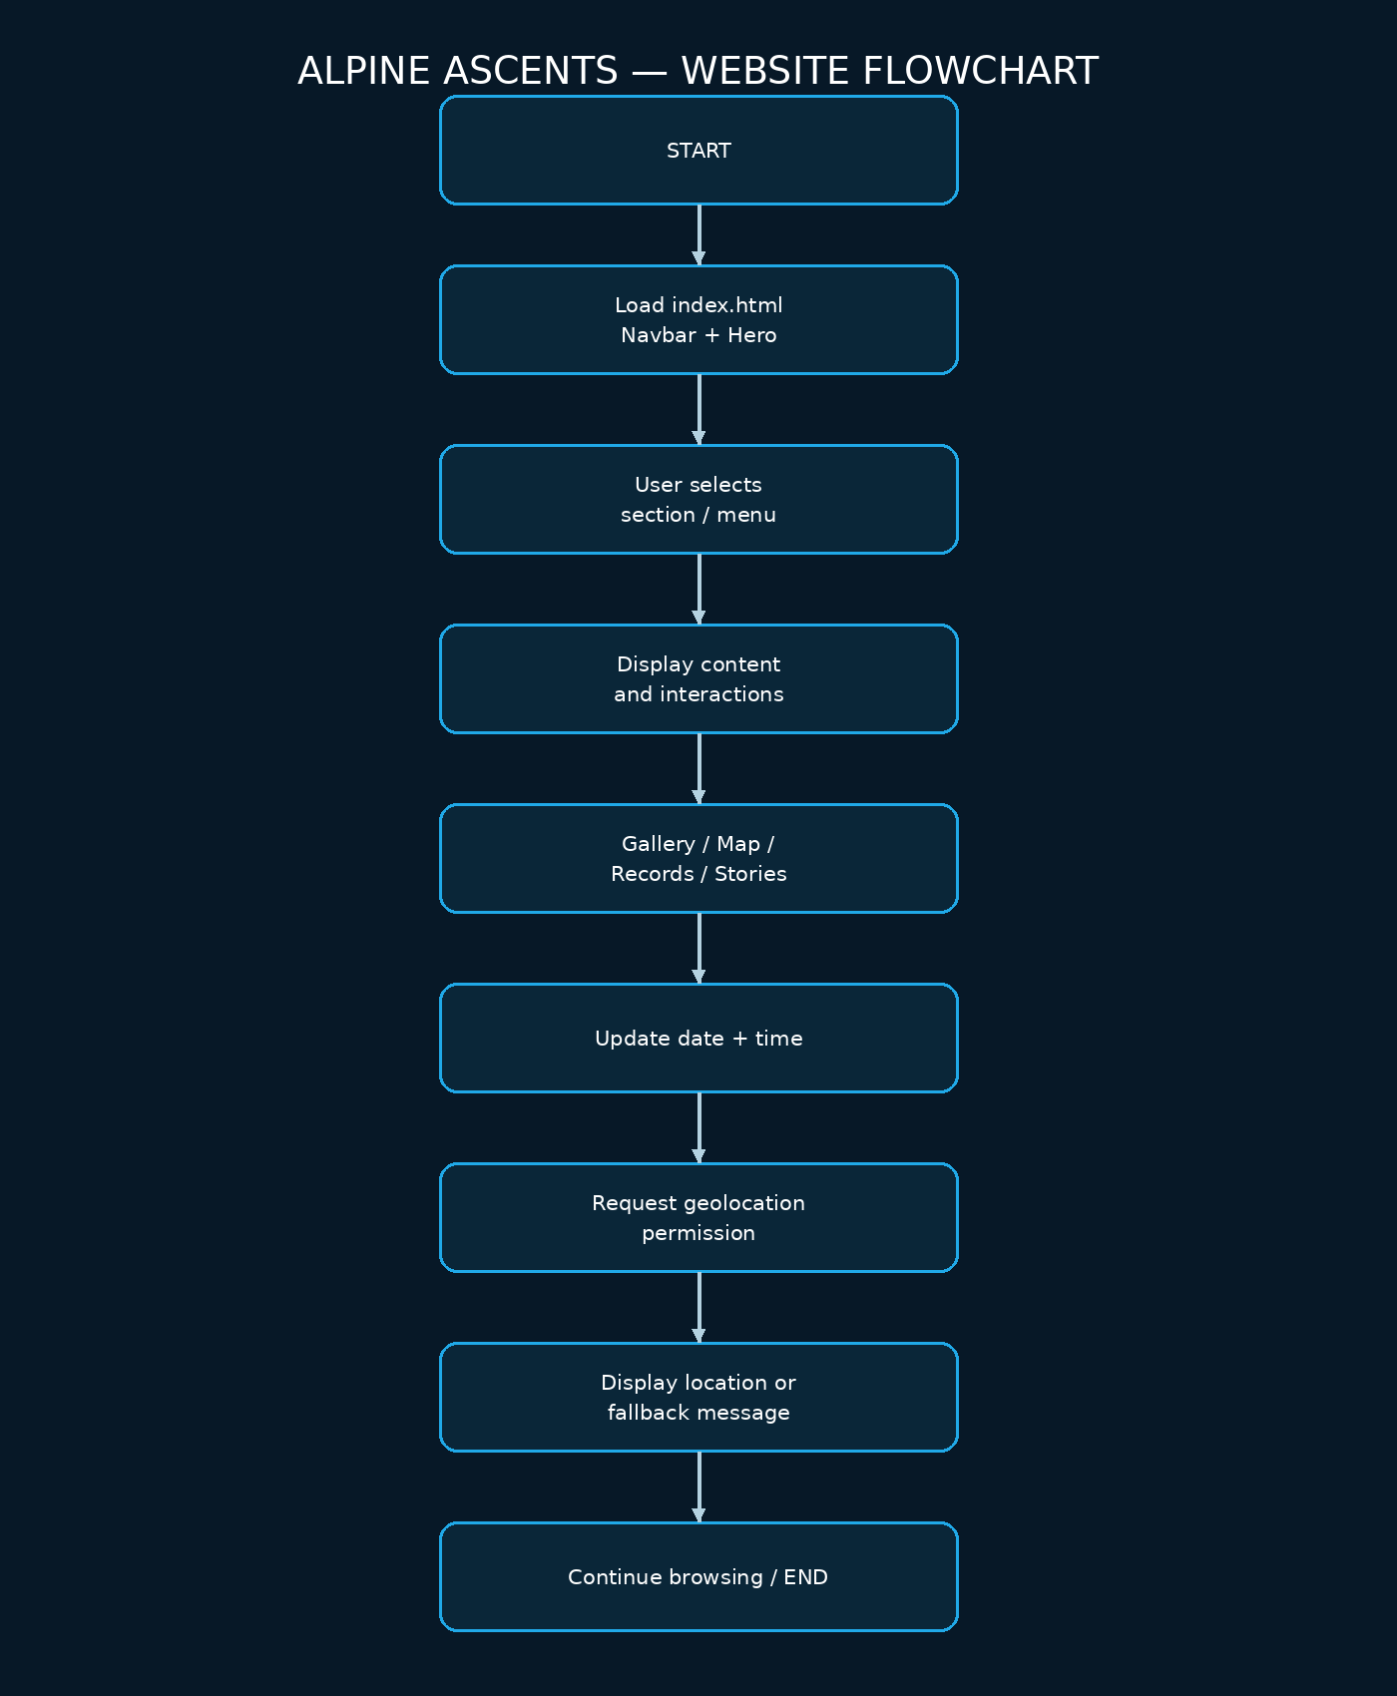

30. DFD Level 0
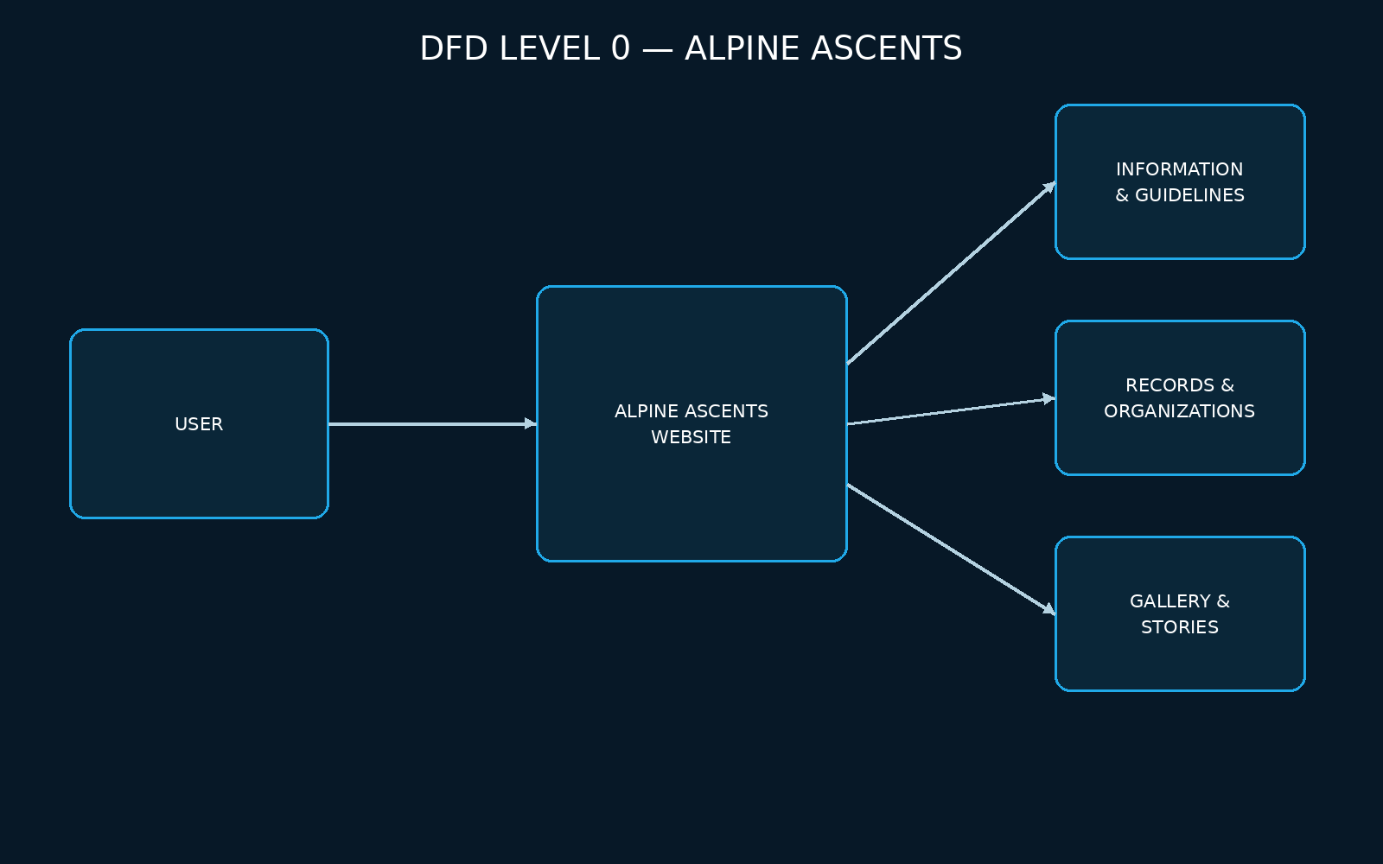

31. DFD Level 1
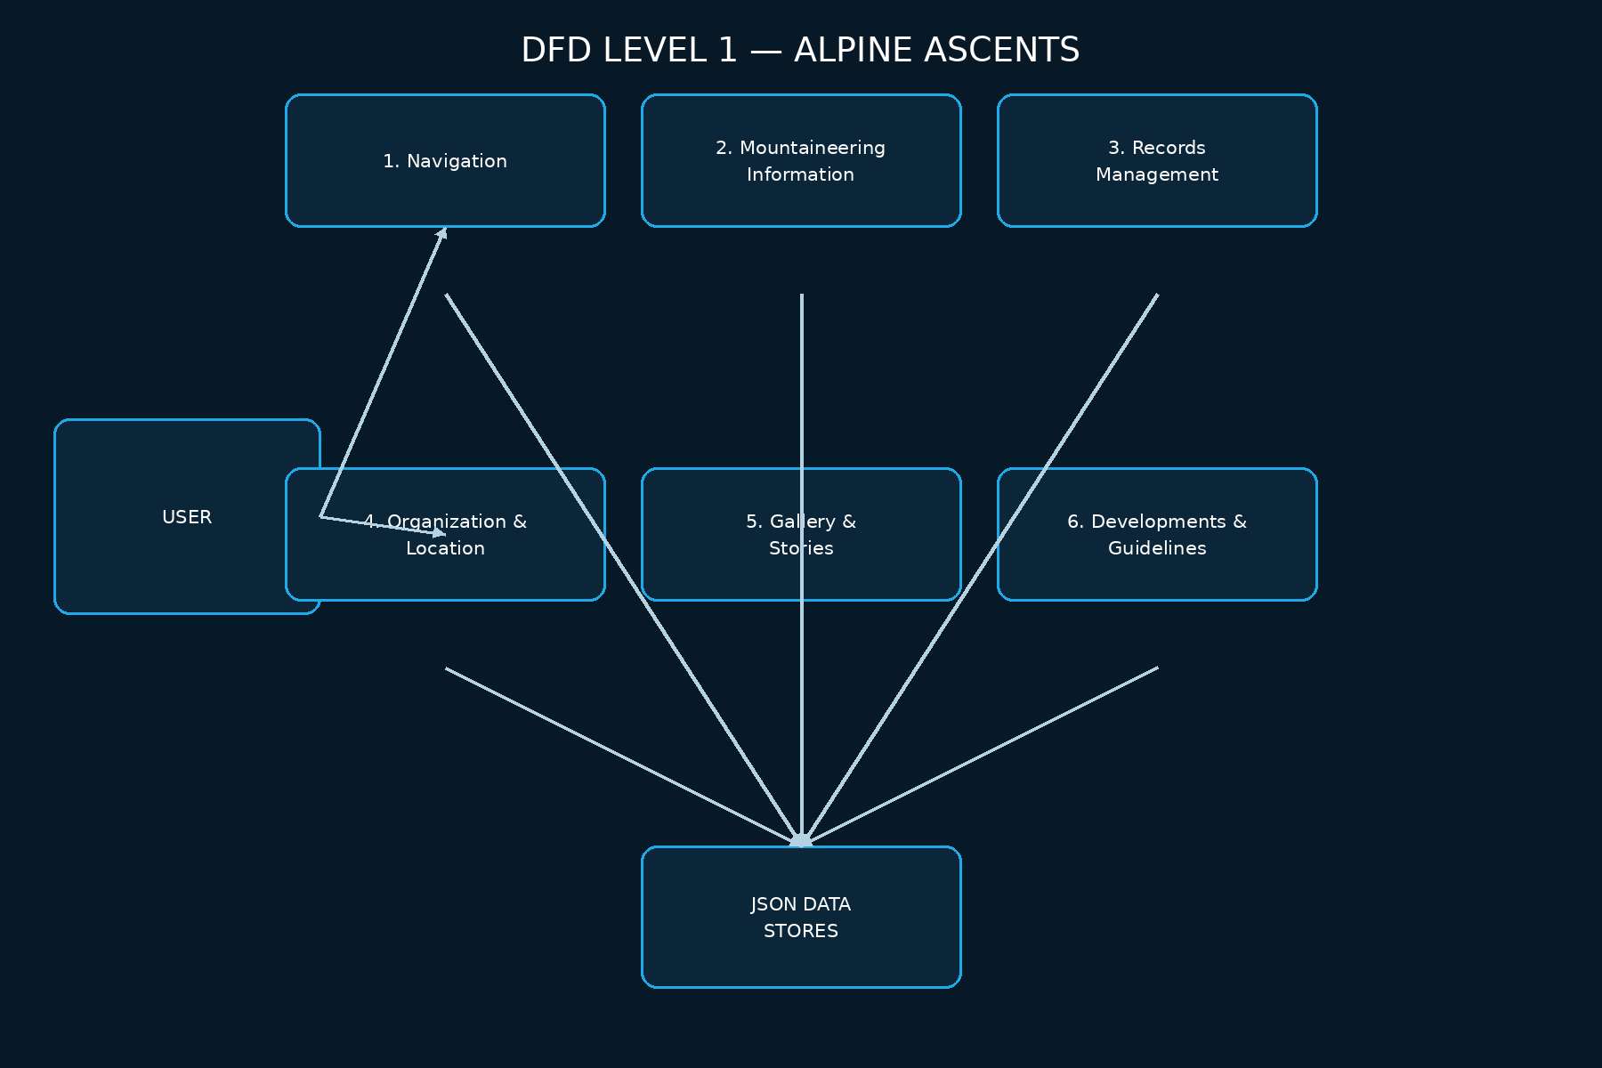

32. Test Case Table
ID | Feature | Input | Expected | Actual | Status
TC-01 | Navbar | Click Home | Scrolls to Home | Scrolls to Home
TC-02 | Dropdown | Click Mountaineering | Dropdown opens | Dropdown opens
TC-03 | Active nav | Scroll/click section | Active state changes | Active state changes
TC-04 | Mobile menu | Narrow viewport | Hamburger menu opens | Hamburger menu opens
TC-05 | Hero CTA | Click Explore | Mountaineering opens | Mountaineering opens
TC-06 | Modal | Click Read more | Modal displays content | Modal displays content
TC-07 | Counters | Scroll to stats | Counters animate | Counters animate
TC-08 | Records | Load page | Record rows appear | Record rows appear
TC-09 | Organizations | Load page | Organization cards appear | Organization cards appear
TC-10 | Map | Click organization | Map focuses marker | Map focuses marker
TC-11 | Geolocation | Click Use my location | Coordinates or fallback shown | Coordinates or fallback shown
TC-12 | Gallery filter | Click Camps | Only camp items show | Only camp items show
TC-13 | Lightbox | Click gallery image | Full image opens | Full image opens
TC-14 | Ticker | Wait 1 second | Clock updates | Clock updates
TC-15 | Visitor counter | New session | Counter increments locally | Counter increments locally
TC-16 | Form validation | Submit empty | Validation blocks submit | Validation blocks submit
TC-17 | Form success | Submit valid | Success toast appears | Success toast appears
TC-18 | Responsive | Resize to mobile | Layout remains readable | Layout remains readable

33. Source Specification Alignment
The source document requires a single-page responsive portal, detailed mountaineering information, history, types/styles, techniques, sheltering, hazards, records, organization/club locations using geolocation/map, success stories, gallery videos/pictures, latest developments, guidelines, hyperlinks, a continuous date/time/location ticker, a top-right visitor count, hover/click menu color changes and fade effects. These requirements are represented in the implementation. The source also lists a broad technology set; this project uses the practical frontend subset needed for a static SPA.

