

**Instructor:**

* Mr. Muhammad Waseem

**Guide Lines/Instructions:**

* Use of Spyder IDE/Anaconda in this lab.

Registration No. Name:

* Create meaningful variable names. Add comments for readability. Indent each line of your code.
* Plagiarism/Cheating is highly discouraged by penalizing to both who tried and one who shared his/her code.

**Today’s Task:**

* Python Environment Setup using Spyder IDE
* Get comfortable with the Python Syntax Specifically Arrays
* Learn to write recursive tasks

**Installation Guideline:**

* Go to the website [Home --- Spyder IDE](https://www.spyder-ide.org/) and click the download button at the bottom or download from the direct link [Spyder Install](https://github.com/spyder-ide/spyder/releases/latest/download/Spyder_64bit_full.exe) (221 MB).
* Run the setup file according to Figure 1. Complete the installation with the emerging instructions.

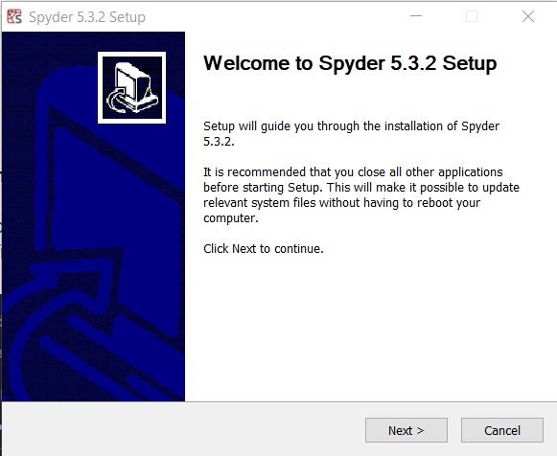

*Figure 1 Spyder Installation Interface*

* Launch the Spyder from the installation directory.
* You will see the interface according to Figure 2.
* Write your first program in python



* Note that python does not require the program template as required in C++ and C#.

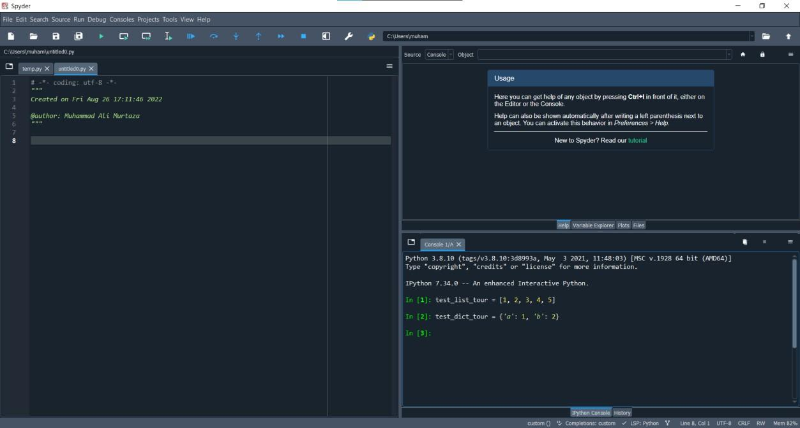

*Figure 2 Spyder IDE Home Screen*

**Part1: Getting Comfortable with Python Activity 1:**

Run the above code using command prompt. Write below the process of running program from cmd (commands).

| Open cmd  Switch to directory using cd Write python Write “print(“Hello world!”) |
| --- |

**Activity 2:**

Describe the process of code compilation and execution in python. How the byte code will be generated? How the process is different from C#. Write in your own words.

| in c# the code runs in compiler i.e the whole is executed before running and converted into an intermediate language While python converts the code into byte code and runs on interpretor i.e it means it runs line by line where the error occurs it breaks the code. |
| --- |

Here are some examples that will provide you the roadma p of Conversion from C# to Python.

**Example 1.1: Write a Program to display value**

| **C#** | **Python** |
| --- | --- |
| using System;  public class ConsoleApp1  {  public static void Main()  {  // declare variable with int datatype int a = 5;  // prints the string System.Console.WriteLine("The  value of a is: " + a);  }  } | # No compulsory library is required for simple programs  a = 5  # no terminator restriction print("The value of a is: ", a) |

**Example 1.2: Input value from User**

**Example 1.3: Array Declaration of 1D and 2D arrays**



**Activity 3:**

We do not specify the data type of variable in python. How python will infer the data type. How will you verify the data type of variable in python. Give convincing justification.

| Python defines the data type dynamically at the run time depending upon the the data we use  to verify the type we use type function int a=5  print(type(a)) |
| --- |

**Example 1.4: Array of Zeros**

**Example 1.5: 1D array of Random ints**



**Example 1.6: Traversal of an array**

| #Traverse in forward direction using for loop  str = [“U”, “E”, “T”]  for x in range(len(str)): print(str[x])  array = [32, 1, 9, 31, 12, 22]  # Reverse by using a slice # slice (start, end, step) print(array[::-1]) | #Traverse in backward direction using reverse method  array.reverse() print(array)  #Traverse through an array using for loop for i in range(len(array)-1, -1, -1):  print(array[i]) |
| --- | --- |

**Example 1.7: Slicing of Arrays—Extracting subarrays**

Slicing in Python is a feature that enables accessing parts of sequences like strings, tuples, and lists. Here are some examples on arrays that would explain slicing.

| **Starting subarray** | **Middle subarray** | **Ending subarray** |
| --- | --- | --- |
| >>> arr = [1,2,3,4,5]  >>> arr [:2]  [1, 2] | >>> arr = [1,2,3,4,5]  >>> arr [1:3]  [2, 3] | >>> arr = [1,2,3,4,5]  >>> arr [2:]  [3, 4, 5] |
| **Important**  In python, subarrays can also be extracted through negative indices.  >>> arr = [1,2,3,4,5]  >>> arr [-2:]  [4, 5]  Here -1 means the first element from last. -2 means second element from last. | | |

**Example 1.8: Read data from File**

Let say we have single file for this code testing named **test.txt** and we have single line written in it as:

**Note:**

Example modes for opening file in python are:

w 🡪 Write mode r 🡪 Read Mode

a 🡪 Append Mode

x 🡪 Open for exclusive creation, failing if the file already exists

**Example 1.9: Write data to File**

| #Write array elements one per line to file  arr = ['Hello world', 'UET']  f = open (file="test.txt", mode="w") for i in arr:  f.write (i + "\n") | **Output:**  Hello World UET |
| --- | --- |

**Example 1.10: Play with functions**

| **Pass an array to function** | **Return array from function** |
| --- | --- |
| def display(arr): for i in arr:  print(i)  array = [1, 2, 3, 4, 5, 6, 7, 8, 9]  display(array) | def get_name ():  names = ['Ali', 'Ahmad', 'Hassan'] return names  names= get_name () |

**Activity 4:**

| python being dynamically-typed language have two types of dataypes i) Immutable ii)Mutable Immutable datatypes are builtin datatypes and cannot be changed after they were created.EX:=> int, bool  Mutable datatypes canbe changed after their creation.Ex: => dictionary,array |
| --- |

What are mutable and immutable data types in python. Give at least three examples for each.

**Part 2: Think Recursively**

**Example 2.1: Calculate sum of integers**

| **Iterative** | **Recursive** |
| --- | --- |
| sum = 0  for i in range (11): sum += i  print(sum) | def sum(n):  if n == 0:  return n else:  return n + sum(n-1) print (sum (10)) |

**Example 2.2: Print array of elements**

| **Iterative** | **Recursive** |
| --- | --- |
| arr = [1,2,3,4,5,6,7,8,9,10]  for i in arr:  print(i) | def printArray (arr, start, end): if start == end:  print(arr[start]) else:  print(arr[start])  printArray (arr, start+1, end)  arr = [1,2,3,4,5,6,7,8,9,10]  printArray (arr, 0, len(arr)-1) |

**Example 2.3: Calculating power function through recursion.**

| **Iterative** | **Recursive** |
| --- | --- |
| num = 2  power = 5  result = 1  for i in range(power): result = result * num  print(result) | def power (n, k): if k == 1:  return n else:  return n * power (n, k-1) |

**Example 2.4: Factorial of Number using recursion**

**Activity 5:**

What is recursion? Give some prose and cons of recursion

| when function call itself in its body its called recursion Example: func():  func()  Pros:Breaks the complex logic into smaller  Cons:Memeory leaks as it stores in memory in stack |
| --- |

**Activity 6:**

How recursive function is evaluated in memory. Give some details

| Recursive function is elevated in stack as stack follows the LIFO(Last In First Out) approach it means the lastly called function is executed completely first time and then the function which calls that function |
| --- |

**Note:**

1. Whenever you are asked to read array, you are required to load array from the file, reading each element per line.
2. Do not take input from console for array.

**Problems**

| 1. Look for the index of the given element x in the given array:  X = [22,2,1,7,11,13,5,2,9]  SearchA(Arr, x) – return array of indices  Arr: Array  x: element to be searched | **Input**: Enter the number: 2  **Output**: Index: 1,7 |
| --- | --- |
| 2. Answer question 1 in the scenario where the input array is already sorted.  How much elements you need to check in sorted array.  SearchB(Arr, x)-- return array of indices  Arr: Array  x: element to be searched | **Input**: Enter the number: 2  **Output**: Index: 1,7 |
| 3. Write a function that takes an array as input, starting and ending index and return the index of minimum element from start to ending index in the array.  Minimum(Arr, starting, ending)— return integer | For example, you are given the following inputs Array: [3,4,7,8,0,1,23,-2,-5]  StartingIndex: 4  EndingIndex: 7  Output: (Return index of minimum element) 7 |
| **4.** Sort an array X using the above generated function.  **Hint:** Find the smallest element from the unsorted part of the array repeatedly and place it at the start of the array.  Sort4(Arr)—return array Arr: Array to be sorted | **Output**: X = [-5, -4, -3, 0, 1, 1, 4, 35,  100, 101] |
| 5. Extract the relevant portion and print it in the reverse direction from the string  s = **"University of Engineering and Technology Lahore"**.  Without using any loop and reverse () method.  StringReverse(str, starting, ending)—returns string | **Output**: "ygolonhceT dn" |

| 6. Given a number, the task is to find the sum of its digits using an iterative and recursive method.  SumIterative(number) – returns integer  SumRecursive(number)-- returns integer | **Input**: 1524  **Output**: Sum of digits is: 12 |
| --- | --- |
| 7. Find the sum of the given matrix both column- and row-wise.  1 13 13  A = [5 11 6 ]  4 4 9  ColumnWiseSum(Mat) – returns 1d array RowWiseSum(Mat) – returns 1d array | 27  **Output**: Row-wise: 22  17  Column-wise: 10 28 28 |
| 8. Without using any sorting methods, combine two sorted arrays keeping the resultant array sorted in ascending order.  A = [0,3,4,10,11]  B = [1,8,13,24]  SortedMerge(Arr1, Arr2) – returns sorted array | **Output:** [0,1,3,4,8,10,11,13,24] |
| 9. Write a recursive function that takes a string and returns if the string is palindrome or not.  PalindromRecursive(str)- returns a boolean | **Input:** "radar"  **Output:** Palindrome |
| 10. Sort the given array so that the elements are arranged in the following way while taking ascending order into consideration Sort10(Arr)—returns array | **Input:** [10, -1, 9, 20, -3, -8, 22, 9, 7]  **Output:** [-8, 7, -3, 9, -1, 9, 10, 20, 22] |

**What to Submit:**

1. Only .py files are allowed.
2. For Lab1, you are required to write all functions in single file, funcs.py
3. For each problem, create a driver .py file
   1. Lab1.py
4. Functions names input and output should be exactly same.
5. Zip all files, and submit on eduko