Report))

Abdulrhman Abdulaziz Alshilil

Report 1 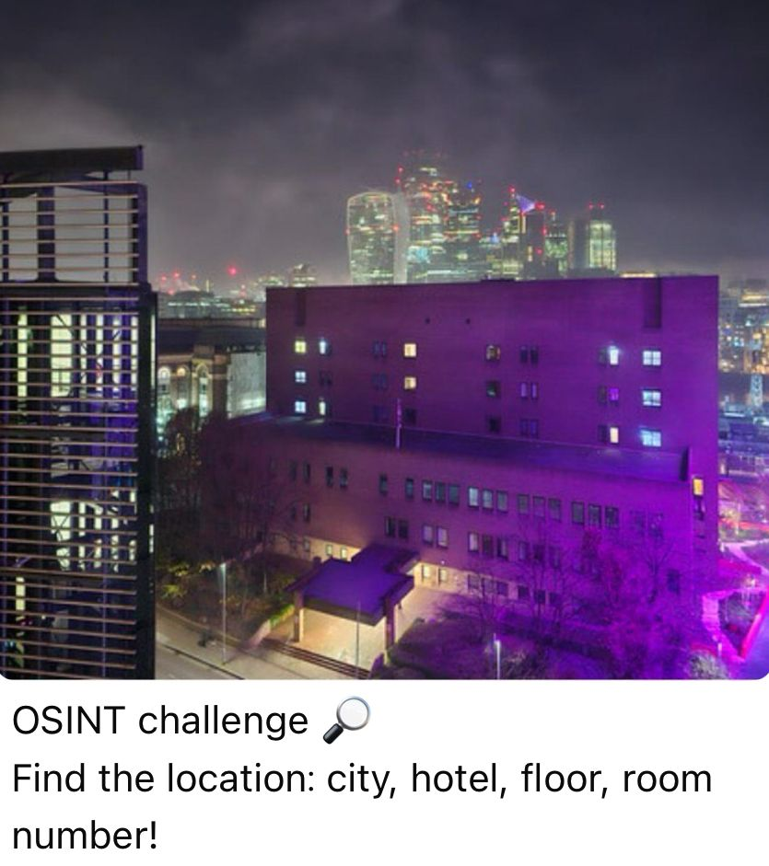

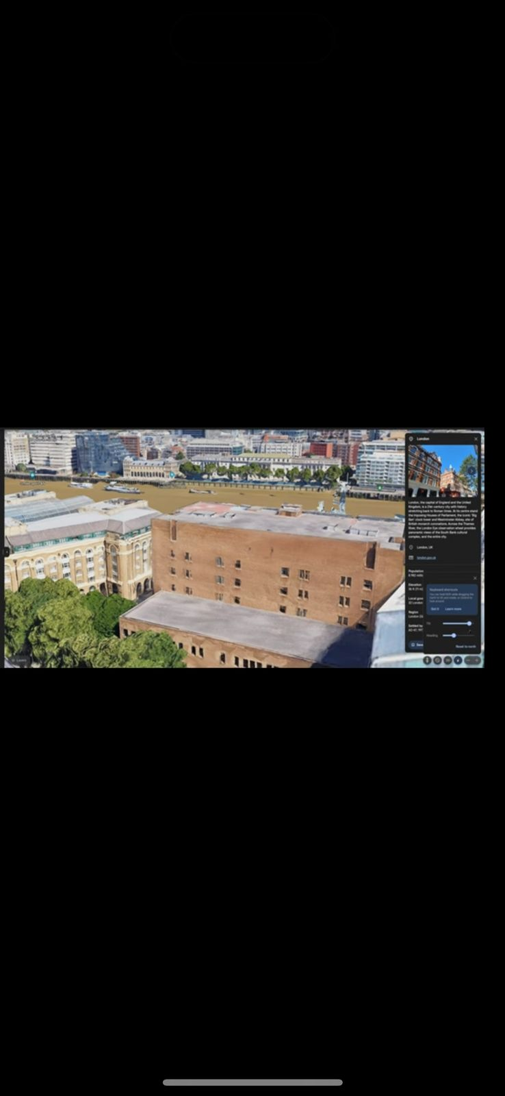The photo was taken from approximately this side

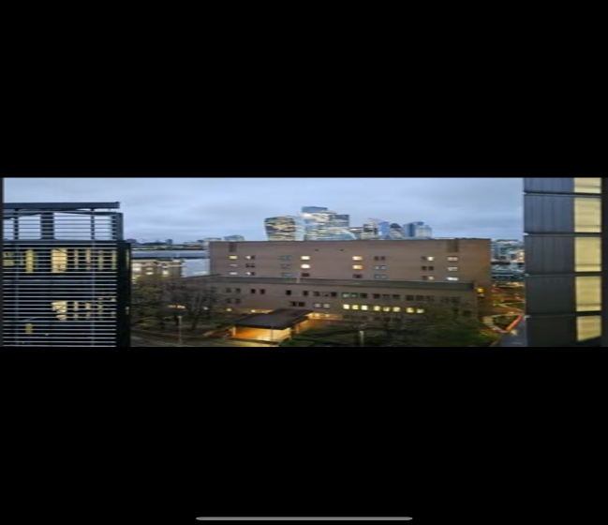

Hotel name: Hilton London

Room number: 809

floor: 8