Final Project Proposal

Idea Title
Traffic Prediction & Urban Mobility Analysis

Team Members
- Abdulrahman Salama (Team Leader)
- Mohamed Alaa
- Menna Mahmoud
- Basant Osama
- Hayam Mostasfe Ghoneem

Task Distribution
Task | Responsible Members
Data Preprocessing & Cleaning | Basant Osama, Menna Mahmoud
Exploratory Data Analysis (EDA) | Basant Osama, Mohamed Alaa
Supervised Machine Learning (Regression / Classification) | Abdulrahman Salama, Hayam Mostasfe
Unsupervised Machine Learning (Clustering + Dimensionality Reduction) | Mohamed Alaa, Hayam Mostasfe
Deep Learning (DNN + Specialized Architecture) | Abdulrahman Salama, Menna Mahmoud
Streamlit Deployment (Dashboard + Integration) | Abdulrahman Salama, Basant Osama

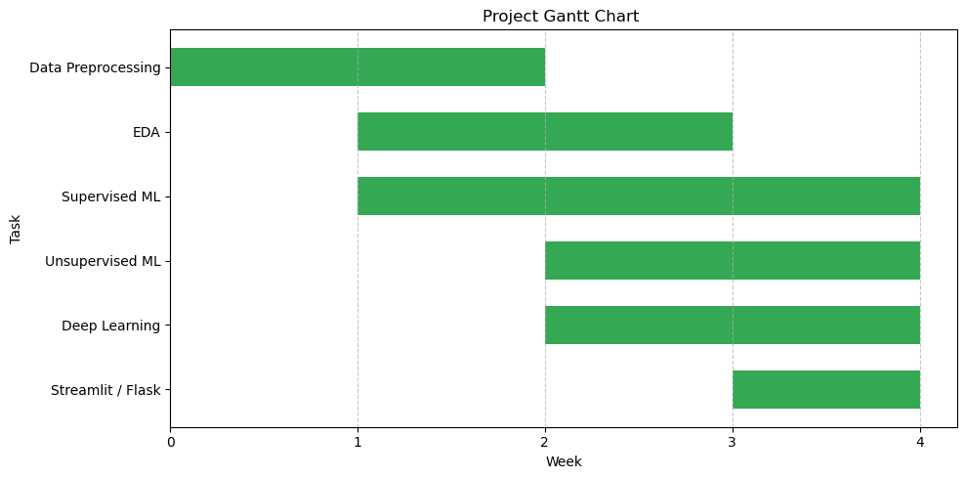
Time plain

