SMART DOCUMENTATION HUB

Key Features of Project

1. Document Upload & Management

- Upload: PDF, images, DOCX, government IDs
- Auto tagging (certificate, ID, resume, etc.)
- Organize in folders

2. Real-Time Document Editing

- React + WebSockets (SignalR in .NET)
- Multiple users can view/edit together
- Live cursor tracking
- Auto-save

3. Inline Comments

- Users can comment on specific text/lines/areas
- Mention people “@username”
- Resolve, reply, delete

4. Version Control

- Every save = new version
- Users can compare versions
- Restore older versions

5. Public Profile + QR Code

- A user gets a unique profile link
- Recruiters scan QR → see user’s:
      - Resume
      - Certificates
      - Basic info

6. Permissions

- View-only
- Edit
- Comment-only
- Expiring links (security)

WHY THIS PROJECT????

We built this project because today people have their documents scattered everywhere — certificates in email, resumes in folders, government IDs in phone gallery, and job documents on portals like Naukri.
There is no single platform where a person can store, edit, and share all their important documents in a clean, secure, and professional way.

So we created a Smart Document Hub that combines the usefulness of DigiLocker and the job-focused features of Naukri.com.
It allows users to store documents securely, edit resumes in real-time, add comments, track versions, and share everything with a single QR code or profile link.

This solves a real problem of document management, job application confusion, and collaboration.

USE CASES

1. Register / Login

“User logs in to access the system and their documents.”

2. Upload Documents

“User uploads certificates, IDs, and resumes safely.”

3. View / Download Documents

“User can open or download their stored documents anytime.”

4. Organize Documents

“User arranges files into folders or tags for easy access.”

5. Real-time Editing

“Users can edit documents live, just like Google Docs.”

6. Inline Comments

“Users or HR can add comments on specific parts of a document.”

7. Version Control

“The system saves multiple versions of a document for restoring later.”

8. Share Profile / QR Code

“User shares all documents using one link or QR code.”

9. Public Profile View (HR)

“HR can open the link and see the user’s documents.”

10. Permission Management

“User controls who can view, comment, or edit their files.”

11. Search Documents

“User finds any document quickly using the search bar.”

12. Delete / Archive Documents

“User can remove or temporarily hide documents.”

13. Admin Management
“Admin monitors all users, documents, and system activities.”

USE CASE DIGRAM
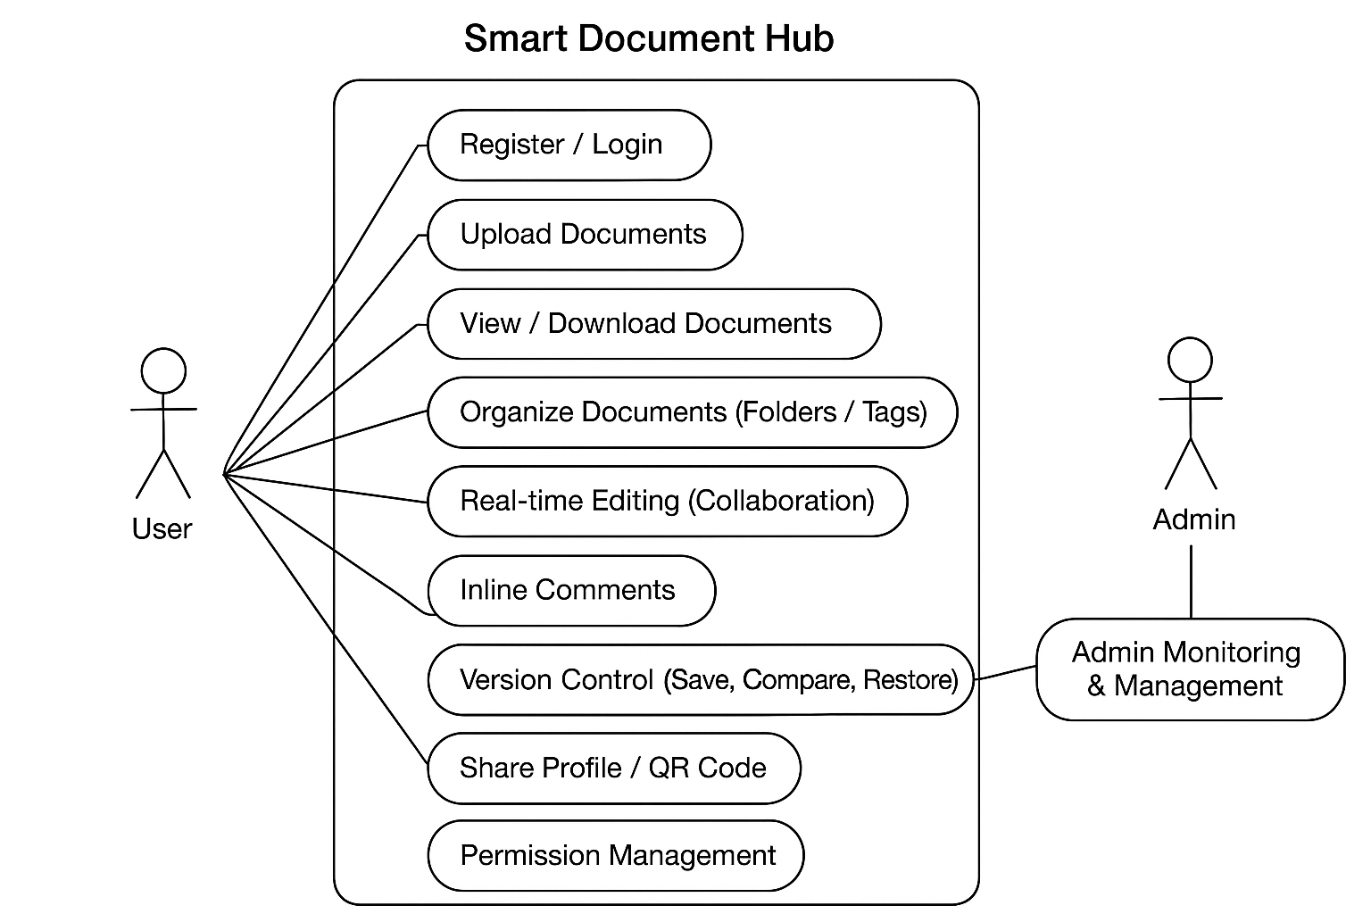

BUSINESS POV / EARNING OPPORTUNITY????

- Extra storage
- Advanced version control
- AI-powered resume enhancement
- Priority support
- Pro analytics (how many HR viewed your profile)

Security & Privacy Protection

Email-Based Selective Access for HR
When an HR wants to review a candidate’s profile, the HR can request access by sending an official email through our platform.
Once the user receives the email:
- The user logs in to the system and opens the access request.
- The system clearly shows which documents the HR is requesting (e.g., “Resume + Degree Certificate”).
- The user can choose to:
  - Allow only the requested document
  - Allow fewer documents than requested
  - Decline the access request completely
- The user can set additional conditions before granting access:
  - Access level → View / Comment / Edit
Validity period → 24 hours / 7 days / 30 days
  - Disable downloads if needed
Only after the user approves the request does the HR receive a secure link and OTP to access the approved files — and nothing else.
This ensures that:
- HR sees only what the user chooses
- No document is ever shared automatically
User remains in complete control of privacy and data access

Document Access Logs
For transparency, the system tracks:
- Who viewed the document
- Date & time of access
Actions performed (viewed, commented, downloaded, edited)
Users can monitor which HRs have accessed their profile.

Compliance & Privacy Policy
The system follows:
- GDPR-inspired privacy standards — user owns and controls their data
- Zero-knowledge policy — admins cannot view user documents
- Data retention policy — deleted documents are permanently destroyed after 30 days

