**Difference Between Method Hiding And Method Overriding In C#**

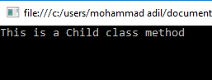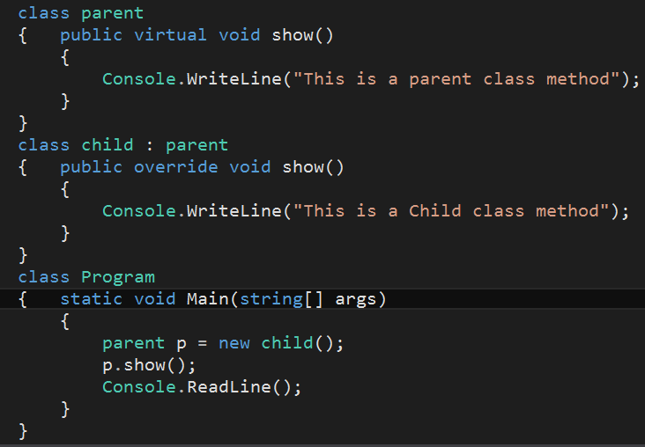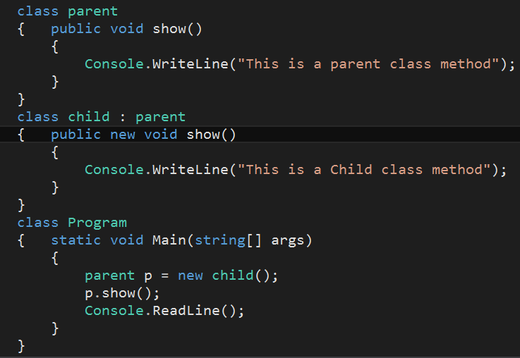

In **method overriding**, a base class reference variable pointing to a child class object, will invoke the overridden method of the child class.

In **method hiding**, a base class reference variable pointing to a child class object, will invoke the hidden method of the base class.

**METHOD OVERRIDING OUTPUT**

**METHOD HIDING OUTPUT**

**METHOD OVERRIDING**

**METHOD HIDING**