**Collections In C# Programming**

|  |  |
| --- | --- |
| ARRAY | COLLECTION |
| Cannot be resized at run-time. | Can be resized at run-time. |
| The individual elements are of the same data type. | The individual elements can be of different data types. |
| Do not contain any methods for operations on elements. | Contain methods for operations on elements. |
| We can never insert a value into a middle of an array. | We can insert a value into a middle of a collection. |
| We can never delete a value from a middle of an array. | We can delete a value from a middle of a collection. |

* A Collection is a set of related data that may not necessarily belong to the same data type that can be set or modified dynamically at run-time.
* In other words, collection is a dynamic array.
  + Its Length can increase on runtime. AUTO RESIZING
* Normal Array’s length is fixed, it means we cannot change the length after declaring an array.
* Array.Resize()
* Resize method of an array destroys old array and create a new array with new length.
* We can never insert a value into a middle of an array, because if we want to do this then array length should be increased but we cannot increase the length of an array after declaring the length of an array.
* We can never delete a value from a middle of an array.
* Accessing collections is similar to accessing arrays, where elements are accessed by their index numbers. However, there are differences between arrays and collections in C#.
* Collections were introduced in C# 1.0
* We have two kinds of Collections.
  + Non-Generic collections
    - Stack, ArrayList, Hashtable, SortedList etc.
    - **System.Collections** namespace have non-generic collections.
  + Generic collections.
    - List<T>, LinkedList<T>, Queue<T>,SortedList<T,V>.
    - 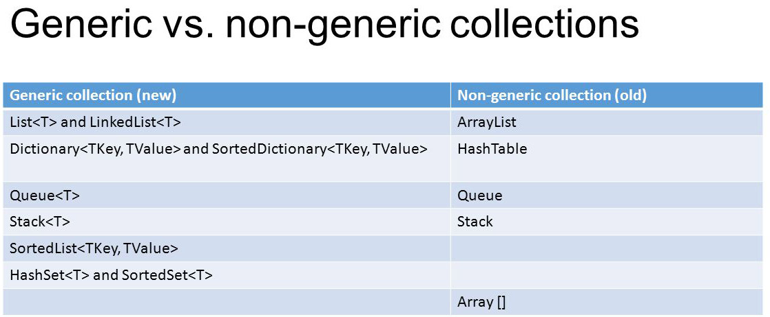**System.Collections.Generic** namespace have generic collections.
* Collections have a mechanism called **auto-resizing.**
* **Capacity** property which tells number of items that can be stored under any collection.
* INSERT METHOD.
* REMOVE AND REMOVEAT METHOD.