**Common Language Runtime (Clr) In Dotnet Framework**

* **The CLR:**
  + Is the foundation of the .NET Framework.
  + Acts as an execution engine for the .NET Framework.
  + Manages the execution of programs and provides a suitable environment for programs to run.
  + Provides a multi-language execution environment.

**The following figure shows a more detailed look at the working of the CLR:**

**MSIL**

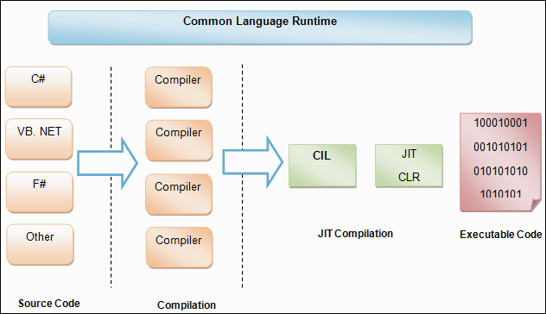

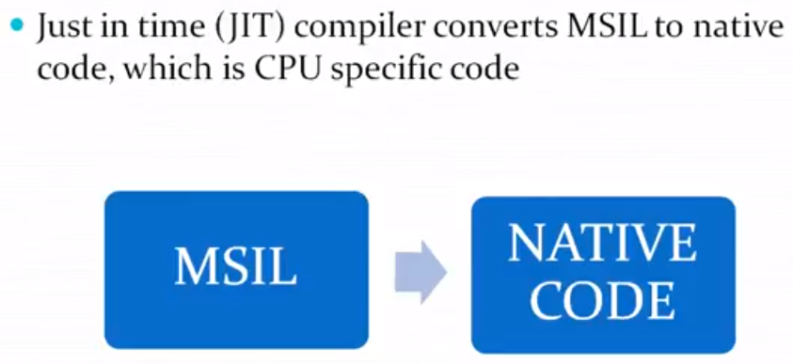

**When a code is executed for the first time;**

* The CIL (COMMON INTERMEDIATE LANGUAGE) code is converted to a code native to the operating system.
* This is done at runtime by the Just-In-Time (JIT) compiler present in the CLR.
* The CLR converts the CIL code to the machine language code.
* Once this is done, the code can be directly executed by the CPU.