**BUILT IN DATA TYPES IN C#**

* **INTEGRAL TYPE**
  + **Signed Integers (Which Takes Negative And Positive Values)**
  + **Unsigned Integers (Which Only Takes Positive Values)**
    - **sbyte**
    - **byte**
    - **short**
    - **ushort**
    - **int**
    - **uint**
    - **long**
    - **ulong**

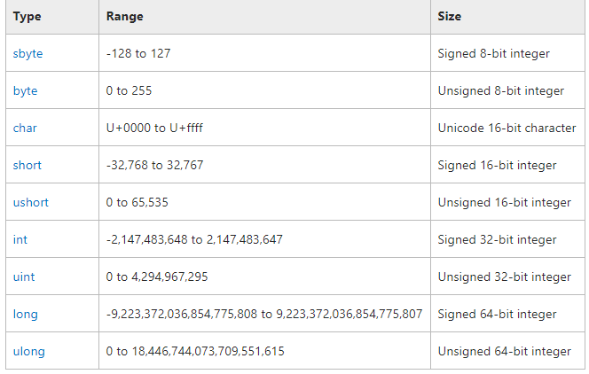

* **MINVALUE** PROPERTY
* **MAXVALUE** PROPERTY

**Boolean Data Type**

**Bool** keyword is used for Boolean data type which only stores **TRUE** or **FALSE**.

**Float Double And Decimal Data Type**

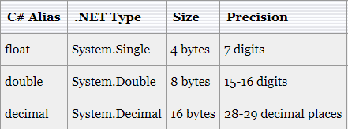

**String And Character Data Type**

* **String** stores multiple characters in a single variable.
* Double quotes will be used with string data type.
* **Char** stores single character at a time in a variable.
* Single quotes will be used for char data type.
* **ESCAPE SEQUENCE**
* **Verbatim Literal**
  + Verbatim literal is a string with an **@** symbol.
  + Verbatim literal make escape sequences translate as normal printable characters to enhance readability.

**Practical Example:**

* WITHOUT VERBATIM LITERAL: "D:\\Adil\\Csharp\\Tutorials" – Less readable
* WITH VERBATIM LITERAL: **@**"D:\Adil\Csharp\Tutorials" – More readable