**types of inheritance in C#**

**The following are the types of inheritance in C#**

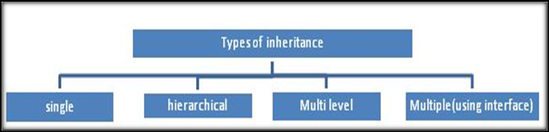

**There are 4 types of Inheritance in C#**

1. Single
2. Multi-level
3. Hierarchical
4. Multiple

The inheritance concept is based on a base class and derived class. Let us see the definition of a base and derived class.

* **BASE CLASS -** is the class from which features are to be inherited into another class.
* **DERIVED CLASS -** it is the class in which the base class features are inherited.

**Single Inheritance In C#**

It is the type of inheritance in which there is one base class and one derived class.

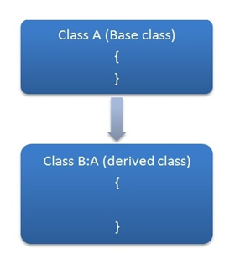**Single Inheritance In C#**

**Source Code Of Single Inheritance**

using System;

using System.Collections.Generic;

using System.Linq;

using System.Text;

using System.Threading.Tasks;

namespace INHERITANCE_CSHARP

{

class PermanentEmployees : Employees

{

public int permanentSalary;

public int permanentHours;

}

class Employees

{

public int EmpId;

public string EmpName;

public int EmpAge;

public int EmpContactNo;

public void show()

{

Console.WriteLine("This is a method of base class !!");

}

}

class Program

{

static void Main(string[] args)

{

PermanentEmployees Asad = new PermanentEmployees();

Asad.EmpId = 12;

Asad.show();

Console.WriteLine(Asad.EmpId);

Console.ReadLine();

}

}

}

**Hierarchical Inheritance**

* This is the type of inheritance in which there are multiple classes derived from one base class.
* This type of inheritance is used when there is a requirement of one class feature that is needed in multiple classes.

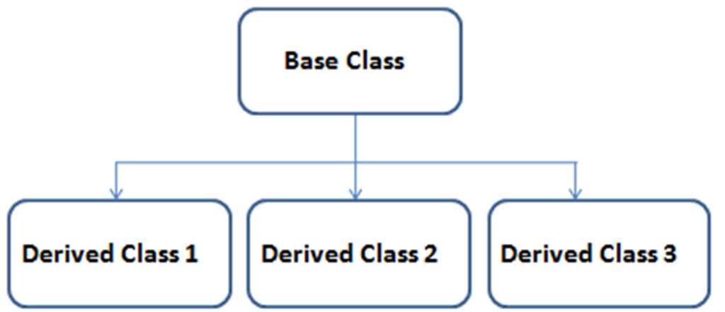

**Multilevel Inheritance**

When one class is derived from another derived class then this type of inheritance is called multilevel inheritance.

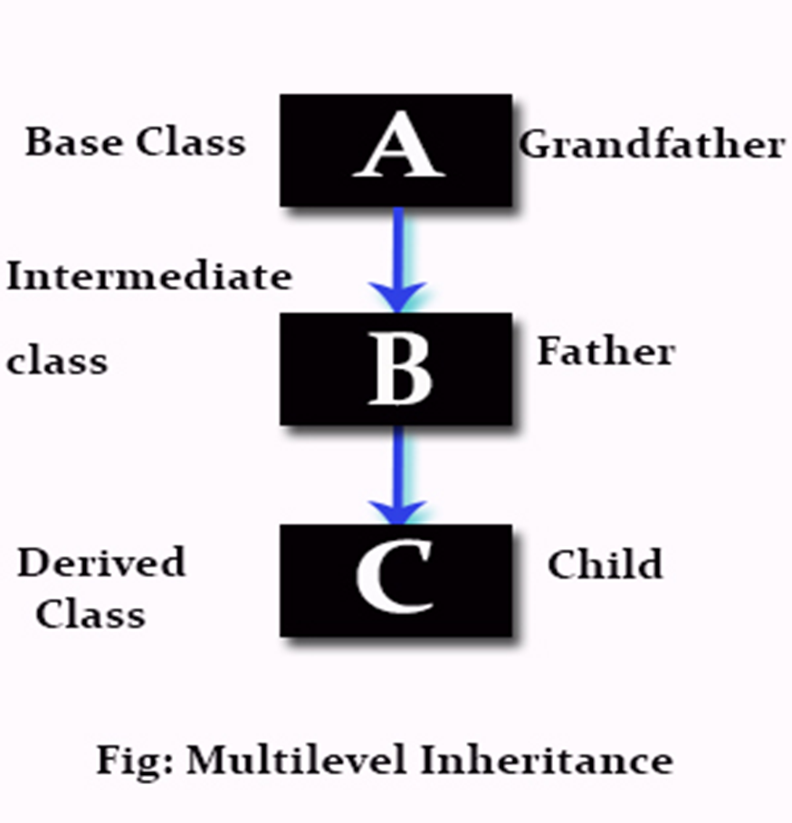

**Multi-level Inheritance**

Inheritance allows the programmer to build hierarchies that can contain multiple levels of inheritance.

**Example**

* Consider three classes Mammal, Animal, and Dog. The class Mammal is inherited from the base class Animal, which inherits all the attributes of the Animal class.
* The class Dog is inherited from the class Mammal and inherits all the attributes of both the Animal and Mammal classes.

**The following figure depicts multi-level hierarchy of related classes:**

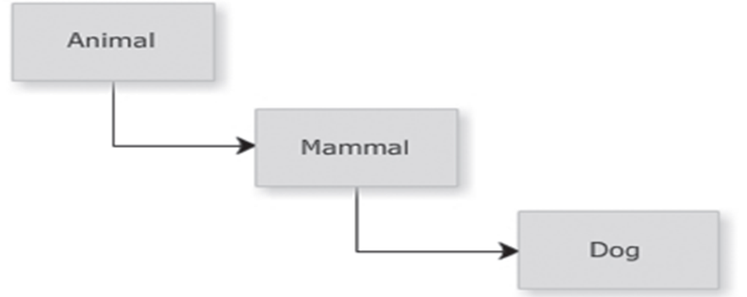

**The following code demonstrates multiple levels of inheritance:**

using System;

class Animal

{

public void Eat()

{

Console.WriteLine(“Every animal eats something.”);

}

}

class Mammal : Animal

{

public void Feature()

{

Console.WriteLine(“Mammals give birth to young ones.”);

}

}

class Dog : Mammal

{

public void Noise()

{

Console.WriteLine(“Dog Barks.”);

}

static void Main(string[] args)

{

Dog objDog = new Dog();

objDog.Eat();

objDog.Feature();

objDog.Noise();

}

}

In Above code, the Main() method of the class Dog invokes the methods of the class Animal, Mammal, and Dog.

**Output**

Every animal eats something.  
Mammals give birth to young ones.  
Dog Barks.