Good Morning every body,This is my 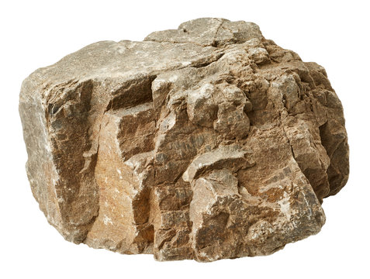 do you like it?