Name: Abdul Saboor
Date:3/13/2026

Hands-On SIEM Project: Brute Force, Persistence & FIM Detection with Wazuh — Including Custom Detection Rule

Table of Contents
Project Overview 2
Lab Environment 2
Attack Simulations 2
Attack 1 — Brute Force Login 2
Attack 2 — Unauthorized Admin Account Creation 3
Attack 3 — Malicious File Drop (FIM) 4
Custom Detection Rule 5
Skills Demonstrated 6

Project Overview
This project involved setting up a Wazuh SIEM in a home lab using two virtual machines — Ubuntu as the Wazuh server and Windows 10 as the monitored agent. I simulated three real-world attack techniques, analyzed the generated alerts in the Wazuh dashboard, and wrote a custom detection rule to extend Wazuh's built-in capabilities.

Disclaimer: All simulations were performed in an isolated virtual environment for educational purposes only. Never attempt these techniques on real devices or systems you do not own.

Lab Environment
Component | Details
Virtualization | Oracle VirtualBox
Wazuh Server | Ubuntu VM — Wazuh Manager + Dashboard
Monitored Agent | Windows 10 VM — Wazuh Agent (Active)

Attack Simulations

Attack 1 — Brute Force Login
What I did: Ran a failed login command 10 times against my own machine using a fake username and wrong password to simulate a brute force attack.
Command used:

What Wazuh detected:
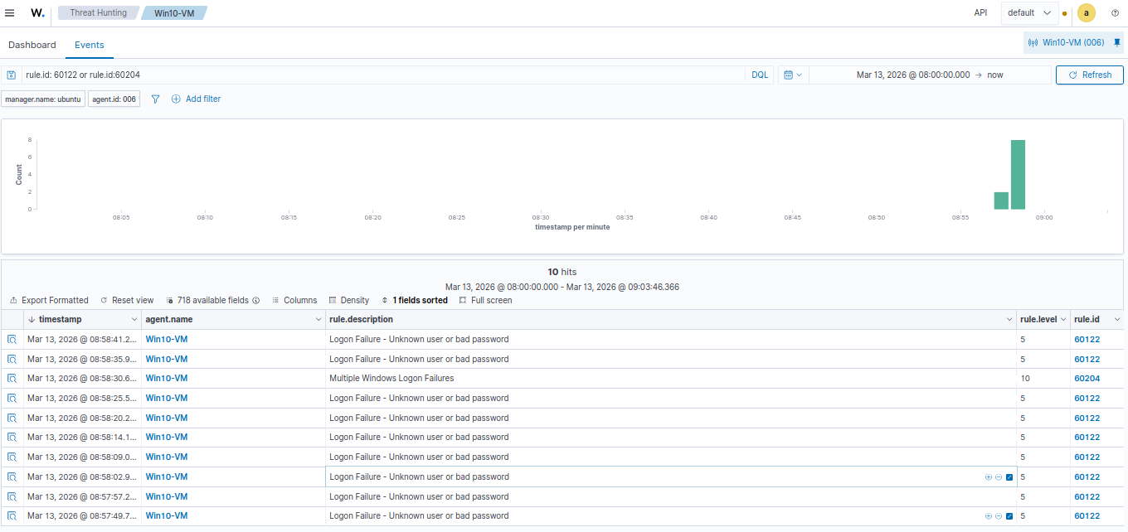

Attack 2 — Unauthorized Admin Account Creation
What I did: Created a fake user account, gave it administrator privileges, then deleted it — simulating how attackers create backdoor accounts and then cover their tracks.

Commands Used:
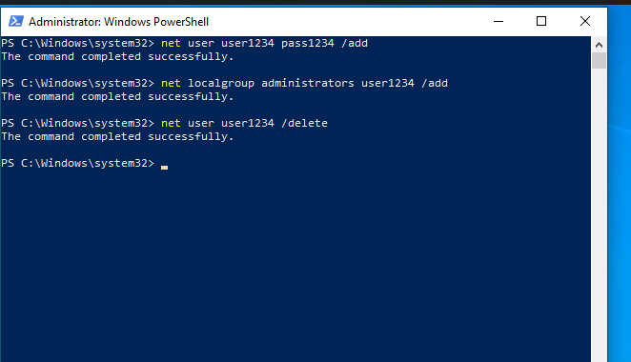

What Wazuh detected:
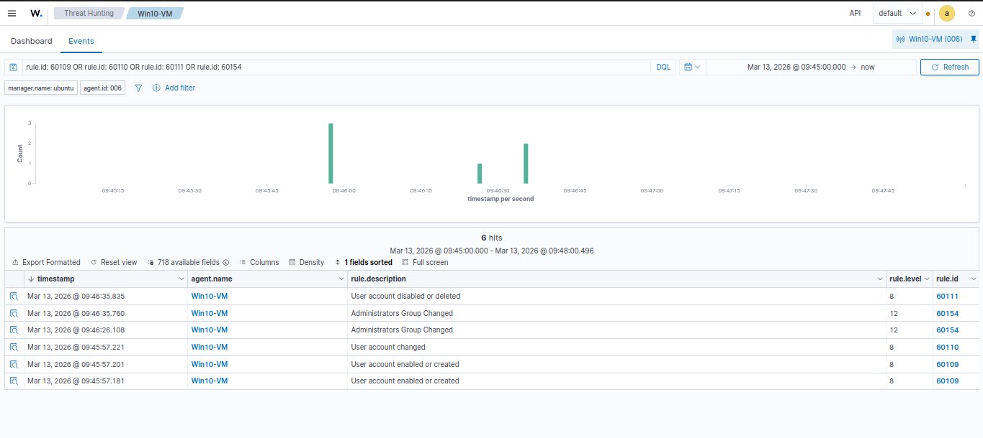
What I learned: Windows fires multiple events from a single command. Even though the attacker deleted the account, Wazuh had already logged every step including the admin privilege escalation at Level 12.

Attack 3 — Malicious File Drop (FIM)
What I did: Configured Wazuh's File Integrity Monitoring (FIM) module to watch a custom folder by editing the Wazuh agent config file on Windows. Then created and deleted a suspicious file to simulate a malware drop.

Commands used:

What Wazuh detected:
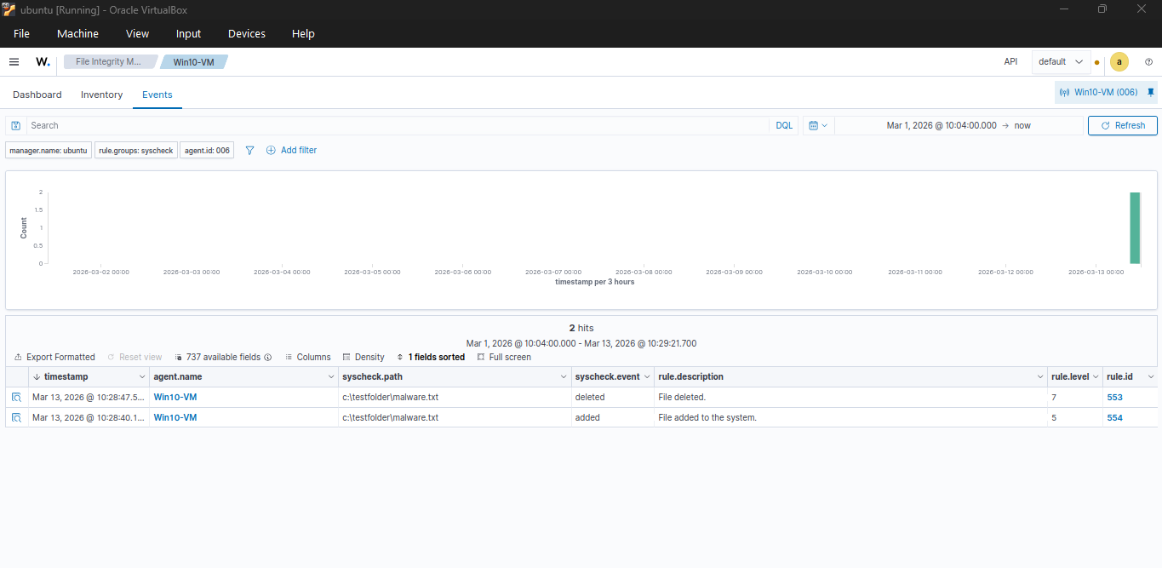

Custom Detection Rule
What I did: Wrote my own custom Wazuh detection rule in XML and deployed it to the Wazuh server. The rule builds on top of Wazuh's built-in FIM rule 554 and escalates any file creation in C:\TestFolder to Level 10 with a custom alert message.
File edited:
/var/ossec/etc/rules/local_rules.xml on Ubuntu VM

Rule written:
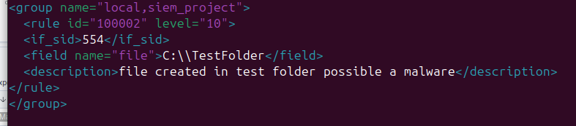

Commands Used:

What Wazuh detected:
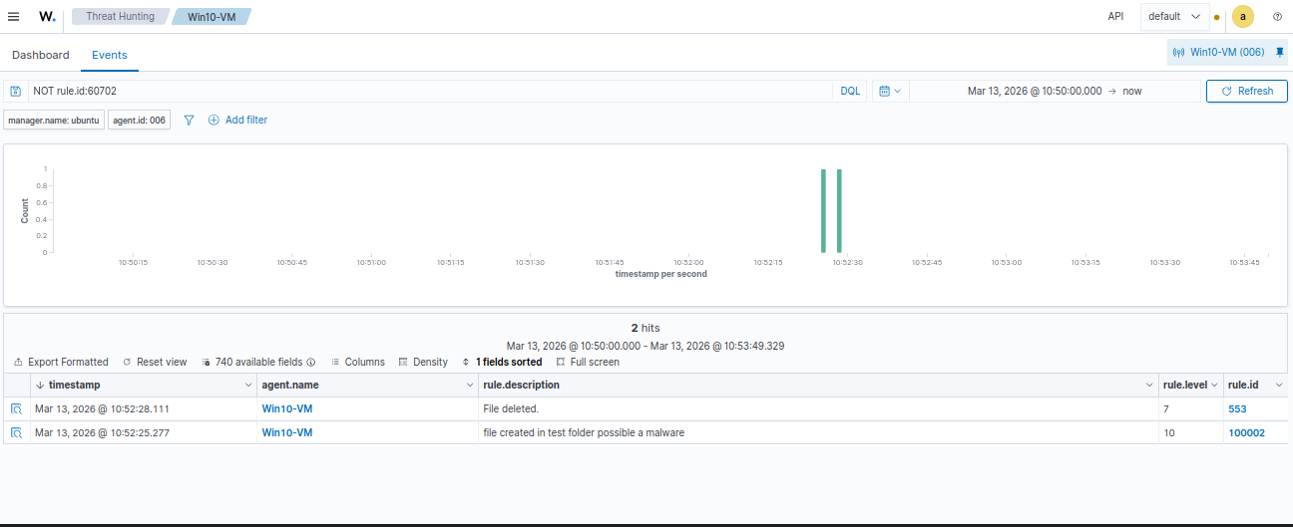

Skills Demonstrated
- Wazuh SIEM deployment and agent configuration
- Windows Event Log analysis
- Simulating brute force, persistence, and file drop attacks
- Configuring File Integrity Monitoring (FIM)
- Reading and filtering alerts in Wazuh dashboard
- Writing custom XML detection rules
- Using Wazuh search operators for log analysis

