Data Summary Report

Phase 1: Data Inspection

Dataset Preview (First 5 Rows)
CustomerID Age Gender City Education MaritalStatus AnnualIncome SpendingScore YearsEmployed PurchaseFrequency OnlineVisitsPerMonth ReturnedItems PreferredDevice LastPurchaseAmount
0 1001 49 Male Pune Masters Single 82953.0 66 23 19 9 2 Laptop 3944
1 1002 44 Male Pune PhD Single 60610.0 56 22 1 23 3 Desktop 3885
2 1003 42 Male Mumbai Bachelors Single 35501.0 44 18 10 29 3 Laptop 3247
3 1004 36 Female Mumbai Masters Married 99312.0 36 10 12 21 3 Mobile 2028
4 1005 23 Male Pune Masters Married 46980.0 56 1 18 9 3 Tablet 1100

Dataset Structure (df.info())
<class 'pandas.DataFrame'>
RangeIndex: 255 entries, 0 to 254
Data columns (total 14 columns):
# Column Non-Null Count Dtype
--- ------ -------------- -----
0 CustomerID 255 non-null int64
1 Age 255 non-null int64
2 Gender 255 non-null str
3 City 255 non-null str
4 Education 243 non-null str
5 MaritalStatus 255 non-null str
6 AnnualIncome 243 non-null float64
7 SpendingScore 255 non-null int64
8 YearsEmployed 255 non-null int64
9 PurchaseFrequency 255 non-null int64
10 OnlineVisitsPerMonth 255 non-null int64
11 ReturnedItems 255 non-null int64
12 PreferredDevice 255 non-null str
13 LastPurchaseAmount 255 non-null int64
dtypes: float64(1), int64(8), str(5)
memory usage: 35.6 KB

Statistical Summary (df.describe())
CustomerID Age AnnualIncome SpendingScore YearsEmployed PurchaseFrequency OnlineVisitsPerMonth ReturnedItems LastPurchaseAmount
count 255.000000 255.000000 243.000000 255.000000 255.000000 255.000000 255.000000 255.000000 255.00000
mean 1126.941176 37.729412 74499.901235 45.721569 14.682353 11.568627 16.078431 1.858824 2795.07451
std 72.397256 9.767842 43939.855655 17.869522 9.651664 7.077899 7.909536 1.409917 1328.77241
min 1001.000000 21.000000 16062.000000 5.000000 1.000000 1.000000 3.000000 0.000000 566.00000
25% 1064.500000 29.000000 56353.000000 34.500000 6.000000 5.000000 10.000000 1.000000 1542.50000
50% 1128.000000 38.000000 69629.000000 47.000000 15.000000 11.000000 16.000000 2.000000 2705.00000
75% 1190.500000 46.000000 84030.500000 57.500000 23.000000 18.000000 23.000000 3.000000 4001.00000
max 1250.000000 54.000000 474327.000000 95.000000 34.000000 24.000000 29.000000 4.000000 4996.00000

Phase 2: Data Cleaning

Missing Values
CustomerID: 0
Age: 0
Gender: 0
City: 0
Education: 12
MaritalStatus: 0
AnnualIncome: 12
SpendingScore: 0
YearsEmployed: 0
PurchaseFrequency: 0
OnlineVisitsPerMonth: 0
ReturnedItems: 0
PreferredDevice: 0
LastPurchaseAmount: 0

Duplicate Rows
Total duplicate rows found: 5

Phase 3: Univariate Analysis

Age Distribution
Most customers fall between age 25 and 40.
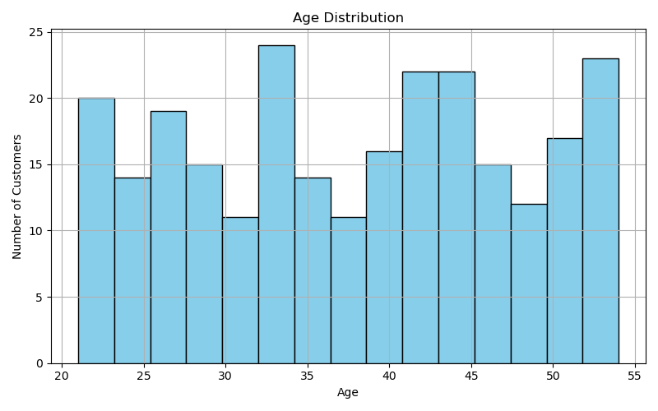

Annual Income Distribution
Income distribution shows slight right skew.
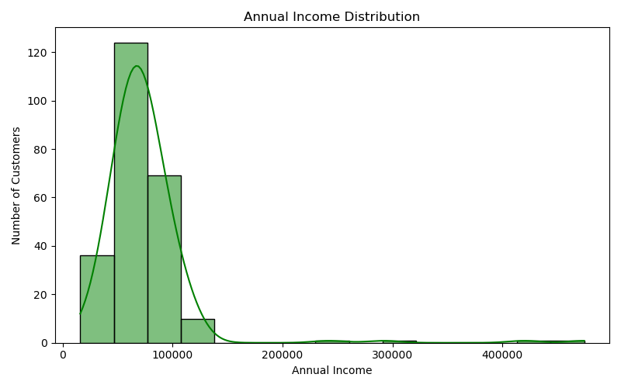

Gender Distribution
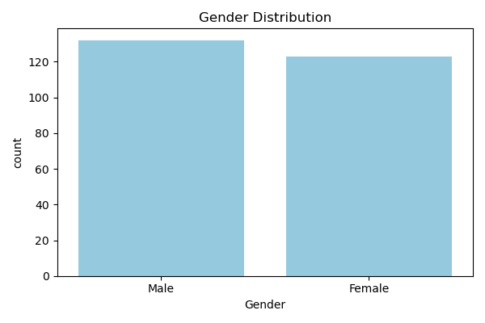

Phase 3: Bivariate Analysis

Income vs Spending Score
Higher income customers tend to have higher spending scores.
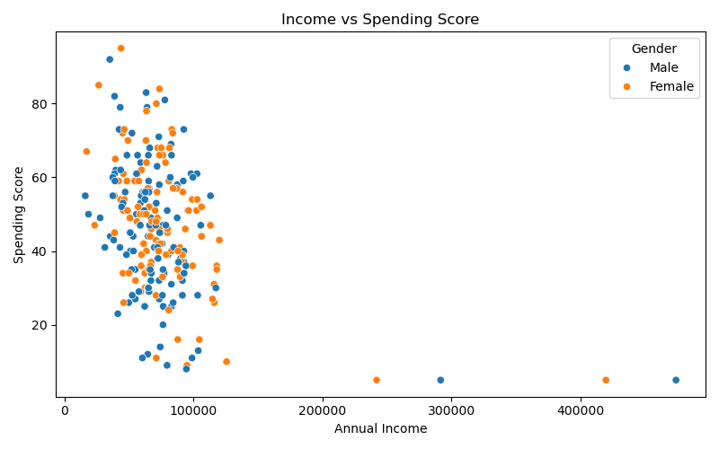

Spending Score by Gender
Spending patterns vary slightly across gender groups.
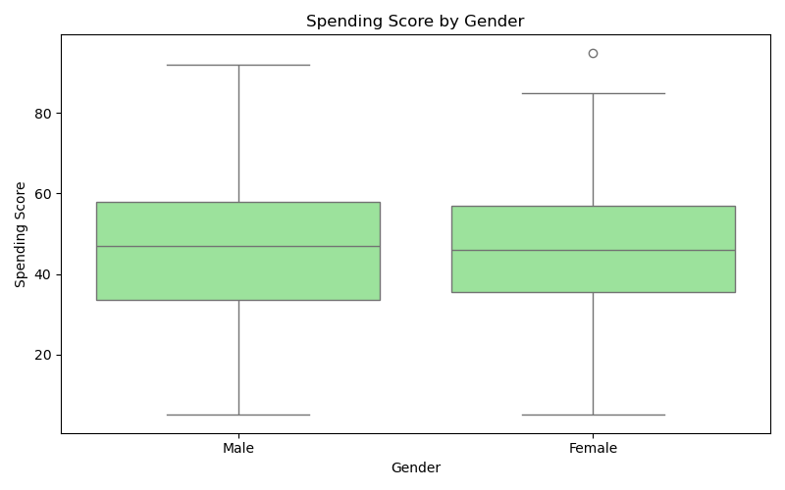

Phase 4: Multivariate Analysis

Correlation Heatmap
The heatmap shows relationships between numerical variables.
