

**BUK TIMETABLE MANAGEMENT SYSTEM, FACULTY OF COMPUTING, BAYERO UNIVERSITY KANO.**

**ABDULLATEEF** **MOHAMMED** **KABIR**

**CST/18/IFT/00212**

This BUK Timetable Management System has two parts, the users interface part for any one to see the content of the website and the admin interface part for the school administrators to add, edit and modify any content.

The website has the ability to generate printable PDF for all content including printing the Timetable, the list of staffs, departments, courses and classroom, everything on this website is user friendly.

1. **THE USERS INTERFACE.**
2. The landing page.

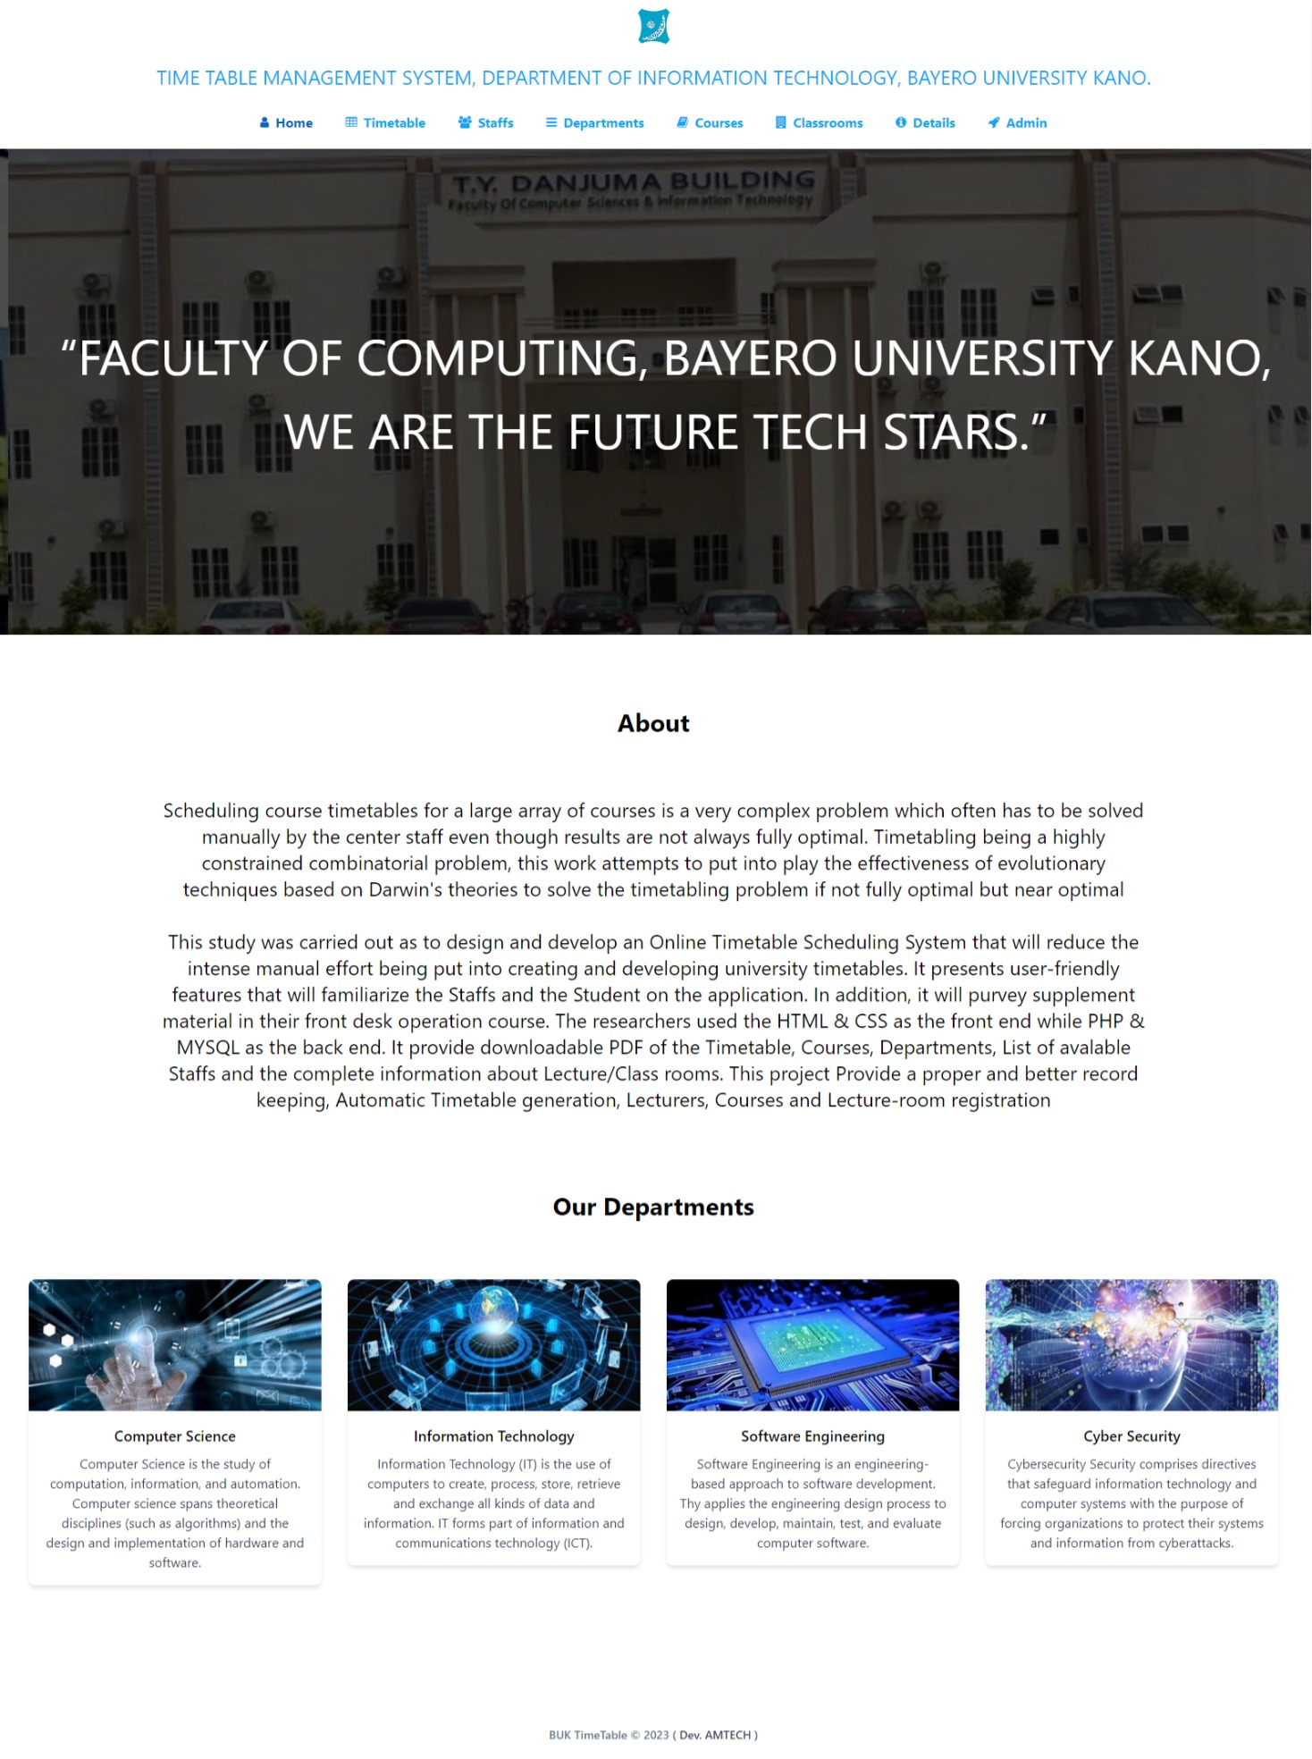

1. The Timetable page, for visitors (i.e., student) to view and download the timetable.

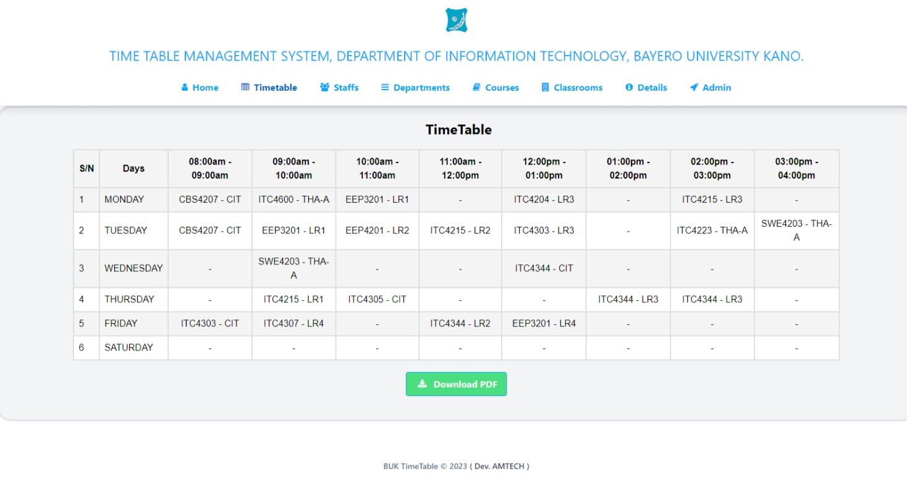

1. The staffs page for student to see their lectures for their respective courses.

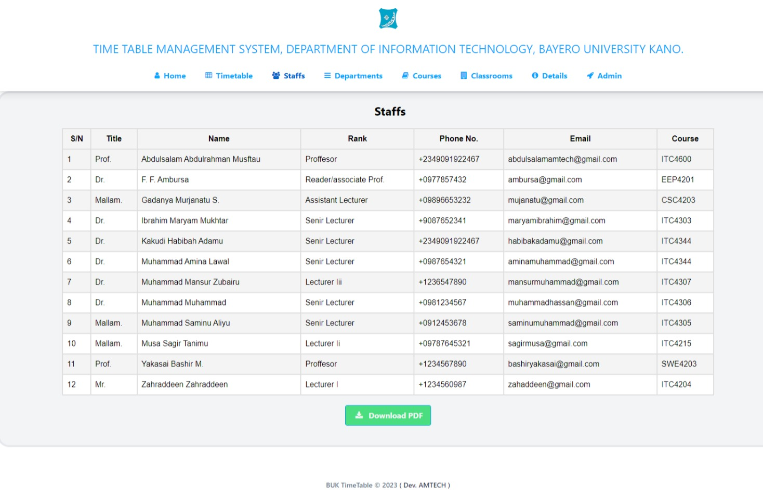

1. The Departments page for student to see the list of departments.

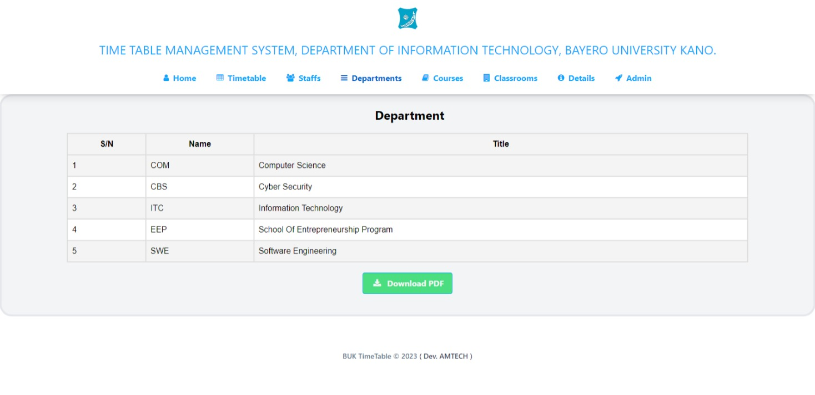

1. The Courses page for the list of courses for the level.

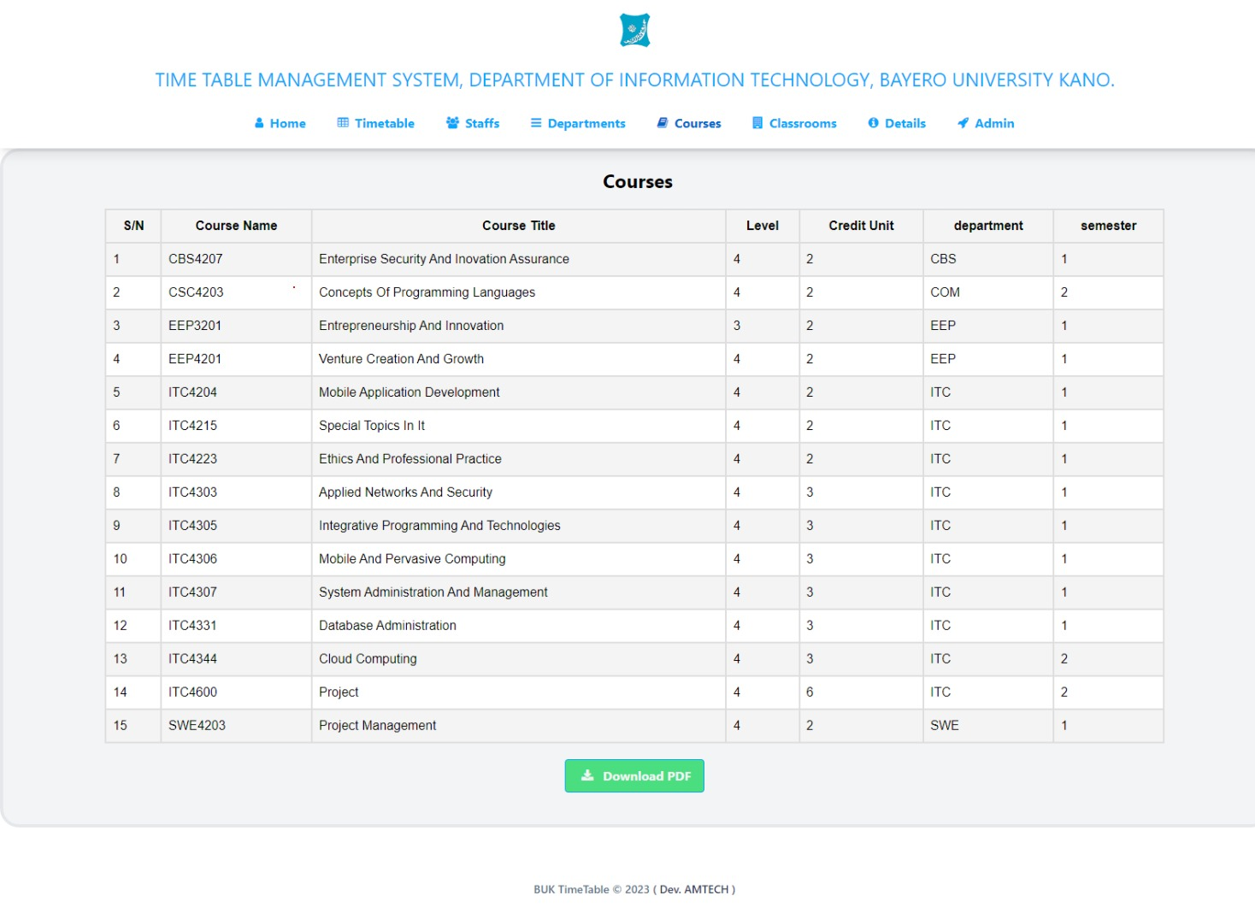

1. The classrooms page for the list of class where all the courses will be taught and the capacity of student it could hold.

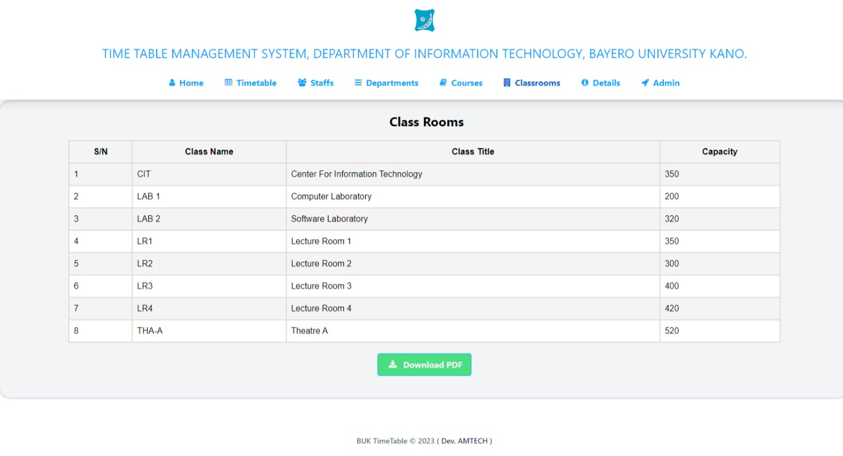

1. The Details page shows the entire content features of the website how to access it and how it works.

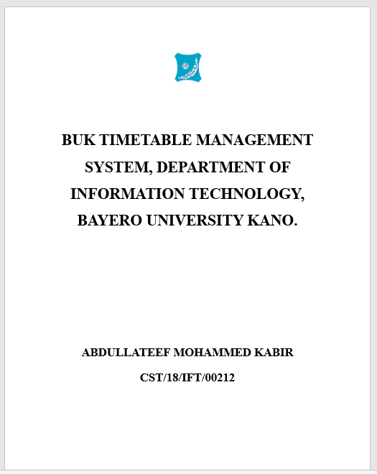

1. The Admin Login page for Administrative access to the Control panel of the entire website, it requires the admin email and password.

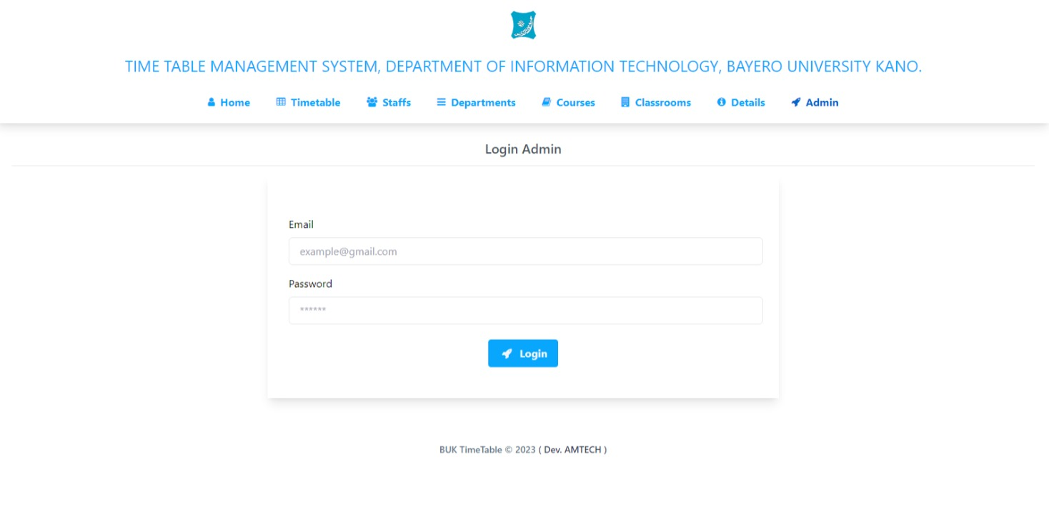

1. **THE ADMIN INTERFACE** (i.e., the control panel).
2. The Admin Dashboard area, this part shows the statistics of the staffs, department, course and classes, Admins can only have access to this page by providing their correct email and password.

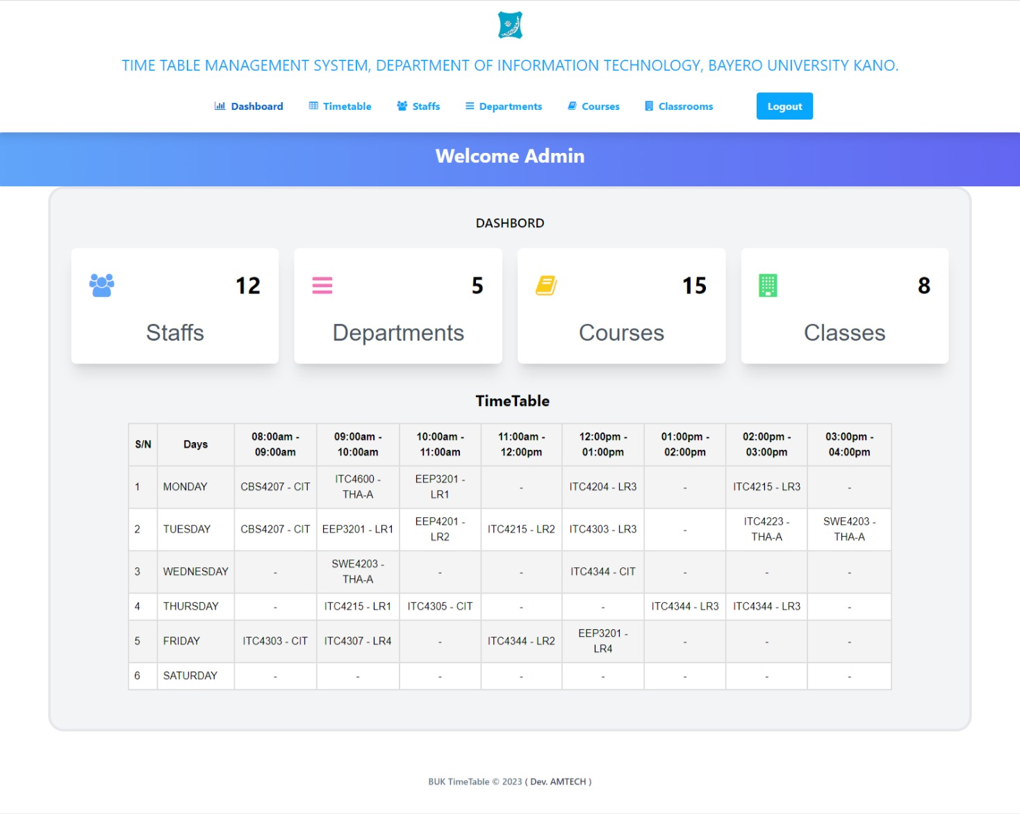

1. Admin Timetable page, the admin as control over everything on this page, they can edit all content of the timetable by setting appropriate time, class and course for the timetable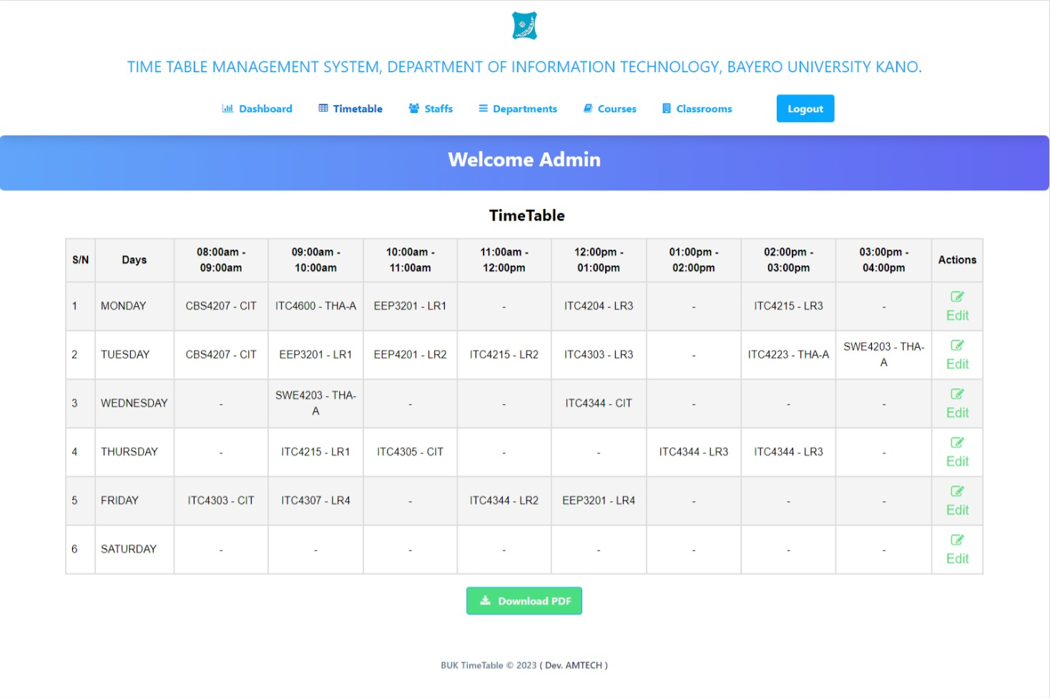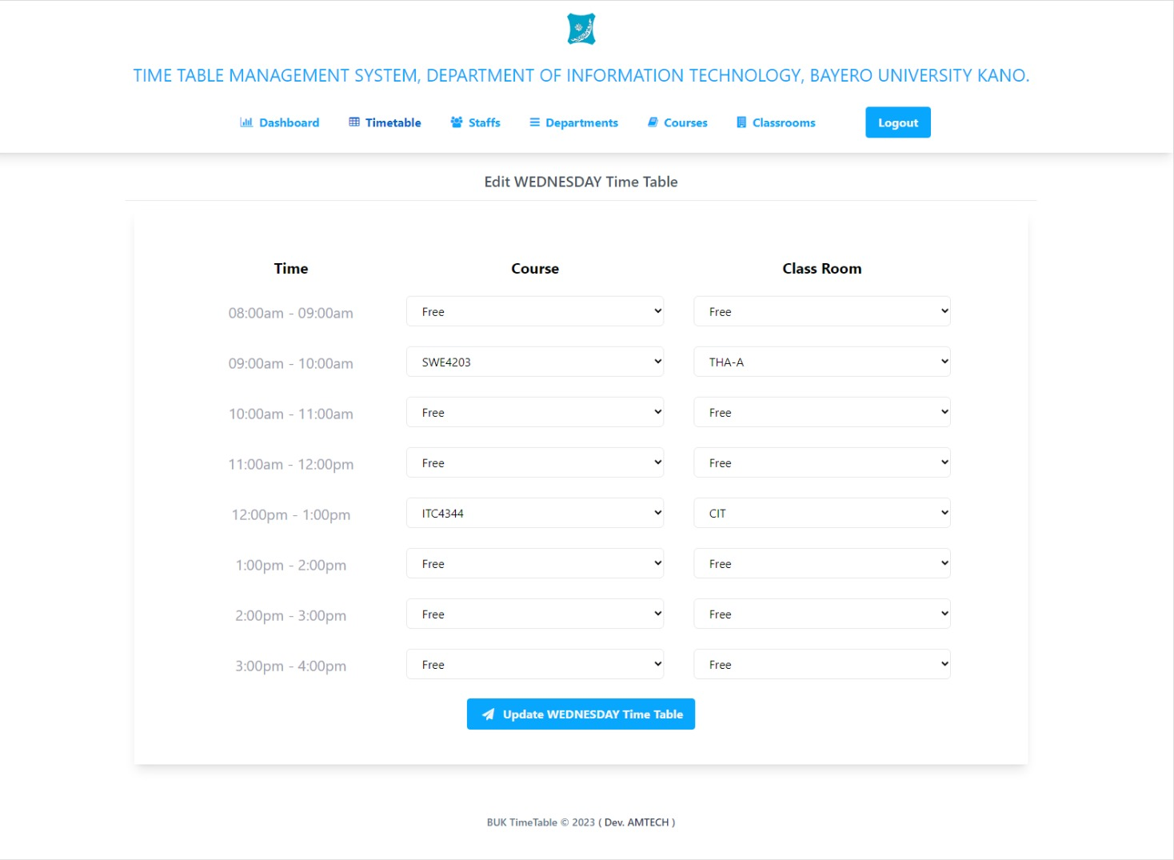
2. Admin Staffs page: The admin can add, edit and delete staffs from this page.

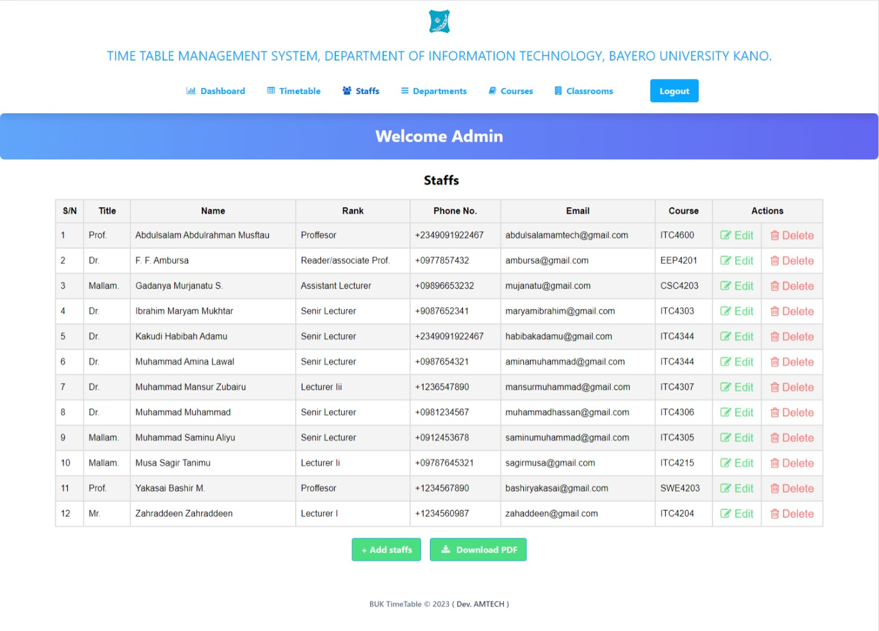

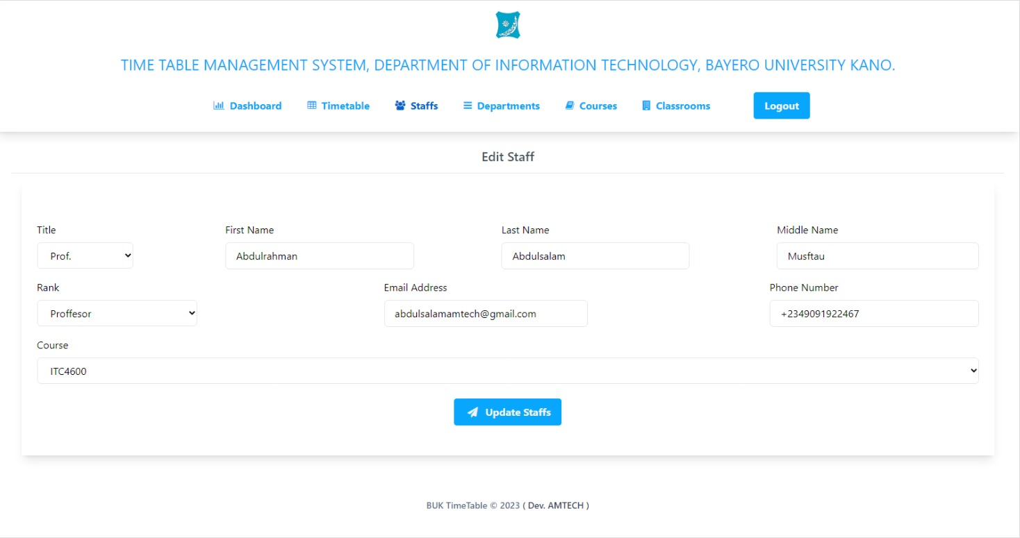

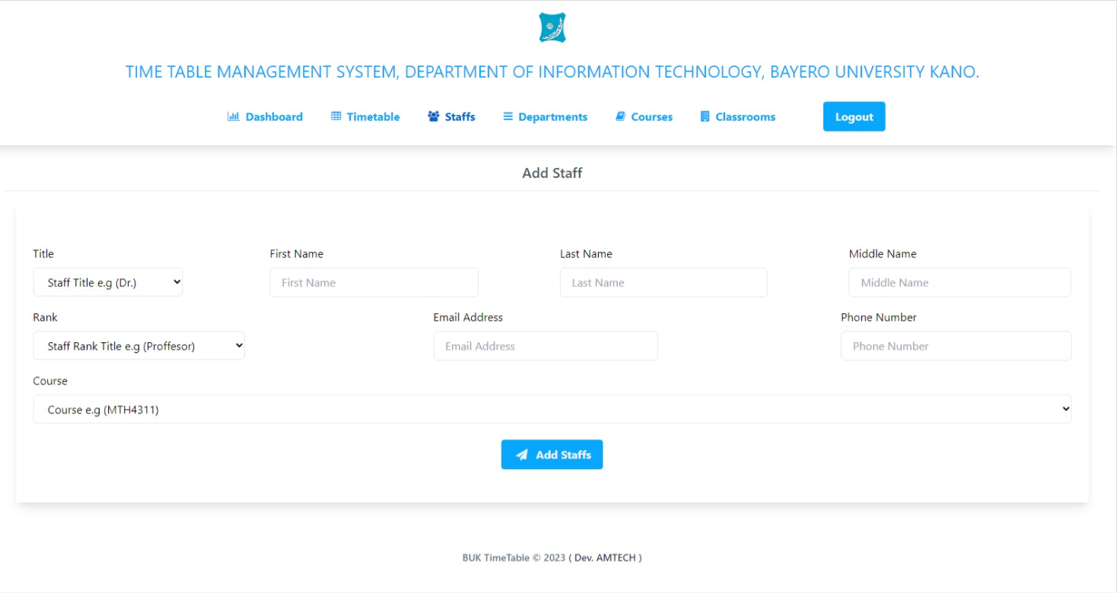

1. Admin Department page: The admin can add, edit and delete departments.

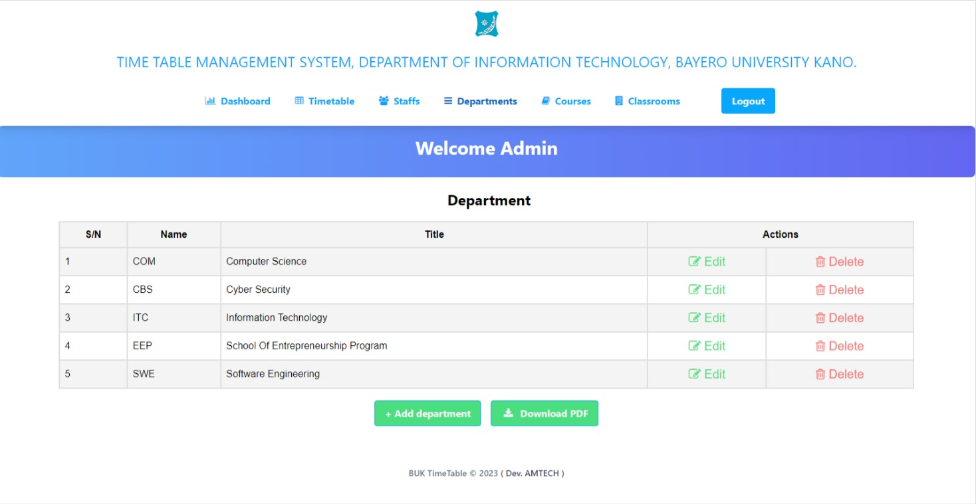

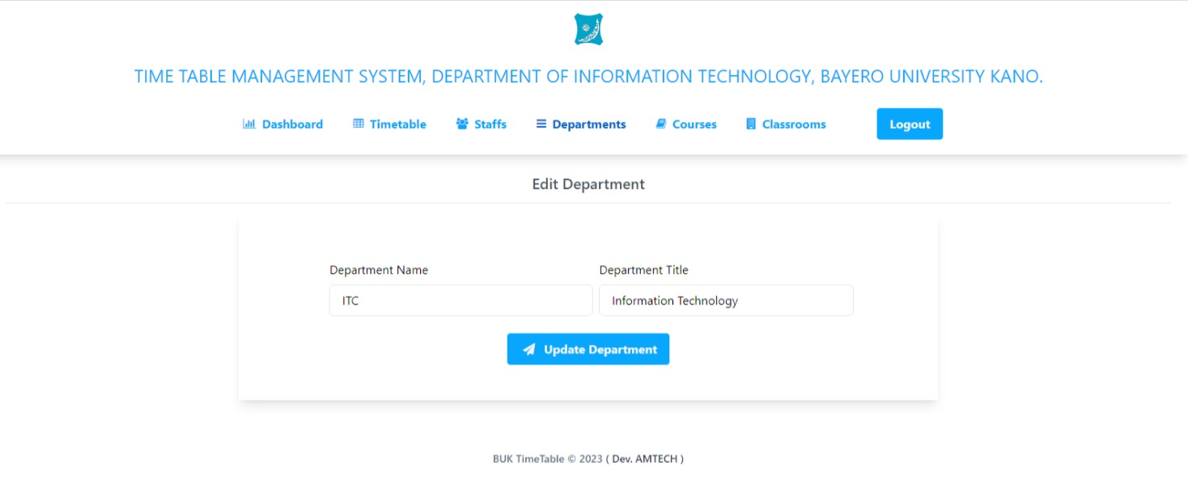

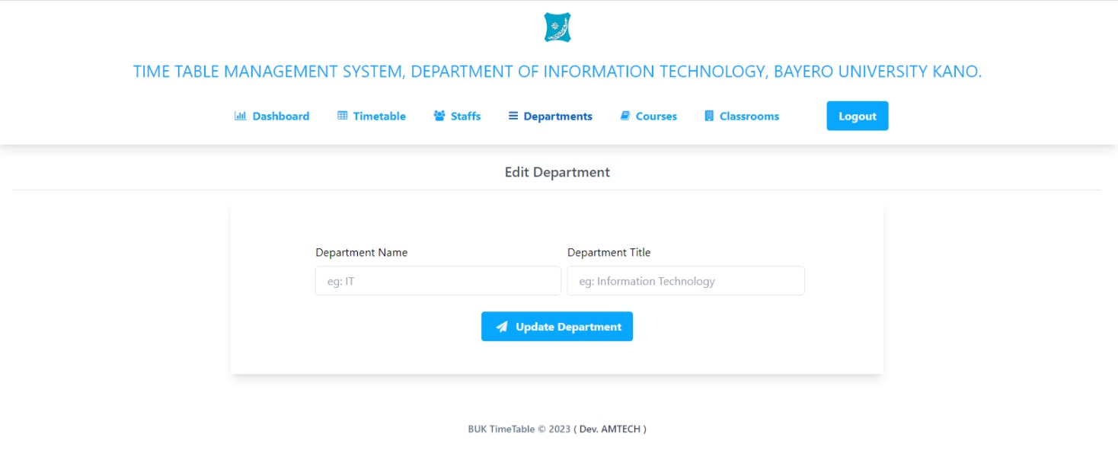

1. Admin Courses page: The admin can add, edit and delete courses.

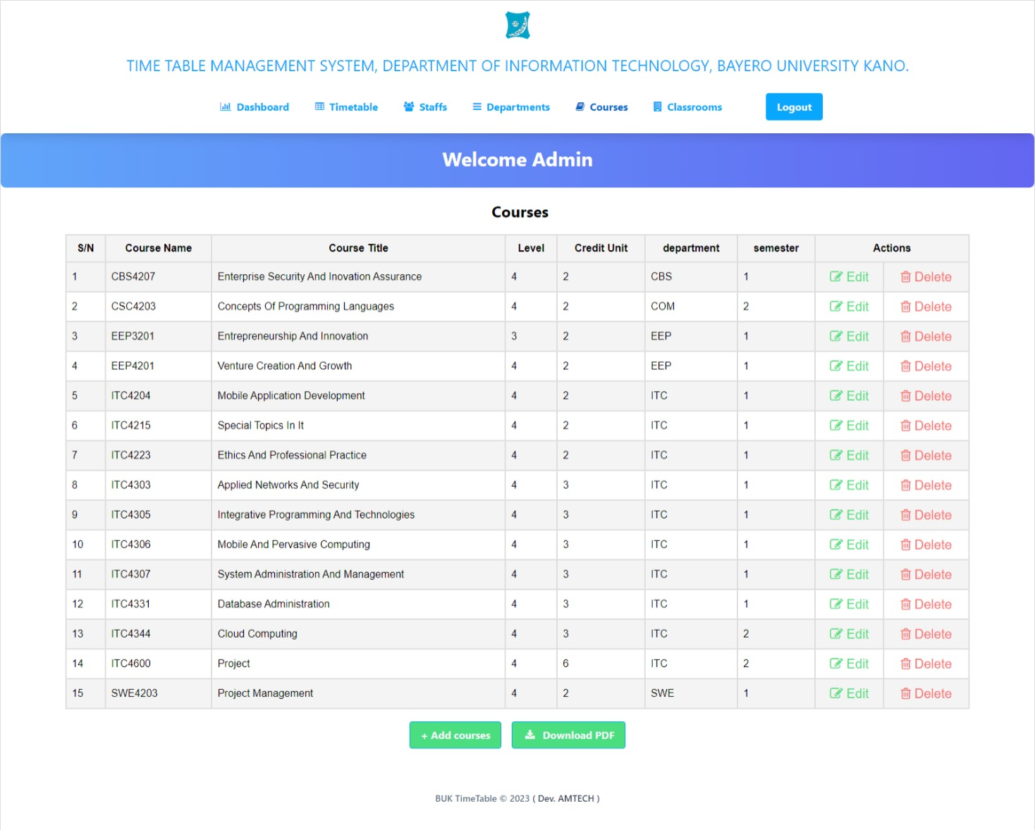

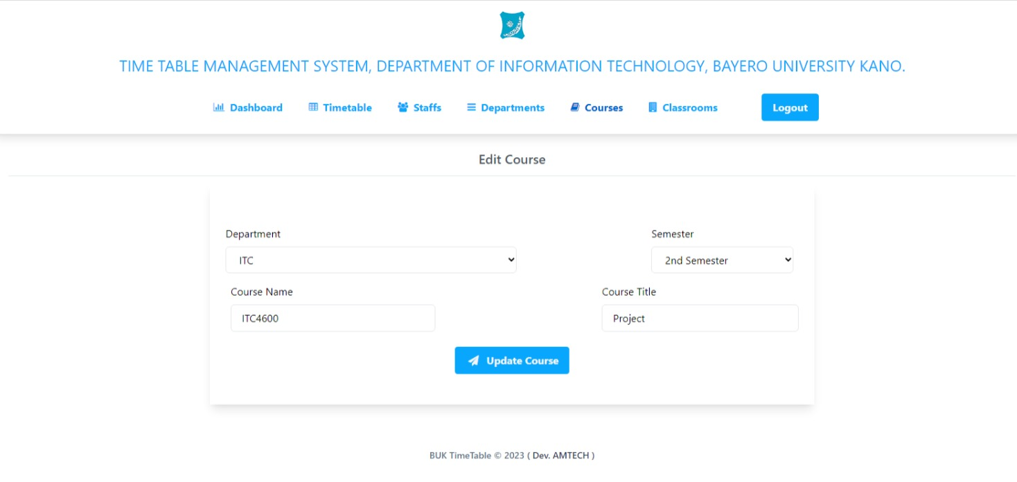

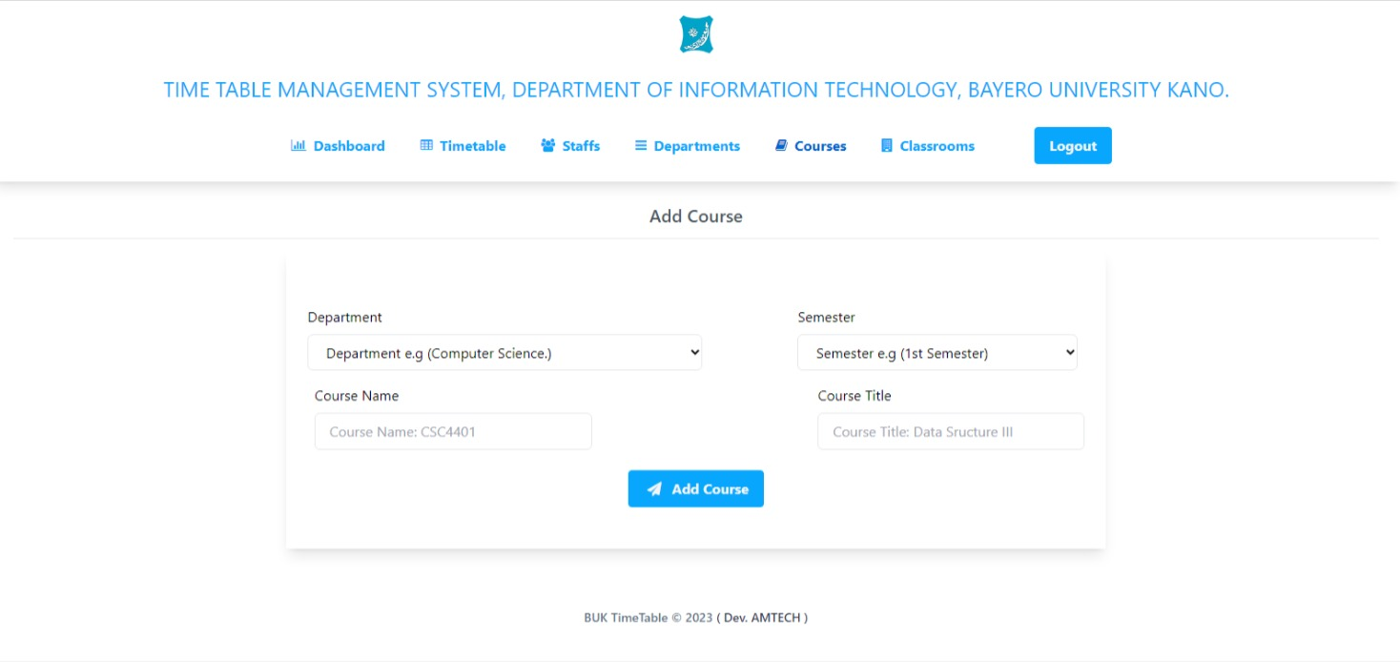

1. Classroom page: The admin can add, edit and delete classrooms.

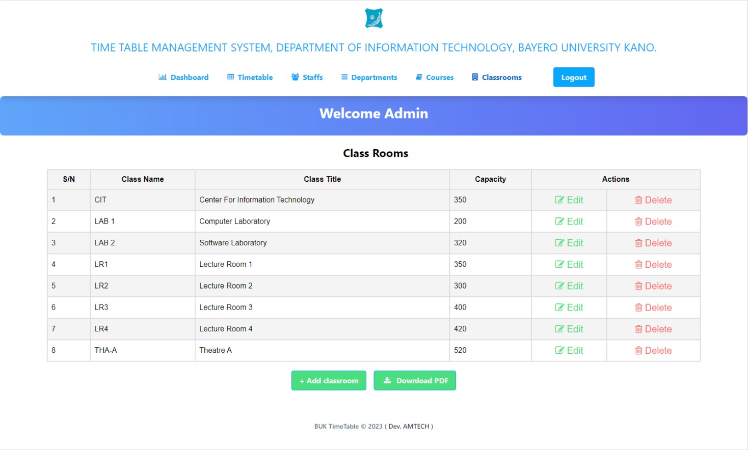

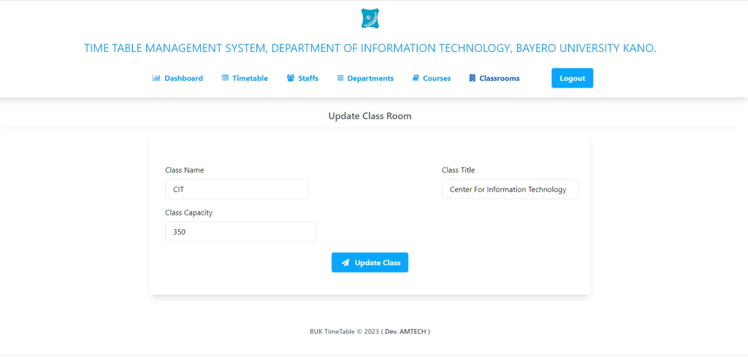

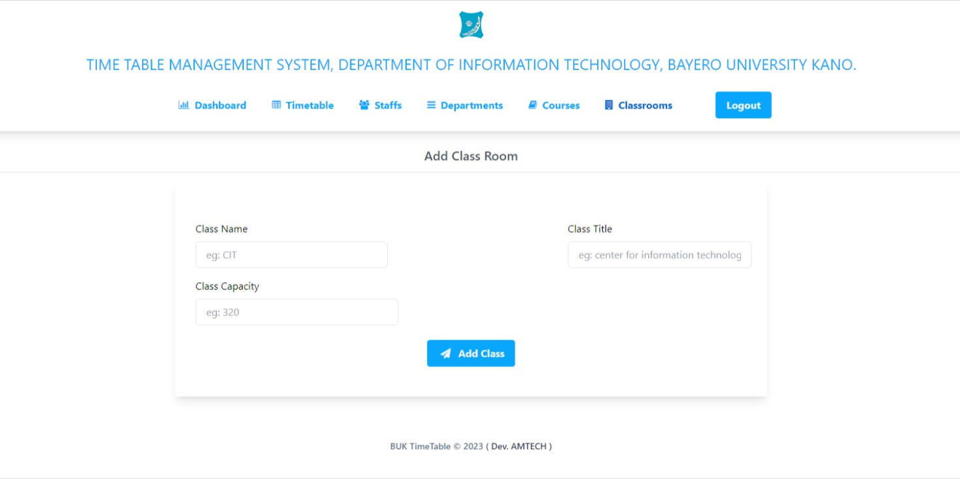

vii. This is the sample of the download Timetable PDF.

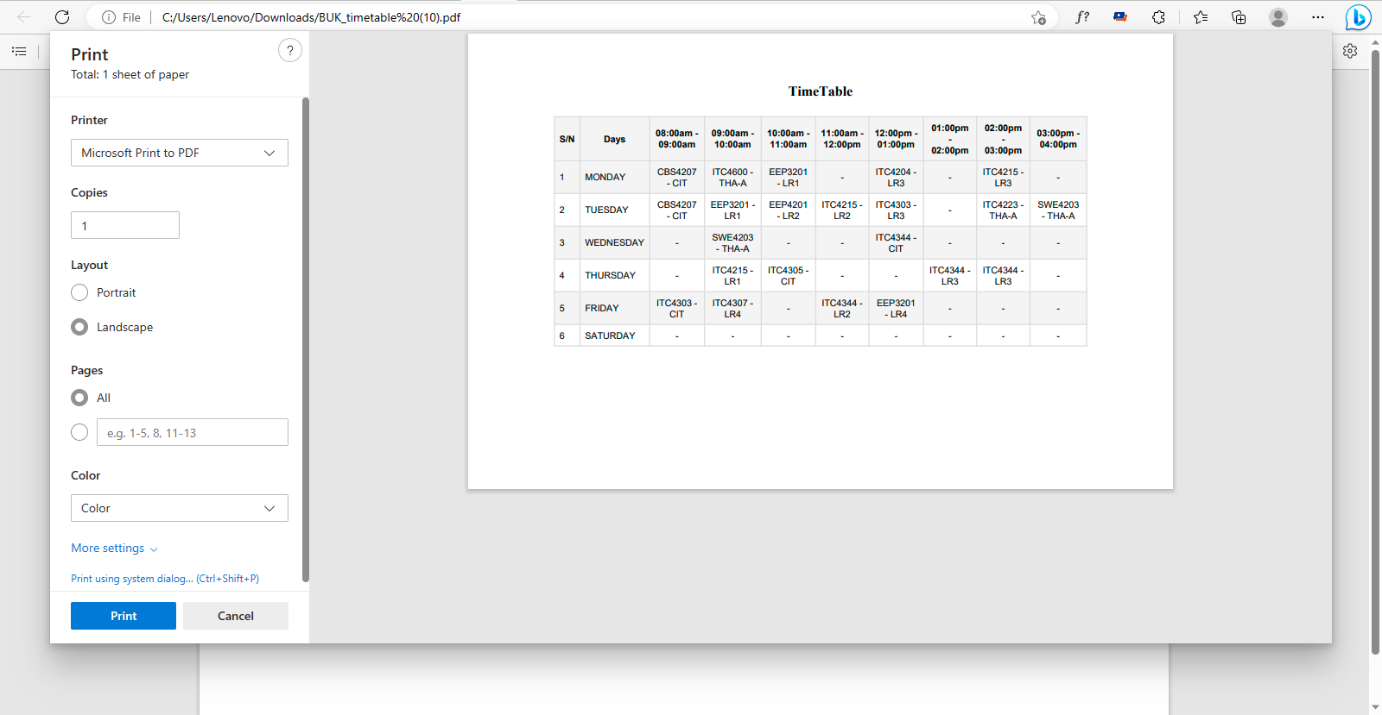

1. Finally, the admin can logout of the dashboard when done with their administrative duties.

**THE STRUCTURE OF THE DATABASE (MYSQL).**

1. Admin.

|  |  |
| --- | --- |
| **Column** | **Type** |
| id | int (11) |
| admin_name | varchar (30) |
| admin_email | varchar (50) |
| hash_password | varchar (255) |

1. Timetable.

|  |  |
| --- | --- |
| **Column** | **Type** |
| id | int (11) |
| day | varchar (15) |
| course_8_9 | varchar (30) |
| class_8_9 | varchar (30) |
| course_9_10 | varchar (30) |
| class_9_10 | varchar (30) |
| course_10_11 | varchar (30) |
| class_10_11 | varchar (30) |
| course_11_12 | varchar (30) |
| class_11_12 | varchar (30) |
| course_12_1 | varchar (30) |
| class_12_1 | varchar (30) |
| course_1_2 | varchar (30) |
| class_1_2 | varchar (30) |
| course_2_3 | varchar (30) |
| class_2_3 | varchar (30) |
| course_3_4 | varchar (30) |
| class_3_4 | varchar (30) |

1. Staffs.

|  |  |
| --- | --- |
| **Column** | **Type** |
| id | int (11) |
| staff_title | varchar (10) |
| first_name | varchar (30) |
| last_name | varchar (30) |
| middle_name | varchar (30) |
| email | varchar (50) |
| phone_number | varchar (15) |
| rank | varchar (30) |

1. Department.

|  |  |
| --- | --- |
| **Column** | **Type** |
| id | int (11) |
| dept_name | varchar (7) |
| dept_title | varchar (50) |

1. Courses.

|  |  |
| --- | --- |
| **Column** | **Type** |
| Id | Int (11) |
| course_name | varchar (7) |
| course_title | varchar (50) |
| credit_unit | int (1) |
| level | int (1) |
| department | varchar (30) |
| semester | int (1) |

1. Classroom.

|  |  |
| --- | --- |
| **Column** | **Type** |
| id | int (11) |
| class_name | varchar (7) |
| class_title | varchar (50) |
| class_capacity | int (11) |