Crypto & Stock Anomaly Detection System
Database Systems (Lab)



Submitted by: Abdul Haseeb & Abdul Samad
Submitted to: Sir Ali Hassan
Github Repo Link: https://github.com/abdulsamad-codes/Crypto-and-Stock-Anomaly-Detection-System
Semester: IV - BSSE (Group-A)
Course Code: CSC 451
Session 2024 –2028 (Fall)

INSTITUTE OF MANAGEMENT SCIENCES
HAYATABAD, PESHAWAR (2025)

Topic | Version | Prof Remarks | Date
ERD & Schema | Version 1.0 |  | April 25, 2026
ERD & Schema Refinement | Version 1.1 |  | May 15, 2026
Dataset Preprocessing & Dataflow | Version 1.2 |  | May 16, 2026
Database Setup (DDL & Optimization) | Version 1.3 |  | May 16, 2026
Data Population & Validation (DML) | Version 1.4 |  | May 17, 2026

Milestone 1
Entity Relationship Diagram (ERD)

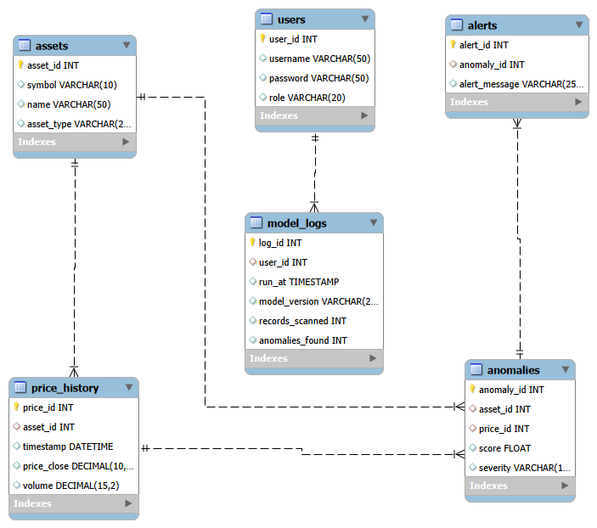

Relational Database Schema

Table Name | Attributes | Keys | Description
assets | asset_id, symbol, name, asset_type | PK: asset_id | Stores metadata of tracked assets
price_history | price_id, asset_id, timestamp, price_close, volume | PK: price_id, FK: asset_id | Historical OHLCV data
anomalies | anomaly_id, asset_id, score, severity | PK: anomaly_id, FK: asset_id | Records detected anomalies
alerts | alert_id, anomaly_id, alert_message | PK: alert_id, FK: anomaly_id | Notification logs
users | user_id, username, password, role | PK: user_id | System access control

Relationship Summary
The system utilizes a normalized relational schema where the assets table serves as the primary entity, linked to price_history and anomalies via Foreign Key constraints to ensure data integrity.
The integration of the users and model_logs tables demonstrates a clear audit trail, where each model run is mapped to the specific user who executed it.

Milestone 2
Normalization Justification
The database schema has been refined to satisfy Third Normal Form (3NF) to ensure data integrity and eliminate redundancy.
- 1NF: All attributes contain atomic values, and each table has a defined Primary Key.
- 2NF: Removed partial dependencies by ensuring all non-key attributes (like price_close) depend entirely on the primary key (price_id).
- 3NF: Eliminated transitive dependencies. Attributes like asset_type are kept in the assets table to prevent duplication across the price_history table.
Updated Relational Schema (Milestone 2 Changes)

Table Name | Attributes | Keys | Improvements Made
assets | asset_id, symbol, name, asset_type | PK: asset_id, UQ: symbol | Added UNIQUE constraint to prevent duplicate symbols.
users | user_id, username, password, role | PK user_id, UQ: username | Added UNIQUE constraint for secure authentication.
NORMALIZATION.md | N/A | N/A | Created a dedicated report explaining the 3NF logic.

Updated ERD Diagram
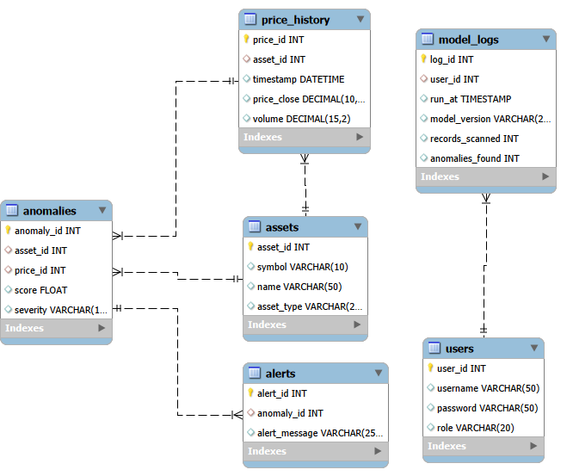
Updated ERD Summary
The ERD has been updated to reflect the UNIQUE constraints and the relationship cardinalities (1:N) between assets and price_history. This ensures that each price record belongs to exactly one specific asset.

Milestone 3
Dataset Preprocessing & Dataflow

Dataflow Description
The system implements an automated pipeline to handle real-time financial data.
- Ingestion: Python scripts fetch live data from CoinGecko (Crypto) and Yahoo Finance (Stocks).
- Preprocessing: Data is cleaned using the Python Pandas library to standardize timestamps (YYYY-MM-DD HH:MM:SS) and handle missing values.
- Storage: The cleaned data is converted into CSV files for initial database population.

Preprocessing Summary
Data Source | Cleaning Step | Tool Used | Output
CoinGecko API | Timestamp UTC conversion | Python (Pandas) | price_history.csv
Yahoo Finance | Removing timezone offsets | Python (yfinance) | price_history.csv
Static Metadata | ID Mapping & De-duplication | Python | assets.csv

Deliverables
- DATAFLOW.md: A formal document explaining the data lifecycle.
- data_generator.py: Python source code for real-time ingestion.
- data_exports/: Folder containing the clean CSV datasets (100+ rows each).

Milestone 4
Database Setup (DDL & Optimization)
Database Implementation Details
The finalized schema was implemented in MySQL with a focus on data integrity and query performance. Every table now includes appropriate primary keys, foreign key constraints, and performance-enhancing indexes.
Key Enhancements in DDL
- Constraints: Applied NOT NULL constraints on critical market columns (price, volume, score) to prevent dirty data entry.
- Indexing: Created non-clustered indexes on price_history.timestamp and price_history.asset_id to ensure ultra-fast retrieval of time-series data for the Flask dashboard.
- Indexing on Severity: Added an index to anomalies.severity to speed up the filtering of "High" vs "Low" anomaly alerts.
- Referential Integrity: Enforced ON DELETE CASCADE / ON UPDATE logic where necessary to keep records synchronized between assets and prices.

Final Table Structure Summary
Table Name | Primary Key | Foreign Keys | Optimization
assets | asset_id | - | Unique Index on symbol
price_history | price_id | asset_id | B-Tree Index on timestamp
anomalies | anomaly_id | asset_id, price_id | Index on severity
alerts | alert_id | anomaly_id | -
users | user_id | - | Unique Index on username

Milestone 5
Data Population & Validation (DML)
Operations performed:
- Bulk Ingestion: Loaded approximately 400 rows of real-market data from assets.csv and price_history.csv using the LOAD DATA INFILE command.
- DML Tasks:
  - Executed an UPDATE to standardize asset names.
  - Executed a DELETE operation to prune invalid/test price records.
- Integrity Checks: Verified Foreign Key links using multi-table JOINs and confirmed row counts match the source CSVs.

The End

