AI Document Verification Pipeline
Multi-document OCR, cross-verification, and stamp/seal detection system

1. What This System Does
This system takes multiple related documents for a single case (for example: a CNIC copy, a stamp paper, an agreement, and an affidavit) and automatically checks whether they are consistent and genuine. Instead of a person manually comparing names, CNIC numbers, dates, and amounts across every document, the pipeline extracts these fields from each document and cross-checks them, flags mismatches, and confirms whether the required stamp paper and signatures are present.
The output is a verification report that says, per document and per field, whether everything matches — with a final PASS/FAIL and confidence score.

2. End-to-End Pipeline
The diagram below shows the full flow, from the moment a document is uploaded to the final verification report.
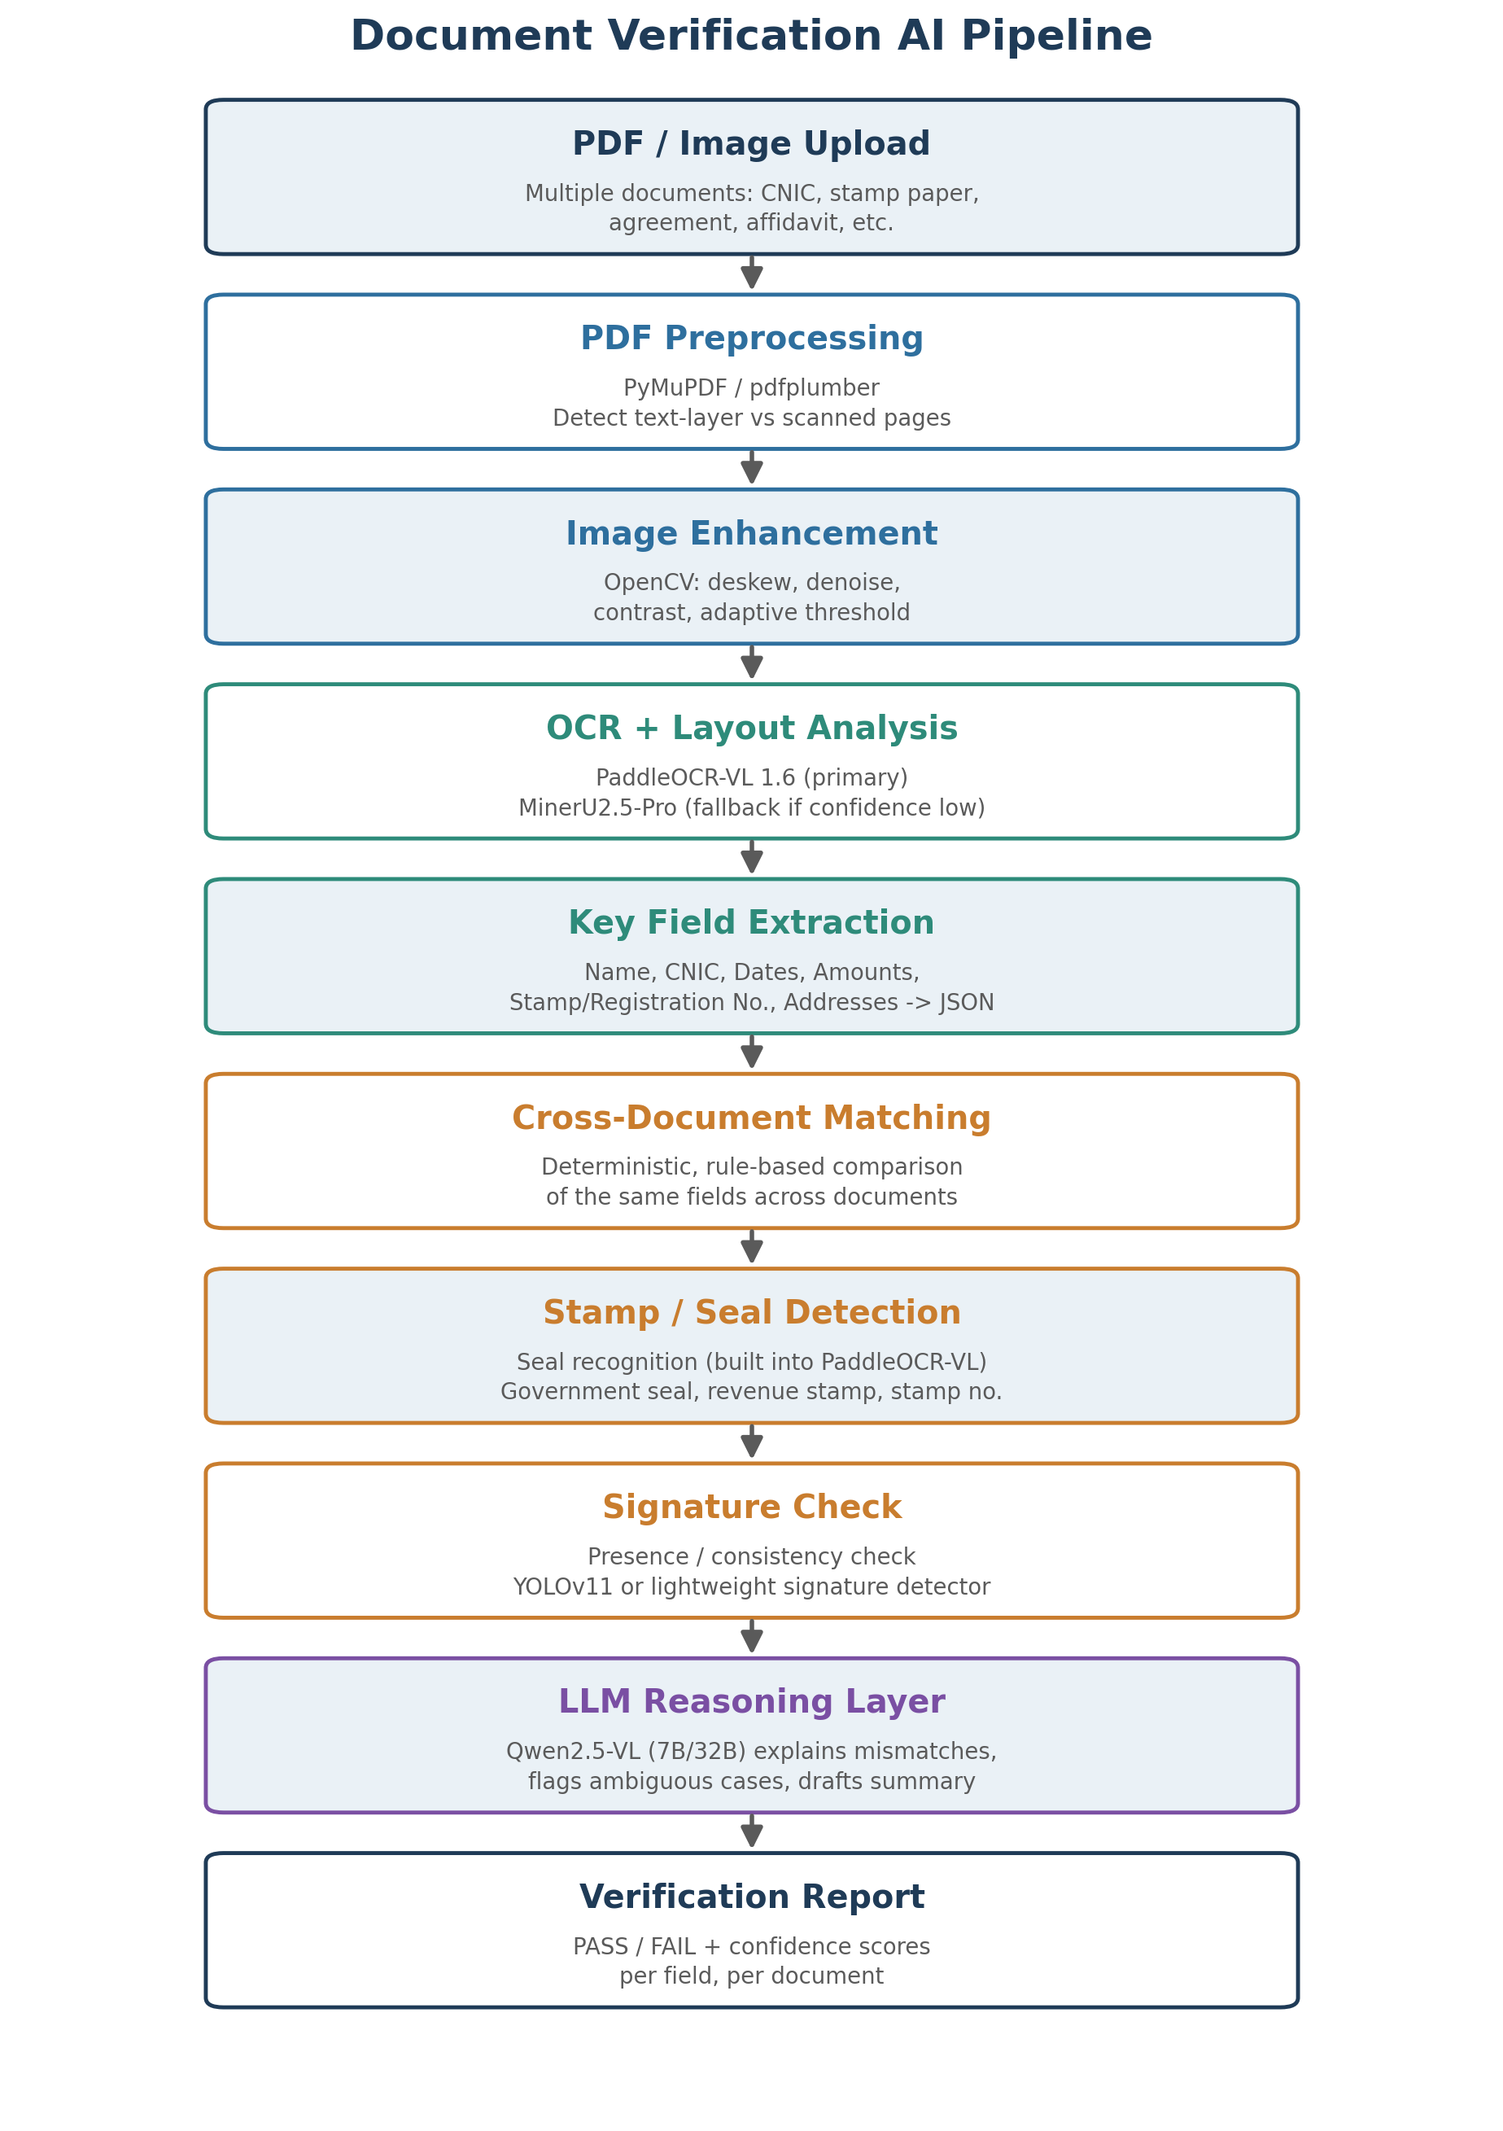
Figure 1: Full document verification pipeline

Stage-by-stage explanation
- PDF Preprocessing — checks whether each page already has selectable text or is a scanned image, since that decides whether OCR is even needed.
- Image Enhancement — cleans up scanned pages (straightens tilted scans, removes noise, sharpens faint print) so OCR has the best possible input.
- OCR + Layout Analysis — reads all text and understands the page structure (paragraphs, tables, stamps) in one pass.
- Key Field Extraction — pulls out only the fields that matter for verification (name, CNIC, dates, amount, stamp number, etc.) into a structured JSON record.
- Cross-Document Matching — compares the same field across all documents in the case using exact rule-based matching, not guesswork.
- Stamp / Seal Detection — confirms whether a government seal or revenue stamp is present and reads the stamp number.
- Signature Check — detects whether a signature is present and whether it looks consistent across documents.
- LLM Reasoning Layer — only steps in for the judgment calls: explaining a mismatch in plain language, or flagging something ambiguous for human review.
- Verification Report — the final structured output, ready to show to a reviewer or store for audit.

3. Cross-Document Field Matching
This is the core logic of the system: the same real-world fact (e.g. a person's name or CNIC number) should appear identically across every document in a case. The matching itself is done with simple, deterministic rules (exact string/number comparison) — not an AI model — because deterministic checks are far more reliable for something like a CNIC number than asking a language model to "eyeball" whether two strings match.
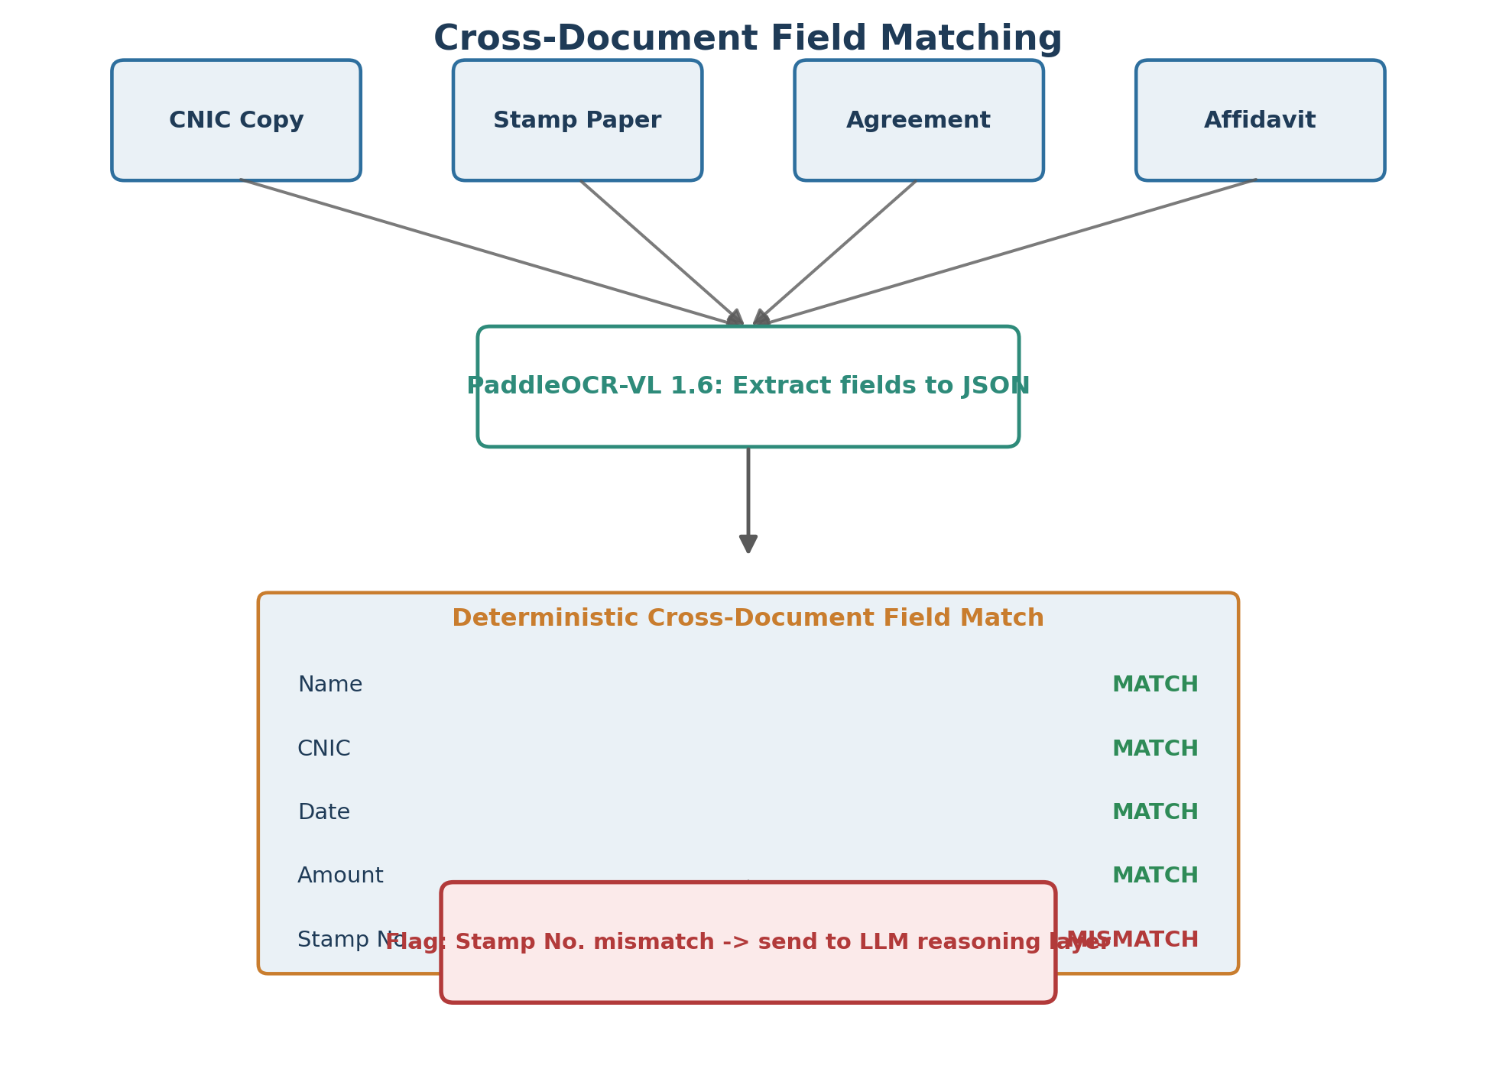
Figure 2: Example of field-level matching across four documents
Only once a mismatch or ambiguity is found does the pipeline call the LLM reasoning layer — to explain the mismatch in plain language and decide whether it's a genuine problem or a minor formatting difference (e.g. "Muhammad Ali" vs "Md. Ali").

4. System Architecture
How the pieces fit together as a deployable system:
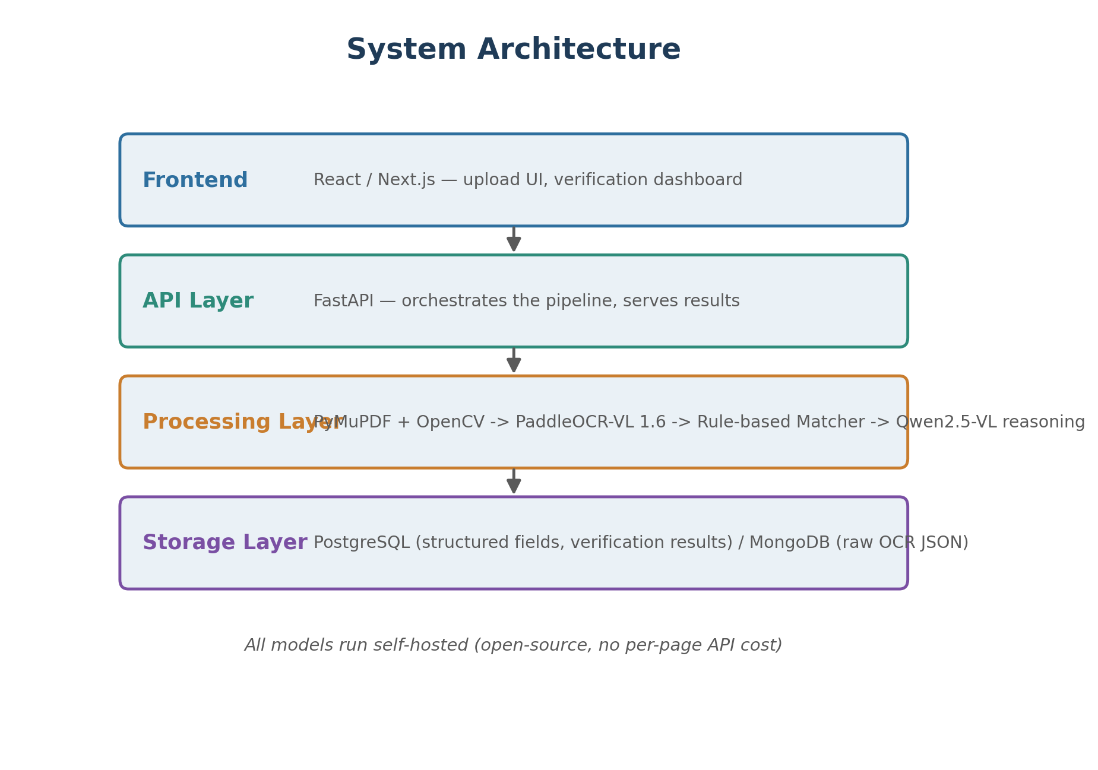
Figure 3: System architecture and technology stack

5. Model Choices — and Why
These recommendations are based on current (July 2026) open-source OCR benchmarks, not just brand recognition. All models below are free and self-hostable.
Purpose | Recommended Model | Why
Primary OCR + Layout | PaddleOCR-VL 1.6 | 0.9B params, 96.33% on OmniDocBench v1.6, built-in seal/stamp recognition, supports Urdu + English
Backup OCR | MinerU2.5-Pro | Near-identical accuracy to PaddleOCR-VL, strong on tables and dense text
Reasoning / explanation | Qwen2.5-VL (7B or 32B) | Apache 2.0 licensed at these sizes; explains mismatches, drafts the verification summary
Signature detection | YOLOv11 | Fast, well-supported object detector for presence/consistency checks
PDF reading | PyMuPDF | Detects text-layer vs scanned pages before deciding whether OCR is needed
Image cleanup | OpenCV | Deskew, denoise, contrast enhancement before OCR

Note: benchmark leaderboards in this space move fast and some published scores are vendor-reported rather than independently verified. Before relying on any single number, it's worth running a small in-house test (20–30 real documents) to confirm PaddleOCR-VL performs well on your actual stamp papers and CNIC scans.

6. What to Build First (Suggested Order)
- PDF/image ingestion + PaddleOCR-VL extraction on a handful of sample documents — confirm OCR quality on real stamp papers and CNICs before anything else.
- Structured field extraction into JSON — define the exact field schema (name, CNIC, date, amount, stamp no., etc.).
- Deterministic cross-document matching — the rule-based comparison logic.
- Stamp/seal presence detection — using PaddleOCR-VL's built-in seal recognition.
- LLM reasoning layer — only after the above works reliably, add Qwen2.5-VL to explain mismatches.
- Signature detection and pixel-level forgery detection — treat as a later phase; these are the least mature parts of the open-source stack and shouldn't block the first working version.

