DEVSPHERE
INTERNSHIP PROGRAM

WEEK 1 — TASK 1
Artificial Intelligence (AI): Basics + Python
AI Learning Recommender

Organization | DevSphere
Internship Week | Week 1
Task | Task 1 — Artificial Intelligence (AI)
Submitted By | Abdul Samad

Repository: https://github.com/abdulsamad010/ai_learning_recommender_python

1. Introduction
As part of the DevSphere Internship Program, Week 1 Task 1 focused on Artificial Intelligence basics and Python. The objective was to develop a simple AI program that demonstrates decision-making through basic conditional logic.

2. Project Overview
For this task, I developed an AI Learning Recommender using Python. The program takes the user's preferred subject, skill level, and learning goal as input. Based on these choices, the system applies predefined rules and provides a suitable learning recommendation with a short explanation.

3. Implementation
The system was developed using Python functions, user input, input validation, and conditional statements. The recommendation logic uses if, elif, and else conditions to evaluate different combinations of user preferences and generate an appropriate result.
The project was developed and tested in Visual Studio Code. The code is organized into source and testing files so that the project remains structured and easy to maintain.

4. Working
The program first asks the user to select a preferred subject, skill level, and learning goal. These inputs are then processed by the recommendation logic. After evaluating the predefined rules, the program displays the recommended learning activity and explains the reason behind the recommendation.

5. Project Structure
ai_learning_recommender_python/
│
├── src/
│ └── ai_recommender.py
│
├── tests/
│ └── test_recommender.py
│
├── screenshots/
├── docs/
├── README.md
├── requirements.txt
└── .gitignore

6. Output
The program was successfully executed and tested with different input combinations. For example, when the selected subject was AI, the skill level was Intermediate, and the learning goal was Build Projects, the system recommended building a Python recommendation system using multiple user preferences.

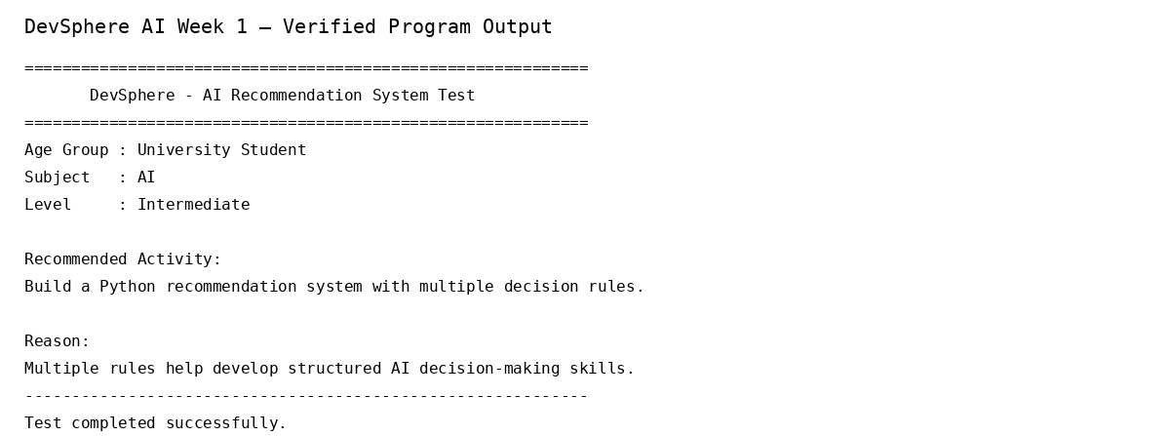
Figure 1: Verified program output

7. Result
The AI Learning Recommender was successfully implemented and tested. The project demonstrates basic Artificial Intelligence decision-making using Python and fulfills the requirements of the DevSphere Week 1 Task 1.

8. Conclusion
This task provided practical experience in Python programming and introduced the concept of rule-based Artificial Intelligence. It also helped demonstrate how predefined conditions can be used to build a simple system that makes decisions based on user input.

Repository
GitHub Repository: https://github.com/abdulsamad010/ai_learning_recommender_python

Submitted by
Abdul Samad

