DEVSPHERE INTERNSHIP
WEEK 3 INTERNSHIP REPORT
Basic Machine Learning Models

Prepared By
Abdul Samad

Internship Organization
DevSphere

Project Repository
ai_ml_basic_models_python
https://github.com/abdulsamad010/ai_ml_basic_models_python/tree/main

1. Week 3 Overview
During Week 3 of the DevSphere internship, two practical supervised machine learning tasks were completed in one weekly repository. The AI task implemented a basic classification model using the Iris dataset and Gaussian Naive Bayes. The ML task implemented a Linear Regression model using selected parameters from the California Housing dataset to predict median house values.
This report records the work that was implemented and executed in Google Colab. The numerical results below are taken from the actual notebook execution.

2. Repository Organization
ai_ml_basic_models_python/
├── ai_basic_ml/
│ └── basic_ml_model.ipynb
├── ml_regression/
│ └── basic_regression_model.ipynb
└── README.md

3. Task 1 — Basic Machine Learning Model

3.1 Objective
Load a standard classification dataset, split it into training and testing sets, train a basic machine learning model, make predictions, evaluate the model, and visualize the results.

3.2 Work Completed
- Loaded the Iris dataset using Scikit-learn.
- Prepared the feature and target data.
- Split the dataset into 80% training data and 20% testing data.
- Visualized the distribution of the three Iris classes.
- Trained a Gaussian Naive Bayes classification model.
- Generated predictions for the test data.
- Calculated Accuracy, Precision, Recall, and F1 Score.
- Generated a confusion matrix.
- Displayed sample predictions.

3.3 Dataset and Model
Metric | Recorded Result
Dataset | Iris Dataset
Total Samples | 150
Training Samples | 120
Testing Samples | 30
Model | Gaussian Naive Bayes
Task Type | Classification

3.4 Actual Results
Metric | Recorded Result
Accuracy | 96.67%
Precision | 96.97%
Recall | 96.67%
F1 Score | 96.66%

3.5 Sample Predictions
1. Actual: setosa | Predicted: setosa
2. Actual: virginica | Predicted: virginica
3. Actual: versicolor | Predicted: versicolor
4. Actual: versicolor | Predicted: versicolor
5. Actual: setosa | Predicted: setosa

3.6 Screenshot — Task 1 Output
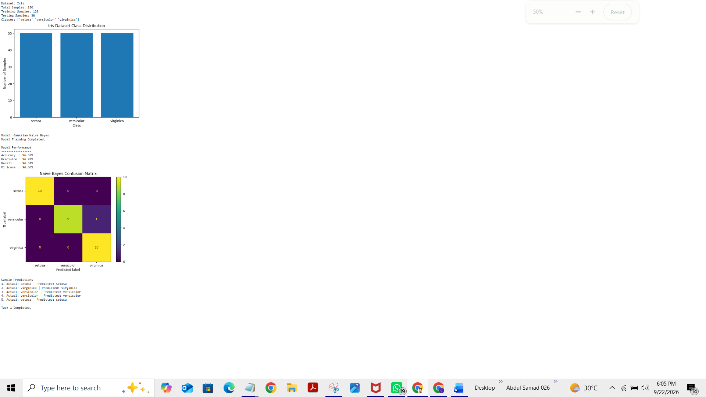

4. Task 2 — Regression Model

4.1 Objective
Load a real housing dataset, select simple housing-related parameters, train a Linear Regression model, predict house values, evaluate the model, and visualize actual versus predicted values.

4.2 Work Completed
- Loaded the California Housing dataset using Scikit-learn.
- Selected five housing-related features: Median Income, House Age, Average Rooms, Latitude, and Longitude.
- Used Median House Value as the target.
- Split the dataset into 80% training data and 20% testing data.
- Trained a Linear Regression model.
- Generated house-value predictions for the test data.
- Calculated R² Score and Mean Squared Error.
- Created an actual-versus-predicted visualization.
- Displayed sample predictions.

4.3 Dataset and Model
Metric | Recorded Result
Dataset | California Housing Dataset
Total Samples | 20,640
Features Used | 5
Training Samples | 16,512
Testing Samples | 4,128
Model | Linear Regression
Task Type | Regression
Target | Median House Value

4.4 Features Used
- Median Income
- House Age
- Average Rooms
- Latitude
- Longitude

4.5 Actual Results
Metric | Recorded Result
R² Score | 0.5814
Mean Squared Error | 0.5486

4.6 Sample Predictions
1. Actual: 0.48 | Predicted: 0.74
2. Actual: 0.46 | Predicted: 1.75
3. Actual: 5.00 | Predicted: 2.47
4. Actual: 2.19 | Predicted: 2.89
5. Actual: 2.78 | Predicted: 2.71

4.7 Screenshot — Task 2 Output
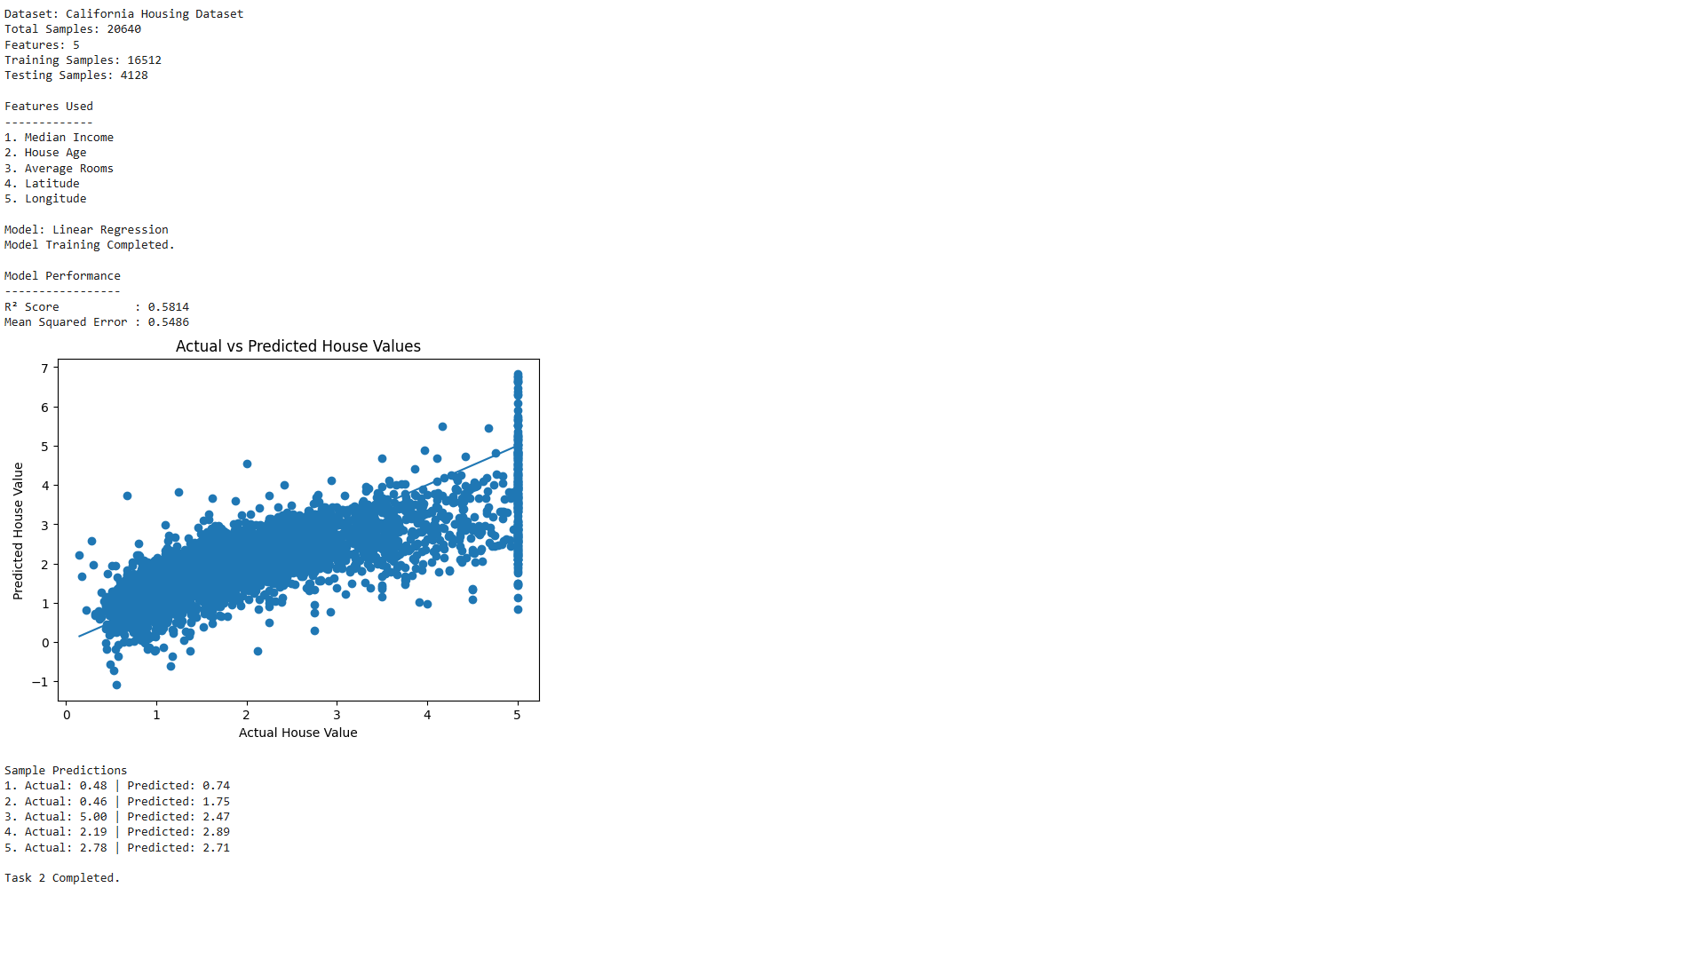

5. Technologies and Tools
Metric | Recorded Result
Python | Programming language and implementation
Scikit-learn | Dataset loading, model training, and evaluation
Matplotlib | Data visualization
Google Colab | Notebook development and execution
GitHub | Repository hosting and project organization

6. Week 3 Completion Summary
Both Week 3 tasks were implemented and successfully executed. The AI task demonstrated a basic classification workflow using Gaussian Naive Bayes on the Iris dataset and recorded the resulting classification metrics and predictions. The ML task demonstrated a basic regression workflow using Linear Regression on selected California Housing features and recorded the R² Score, Mean Squared Error, visualization, and sample predictions.

7. Repository
GitHub: https://github.com/abdulsamad010/ai_ml_basic_models_python/tree/main

8. Final Statement
Week 3 provided practical experience in supervised machine learning, dataset preparation, classification, regression, model evaluation, prediction, and visualization. The tasks were organized under one weekly repository with separate AI and ML notebooks.

