DEVSPHERE INTERNSHIP
WEEK 6 FINAL PROJECT REPORT
AI Intelligent Digit Recognition
and
ML House Price Prediction

Item | Details
Prepared By | Abdul Samad
Internship Organization | DevSphere
Repository Name | ai_ml_final_projects_python
Notebook | AI_ML_Week6_Final_Project.ipynb

GitHub Repository
https://github.com/abdulsamad010/ai_ml_final_projects_python

1. Project Overview
This report documents the two Week 6 final projects completed for the DevSphere Internship. Both tasks are implemented in one Google Colab notebook using Python and Scikit-learn.
Task | Objective | Dataset / Model
Task 1 — AI | Recognize handwritten digits and support sample-based user interaction. | Digits Dataset; Multi-Layer Perceptron neural network.
Task 2 — ML | Compare and tune regression models to predict median house values. | California Housing Dataset; Linear Regression and Random Forest Regressor.

2. Tools and Technologies
- Python for implementation.
- Pandas and NumPy for data inspection and numerical operations.
- Matplotlib for charts and visualizations.
- Scikit-learn for datasets, preprocessing, pipelines, models, tuning, and evaluation.
- Google Colab for notebook development and execution.
- GitHub for project hosting.

3. Task 1 — AI Intelligent Digit Recognition System

3.1 Objective and Workflow
The objective was to build an AI classification system that recognizes handwritten digits from 0 to 9. The workflow includes dataset inspection, class-distribution visualization, sample-image display, feature scaling, neural-network training, evaluation, and user-selected sample prediction.

3.2 Dataset and Model
Item | Details
Dataset | Scikit-learn Digits Dataset
Total samples | 1,797
Features | 64 pixel values per sample
Image dimensions | 8 × 8
Classes | Digits 0–9
Training samples | 1,437
Testing samples | 360
Model | Multi-Layer Perceptron (MLP) Neural Network
Pipeline | StandardScaler followed by MLPClassifier

3.3 Actual Results
Metric | Recorded result
Accuracy | 96.11%
Weighted precision | 96.21%
Weighted recall | 96.11%
Weighted F1 score | 96.11%
User-selected sample | 300
Actual digit | 5
Predicted digit | 5
Displayed confidence | 97.25%

3.4 Sample Predictions
1. Actual: 5 | Predicted: 5
2. Actual: 2 | Predicted: 2
3. Actual: 8 | Predicted: 8
4. Actual: 1 | Predicted: 8
5. Actual: 7 | Predicted: 7

3.5 Task 1 Screenshot Placeholders
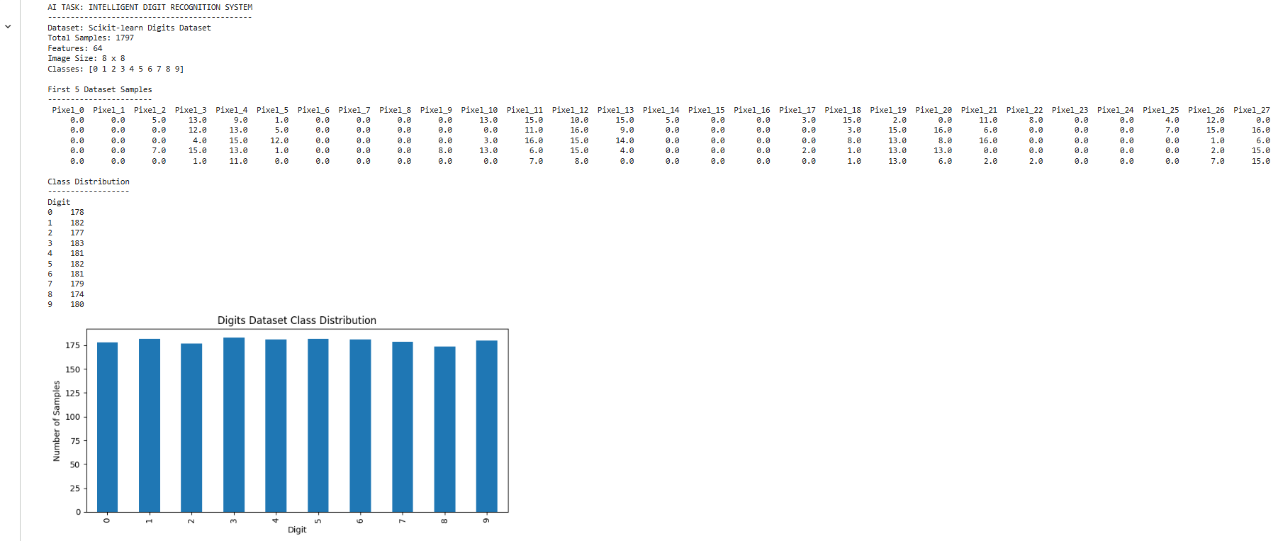

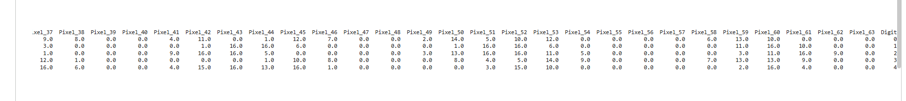

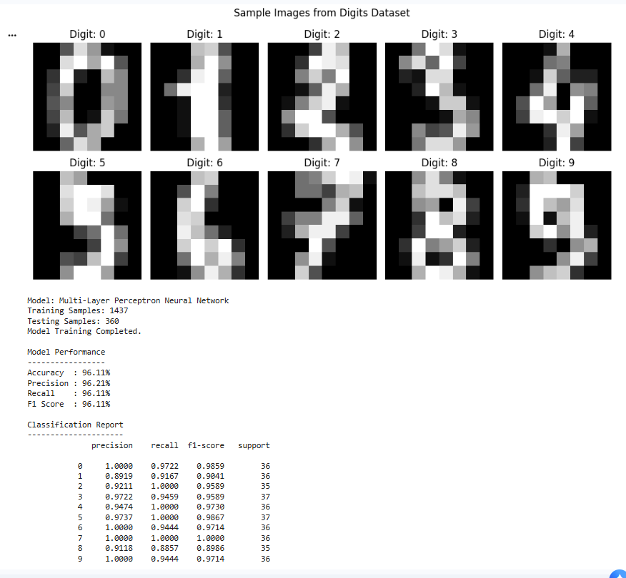

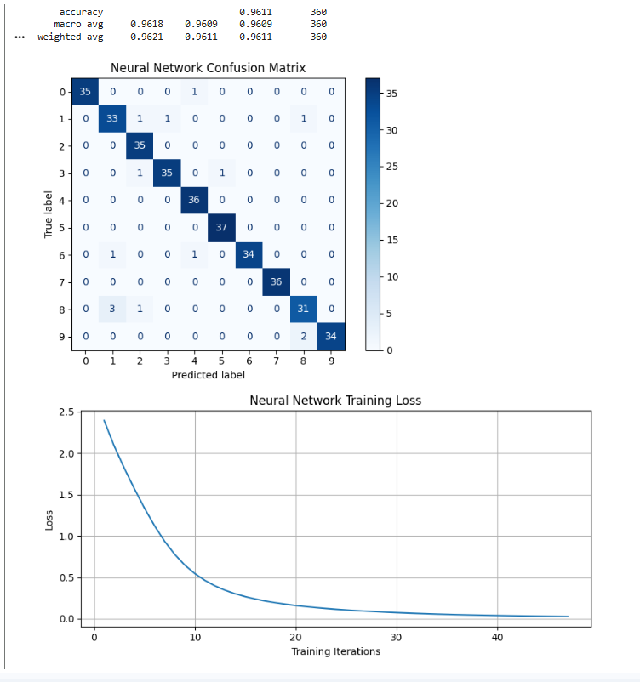

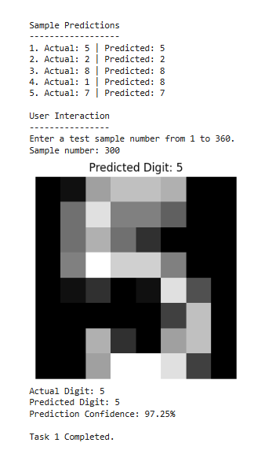

4. Task 2 — ML California House Price Prediction

4.1 Objective and Workflow
The objective was to build a regression prediction system using California housing data. The project explores the dataset, compares Linear Regression and Random Forest Regression, tunes Random Forest with GridSearchCV, evaluates predictions, visualizes feature importance, and accepts user-provided feature values.

4.2 Dataset and Models
Item | Details
Dataset | California Housing Dataset from Scikit-learn
Total samples | 20,640
Features | 8
Target | Median house value, in units of $100,000
Training samples | 16,512
Testing samples | 4,128
Models | Linear Regression and Random Forest Regressor
Tuning method | GridSearchCV with 3-fold cross-validation

4.3 Initial Model Comparison
Model | R² Score | MAE | RMSE
Linear Regression | 0.5758 | 0.5332 | 0.7456
Random Forest | 0.8051 | 0.3275 | 0.5053

4.4 Tuned Random Forest Results
Metric | Recorded result
Best cross-validation R² | 0.8012
Test R² score | 0.8057
Mean Absolute Error (MAE) | 0.3266
Root Mean Squared Error (RMSE) | 0.5046
Best max_depth | None
Best min_samples_leaf | 2
Best n_estimators | 120

4.5 Sample Predictions
Sample | Actual value | Predicted value
1 | $47,700 | $50,128
2 | $45,800 | $77,323
3 | $500,001 | $488,297
4 | $218,600 | $254,309
5 | $278,000 | $233,950

The submitted user-input example used 33,44,55,66,77,11,55,66 and displayed an estimated value of $320,256. These values are outside normal ranges for some features and should not be treated as a meaningful real-world housing estimate.

4.6 Task 2 Screenshot Placeholders
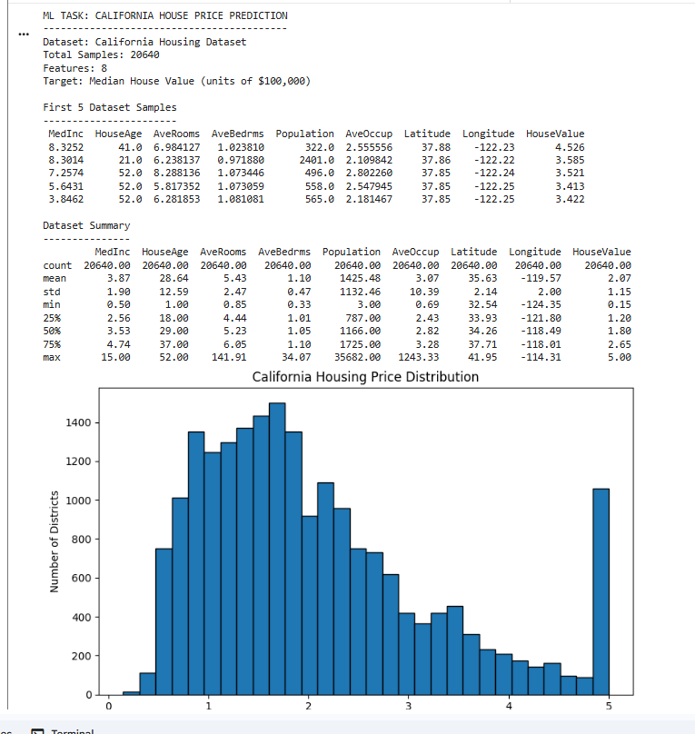

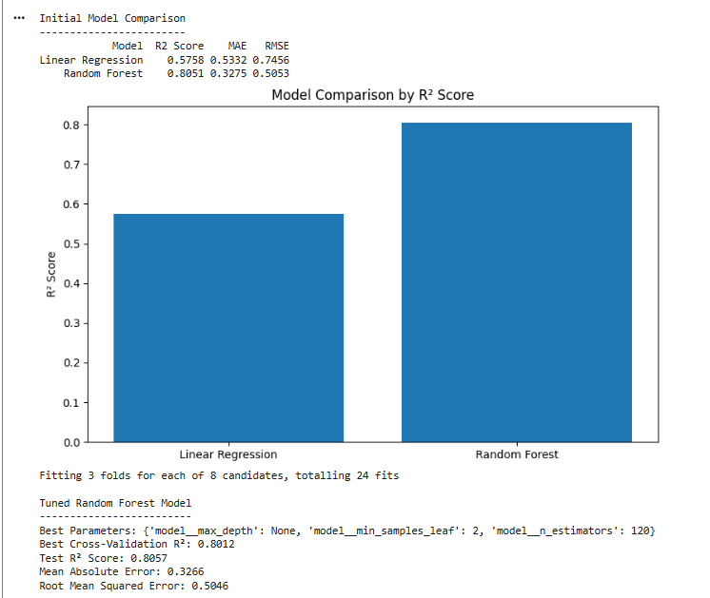

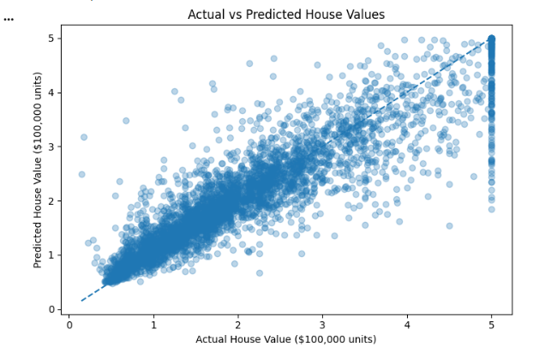

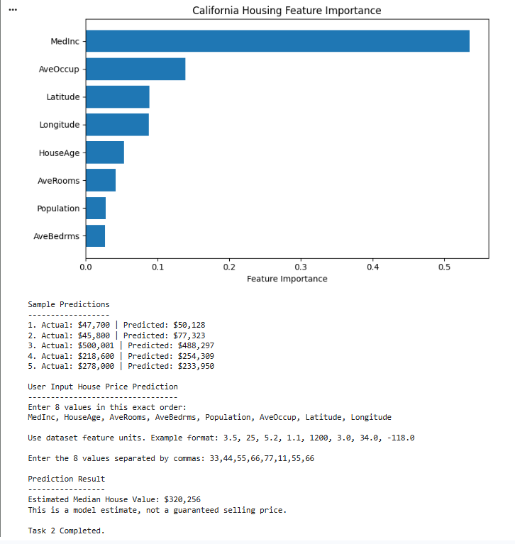

5. Summary and Learning Outcomes
The AI project used an MLP neural network and achieved 96.11% accuracy in the supplied output. The ML project compared two regression approaches and tuned a Random Forest model, achieving a test R² score of 0.8057 in the supplied output.
- Dataset inspection, exploration, and visualization.
- Pipeline-based preprocessing and model training.
- Neural-network classification and regression workflows.
- Evaluation using suitable classification and regression metrics.
- Cross-validation and hyperparameter tuning with GridSearchCV.
- Interpreting confusion matrices, loss curves, prediction plots, and feature importance.
- Basic user interaction for model predictions.

6. Repository and Submission
GitHub Repository: https://github.com/abdulsamad010/ai_ml_final_projects_python

