DEVSPHERE INTERNSHIP
WEEK 5 INTERNSHIP REPORT
AI Intelligent System & ML Model Evaluation and Tuning

Item | Details
Prepared By | Abdul Samad
Internship Organization | DevSphere
Project Repository | ai_ml_intelligent_model_tuning_python
Notebook | AI_ML_Week5_Intelligent_System.ipynb

GitHub Repository
https://github.com/abdulsamad010/ai_ml_intelligent_model_tuning_python

1. Week 5 Overview
This report documents two practical tasks completed for Week 5 of the DevSphere Internship. Both tasks are included in one Google Colab notebook and use the Breast Cancer Wisconsin dataset provided by Scikit-learn.
Item | Details
Task 1 — AI | AI-based intelligent classification system using a Random Forest Classifier.
Task 2 — ML | Model comparison and hyperparameter tuning using Logistic Regression, Decision Tree, and Random Forest.

2. Tools and Technologies
Item | Details
Python | Programming language
Scikit-learn | Dataset loading, preprocessing, model training, tuning, and evaluation
Pandas and NumPy | Dataset inspection and numerical operations
Matplotlib | Graphs and model visualizations
Google Colab | Notebook development and execution
GitHub | Project hosting and version control

3. Task 1 — AI-Based Intelligent Classification System

3.1 Objective
Develop an intelligent classification system that inspects data, preprocesses it, trains a model, predicts classes, evaluates performance, handles a user selection, and displays visual results.

3.2 Dataset and Model
Item | Details
Dataset | Breast Cancer Wisconsin Dataset (Scikit-learn)
Total samples | 569
Features | 30
Classes | Malignant and Benign
Training samples | 455
Testing samples | 114
Model | Random Forest Classifier

3.3 Implementation
- Inspected dataset dimensions, feature names, class labels, and the first five records.
- Visualized the distribution of malignant and benign samples.
- Split the dataset into training and testing subsets using stratification.
- Used a Scikit-learn pipeline with median imputation and a Random Forest classifier.
- Generated predictions and evaluated the model using accuracy and a classification report.
- Visualized the confusion matrix and the top ten feature importances.
- Added a user-input step to select a complete sample from the test set and display its predicted class and confidence.

3.4 Actual Results
Item | Details
Accuracy | 94.74%
Malignant precision / recall / F1 | 0.9286 / 0.9286 / 0.9286
Benign precision / recall / F1 | 0.9583 / 0.9583 / 0.9583
Confusion matrix | 39 malignant correctly classified; 3 malignant classified as benign; 3 benign classified as malignant; 69 benign correctly classified.
User input example | Test sample 14 — predicted class: malignant; displayed confidence: 100.00%.

3.5 Sample Predictions
1. Actual: malignant | Predicted: malignant
2. Actual: benign | Predicted: benign
3. Actual: malignant | Predicted: malignant
4. Actual: benign | Predicted: malignant
5. Actual: malignant | Predicted: malignant
Note: This is an educational machine-learning demonstration and is not a medical diagnostic tool.

3.6 Task 1 Screenshots
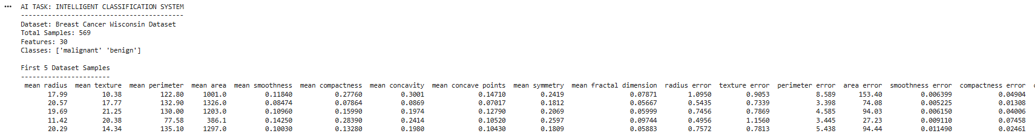

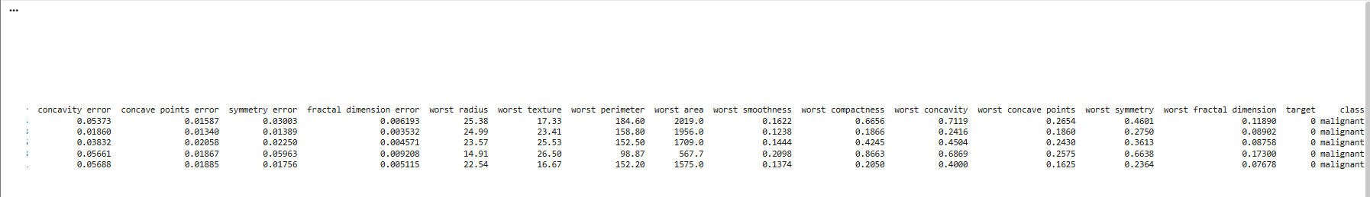

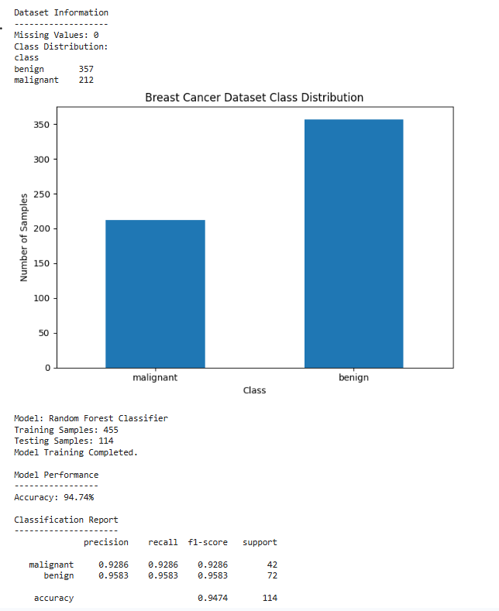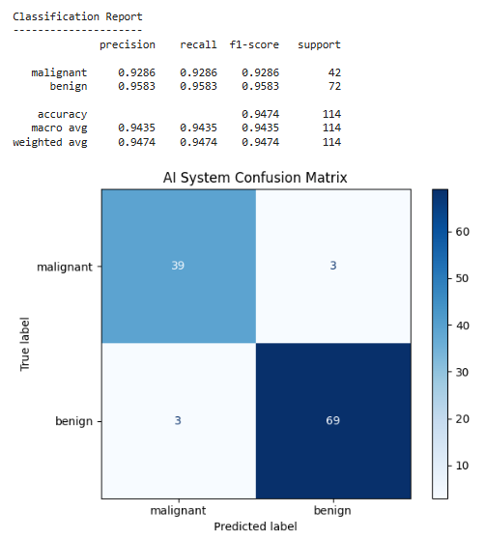

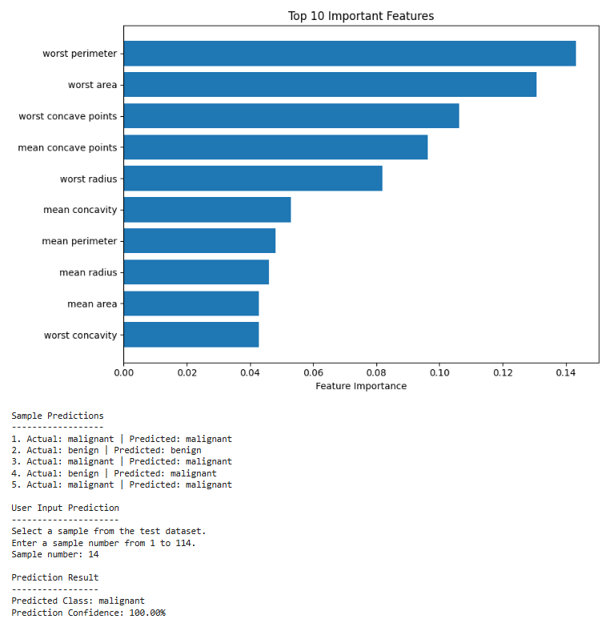

4. Task 2 — ML Model Evaluation and Tuning

4.1 Objective
Train multiple classification models, compare their performance using several evaluation metrics, tune Logistic Regression with cross-validation, and visualize the results.

4.2 Dataset and Experimental Setup
Item | Details
Dataset | Breast Cancer Wisconsin Dataset
Total samples | 569
Features | 30
Training samples | 455
Testing samples | 114
Models compared | Logistic Regression, Decision Tree, Random Forest
Tuning method | GridSearchCV with stratified 5-fold cross-validation

4.3 Model Comparison Results
Model | Accuracy | Precision | Recall | F1 Score | ROC AUC
Logistic Regression | 0.9825 | 0.9861 | 0.9861 | 0.9861 | 0.9954
Decision Tree | 0.9123 | 0.9559 | 0.9028 | 0.9286 | 0.9157
Random Forest | 0.9561 | 0.9589 | 0.9722 | 0.9655 | 0.9937

4.4 Tuning Results
Item | Details
Best C parameter | 0.1
Best solver | liblinear
Best cross-validation accuracy | 98.24%
Tuned test accuracy | 98.25%
Precision | 0.9861
Recall | 0.9861
F1 Score | 0.9861
ROC AUC | 0.9960

4.5 Confusion Matrix
Item | Details
Actual malignant | 41 predicted malignant; 1 predicted benign
Actual benign | 1 predicted malignant; 71 predicted benign

4.6 Sample Predictions After Tuning
1. Actual: malignant | Predicted: malignant
2. Actual: benign | Predicted: benign
3. Actual: malignant | Predicted: malignant
4. Actual: benign | Predicted: benign
5. Actual: malignant | Predicted: malignant

4.7 Task 2 Screenshots
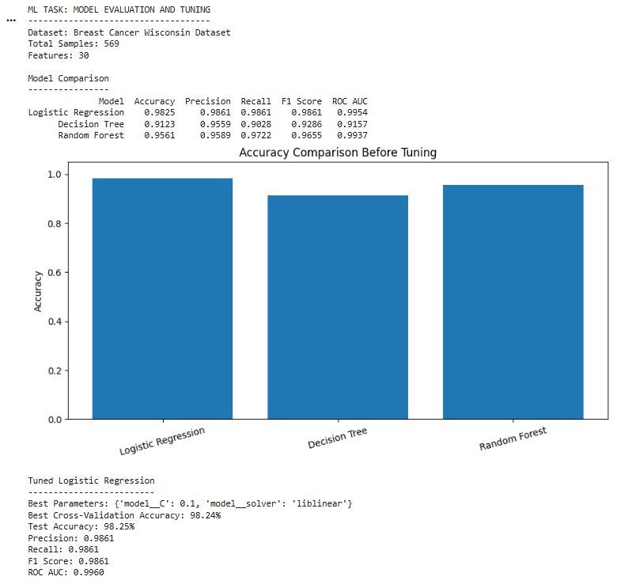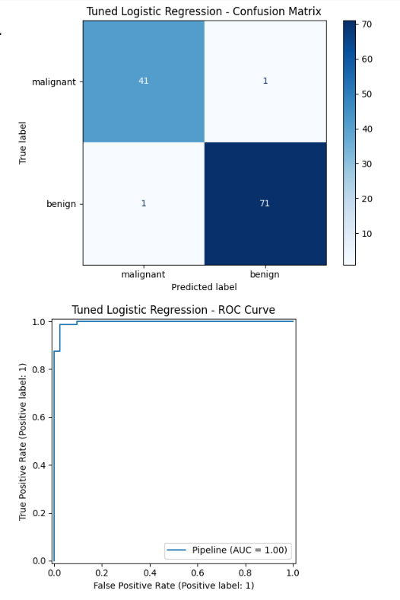

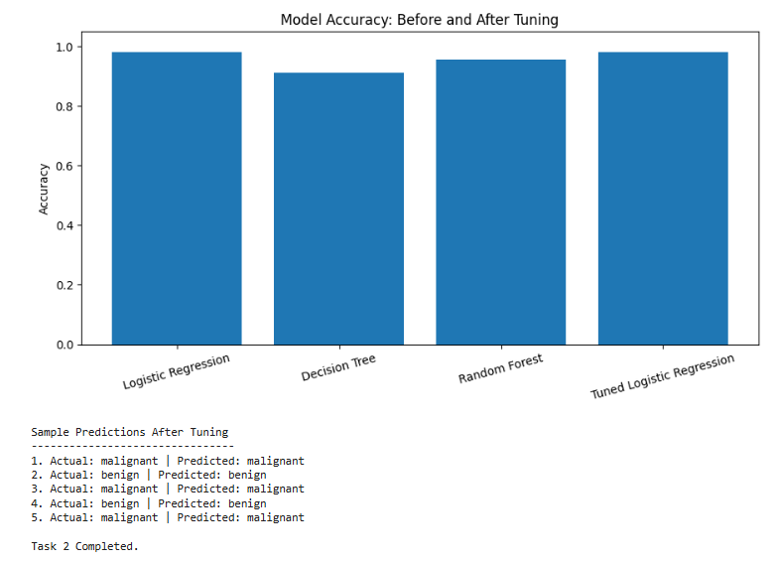

5. Summary and Learning Outcomes
The AI task implemented a Random Forest-based classification system and achieved 94.74% accuracy in the supplied execution. The ML task compared three classifiers and tuned Logistic Regression, which achieved 98.25% test accuracy in the supplied output.
- Dataset inspection and preparation using Scikit-learn and Pandas.
- Training/testing splits and pipeline-based preprocessing.
- Classification using Random Forest, Logistic Regression, and Decision Tree models.
- Model comparison and hyperparameter tuning with GridSearchCV.
- Evaluation using accuracy, precision, recall, F1 score, ROC AUC, and confusion matrices.
- Creating charts to communicate class distributions, feature importance, and model performance.

6. Repository Link
GitHub Repository: https://github.com/abdulsamad010/ai_ml_intelligent_model_tuning_python

