DEVSPHERE INTERNSHIP
WEEK 4 INTERNSHIP REPORT
Neural Network & Classification Models
Prepared By
Abdul Samad
Internship Organization
DevSphere
Project Repository
ai_ml_neural_classification_python
https://github.com/abdulsamad010/ai_ml_neural_classification_python

1. Week 4 Overview
During Week 4 of the DevSphere internship, two practical machine learning tasks were completed in a single Google Colab notebook. The AI task focused on Neural Network Basics using the Digits dataset and a Multi-Layer Perceptron Neural Network. The ML task focused on Classification Models using the Breast Cancer Wisconsin dataset and Logistic Regression.
Both implementations followed a structured workflow covering dataset inspection, data preparation, training, prediction, evaluation, and visualization.

2. Repository Organization
ai_ml_neural_classification_python/
├── AI_ML_Week4_Neural_Classification.ipynb
├── README.md
└── DevSphere_Week4_Report_By_Abdul_Samad.docx

3. Task 1 — Neural Network Basics

3.1 Objective
Implement a basic neural network, train it on a dataset, generate predictions, display results, and briefly demonstrate the neural network workflow.

3.2 Dataset
Item | Result
Dataset | Digits Dataset
Total Samples | 1,797
Features | 64
Image Size | 8 × 8
Classes | 10 (0–9)
Training Samples | 1,437
Testing Samples | 360

3.3 Model and Implementation
- Loaded the Digits dataset using Scikit-learn.
- Inspected the dataset and displayed sample digit images.
- Split the data into training and testing sets.
- Applied feature scaling using StandardScaler.
- Trained a Multi-Layer Perceptron (MLP) Neural Network.
- Used a hidden layer containing 64 neurons.
- Generated predictions for the testing data.
- Calculated accuracy and classification metrics.
- Generated a confusion matrix and training loss curve.
- Displayed sample predictions.

3.4 Actual Results
Item | Result
Model | Multi-Layer Perceptron Neural Network
Accuracy | 98.06%
Macro Average F1 | 0.9803
Weighted Average F1 | 0.9805

3.5 Sample Predictions
1. Actual: 5 | Predicted: 5
2. Actual: 2 | Predicted: 2
3. Actual: 8 | Predicted: 8
4. Actual: 1 | Predicted: 8
5. Actual: 7 | Predicted: 7

3.6 Screenshot Spaces
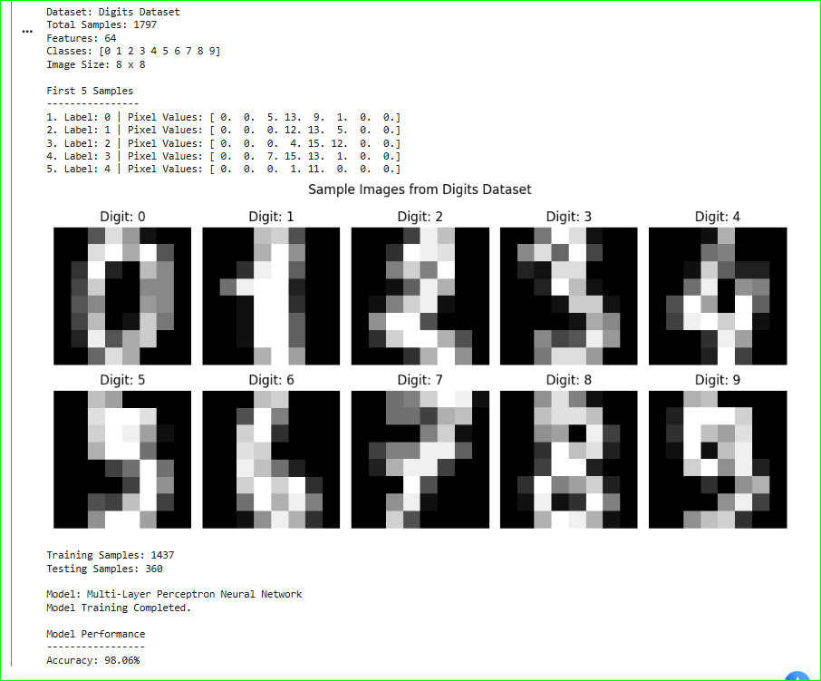

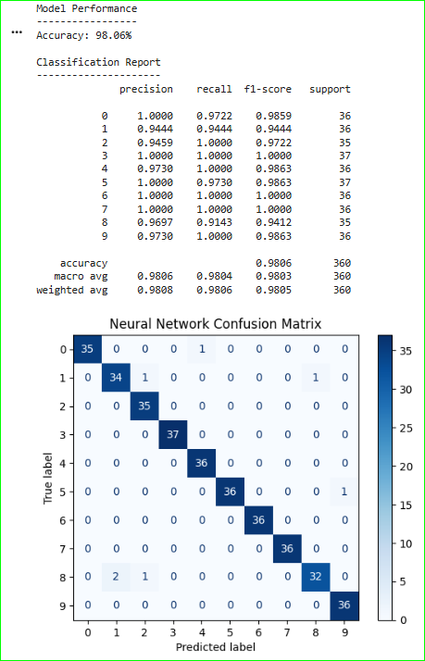

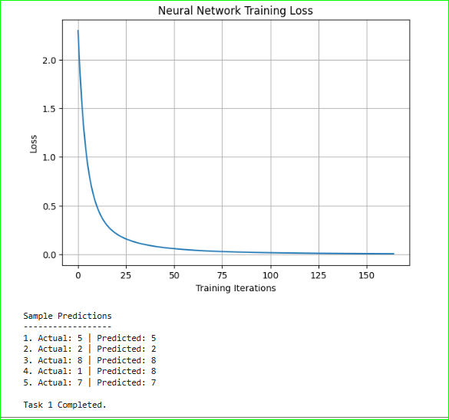

4. Task 2 — Classification Model

4.1 Objective
Implement a classification model using a classification dataset, train the model, generate predictions, and show the accuracy and supporting classification results.

4.2 Dataset
Item | Result
Dataset | Breast Cancer Wisconsin Dataset
Total Samples | 569
Features | 30
Classes | 2 — Malignant and Benign
Training Samples | 455
Testing Samples | 114

4.3 Model and Implementation
- Loaded the Breast Cancer Wisconsin dataset using Scikit-learn.
- Inspected the dataset and displayed sample feature values.
- Visualized the class distribution.
- Split the data into training and testing sets.
- Applied feature scaling using StandardScaler.
- Trained a Logistic Regression classification model.
- Generated predictions for the testing data.
- Calculated the accuracy score and classification report.
- Generated a confusion matrix and ROC curve.
- Displayed sample predictions.

4.4 Actual Results
Item | Result
Model | Logistic Regression
Accuracy | 98.25%
ROC AUC | 1.00

4.5 Classification Report
Item | Result
Malignant | Precision 0.9762 | Recall 0.9762 | F1 0.9762 | Support 42
Benign | Precision 0.9861 | Recall 0.9861 | F1 0.9861 | Support 72
Macro Average | Precision 0.9812 | Recall 0.9812 | F1 0.9812
Weighted Average | Precision 0.9825 | Recall 0.9825 | F1 0.9825

4.6 Confusion Matrix
The recorded confusion matrix contained 41 correctly classified malignant samples, 1 malignant sample classified as benign, 1 benign sample classified as malignant, and 71 correctly classified benign samples.

4.7 Sample Predictions
1. Actual: malignant | Predicted: malignant
2. Actual: benign | Predicted: benign
3. Actual: malignant | Predicted: malignant
4. Actual: benign | Predicted: benign
5. Actual: malignant | Predicted: malignant

4.8 Screenshot Spaces
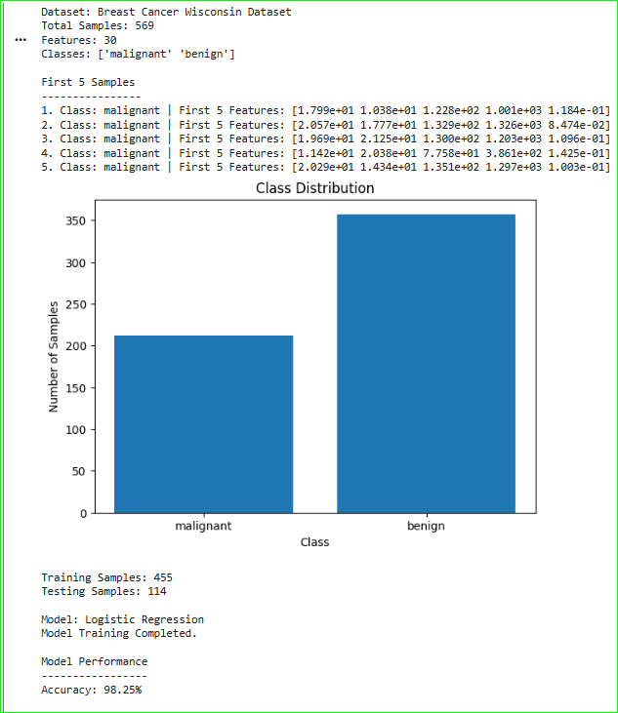

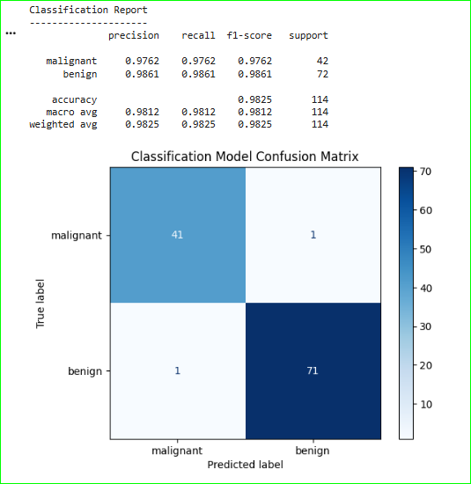

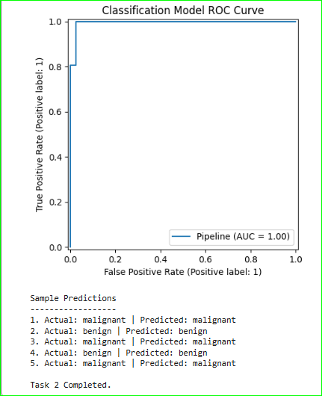

5. Technologies and Tools
Item | Result
Python | Programming and model implementation
Scikit-learn | Datasets, preprocessing, models, pipelines, and evaluation
Matplotlib | Graphs and visualizations
Google Colab | Notebook development and execution
GitHub | Repository hosting and project organization

6. Evaluation Summary
Task | Dataset + Model | Result
AI — Neural Network | Digits Dataset + MLP Neural Network | 98.06% Accuracy
ML — Classification | Breast Cancer Wisconsin + Logistic Regression | 98.25% Accuracy

7. Completion Summary
Both Week 4 tasks were implemented and successfully executed in a single Google Colab notebook. The AI task demonstrated a basic neural network workflow using the Digits dataset and achieved 98.06% accuracy. The ML task demonstrated a classification workflow using Logistic Regression on the Breast Cancer Wisconsin dataset and achieved 98.25% accuracy. The notebook also includes visualizations, confusion matrices, training loss, ROC analysis, and sample predictions.

8. Repository
GitHub Repository: https://github.com/abdulsamad010/ai_ml_neural_classification_python

9. Final Statement
Week 4 provided practical experience in neural networks and classification models, including dataset inspection, preprocessing, pipeline-based model training, prediction, evaluation, and visualization.

