Beyond Metric Inflation: Source-Family Exposure Distorts Compression, Pretraining and Distillation Conclusions in Tomato Disease Detection
[Author names] · [Affiliations] · Corresponding author: [e-mail]
Draft manuscript, generated 13 October 2026. Bracketed items must be completed by the authors.

Abstract
Image-based plant-disease benchmarks are often distributed with offline augmented copies of each source photograph, and random file-level splits then place siblings of the same photograph in training and evaluation partitions. Prior work treats this mainly as score inflation. We ask whether it also changes the engineering conclusions drawn from a benchmark. Using the Tomato-Village object-detection data (14,368 files from 1,796 source photographs; every official validation file has a training sibling), we built a source-family-aware split and two development evaluation arms: a source-exposed arm and a source-independent arm. With five paired seeds and pre-registered decision rules we measured the effect of uniform width compression of YOLO11n, a localization-motivated width reallocation, COCO pretraining and localization-focused knowledge distillation under both arms. Source exposure magnified every estimated effect: shrinking to 0.50× width cost −12.2 AP under exposure but −1.8 AP under independent evaluation, and pretraining added +15.1 versus +3.9 AP. Under the same frozen selection rule, source-exposed validation rejected all reduced-width models, whereas source-independent validation selected a 1.57 M-parameter model (0.75× width) as equivalent to the 2.59 M-parameter model within ±1.5 AP. Error decomposition showed that the dominant failure is lesions that receive no nearby detection at all (about half of ground-truth boxes), not disease misclassification (≤1.8 errors per 100 boxes); compression increased fully missed lesions and hurt small lesions most in relative terms. Distillation from a pretrained teacher reduced fully missed lesions and tightened boxes, raising the 0.75× model by +0.95 AP (95% CI +0.21 to +1.69) on the independent arm. On a locked test set evaluated once after all selections were frozen, the distilled 1.57 M model reached 16.08 AP, similar to the 2.59 M scratch model (16.19 AP), while the pretrained full-width model remained best (17.27 AP). Source-family exposure therefore biases intervention estimates and can change the model one would deploy.
Keywords: data leakage; evaluation validity; object detection; plant disease; model compression; knowledge distillation; pre-registration; YOLO.

1. Introduction
Field detection of foliar disease is a natural deployment target for compact one-stage detectors, and the literature on lightweight plant-disease detectors is large [ADD REFS]. Most of these studies are developed and compared on public benchmarks whose images were augmented offline before release: each source photograph is accompanied by rotated, flipped, cropped or photometrically altered copies, and the copies are then split at the file level. Siblings of one photograph can then sit in both the training and the evaluation partitions. The consequence usually discussed is that reported accuracy is inflated, which is a familiar form of data leakage [12, 13].
This paper asks a different question: does source exposure also bias the comparisons that guide model design? If exposure magnifies the apparent benefit of more capacity, pretraining or an architectural change, then conclusions about which model to build and deploy may differ from those that an independent evaluation would support. We study this on Tomato-Village [1], a field-condition tomato disease detection dataset in which every source photograph is distributed as eight files.
Our contributions are:
- Leakage characterisation. We show that every one of the 1,796 source photographs has exactly seven augmented siblings and that all 2,875 official validation files have a sibling in official training. We then build a family-aware split and paired source-exposed and source-independent development arms.
- Decision distortion. Across six interventions (three compression levels, a width reallocation, COCO pretraining and distillation), exposure magnified every estimated effect. Under one frozen non-inferiority rule, the exposed protocol keeps the 2.59 M model while the independent protocol selects a 1.57 M model.
- Mechanism. A TIDE-style error decomposition [4], an IoU sweep and a lesion-size analysis show that the dominant failure under independent evaluation is missed lesions, not misclassification, and that compression harms small lesions most in relative terms.
- A compact model with localization-focused distillation. Distilling box distributions and P3/P4 spatial attention from a pretrained teacher partly restores localization in the 0.75× model without changing its inference graph. On a locked test set it matches the full-width scratch model but not the pretrained one.
- Evidentiary discipline. Primary analyses were pre-registered with hashed scripts, the test set was evaluated once after model selection was locked, and post-hoc analyses were specified and hashed before computation.

2. Related work
Leakage and evaluation validity. Leakage, in which information unavailable at deployment time influences training or evaluation, is a recognised source of irreproducible machine-learning results [12, 13]. In plant pathology, studies using PlantVillage [14, 16] reported very high accuracies that later work attributed partly to acquisition artefacts and near-duplicate images [ADD REFS]. Group-aware splitting is the standard remedy when observations share a source. Our contribution is to measure how much the resulting bias propagates into treatment effects and model-selection decisions, rather than only into absolute scores.
Lightweight detectors for plant disease. Recent agricultural detectors combine YOLO-family backbones with attention modules, lightweight convolutions, modified necks or new box losses, typically reporting gains of a few AP points on random file-level splits [ADD REFS]. We use the YOLO11 family [2] and vary only width, one channel allocation, initialisation and the training loss, so that each effect can be attributed.
Distillation for detection. Knowledge distillation [5] has been adapted to dense detectors through feature imitation and localization distillation of box distributions [6]. The latter builds on the discretised box representation of Generalized Focal Loss [7], which YOLO11 also uses (distribution focal loss). We combine box-distribution distillation with channel-free spatial attention transfer [8].
Error analysis. TIDE [4] separates detection errors into classification, localization, duplicate, background and missed categories. We use a count-based variant at a fixed operating point.

3. Materials and methods

3.1 Data and source-family structure
We use Variant-c (object detection) of Tomato-Village [1]. The released files carry YOLO-format boxes for eight classes, two of which (Early Blight, Healthy) have no boxes. Files are named after their source photograph, with suffix _augN for derived copies. Grouping by source gives 1,796 families, each with exactly eight files (one original and seven copies; 14,368 files in total). The official split has 11,493 training and 2,875 validation files. 1,484 families span both partitions, and 100% of validation files have a training sibling; there is no official test split.
Comparing each copy's labels with its original's (box-matching tolerance 0.01 in normalised coordinates) classifies the 12,572 copies as follows. Photometric changes are invisible to labels.
- 32.7% label-identical (photometric only);
- 28.3% crop, scale or shift;
- 14.2% horizontal flip and 14.2% vertical flip;
- 7.2% 90° rotation and 3.5% 180° rotation.

3.2 Family-aware split and evaluation arms
We grouped files by source photograph and merged near-duplicate photographs (difference hash, Hamming distance ≤ 4; 59 pairs, giving 1,740 clusters). We then split clusters 70/15/15, stratified by majority class. This gives 1,260 training photographs (10,080 files including their copies), 268 validation photographs and 268 test photographs (3,205 boxes, 261 clusters). Copies are kept in training only. The split manifest is released with the code.
For development we re-used the official validation files as two disjoint evaluation arms (Table 1). Both arms exclude every test family. They are scored from the same inference pass, so they differ only in which images enter the metric.
Table 1. Development evaluation arms built from the official validation files.
Arm | Definition | Families | Files | Boxes
A: source-exposed | official-validation files whose source family is in our training split | 1,047 | 2,028 | 23,225
B: source-independent | official-validation files whose source family is in our validation split | 213 | 411 | 4,683
Arm B is the primary development metric. Arm A reproduces how a random file-level split behaves.

3.3 Models and training protocol
All models are Ultralytics YOLO11n [2] variants trained with one protocol (Table 2). The protocol (YOLO11n, 512 px, a fixed 24,570-update budget with a fixed checkpoint grid) was set in earlier development phases using validation data only (Section 3.6).
Table 2. Training and evaluation protocol shared by all models.
Setting | Value
Detector / input | YOLO11n family, 512 × 512
Optimiser | SGD, lr0 = 0.01, final lr factor 0.01 (linear), momentum 0.937, weight decay 5×10⁻⁴
Batch / budget | 16 (nominal 64) · 39 epochs × 630 steps = 24,570 updates · 933 warm-up updates · mosaic off for the last 5 epochs
Other | Early stopping disabled · mixed precision · deterministic seeding · default Ultralytics augmentation
Checkpoints | Fixed at 6,300 / 11,970 / 18,270 / 24,570 updates; no best-validation selection
Seeds | 0–4 for every model; comparisons are paired by seed
Inference | conf 0.001, NMS IoU 0.7, max 300 detections, top 100 per image, no test-time augmentation
Scorer | pycocotools AP@[.50:.95] [3], maxDets 100, 8 categories
Operating point | conf ≥ 0.25; greedy one-to-one matching at IoU 0.50 (strict 0.75). Localization recall = matched GT / all GT (class-agnostic); conditional class correctness = class-correct share of matched boxes

Width. Uniform channel width at 1.00×, 0.75×, 0.50× and 0.35× of YOLO11n, all trained from random initialisation. Initialising only some widths from COCO weights would confound width with initialisation: only 1.00× can load 98% of the pretrained parameters, against 8–23% for the narrower models.
LPWA-50. This localization-preserving width allocation keeps the YOLO11n topology and moves channels from the stride-32 (P5) path to the stride-8/16 (P3/P4) paths. A parameter audit showed that the class branch is under 2% of parameters, and that the box branch is already floored at 64 channels at every width. So the reallocatable budget sits in the backbone and neck, not the head. The allocation was solved by a rule fixed in advance: largest P3/P4 multiplier subject to parameters ≤ 0.811 M (uniform 0.50×) and GFLOPs ≤ 2.0. This gave P3/P4 ×1.37 and P5 ×0.69, i.e. 0.787 M parameters and 1.965 GFLOPs.
Pretrained reference. YOLO11n initialised from COCO weights and trained with the same protocol.
Localization-focused distillation. The teacher is the pretrained 1.00× model (seed 0, final checkpoint), frozen. The student is the 0.75× model with an unchanged architecture and random initialisation identical to its baseline. The loss is
L = L_box + L_cls + L_dfl + λ_LD · g_dfl · L_LD + λ_AT · L_AT,
where:
- L_LD is the KL divergence between teacher and student softmax distributions over the 16 DFL bins of each box side, averaged over the student's task-aligned-assigner foreground anchors [11] (temperature 1);
- L_AT sums, over P3 and P4, the squared distance between L2-normalised channel-mean squared activation maps [8]. These maps are channel-free, so no adapter layers are needed;
- g_dfl = 1.5 is the existing DFL gain, λ_LD = 1.0, and λ_AT = 1.25. λ_AT was set by a rule fixed before training: equal magnitude of the two distillation terms over the first ten training batches.
No class-logit distillation was used and no trainable parameters were added. A dry run confirmed two things: with both λ set to zero the training loss reproduces the ordinary trainer exactly over 20 batches, and the teacher receives no gradients.

3.4 Statistics
- Seed uncertainty: paired t over five seeds (df = 4).
- Evaluation-set uncertainty: a source-family bootstrap with 1,000 resamples, in which all files of a family move together. It holds trained checkpoints fixed. The two sources are reported separately and never pooled.
- Equivalence margin: ±1.5 AP, set before Phase 15 from the median 5-seed paired standard deviation of arm-B AP differences across 45 earlier model pairs (0.84 AP). At ±1.0 AP equivalence would only be attainable for |Δ| < 0.20.
- Non-inferiority: one-sided, Holm-corrected across the three reduced widths. A width is non-inferior when its Holm-rank-level lower confidence bound exceeds −1.5 AP.
- Exposure distortion of an intervention is D = Δ_A − Δ_B, where Δ is the paired effect on six-class AP. We emphasise absolute D and give ratios |Δ_A|/|Δ_B| only descriptively, because they are unstable when Δ_B is near zero.

3.5 Evidentiary categories
Results fall into four categories, labelled throughout (Table 3).
Table 3. Evidentiary status of each analysis.
Category | Analyses | Safeguard
Prospective, pre-registered | Width non-inferiority (Phase 15); LPWA-50 gates (Phase 16A); distillation gate (Phase 17) | Rules, margins and script SHA-256 hashes frozen before training
Locked test | One evaluation of four models × five seeds | Checkpoints and settings hashed; run lock; no gate and no selection
Post-hoc, plan hashed | Error decomposition, IoU sweep, operating curves, calibration, protocol decision comparison | Written and hashed after the primary experiments but before computation; development arms only
Exploratory | Pretraining contrast; size thresholds; per-class effects; copy-type breakdown | Labelled exploratory; pretraining-analysis plan written before scoring

3.6 Development history and test-set disclosure
This study grew out of an attempt to improve YOLO necks with a gated detail–context fusion module. Under the family-aware split that module gave no benefit:
- YOLO11s −0.4 AP (p = 0.75);
- 5-fold grouped cross-validation 19.9 vs 20.1 AP;
- its learned gate stayed at α ≈ 0.50 everywhere.
Subsequent development phases, all evaluated on validation data, chose YOLO11n over larger variants (no meaningful gain from size), 512 px input (equivalent to 640 px at ~64% of the GFLOPs) and the full three-scale head.
The original pipeline from that early phase automatically scored the family-aware test split for those earlier models, and one further test evaluation was made of 15 YOLO11s checkpoints. None of the models reported here, and no protocol choice from the YOLO11n phases onward, was scored on or selected with the test split. We therefore describe the test set as held out from all models and decisions reported in this paper, not as never opened.

4. Results

4.1 Width compression under independent evaluation
Table 4. Width compression (arm B, 24,570 updates, mean ± SD over 5 seeds). Δ is versus 1.00×; LCB is the Holm-adjusted one-sided lower confidence bound.
Width | Params | GFLOPs | AP arm B | Δ | LCB | Verdict (margin −1.5) | AP arm A
1.00× | 2.59 M | 4.15 | 13.65 ± 0.39 | — | — | reference | 29.76
0.75× | 1.57 M | 2.71 | 13.34 ± 0.54 | −0.31 | −1.32 | non-inferior (TOST-equivalent) | 23.96
0.50× | 0.81 M | 1.55 | 11.85 ± 0.52 | −1.80 | −2.80 | not established | 17.54
0.35× | 0.54 M | 1.16 | 10.45 ± 0.89 | −3.20 | −3.95 | not established | 13.21

Only 0.75× met the pre-registered criterion (Table 4). It was also equivalent to 1.00× under two-sided TOST (Holm p = 0.030). Batch-16 GPU latency was flat across widths (6.6–7.1 ms); batch-1 CPU latency fell from 27 ms to 17 ms. The narrower models were still improving between 18,270 and 24,570 updates, so their results are fixed-budget results.

4.2 The deployment decision depends on the evaluation protocol
Applying the identical frozen rule with arm-A instead of arm-B AP changes the selected model (Table 5, Figure 1). Under the same frozen model-selection rule, source-exposed validation rejected all reduced-width models, whereas source-independent validation selected the 1.57 M-parameter model.
Table 5. Model selected by the Phase 15 rule under each validation protocol.
Validation | 0.75× (Δ, LCB) | 0.50× | 0.35× | Selected
Independent (arm B) | −0.31, −1.32 ✓ | −1.80, −2.80 ✗ | −3.20, −3.95 ✗ | 0.75× (1.57 M)
Exposed (arm A) | −5.79, −7.95 ✗ | −12.22, −14.06 ✗ | −16.54, −18.13 ✗ | 1.00× (2.59 M)

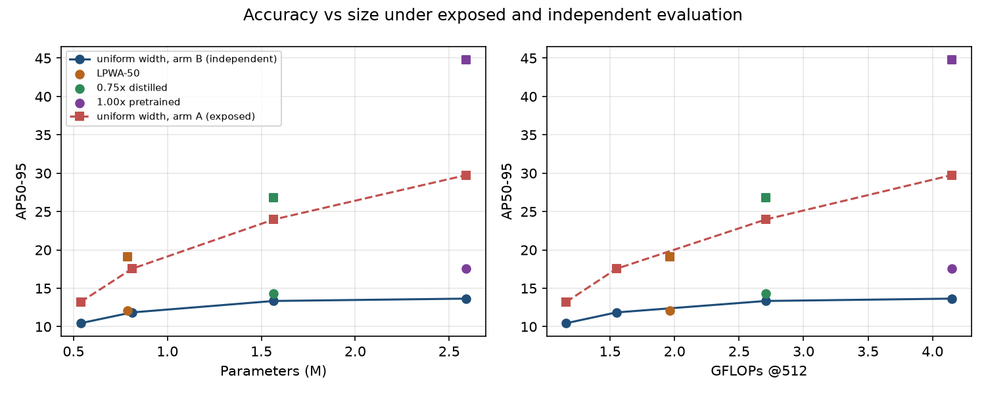
Figure 1. Accuracy versus parameters (left) and GFLOPs (right). Circles and solid line: source-independent arm B. Squares and dashed line: source-exposed arm A. Uniform widths are joined; LPWA-50, distilled 0.75× and pretrained 1.00× are single markers. Exposure steepens the apparent cost of compression.

4.3 Exposure distorts every intervention
Table 6. Effect of each intervention on six-class AP under each arm (paired over 5 seeds, 95% CI).
Intervention | Δ independent (B) | Δ exposed (A) | Distortion D = Δ_A − Δ_B | |Δ_A| / |Δ_B|
Width 0.75× (vs 1.00×) | −0.31 [−1.19, 0.57] | −5.79 | −5.48 [−6.58, −4.39] | 18.9
Width 0.50× | −1.80 [−2.80, −0.80] | −12.22 | −10.42 [−12.56, −8.27] | 6.8
Width 0.35× | −3.20 [−4.17, −2.24] | −16.54 | −13.34 [−15.03, −11.66] | 5.2
LPWA-50 (vs uniform 0.50×) | +0.26 [−0.51, 1.03] | +1.58 | +1.32 [−1.08, 3.73] | (6.2)
COCO pretraining (vs scratch 1.00×) | +3.93 [3.25, 4.61] | +15.07 | +11.13 [9.60, 12.66] | 3.8
Distillation (vs ordinary 0.75×) | +0.95 [0.21, 1.69] | +2.81 | +1.86 [−0.60, 4.32] | 3.0
Ratios are descriptive; the LPWA ratio is unstable because Δ_B is near zero.
Source exposure consistently magnified apparent intervention effects (Table 6, Figure 2). The largest absolute distortions occurred for aggressive width reduction (−10.4 and −13.3 AP) and pretraining (+11.1 AP), where the confidence intervals exclude zero. For LPWA-50 and distillation, the direction was the same but the distortion intervals include zero. The pretraining contrast is exploratory: its analysis plan was written before scoring, but it was not part of a pre-registered phase.
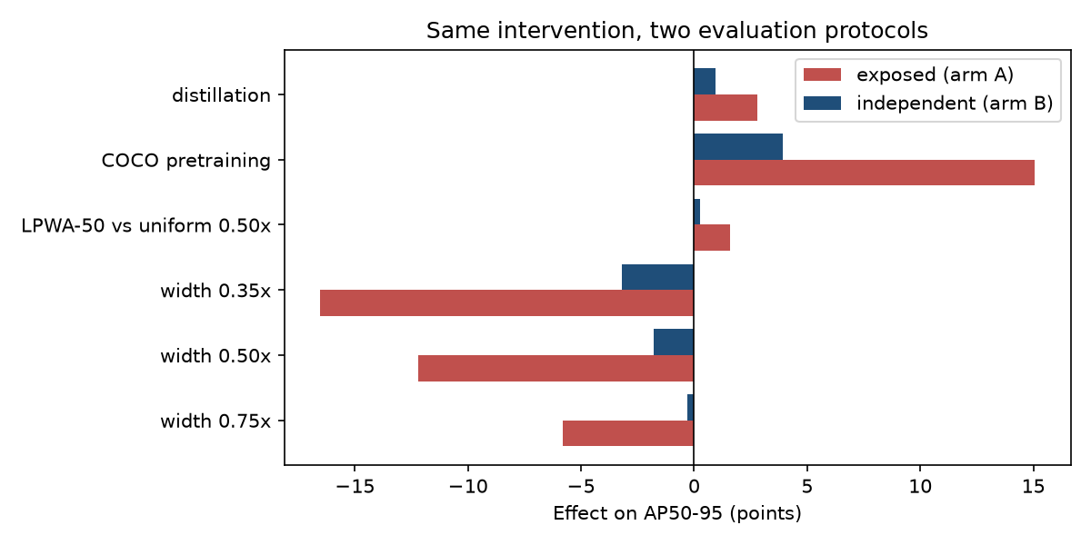
Figure 2. The same intervention measured under the source-exposed (red) and source-independent (blue) protocol. Effects are paired seed means of six-class AP.

4.4 A localization-motivated reallocation does not pass its gate
LPWA-50 failed its pre-registered AP gate. Against uniform 0.50× it gave ΔAP_B = +0.26 [−0.51, +1.03], below the required +0.75. It did raise localization recall at IoU 0.50 by +1.31 [+0.33, +2.28], positive in all five seeds. Its gain under exposure was six times larger (+1.58), so a source-exposed study would have reported it as an architectural improvement. Architecture work stopped here under the frozen rule.

4.5 Localization-focused distillation
Table 7. Distillation into the 0.75× model (arm B, 24,570 updates).
Model | Params | AP arm B | AP arm A | Loc. recall @0.50 | AP75
Pretrained 1.00× (teacher family) | 2.59 M | 17.59 | 44.82 | 43.7 | 15.22
Distilled 0.75× | 1.57 M | 14.30 ± 0.59 | 26.78 | 36.3 | 11.88
From-scratch 1.00× | 2.59 M | 13.65 ± 0.39 | 29.76 | 36.9 | 10.41
Ordinary 0.75× | 1.57 M | 13.34 ± 0.54 | 23.96 | 34.6 | 10.17

Distillation passed its gate (Table 7):
- AP: ΔAP_B = +0.95 [+0.21, +1.69], positive in all five seeds (+0.96, +0.62, +0.47, +1.97, +0.74; Figure 3).
- Localization: recall at IoU 0.50 rose by +1.75 [+0.79, +2.72], and AP75 by +1.70 [+0.44, +2.97].
- Classification: conditional class correctness was unchanged (+0.05).
- Model: parameters, GFLOPs, state-dict layout and file size are identical to the ordinary 0.75×, and so is latency.
- Caveats: the family-bootstrap interval for ΔAP_B is wider (−0.09 to +1.72); the student recovers only 22% of the gap to the pretrained teacher family; and the effect is again larger under exposure (+2.81).
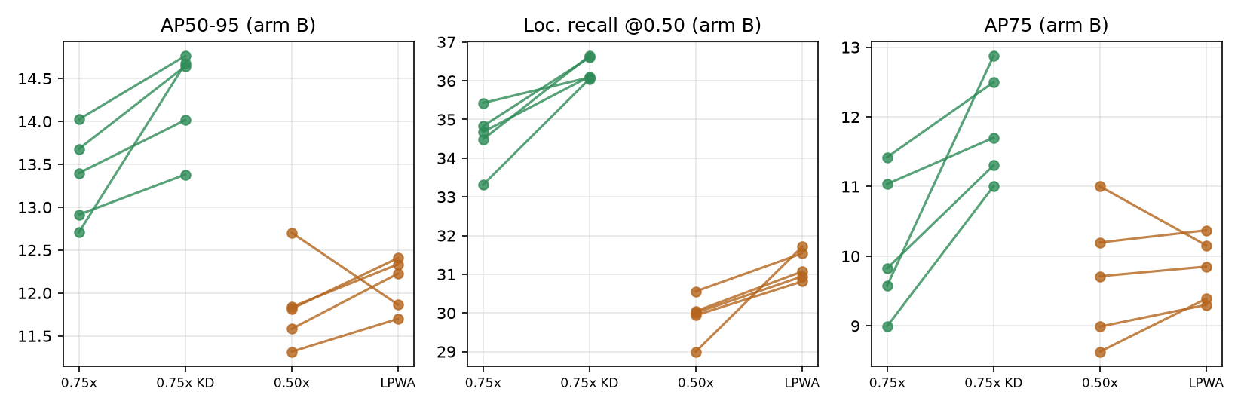
Figure 3. Seed-level paired effects on arm B. Green: ordinary 0.75× → distilled 0.75×. Orange: uniform 0.50× → LPWA-50. Left to right: AP50-95, localization recall at IoU 0.50, AP75.

4.6 Mechanism: missed lesions dominate, and small lesions are most fragile
Error decomposition (post-hoc, plan hashed). At the operating point, about half of ground-truth lesions receive no detection overlapping them at IoU ≥ 0.1 (Table 8). Classification errors are rare in every model.
- Compression raised the fully missed share by +3.2, +9.2 and +12.7 points for 0.75×, 0.50× and 0.35×.
- Distillation lowered it by −2.7 points, recovering 84% of the 0.75× increase, with no change in classification errors.
- Pretraining lowered it by −9.8 points.
Table 8. TIDE-style error counts on arm B at conf ≥ 0.25 (events per 100 ground-truth boxes; missed types as % of GT).
Model | TP | Loc. err. | Cls. err. | Cls+loc | Dup. | Backgr. | Near-missed % | Fully missed %
1.00× scratch | 35.6 | 9.7 | 1.5 | 0.8 | 2.2 | 8.6 | 13.1 | 51.2
0.75× | 33.5 | 8.5 | 1.3 | 0.8 | 2.3 | 7.6 | 12.1 | 54.5
0.50× | 29.0 | 7.3 | 1.0 | 0.6 | 2.3 | 5.9 | 10.6 | 60.4
0.35× | 26.5 | 6.6 | 0.8 | 0.5 | 2.3 | 5.5 | 9.5 | 64.0
LPWA-50 | 30.3 | 7.4 | 1.0 | 0.6 | 2.2 | 6.4 | 10.9 | 58.8
0.75× distilled | 35.2 | 8.9 | 1.3 | 1.0 | 2.3 | 8.4 | 13.0 | 51.8
1.00× pretrained | 42.3 | 12.5 | 1.8 | 1.4 | 1.7 | 12.8 | 16.3 | 41.4

IoU sweep. Distillation's AP gain was largest at IoU 0.70–0.80 (+1.70 and +1.32, against +0.78 at 0.50; Figure 4). This is consistent with tighter boxes and not only more detections. Its recall gain declined smoothly from +1.75 at IoU 0.50 to +0.47 at 0.90.
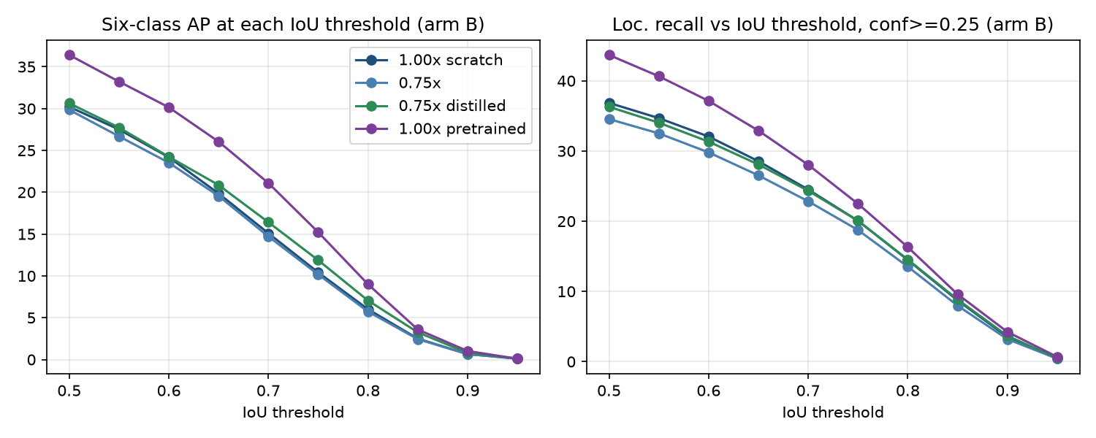
Figure 4. Six-class AP (left) and localization recall at conf ≥ 0.25 (right) as a function of the IoU threshold on arm B.
Lesion size (exploratory thresholds). We binned ground truth by tertiles of √area on arm B (cut points 42.7 and 77.1 px; Table 9, Figure 5).
- Compression hurt small lesions most in relative terms. 0.75× lost 23% of small-lesion recall against 2% of large-lesion recall; 0.50× lost 53% against 8%. Absolute losses were largest for medium lesions.
- Distillation recovered 59% (small), 75% (medium) and more than 100% (large) of the 0.75× loss.
- Small lesions remain the unresolved problem: even the pretrained model found only 14% of them.
Table 9. Localization recall at IoU 0.50 by lesion size on arm B (tertiles of √area).
Model | Small (< 43 px) | Medium | Large (≥ 77 px)
1.00× scratch | 9.6 | 37.5 | 63.5
0.75× | 7.4 | 34.1 | 62.0
0.50× | 4.5 | 27.1 | 58.1
0.35× | 3.5 | 23.3 | 54.6
0.75× distilled | 8.7 | 36.6 | 63.5
1.00× pretrained | 14.3 | 47.1 | 69.6

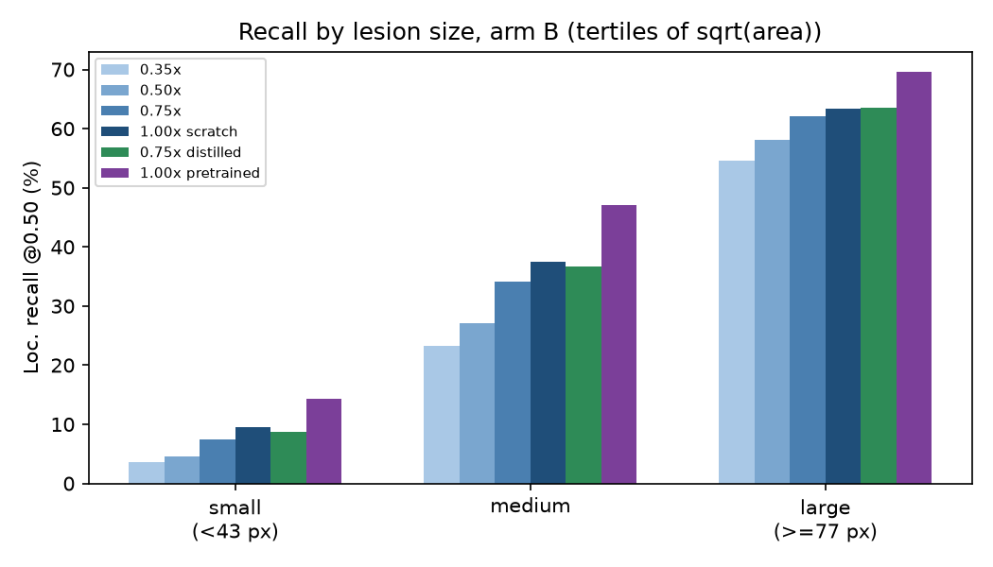
Figure 5. Localization recall at IoU 0.50 by lesion-size tertile on arm B.
Per class (exploratory). The recall loss from compression and the recall gain from distillation appeared in nearly every class. Three classes have fewer than 100 arm-B boxes (Late Blight 78, Potassium 39, Nitrogen 32). The two deficiency classes among them are nearly undetectable (AP < 4) for every model (Supplementary Table S1).

4.7 Operating points and calibration
At matched false-positive rates of 2, 3 and 4 per family (Figure 6):
- the distilled 0.75× (29.1 / 32.6 / 35.0% recall) matched the 1.00× scratch model (28.9 / 32.4 / 35.0%);
- it exceeded the ordinary 0.75× by about 1.2 points;
- the pretrained model was best (32.6 / 36.5 / 39.3%).
Detection calibration error (D-ECE, 10 bins) was 0.026–0.030 for every model and was not affected by compression or distillation (Supplementary Figure S1).
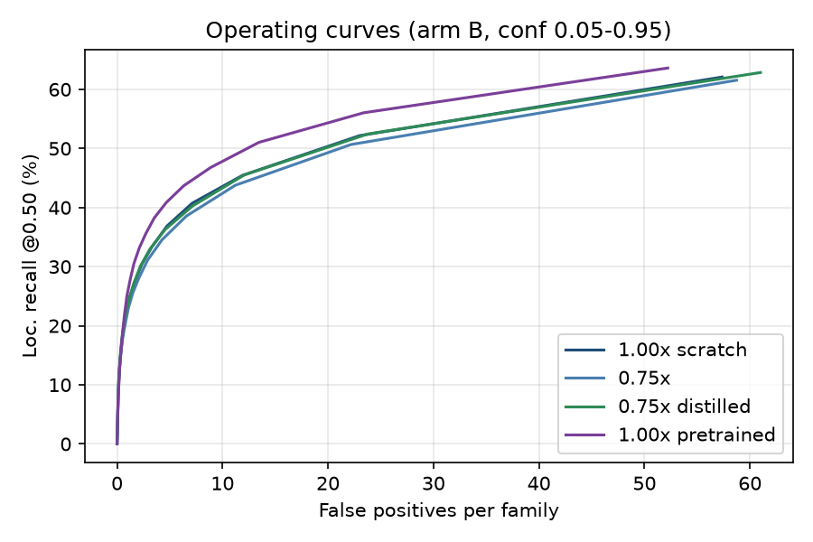
Figure 6. Recall–false-positive operating curves on arm B for confidence thresholds 0.05–0.95.

4.8 Leakage advantage depends on sibling similarity
This analysis is exploratory, for the 1.00× scratch model. The exposure advantage in localization recall (arm A minus arm B, same file type) was largest for images closest in pixels to a training sibling:
- originals: +13.6 points;
- photometric copies: +15.6;
- flips: about +14.5;
- crop or rescale copies: smallest, +6.4.
Exposure benefit therefore follows visual similarity rather than being a uniform shift.

4.9 Locked test evaluation
After every selection was frozen, the four models were evaluated once on the 268 test photographs, with five seeds each and identical settings (Table 10).
Table 10. Locked test results (mean ± SD over 5 seeds; one evaluation).
Model | Params | AP | AP50 | AP75 | AR100 | Loc. R@0.50 | Loc. R@0.75 | Cls. correct | FP/family
Distilled 0.75× | 1.57 M | 16.08 ± 0.96 | 33.07 | 13.71 | 31.29 | 39.64 | 22.05 | 96.5 | 2.63
Ordinary 0.75× | 1.57 M | 14.95 ± 0.98 | 31.23 | 12.35 | 29.58 | 37.91 | 20.79 | 96.9 | 2.47
From-scratch 1.00× | 2.59 M | 16.19 ± 0.69 | 33.69 | 13.46 | 31.55 | 40.27 | 22.12 | 96.6 | 2.68
Pretrained 1.00× | 2.59 M | 17.27 ± 0.39 | 34.66 | 15.04 | 30.11 | 46.42 | 25.09 | 96.5 | 3.43
Paired Δ (distilled − reference), seed CI / family-bootstrap CI: vs ordinary 0.75× +1.14 [−0.42, 2.70] / [−0.21, 2.45]; vs scratch 1.00× −0.11 [−1.75, 1.53] / [−1.53, 1.17]; vs pretrained 1.00× −1.19 [−2.64, 0.26] / [−2.35, −0.08]. Localization recall @0.50 vs ordinary 0.75×: +1.73 [+0.29, +3.17].
The test reproduced the development ranking: pretrained 1.00× > distilled 0.75× ≈ scratch 1.00× > ordinary 0.75×.
- The distillation gain (+1.14 AP) had the same size as on arm B, but its test-only interval includes zero.
- The localization-recall gain (+1.73) replicated with an interval excluding zero.
- The distilled 1.57 M model reached a similar observed mean AP to the 2.59 M scratch model, while the pretrained full-width model remained strongest. Under a pre-registered addendum, no model change followed from these results.

5. Discussion
From metric inflation to decision distortion. Leakage is usually framed as an accounting error that inflates headline numbers. Our results show a more consequential effect: exposure changes the differences between models. A practitioner tuning capacity on a file-level split would conclude that even modest narrowing is costly, and would keep a model 1.65× larger than an independent evaluation supports. The same bias makes pretraining look four times as valuable and turns a null architectural change into an apparent gain. These are precisely the comparisons that architecture papers report, so exposure-aware evaluation should be a precondition for claims about plant-disease detector design.
What the detectors actually fail at. Under independent evaluation the detectors rarely confuse diseases. Given a found lesion, the class is right about 97% of the time in every condition. They fail by not finding lesions, and especially small ones. This shifts priorities away from classification-oriented additions (for example, attention for discriminating disease classes) toward high-resolution localization. It also explains why distilling box distributions helped while channel reallocation helped little: the student needed better localization targets, not merely more P3/P4 channels.
Why the exposure gradient matters. The leakage advantage was largest for copies most similar in pixels to a training image and smallest for crops or rescales. This supports interpreting the exposure effect as memorisation of specific photographs rather than an artefact of the split procedure, and suggests that label-preserving offline augmentation is the most harmful kind to split at the file level.
Practical recommendations.
- Release benchmarks with source identifiers.
- Split by source family.
- Report both exposed and independent results whenever a public split is compared with prior work.
- Base design decisions only on independent results.

6. Limitations
- One dataset with a 268-photograph test set (261 clusters); effects under about 1 AP have wide intervals, and test-only distillation evidence is directional.
- Severe class imbalance; two classes have no boxes and three have fewer than 100 development boxes.
- A fixed 24,570-update budget; smaller and from-scratch models had not plateaued.
- Desktop GPU/CPU timing only; no edge-device measurements and no speed claim (GPU latency was flat across widths).
- The test split was scored for earlier models outside this study (Section 3.6).
- Size thresholds, per-class effects, copy-type analyses and the pretraining contrast are exploratory.
- The distillation attention weight was set by a pre-specified scale-matching rule rather than tuned, and only one distillation configuration was tested.

7. Conclusion
Source-family exposure distorts the estimated effects of compression, pretraining, architecture changes and distillation, and can reverse the resulting deployment decision. Under source-independent evaluation, the dominant failure of compact tomato-disease detectors is missed lesions rather than misclassification. Localization-focused distillation partly repairs that failure, giving a 1.57 M-parameter model that matches a 2.59 M-parameter scratch model on a locked test set. Small-lesion localization remains the main open problem.

Data and code availability
The split manifest, pre-registrations with script hashes, analysis scripts, per-checkpoint results and trained weights will be released at [repository URL]. Tomato-Village is available from its authors [1].

Author contributions, funding and competing interests
[To be completed by the authors.]

References
[1] Gehlot M, Saxena RK, Gandhi GC. "Tomato-Village": a dataset for end-to-end tomato disease detection in a real-world environment. Multimedia Systems. 2023. doi:10.1007/s00530-023-01158-y.
[2] Jocher G, Qiu J. Ultralytics YOLO11. 2024. https://github.com/ultralytics/ultralytics.
[3] Lin T-Y, Maire M, Belongie S, et al. Microsoft COCO: Common Objects in Context. ECCV. 2014.
[4] Bolya D, Foley S, Hays J, Hoffman J. TIDE: A General Toolbox for Identifying Object Detection Errors. ECCV. 2020.
[5] Hinton G, Vinyals O, Dean J. Distilling the Knowledge in a Neural Network. arXiv:1503.02531. 2015.
[6] Zheng Z, Ye R, Wang P, et al. Localization Distillation for Dense Object Detection. CVPR. 2022.
[7] Li X, Wang W, Wu L, et al. Generalized Focal Loss: Learning Qualified and Distributed Bounding Boxes for Dense Object Detection. NeurIPS. 2020.
[8] Zagoruyko S, Komodakis N. Paying More Attention to Attention: Improving the Performance of Convolutional Neural Networks via Attention Transfer. ICLR. 2017.
[9] Schuirmann DJ. A comparison of the two one-sided tests procedure and the power approach for assessing the equivalence of average bioavailability. J Pharmacokinet Biopharm. 1987;15:657–680.
[10] Holm S. A simple sequentially rejective multiple test procedure. Scand J Stat. 1979;6:65–70.
[11] Feng C, Zhong Y, Gao Y, Scott MR, Huang W. TOOD: Task-aligned One-stage Object Detection. ICCV. 2021.
[12] Kapoor S, Narayanan A. Leakage and the reproducibility crisis in machine-learning-based science. Patterns. 2023;4(9):100804.
[13] Kaufman S, Rosset S, Perlich C, Stitelman O. Leakage in data mining: formulation, detection, and avoidance. ACM Trans Knowl Discov Data. 2012;6(4):15.
[14] Hughes DP, Salathé M. An open access repository of images on plant health to enable the development of mobile disease diagnostics. arXiv:1511.08060. 2015.
[15] Efron B, Tibshirani RJ. An Introduction to the Bootstrap. Chapman & Hall; 1993.
[16] Mohanty SP, Hughes DP, Salathé M. Using deep learning for image-based plant disease detection. Front Plant Sci. 2016;7:1419.
[ADD REFS] markers indicate where recent lightweight agricultural detectors and PlantVillage bias studies should be cited; verify every reference before submission.

Supplementary material
Table 11. S1. Per-class results on arm B (exploratory; mean over 5 seeds). ⚑ = fewer than 100 ground-truth boxes.
Class | GT boxes | AP 1.00× | AP 0.75× | AP 0.75× distilled | Δ recall, width 0.75× | Δ recall, distillation
Leaf Miner | 3,138 | 18.0 | 17.1 | 17.9 | −2.8 | +1.9
Spotted Wilt Virus | 899 | 19.5 | 19.4 | 20.2 | −0.1 | +0.0
Magnesium Deficiency | 497 | 22.1 | 20.9 | 23.1 | −3.4 | +3.3
Late Blight ⚑ | 78 | 16.9 | 17.2 | 21.1 | −0.8 | +3.8
Potassium Deficiency ⚑ | 39 | 3.3 | 3.7 | 2.4 | −5.6 | +4.1
Nitrogen Deficiency ⚑ | 32 | 2.1 | 1.6 | 1.1 | −3.1 | +5.0

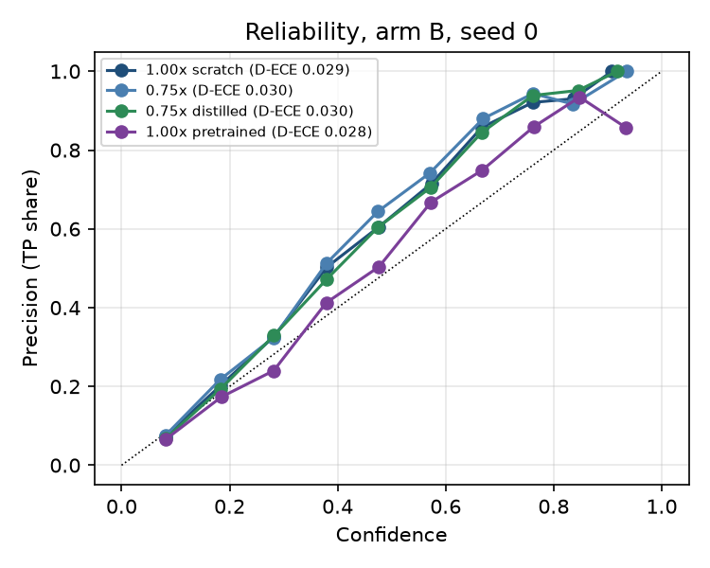
Figure 7. (S1) Reliability diagram on arm B, seed 0, with detection-ECE per model.
Table 12. S2. Inferred augmentation type of the 12,572 released copies, and exploratory exposure advantage in localization recall at IoU 0.50 (1.00× scratch, 5 seeds).
File type | Share of copies | Recall arm A | Recall arm B | Exposure advantage
Original photograph | — | 53.9 | 40.3 | +13.6
Label-identical (photometric) | 32.7% | 50.8 | 35.2 | +15.6
Horizontal flip | 14.2% | 53.3 | 38.8 | +14.5
Vertical flip | 14.2% | 49.8 | 35.3 | +14.6
Crop / scale / shift | 28.3% | 45.9 | 39.4 | +6.4
90° rotation | 7.2% | 43.3–48.5 | 30.6–33.4 | +12.6–15.1
180° rotation | 3.5% | 42.0 | 35.5 | +6.5

Additional supplementary items available in the repository: full IoU-sweep tables, per-checkpoint learning curves, pre-registration documents (Phases 15, 16A, 17, locked test) and the post-hoc analysis plan with its SHA-256 hash.

