**NAME : ABDUL SAMAD NJ** 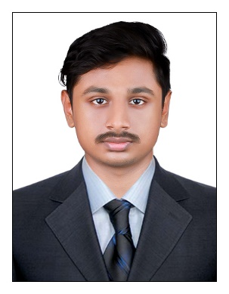

Address : Nedumpillichalil Chalikkavattom Vennala P.O

Email : abdulsamadhnj@gmail.com

Contact : 8590044449

**CAREER SUMMARY**

Motivated, inspired and hardworking individual who is intending to jump-start a career with the leading co-operate alongside skilled and dedicated people which would provide more opportunities for myself to fully realize my potential and for my dream to reach the top.

**TRAINING & CERTIFICATIONS**

|  |
| --- |
| **Java - React.js Full Stack Development** course from ROGERSOFT Technologies  ( 17-08-22 to 15-02-23 )   * Experience in developing applications using Java, Spring Boot , React.js . * Working with latest technologies like HTML , Java and React.js. |

**TECHNICAL SKILLS**

|  |
| --- |
| * Programming language : C, Core Java * Web Technologies : HTML, JavaScript, CSS * Frameworks : Spring Boot * Front-end : React * Development Tools : Eclipse * Database Skills : MySQL * Operating System : Windows * Office Suite : MS Office(Word, Excel, PowerPoint) |

**ACADEMIC QUALIFICATIONS**

|  |  |  |  |  |
| --- | --- | --- | --- | --- |
| **Qualification** | **Name of the Institution** | **University/ Board** | **Year of Passing** | **Percentage/ CGPA** |
| Graduation  BCA | CHINMAYA COLLEGE OF ARTS ,COMMERCE & SCIENCE | Kerala State Board | 17-08-2021 | 6.58 |
| Plus Two | GOVT.HIGHER SECONDARY SCHOOL EDAPALLY | Kerala State Board | 10-05-2018 | 71% |
| SSLC | DARUL ULOOM V.H.S.S ERNAKULAM | MG University | 27-04-2016 | 98% |

**ACADEMIC PROJECTS**

Title **: Resume-Builder-App**

Description **:** Resume builder app will help create professional resume for job application.

**PERSONAL SKILLS**

|  |
| --- |
| * Keen learner and a strong believer in teamwork and integrity * Good Problem Solving Skills * Good interpersonal and organizing skills * Excellent analyzing skills and communication skills * Ready to learn new things |

**PERSONAL DETAILS**

|  |  |
| --- | --- |
| * Gender : Male * Date of Birth : 30-11-2000 * Marital Status : Single * Languages known : English ,Malayalam ,Hindi * Nationality : India * Hobbies & Interests : Reading ,Chess ,football ,travelling |  |

**DECLARATION**

I hereby declare that all the details given above are true to the best of my knowledge and belief .

**ABDUL SAMAD NJ**