Sample Course Name

Sample Course Module Name

Author: Asst. Prof. Dr. Uğur CORUH

## CE103 Algorithms and Programming I

### Week-1 (Database Systems)

#### Spring Semester, 2022-2023

Download [DOC](week-1.en.md_doc.pdf), [SLIDE](week-1.en.md_slide.pdf), [PPTX](week-1.en.md_slide.pptx)

### Outline

* Understanding The Concept of Database and Relational Database
* Database Design

## **Database**

### Database

* **What is Database?** 1-) Database is a regular collection of information. 2-) Database is regular data stored in a computer environment. 3-) Systematic access in computer terminology capable, manageable, updateable, portable, defined relationships between each other is a set of available information. 4-) Systematically stored on the computer, It is a chunk of data that can be processed in programs.

### DBMS

* **What is the Database Management System-DBMS**

Defining and creating a database, to keep alive and audited to the database used to gain access software system.



bg right:50% h:300px

### DBMS

* **Database systems contain the following information**

Collection of interrelated data The set of software required to access the data

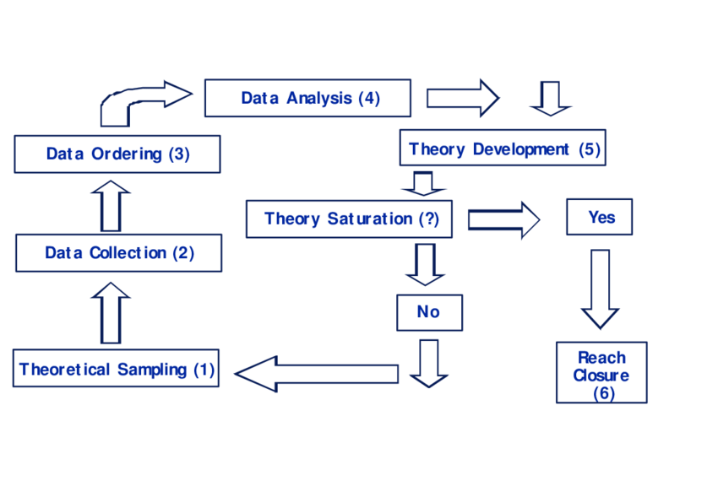

bg right:50% h:400px

### DBMS

* **Advantages of Database Systems** Database Systems prevents duplication of data. Establishing relationships between database systems and subsystems and many In practice, it requires data to be designed jointly within the same database.

### DBSM

* **Advantages of Database Systems** Database Systems ensures that the data is consistent. Data integrity, the accuracy and consistency of the data means. By placing constraints on data entries, only the desired range can be entered.

### The Entity-Relationship Model

Revealing relationships in data analysis and modeling. It is the tool used to put it on. Entity: Distinguish from other objects in a field. “thing” or “object”. By set of attributes is defined. Relationship: The relationship between more than one entity.



bg left:50% h:500px

### Relationship and Relationship Sets

The link between entities is called a relationship. For example, with the entity “Burak”, “Lessons” There is a relationship between existence. Relationship set is the set of relationships of the same type, this set of relations is denoted by R.

## References

* https://avesis.erdogan.edu.tr/ugur.coruh
* https://www.linkedin.com/in/ugurcoruh/
* https://csworlds.com/what-is-dbms-database-management-system/
* https://prepinsta.com/dbms/entity-relationship-model-er-model/

$End−Of−Week−1−Module$