**REPORT**

**FOR**

**<Food Store**

**Management**

**System>**

Muhammed Zübeyir İncekara 150119038

Mehmet Alıcı 150118060

Abdül Samet Yılmaz 150118059

Obaidah Kalajo 150119542

**PROJECT DESCRIPTON**

In this project, we created a database of a food store. According to the information conveyed to us by an employee we are contact with, we designed a database to record the products of the store and to perform some operations involving the products through this record and record them also for store.

**SCOPE**

The sale of the product to the customer, the purchase of bulk products from the supplier company to the store, the return of the products purchased in bulk from the supplier company when necessary, the return of a product purchased by the customer to the store, the keeping of the price change record of the products, the destruction of the product by the department employee when necessary and when the product cannot be returned to the supplier, etc. . The database we have created provides the realization and recording of such transactions.

At the same time, it also performs some operations such as keeping the personal information of its employees and keeping the skills of the department employees.

**What is Included**

Since we thought that it could not be done beforehand and it would not have much impact on the market budget, we would ignore the registration of the cancellation of the tax to be given to the state by the store in customer returns. But when we learned about the use of triggers, we realized that we could easily add this, and we added this price as a field to the customer return table. At the same time, we thought that we could not keep the stock amount of a product directly with the product, so we were thinking of finding the quantities from the transactions performed each time. Again, when we learned how to use triggers, we realized that we could do this easily, and we added a 'quantity' field to each product. We have always kept the stock amount up to date by updating this field in every transaction such as trading and return.

We said that we would always do all the operations related to open products in grams, but we decided to do all the operations in kilograms for ease of operation and not to create additional fields in the tables. For example, if there is a 300g product, we always stated it as 0.300, not as 300.

**What is Exclude**

Previously, we thought that the person we were in contact with wanted us to see how much profit the store made in certain time intervals. Then, when we contacted again about how to calculate this profit while designing our database, the employee told us that the store did not want anything as a profit concept, instead they wanted a report of the money flow between certain dates and the turnover achieved. So, we left the profit determination job that we stated we would do and handled the turnover and money flow calculations requested by the store.

So the job of calculating profits was conceptually abandoned.

As we mentioned in the included section, the processing of open products over grams has been cancelled. It was replaced by processing over kilos.

**BUSINESS PROCESS**

**Wholesale Purchasing:** Purchasing agents meet with department managers. They learn from them which products their departments need and how much. Then they search for suppliers where they can buy these products wholesale. They determine with them at what unit price they can buy these products in the store. They purchase products from the most suitable suppliers for the store.

**Making the Products Ready for Sale:** Department employees offer the products directly for sale if they are in ready-made packages. If the products come open (for example 100kg of olives), they package them before or during the sale and record the kg on their labels.

**Sale:** The customer comes to the cashier with the products. The cashier reads the barcode of each product and enters the number of that product or if the product is an open product (as in the case of 100kg olives), its amount in kg. The system creates a sales record for each product with different barcodes and keeps the product information with the sales amount in this record.

**Customer Return:** The customer can return a purchased product by stating the reason. For this, he/she must come with the sales receipt, which is proof of purchase of the product. In this case, the cashier enters the barcode of the product, the return amount, the return unit price (with the information obtained from the sales receipt) into the system.

**Product Destruction:** Sometimes products may become unusable due to the store's own causes. For example, the coolers that cool the dairy products do not work, the expired products. In such cases, department staff destroy these products.

**Return to the Company:** Sometimes there are situations where the products must be returned to the suppliers from which they were purchased wholesale. For example, the expiry date of a product is very close and the product cannot be sold as expected, or there is a problem with the products sent to the store. In such cases, the buyer contacts the supplier company from which the product is purchased wholesale, and if an agreement is reached, the product is returned at a determined new unit price or over the old price. Supplier companies can accept such returns in order to produce new products from the returned products (reuse) and to maintain good relations with the stores. If there is a problem with the products they send to the store in wholesale, they have to accept it anyway.

**BUSINESS REQUIREMENTS**

1. **Functional Requirements:**

-The salary of the desired employee can be arranged through the system.

-The salary of all employees whose salary is within the specified range can be  
 arranged collectively.

-The price of the desired product can be changed.

-The price history of a product can be viewed.

-The turnover of the store or a department within a certain date range can be  
 viewed.

-All sales, customer returns, destructions, wholesale purchases, returns to  
 suppliers can be viewed within the desired date range.

-A list of all employees, cashiers, department staff, purchase agents,  
 departments, department managers, suppliers, products, products belonging  
 to a certain class or department can be obtained.

-The amount of a product left in the hands of the store can be displayed.

-Money flow (income-expense) of the whole store in a desired time period can  
 be displayed.

1. **Non-Functional Requirements:**-The user interface should be user-friendly in a way that everyone can easily understand.  
     
   -The database should be portable so the user can access it from any kind of platform.  
     
   -The data in the records should be accessible to every employee in the store, however some data (employee salary info etc.) should be updatable only by some certain employees and managers.

**Diagram of Whole Database**

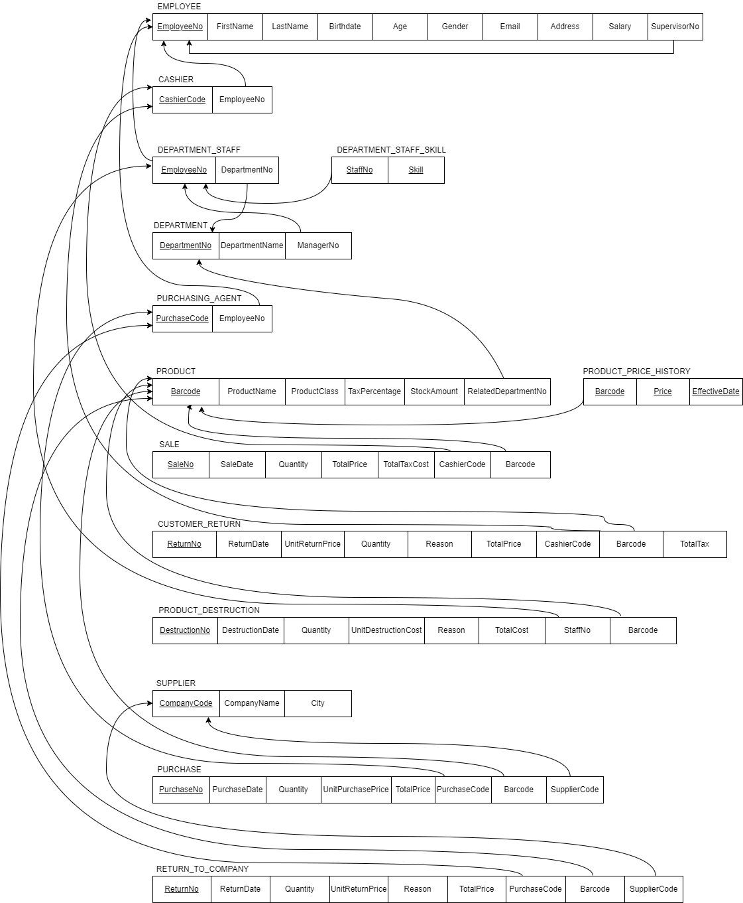

**TABLES**

**Employee:** Any person who works and receives a salary in the store, including a manager.

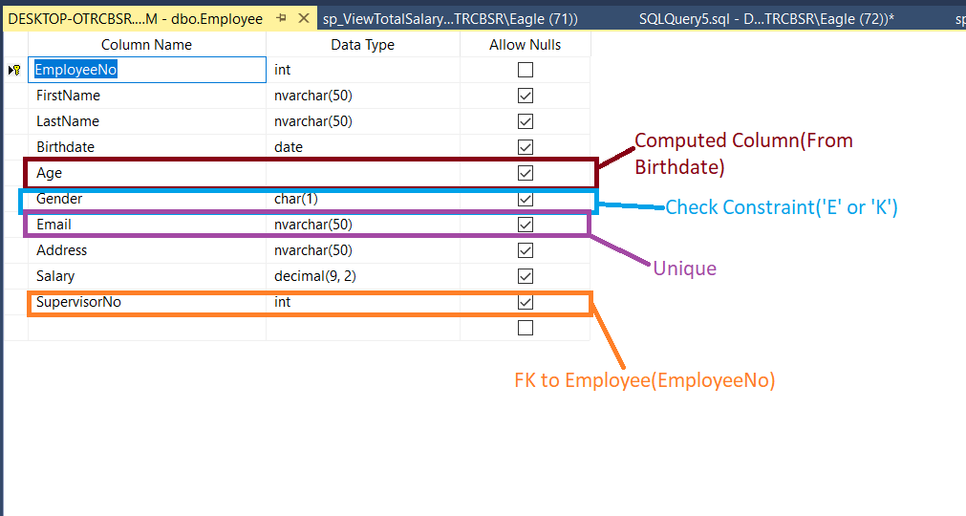

**Cashier:** An employee who reads the barcodes of the products that the customers want to buy, records their sales in the system, collects the money of the products from the customers and receives the return of the products when necessary.

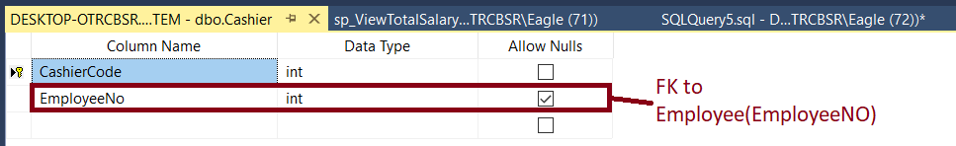

**PurchasingAgent:** The employee who learns the information about the products needed for the store from the department managers, determines from which suppliers these products can be procured, makes an agreement with these suppliers with the authority given by the store, and buys the products in the store, and in some cases, returns the purchased goods to the supplier at the new agreed or old price

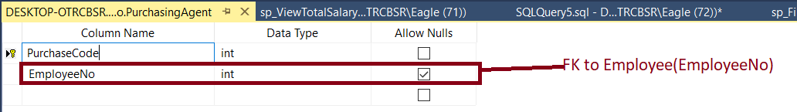

**Department:** The section of the store where certain class products are processed & packaged (if they are open products) and where they are presented to the customers' view and sale. The sub-part of the store, which has examples such as a greengrocer, butcher and is managed by a department staff.

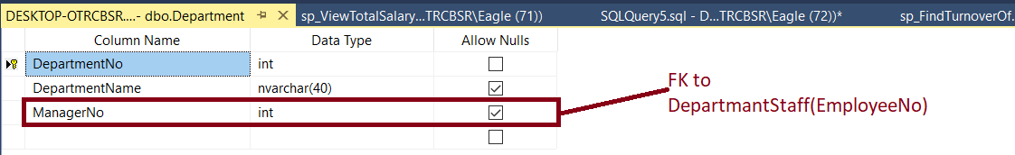

**Department Staff:** In any department that is a sub-part of the store; The employee who performs the tasks of opening the product, packaging it, arranging the packaged products for sale, providing services such as informing and assisting customers during sales, destroying the product when necessary and reporting it to the system.

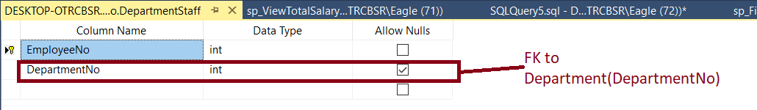

**DepartmentStaffSkill:** Skils of an department staff.

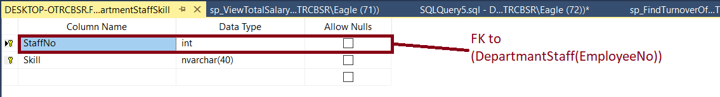

**Product:** Assets, each of which has a unique barcode, purchased wholesale from the agreed supplier companies, a sales price is determined by the department manager, and processed by the department employees when necessary, or offered for retail sale directly to the customers. And each product has a tax rate.

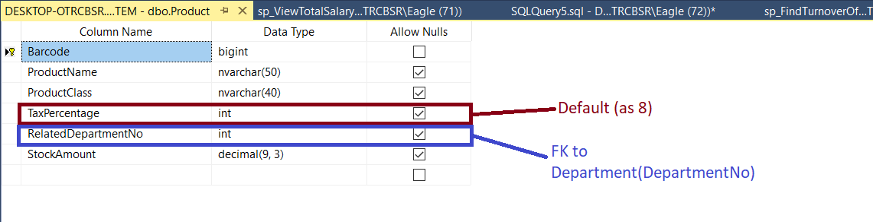

**ProductPriceHistory:** It keeps date and price record for a product.

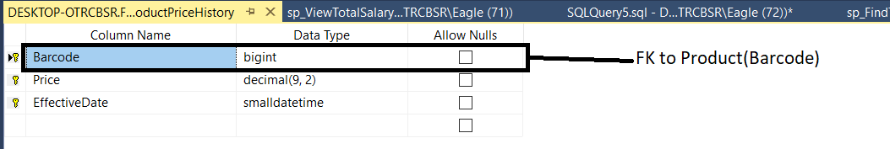

**Supplier:** The company from which the store buys wholesale products through its purchasing agent.

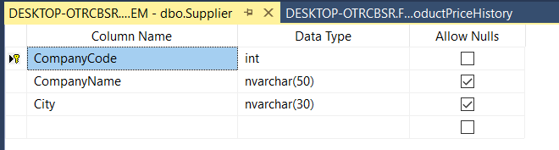

**Sale:** The process by which the cashier collects and records a product purchased by the customer.

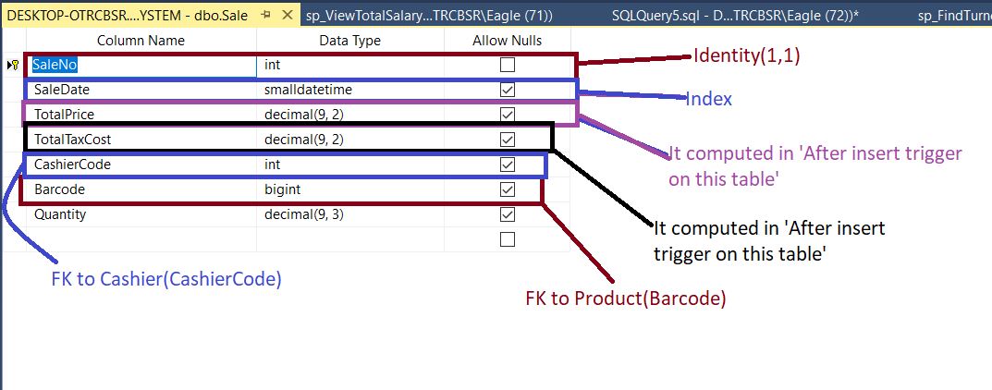

This table has a After Insert trigger. With it’s help when a new record entered to this table ‘StockAmount’ of table ‘Product’ decreased with this table’s quantity field.

**Customer Return:** The process of returning a product that the customer previously bought from the store, for any reason, by presenting the sales receipt to the store.

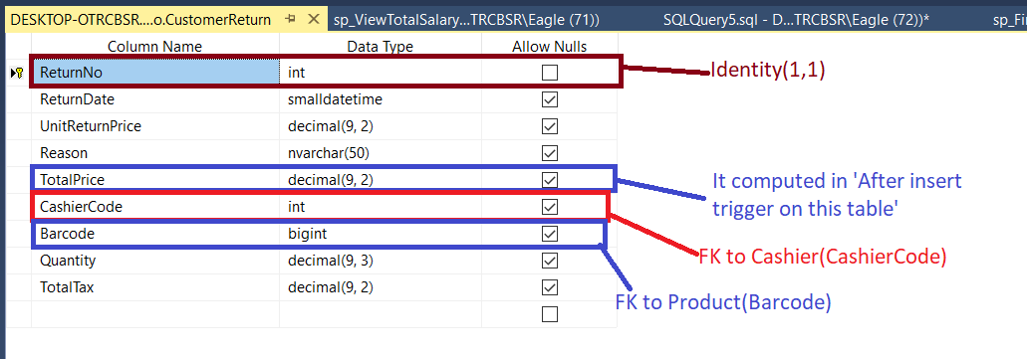

This table has a After Insert trigger. With it’s help when a new record entered to this table ‘StockAmount’ of table ‘Product’ increased with this table’s quantity field.

**Product Destruction:** The destruction of products that are damaged due to the store's own fault (like meat spoiled by the deterioration of the refrigerator) and cannot be used in any way, by a department staff.

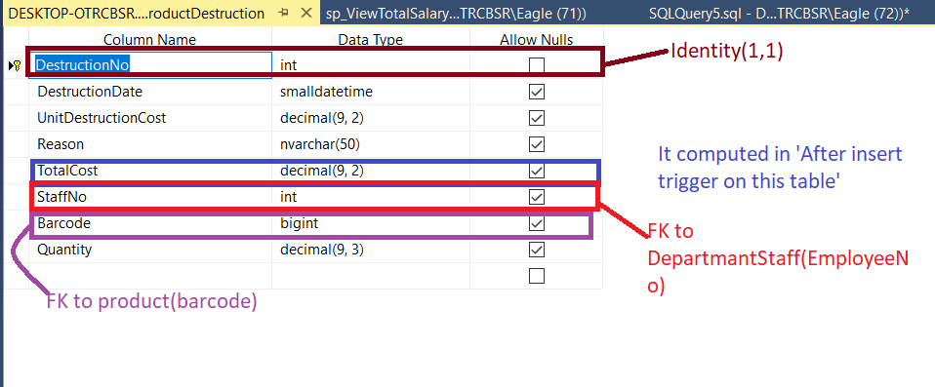

This table has a After Insert trigger. With it’s help when a new record entered to this table ‘StockAmount’ of table ‘Product’ decreased with this table’s quantity field.

**Purchase:** The wholesale purchase of a product from a supplier in a certain quantity at a specified price by purchase agent.

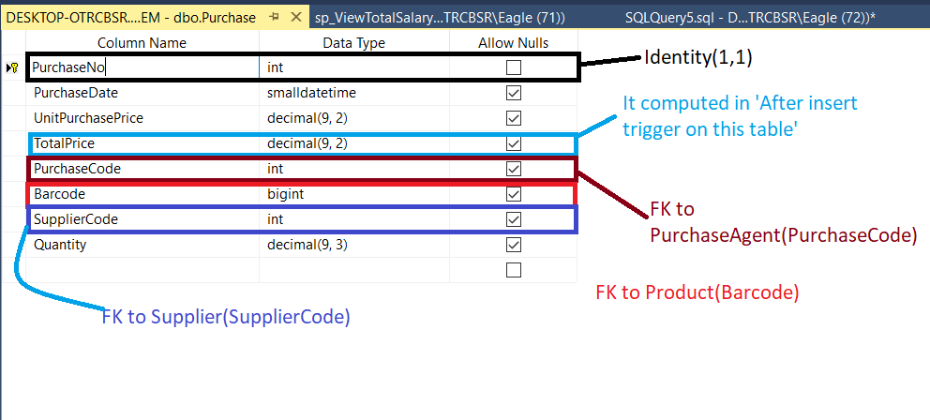

This table has a After Insert trigger. With it’s help when a new record entered to this table ‘StockAmount’ of table ‘Product’ increased with this table’s quantity field.

**Return to Company:** The process of returning a certain amount of the product to the supplier company, from which the product was previously purchased in wholesale, over the new agreed or old price, for a reason.

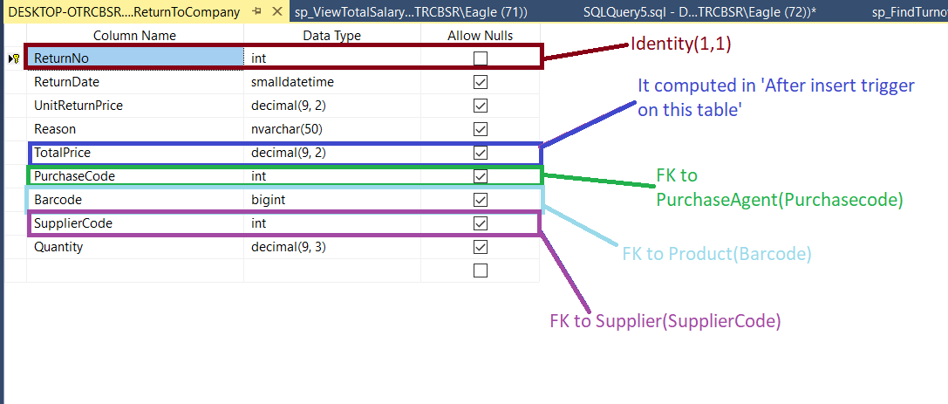

This table has a After Insert trigger. With it’s help when a new record entered to this table ‘StockAmount’ of table ‘Product’ decreased with this table’s quantity field.