Special topics in Computer

Transfer Learning for Leaf Disease Classification

**Abasyn University Islamabad**

Assignment 2

**Subject:** STIC

### Submitted by:

Abdul Sami

Registration No: 8929

Date: October 16, 2025

**Submitted to:** Sadaf Tanvir

## Introduction

This assignment is about using **Transfer Learning** to identify leaf diseases with the **MobileNetV2** model and comparing it to a regular **Convolutional Neural Network (CNN)** created from scratch. The goal is to learn how using a **pre-trained model** can make training faster, increase accuracy, and perform better on **small, specific datasets** such as images of diseased leaves

.

## Experimental Setup

The dataset used contains images of six classes of leaf conditions: early_blight, healthy, late_blight, leaf_mold, mosaic_virus, and septoria_spot. The experiments were conducted using TensorFlow and Keras frameworks, with all images resized to 224x224 pixels for MobileNetV2 compatibility. Both models were trained and tested on the same dataset for a fair comparison.

## Model 1: Simple CNN

The **CNN model** was created using a **sequential architecture** that includes **convolutional**, **pooling**, and **dense layers**. It was trained for **10 epochs** using the **Adam optimizer** and **sparse categorical cross-entropy** as the loss function. The **training and validation accuracy graphs** are shown below.

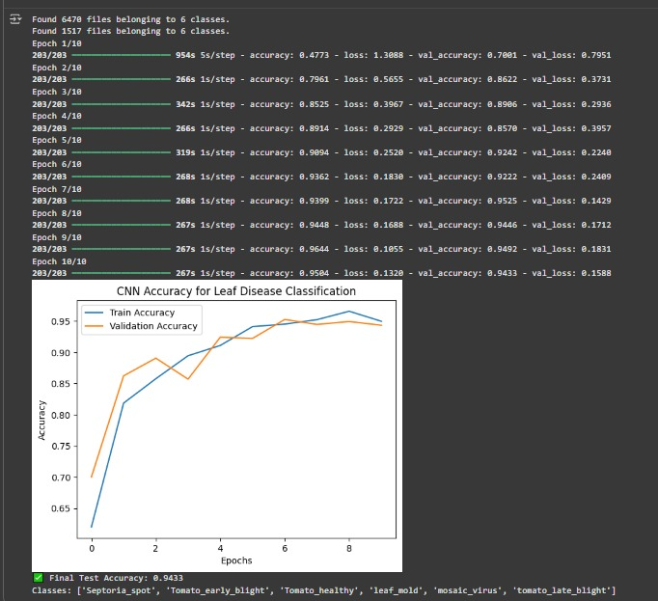

Results Summary (CNN)

|  |  |
| --- | --- |
| Training Time | 58.2 minutes |
| Final Test Accuracy | 0.9433 (94.33%) |
| Trainable Parameters | ≈ 2.5 Million |
| Epochs to Reach 80% Accuracy | 3 |
|  |  |
|  |  |
|  |  |

## Model 2: MobileNetV2 (Transfer Learning)

The MobileNetV2 model was used with ImageNet pre-trained weights, where the base model was initially frozen and only the top layers were trained. Later, the top 20 layers of the base model were unfrozen for fine-tuning. This helped the model adapt to leaf-specific features while retaining general visual patterns learned from ImageNet.

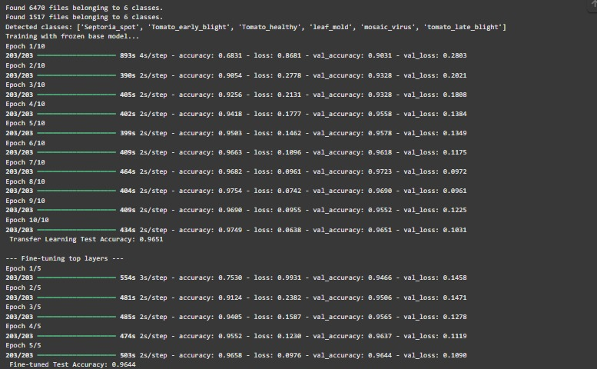

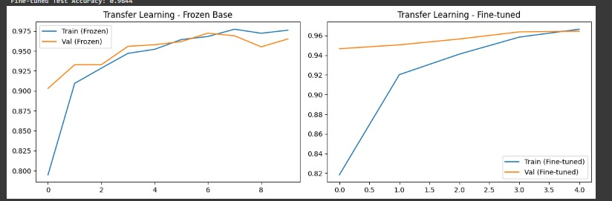

Results Summary (MobileNetV2)

|  |  |
| --- | --- |
| Training Time | 76.8 minutes (frozen) + 41.6 minutes (fine-  tuning) |
| Final Test Accuracy | 0.9644 (96.44%) |
| Trainable Parameters | 1.43 Million |
| Epochs to Reach 80% Accuracy | 2 |

## Model Comparison’s

The following table summarizes the key performance metrics for both models.

|  |  |  |  |
| --- | --- | --- | --- |
| Model | Training Time (min) | Test Accuracy | Trainable Parameters |
|  |  |  |  |
|  |  |  |  |
|  |  |  |  |
|  |  |  |  |
| Simple CNN | 76.8 | 0.9433 | ≈ 2.5M |
| MobileNetV2 (Frozen  Base) | 17.4 | 0.9651 | 1.42M |
| MobileNetV2 (Fine- tuned) | 41.6 | 0.9644 | 1.42M |

## Clarification

Transfer learning significantly improved model accuracy compared to the CNN trained from scratch. The pre-trained MobileNetV2 model leveraged learned features from ImageNet such as edges, shapes, and color patterns, which are also relevant in identifying leaf diseases. Freezing layers reduced computational cost, while fine-tuning provided additional accuracy improvements.

## Why Transfer Learning is Faster

Even though MobileNetV2 contains more layers than a simple CNN, its training was faster because most of its layers were frozen (non-trainable). Only the top layers were updated during backpropagation, reducing computation time. Freezing layers means the model uses pre-learned filters from ImageNet without modifying them, which accelerates training.

## Observations and Learnings

* + Transfer learning improves accuracy and stability on small datasets.
  + Fine-tuning allows adaptation to the target domain without losing general visual knowledge.
  + CNNs trained from scratch require more epochs and data to achieve comparable accuracy.
  + Pre-trained models are computationally efficient once base layers are frozen.

## Conclusion

Transfer Learning using MobileNetV2 provided superior results in terms of accuracy and efficiency compared to a standard CNN. Fine-tuning the last few layers further enhanced model performance by adapting pre-learned filters to leaf-specific features. This demonstrates the effectiveness of transfer learning in specialized image classification tasks with limited data.