# Capturing Traffic:

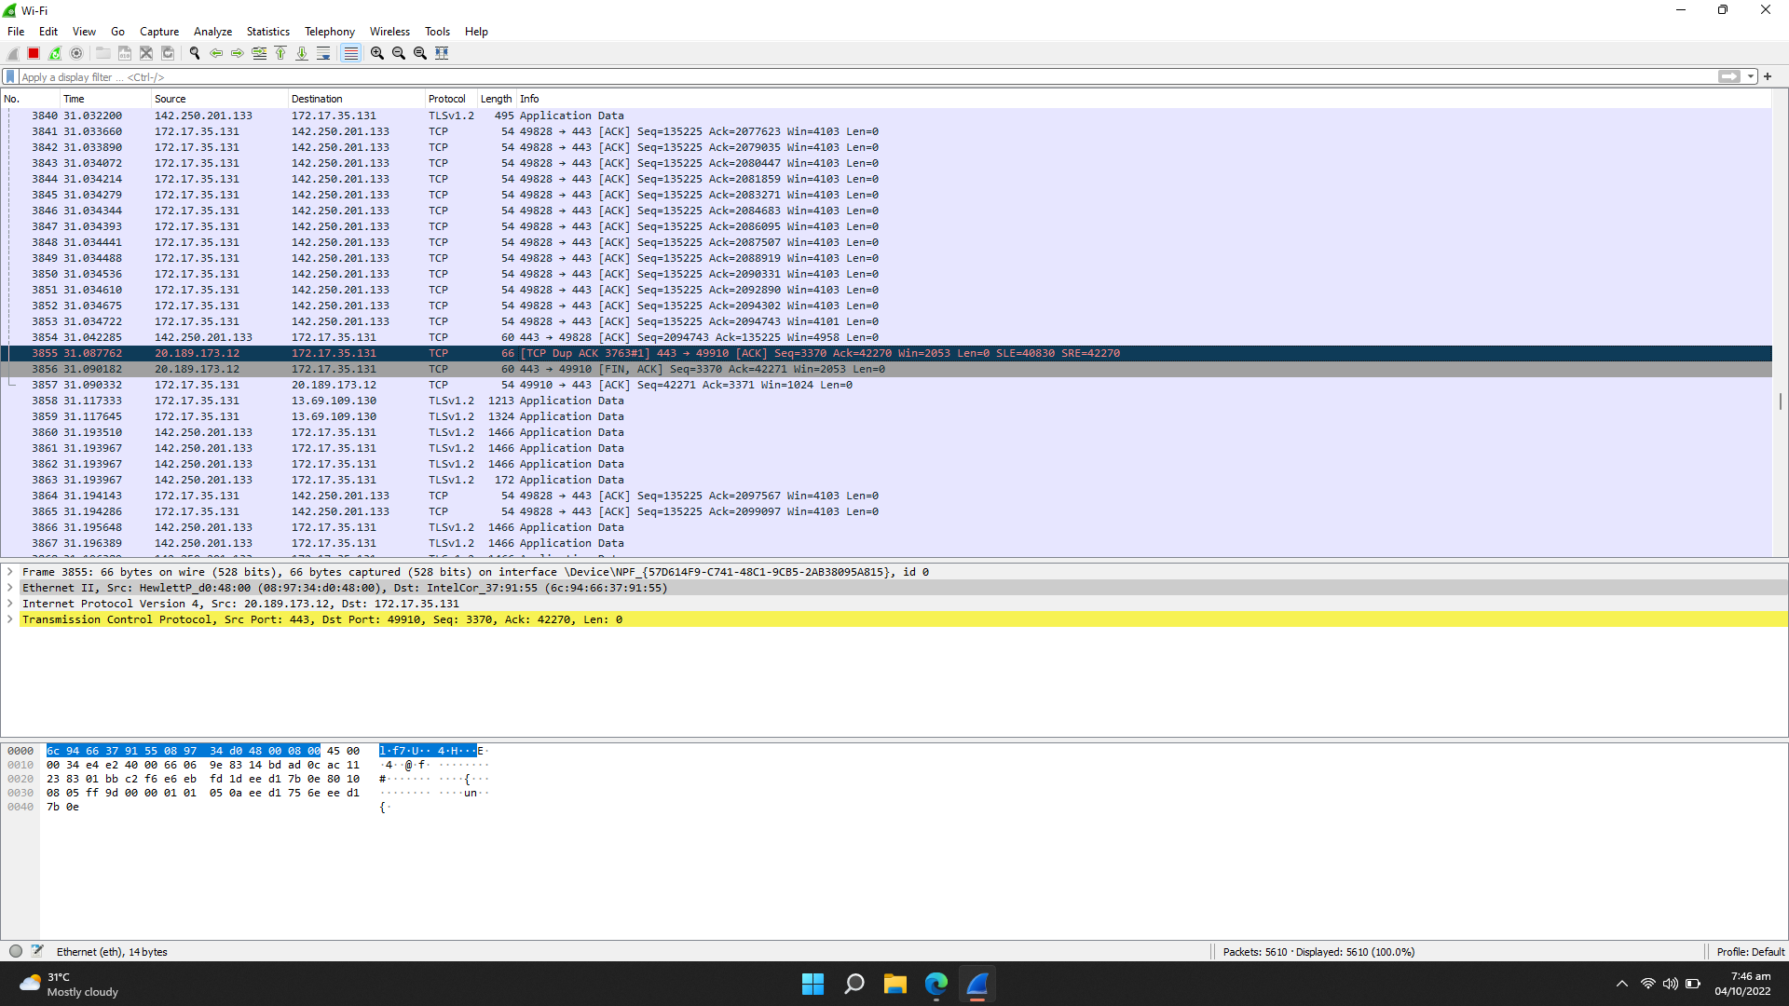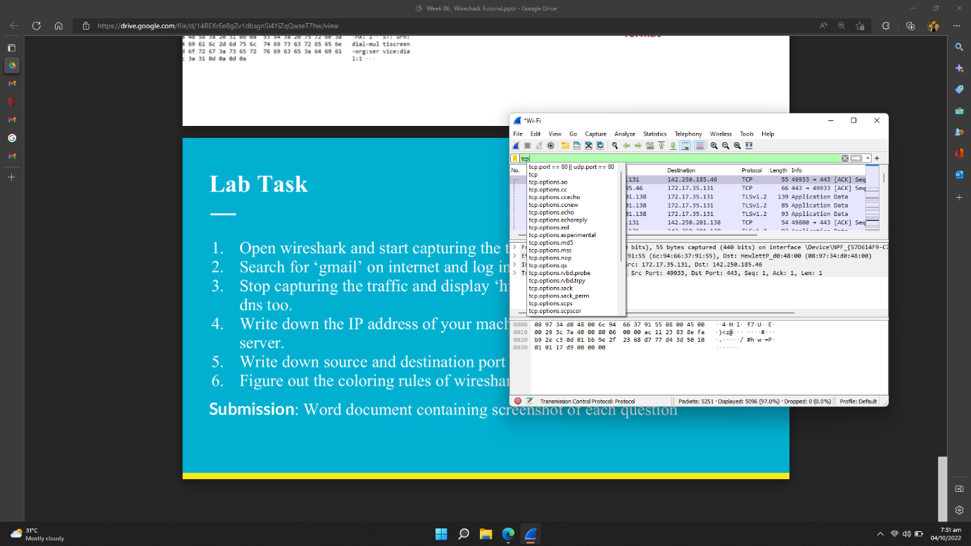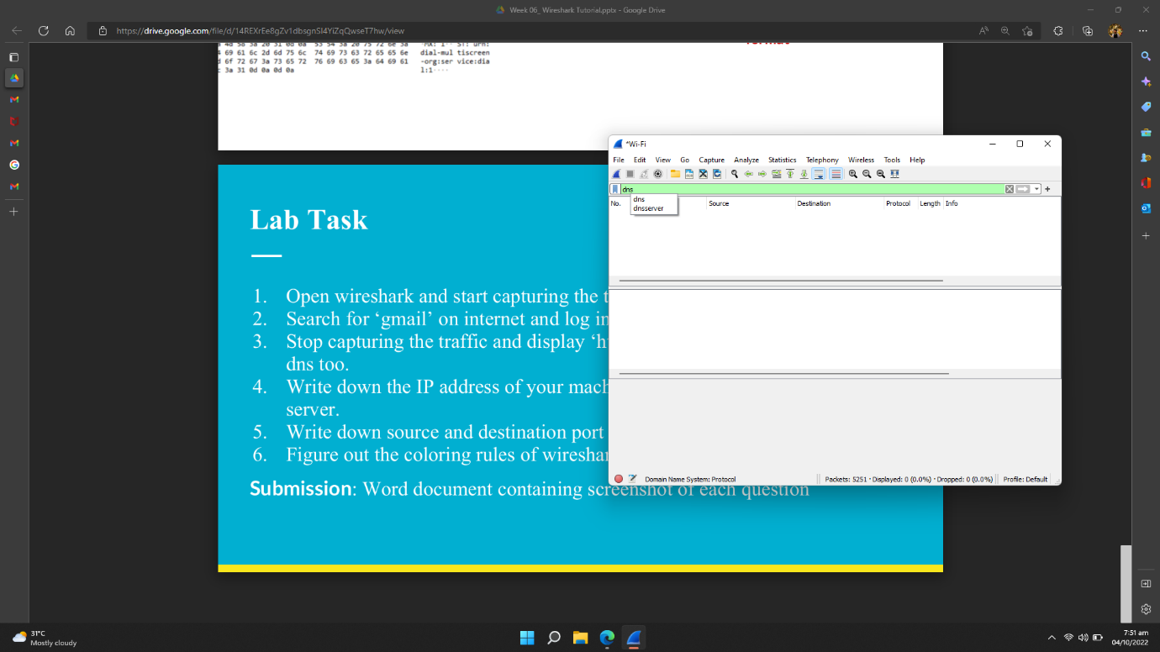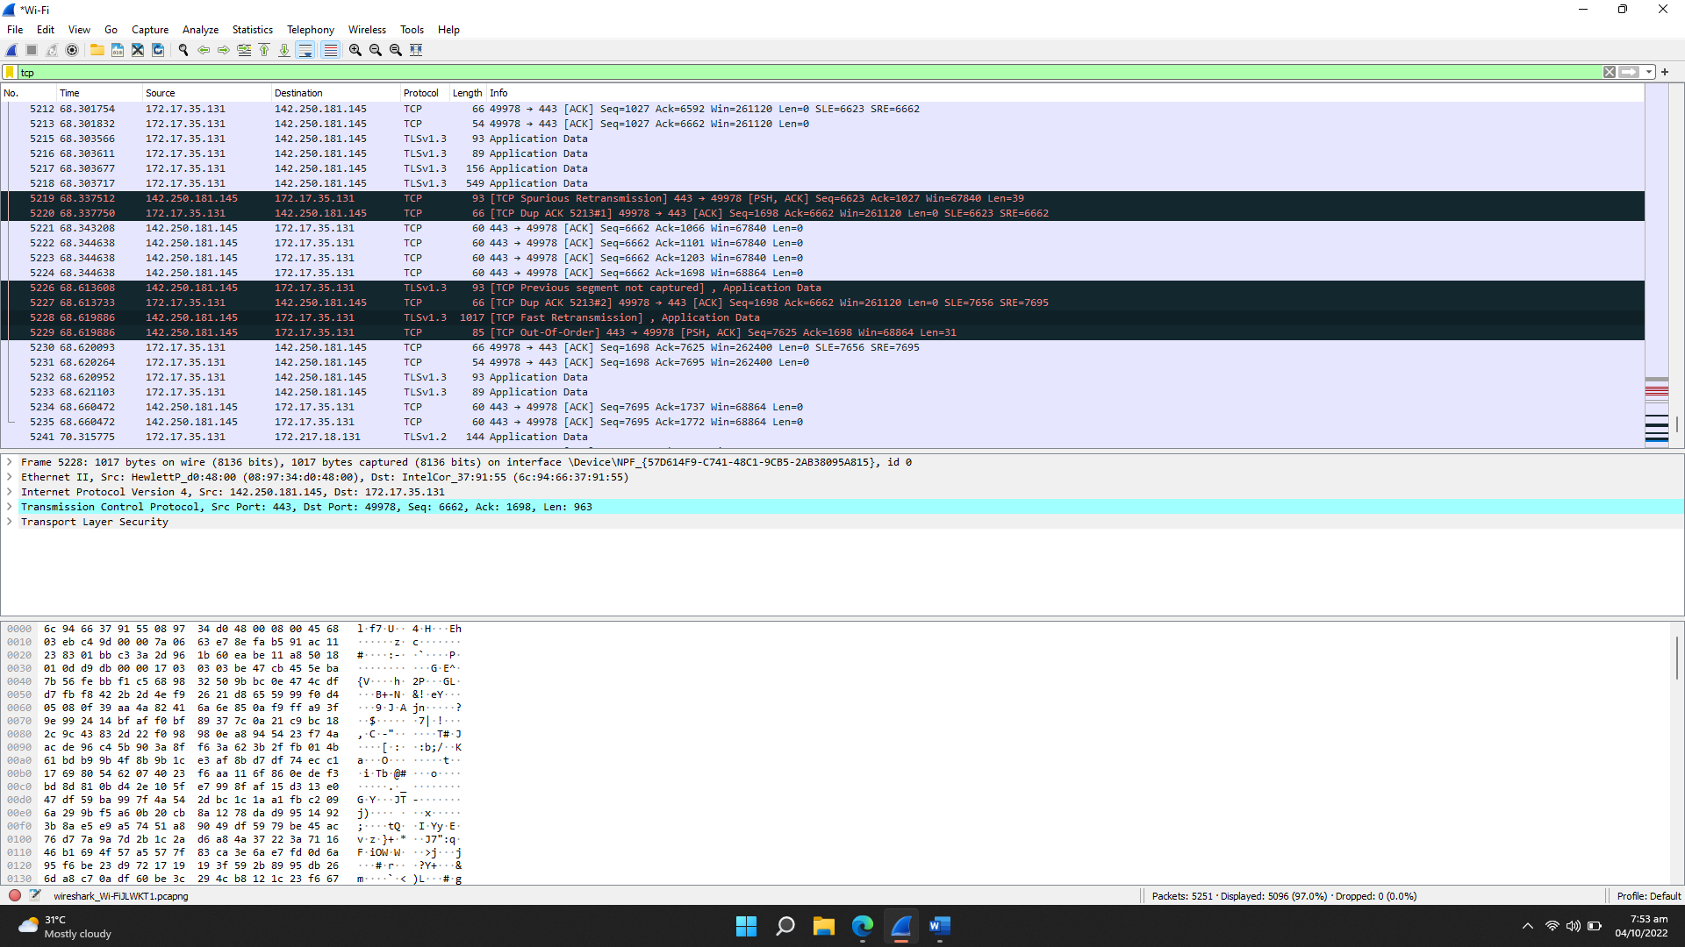

# IP Address:

Source IP Address: 142.250.181.145

Destination IP Address: 172.17.35.131

# Port Number:

Source Port Number: 443

Destination Port Number: 49978

# Coloring Rules:

Packet colorization is a feature of Wireshark that is highly helpful. Wireshark can be configured to colourize packets in accordance with a display filter. This enables you to draw attention to the packets that you might find interesting. The Wireshark Wiki Coloring Rules page, located at https://gitlab.com/wireshark/wireshark/wikis/ColoringRules, contains numerous instances of colouring rules in use.

In Wireshark, there are two different kinds of colouring rules: temporary rules that last only until you exit the application, and permanent rules that are kept in a preference file and are accessible the following time you use Wireshark. By picking a packet and pressing the Ctrl key along with a number key, temporary rules can be added. This will generate a colouring rule depending on the dialogue that is presently being selected. It will attempt to build a conversation filter using TCP, UDP, IP, and Ethernet in that order. Additionally, temporary filters can be made by right-clicking on the packet detail pane and choosing the Colorize with Filter Color X menu options.