IMG_256

**BANNARI AMMAN INSTITUTE OF TECHNOLOGY**

**An Autonomous Institution Affiliated to Anna University - Chennai, Accredited by NAAC with A+ Grade**

**Sathyamangalam - 638401 Erode District, Tamil Nadu, India**

**Student Name:**ABDUL SATHAR A

**Seat No:**121

**Project ID:**01

**Project title:**Placement Registration Form

**Technical components**

| **Component** | **Tech Stack** |
| --- | --- |
| Backend | Django |
| Frontend | HTML, CSS, JavaScript |
| Database | MYSQL |
| API | OPEN API |

**Implementation Timeline**

| **Phase** | **Deadline** | **Status** | **Notes** |
| --- | --- | --- | --- |
| Stage 1 | - | In progress | Planning and Requirement gathering |
| Stage 2 | - | Not started | Design and Prototyping |
| Stage 3 | - | Not started | DB Designing |
| Stage 4 | - | Not started | Backend Implementation |
| Stage 5 | - | Not started | Testing & Implementation |

**PROBLEM STATEMENT:**

The decentralized nature of job placement registration within educational institutions presents numerous challenges, such as:

* **Job Posting Management System**: Facilitate the creation, updating, and viewing of job postings by authorized personnel with specific criteria and eligibility requirements.
* **Eligibility Verification System:**Automatically verify student eligibility for job applications based on up-to-date academic records and predefined job criteria.
* **Academic Record Management:**Allow for the regular updating of student academic details in a secure and accessible manner.
* **Placement and Re-Application Control System:** Implement and manage restrictions on students who have been successfully placed in a job from applying to additional opportunities, in order to distribute opportunities fairly among all students.

**PROJECT-FLOW:**

**Purpose:**

To establish a systematic and effective system for managing job roles and applications within a forum, the focus will be on facilitating communication between eligible students, the placement cell, and companies. This will help in organizing student schedules and activities efficiently while ensuring timely updates from the companies. The primary goal of this endeavor is to address existing issues related to scheduling conflicts and communication discrepancies.

**Scope:**

This system comprises user authentication, student information update form, company availability forum, student status verification, and a real-time dashboard for monitoring and organizing schedules. It also features administrator

authentication, company information update form, student status modification, graphical representation of company and student data, and a real-time dashboard for monitoring and organizing schedules.

**Business Context:**

The centralized placement registration system aims to improve scheduling clarity and efficiency throughout BIT , thereby enhancing organizational effectiveness through the reduction of scheduling conflicts. Key stakeholders involved are students, faculty, administrative staff, and partnering companies.

**Consideration:**

* **Data Accuracy** : Implement mechanisms to verify and validate the accuracy of academic details submitted by students.This could involve integration with official databases or manual verification processes.
* **Scalability** : Design the platform to accommodate a growing number of users, job postings, and data entries.Consider Scalability in terms of server capacity, database management, and system performance.
* **Communication** : Establish clear communication channels between students, employers, and administrators.Provide timely notifications, feedback, and support throughout the application and hiring process.

**Dependencies:**

* **Technical Infrastructure:**The project relies on a robust technical infrastructure, including servers, databases, and networking components, to host the job posting platform, manage student data securely, and ensure smooth functionality.
* **Integration with Educational Institutions**:To update students' academic details regularly, there needs to be integration with educational institutions'

databases or systems.This may require cooperation and support from the institutions' IT departments.

**User personas:**

* **Student:** Requires a up-to-date schedule to efficiently organize their activities.
* **Faculty**: Needs to efficiently handle student updates, company updates, and announcements.
* **Admin Staff**: Oversees system operations, resolves conflicts, and verifies information.

**User Stories:**

* As a student, I desire to access a consolidated timetable of my interviews and events in order to efficiently plan my day.
* As a faculty member, it is imperative for me to guarantee that the company's outreach to students does not clash with their other prearranged commitments.

**Functional Requirements:**

* **User Authentication and Authorization :** Secure login processes for students and administrative staff with different access rights.
* **Reporting and Analytic** : Generate reports on job placements, application statuses, and student eligibility statistics.
* **Dynamic Dashboard :** Real-time schedule viewing and interaction.
* **Data Security and Privacy** : Ensure all student data is handled in compliance with relevant data protection regulations.

# Website outline

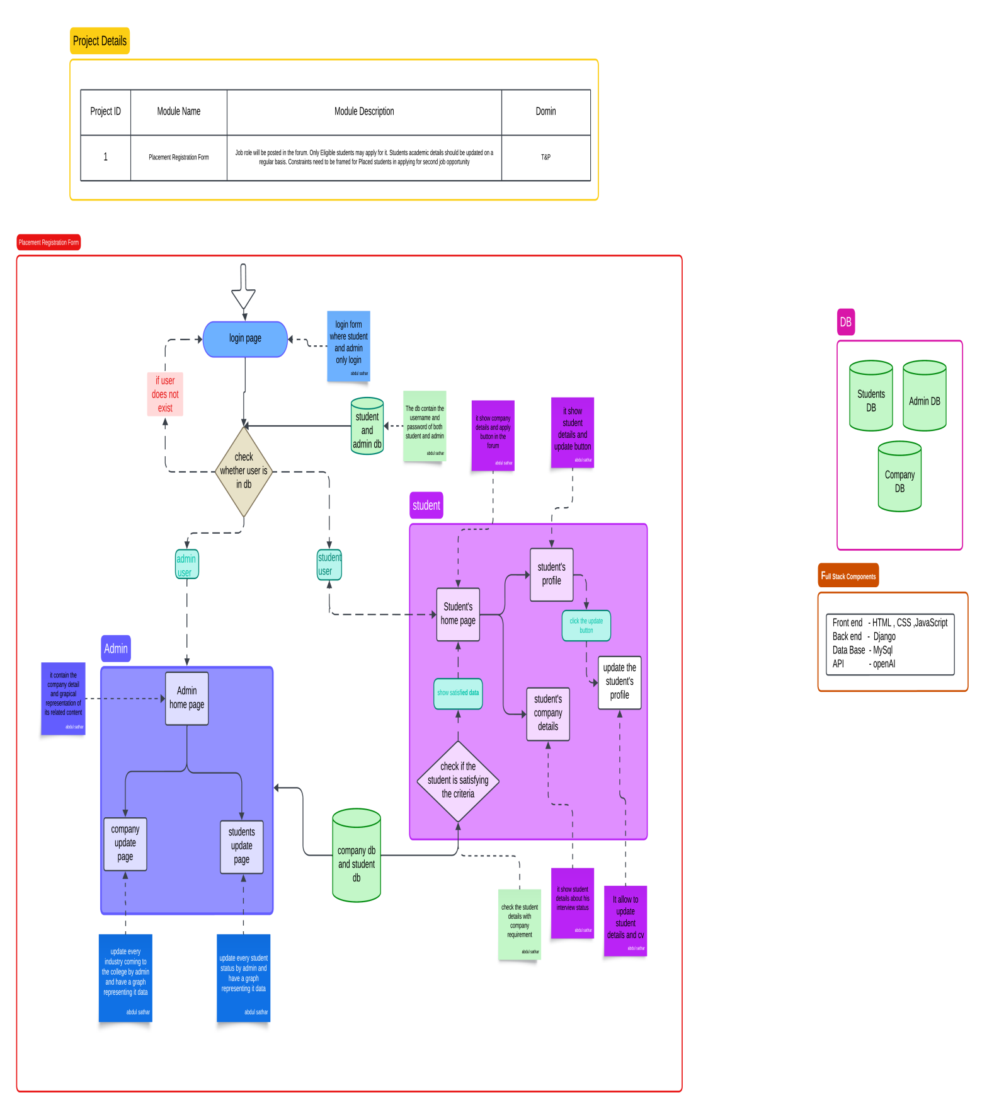

# Flow chart

