

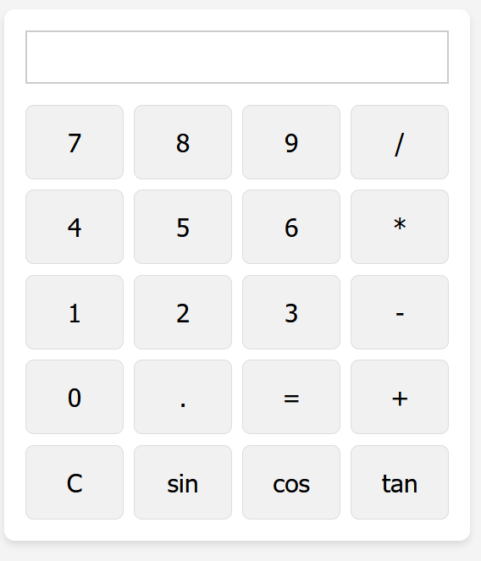

Code

OUTPUT

