ASSIGNMENT 2

-- 1. Fetch all the Customer Details along with the product names that the customer has
-- ordered.

SELECT c.*,p.product_name
FROM orders o
JOIN customer c USING(customer_id)
JOIN order_details od USING (order_id)
JOIN product p USING(product_id)
ORDER BY customer_id;

OUTPUT:
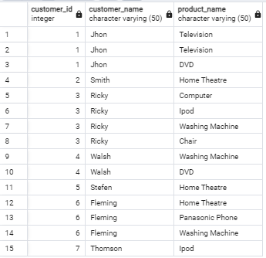

--2. Fetch Order_Id, Ordered_Date, Total Price of the order (product price*qty).

SELECT o.order_id,o.ordered_date,(p.product_price * od.quantity) AS total_salary
FROM orders o
JOIN order_details od USING(order_id)
JOIN product p USING(product_id)

OUTPUT:

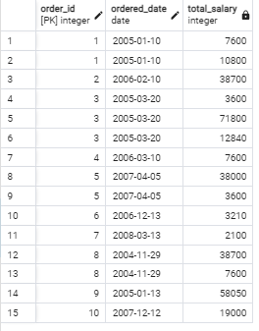
-- 3.Fetch the Customer Name, who has not placed any order

SELECT c.*
FROM customer c
LEFT JOIN orders o USING(customer_id)
WHERE o.order_id IS NULL

OUTPUT:
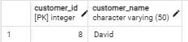

-- 4) Fetch the Product Details without any order(purchase)

SELECT p.*
FROM product p
LEFT JOIN order_details od USING(product_id)
WHERE od.order_id IS NULL
ORDER BY p.product_id

OUTPUT:

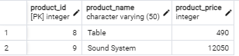

-- 5) Fetch the Customer name along with the total Purchase Amount

SELECT c.customer_name,SUM(p.product_price) AS total_price
FROM orders o
JOIN customer c USING(customer_id)
JOIN order_details od USING (order_id)
JOIN product p USING(product_id)
GROUP BY c.customer_name;

OUTPUT:

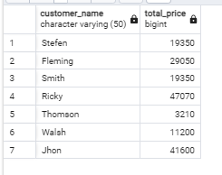

-- 6) Fetch the Customer details, who has placed the first and last order

SELECT c.*,MIN(o.ordered_date) AS first_order,MAX(ordered_date) AS last_order
FROM customer c
JOIN orders o USING (customer_id)
GROUP BY c.customer_id
ORDER BY last_order DESC
LIMIT 1

OUTPUT:

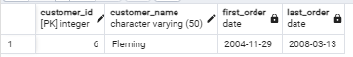

-- 7) Fetch the customer details , who has placed more number of orders

SELECT c.*, COUNT(*) AS total_orders
FROM orders o
LEFT JOIN customer c USING(customer_id)
GROUP BY c.customer_id
ORDER BY total_orders DESC
LIMIT 3

OUTPUT:

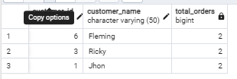

-- 8) Fetch the customer details, who has placed multiple orders in the same year

SELECT c.*,EXTRACT(YEAR FROM o.ordered_date)
FROM orders o
JOIN customer c USING(customer_id)
ORDER BY c.customer_id
LIMIT 2

OUTPUT:
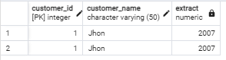

-- 9) Fetch the name of the month, in which more number of orders has been placed

SELECT COUNT(*) AS no_of_orders,to_char(o.ordered_date,'Month') AS month_h
FROM orders o
GROUP BY month_h
ORDER BY no_of_orders DESC
LIMIT 1

OUTPUT:



-- 10) Fetch the maximum priced Ordered Product

SELECT p.product_name,p.product_price
FROM customer c
LEFT JOIN orders o USING(customer_id)
JOIN order_details od USING (order_id)
JOIN product p USING(product_id)
ORDER BY p.product_price DESC
LIMIT 1

OUTPUT:
